Series
XB Explosion-Proof Heater
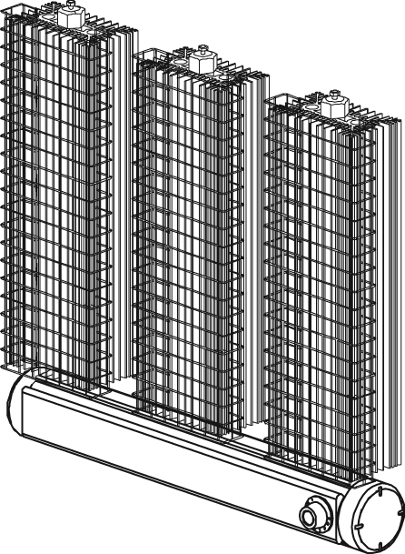  Type 3 unit with optional thermostat.

Features
Voltage - 120V, 208V, 240V, 480V, 600V, 1-phase.
Construction - Unique design.
- Efficient aluminum convector.
- Standard protective grille.
- Low temperature convection.
- Sealed junction box.
Heating element - Tubular heating element inserted in an aluminum heat sink.
Watt density - Varies according to temperature code.
Control - Built-in thermostat available.
Installation - Built-in wall support.
Warranty - 1-year warranty against defects.
Applications - Refinery, chemical storage, mining industry.
Maximum room temperature: 25 °C (77 °F).
Consult the Electrical Code in your area before installing this unit.

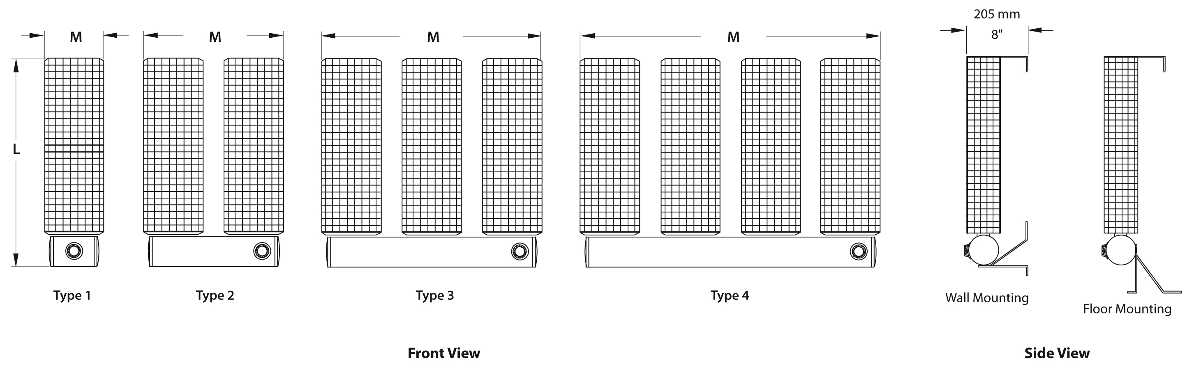
Models
Product # | Qty | Volts | Watts | Temperature Code² | Type | L |  | M |  | Weight
 |  |  |  |  |  | in. | mm | in. | mm | lb | kg
Class I, Division 1, Groups A, B, C and D
XB1-1047T2D11 |  | 120 | 475 | T2D | 1 | 10 | 254 | 7 _{5/16} | 184 | 10.0 | 4.5
XB1-4100T2D11 |  | 120 | 1000 | T2D | 1 | 23 _{7/16} | 594 | 7 _{5/16} | 184 | 20.0 | 9.1
XB2-3150T2D11 |  | 120 | 1500 | T2D | 2 | 16 _{3/4} | 424 | 16 _{1/8} | 410 | 30.0 | 13.6
XB1-4100T2D21 |  | 208 | 1000 | T2D | 1 | 23 _{7/16} | 594 | 7 _{5/16} | 184 | 20.0 | 9.1
XB2-3150T2D21 |  | 208¹ | 1500 | T2D | 2 | 16 _{3/4} | 424 | 16 _{1/8} | 410 | 30.0 | 13.6
XB2-4200T2D21 |  | 208¹ | 2000 | T2D | 2 | 23 _{7/16} | 594 | 16 _{1/8} | 410 | 40.0 | 18.1
XB3-4300T2D21 |  | 208¹ | 3000 | T2D | 3 | 23 _{7/16} | 594 | 25 | 635 | 60.0 | 27.2
XB4-6450T2D21 |  | 208¹ | 4500 | T2D | 4 | 30 _{1/8} | 765 | 33 _{15/16} | 860 | 100.0 | 45.4
XB1-4100T2D31 |  | 240 | 1000 | T2D | 1 | 23 _{7/16} | 594 | 7 _{5/16} | 184 | 20.0 | 9.1
XB2-3150T2D31 |  | 240¹ | 1500 | T2D | 2 | 16 _{3/4} | 424 | 16 _{1/8} | 410 | 30.0 | 13.6
XB2-4200T2D31 |  | 240¹ | 2000 | T2D | 2 | 23 _{7/16} | 594 | 16 _{1/8} | 410 | 40.0 | 18.1
XB3-4300T2D31 |  | 240¹ | 3000 | T2D | 3 | 23 _{7/16} | 594 | 25 | 635 | 60.0 | 27.2
XB4-6450T2D31 |  | 240¹ | 4500 | T2D | 4 | 30 _{1/8} | 765 | 33 _{15/16} | 860 | 100.0 | 45.4
XB1-4100T2D71 |  | 480 | 1000 | T2D | 1 | 17 _{3/4} | 451 | 7 _{5/16} | 184 | 20.0 | 9.1
XB2-4200T2D71 |  | 480¹ | 2000 | T2D | 2 | 17 _{3/4} | 451 | 16 _{1/8} | 410 | 40.0 | 18.1
XB3-4300T2D71 |  | 480¹ | 3000 | T2D | 3 | 17 _{3/4} | 451 | 25 | 635 | 60.0 | 27.2
XB4-6450T2D71 |  | 480¹ | 4500 | T2D | 4 | 30 _{1/8} | 765 | 33 _{15/16} | 860 | 100.0 | 45.4
XB1-4100T2D81 |  | 600 | 1000 | T2D | 1 | 17 _{3/4} | 451 | 7 _{5/16} | 184 | 20.0 | 9.1
XB2-4200T2D81 |  | 600¹ | 2000 | T2D | 2 | 17 _{3/4} | 451 | 16 _{1/8} | 410 | 40.0 | 18.1
XB3-4300T2D81 |  | 600¹ | 3000 | T2D | 3 | 17 _{3/4} | 451 | 25 | 635 | 60.0 | 27.2
XB4-6450T2D81 |  | 600¹ | 4500 | T2D | 4 | 30 _{1/8} | 765 | 33 _{15/16} | 860 | 100.0 | 45.4
Class I, Divisions 1 and 2, Groups A, B, C and D

Class II, Divisions 1 and 2, Groups E, F and G — Class III, Division 1
XB3-6225T3B11 |  | 120 | 2250 | T3B | 3 | 30 _{1/8} | 765 | 25 | 635 | 75.0 | 34.0
XB3-6225T3B21 |  | 208¹ | 2250 | T3B | 3 | 30 _{1/8} | 765 | 25 | 635 | 75.0 | 34.0
XB3-6225T3B31 |  | 240¹ | 2250 | T3B | 3 | 30 _{1/8} | 765 | 25 | 635 | 75.0 | 34.0
XB3-6225T3B71 |  | 480¹ | 2250 | T3B | 3 | 30 _{1/8} | 765 | 25 | 635 | 75.0 | 34.0
XB3-6225T3B81 |  | 600¹ | 2250 | T3B | 3 | 30 _{1/8} | 765 | 25 | 635 | 75.0 | 34.0

Options
Product #  Kit | Product #  Factory installed* | Description | Qty
- | T | Single-pole thermostat for single phase units only
- | T2 | Double-pole thermostat
XB-TM | - | Explosion-proof wall thermostat, range -18 °C to 40 °C (0 °F to 100 °F): 15A at 600V, 25A at 277V
XB-TM2 | - | Double-pole explosion-proof wall thermostat, range -18 °C to 40 °C (0 °F to 100 °F):  15A at 600V, 25A at 277

* For factory installed options, add the option number to the product number. See the Product Code section inside the front cover.
¹ 3-phase models available upon request. If built-in thermostat is required, use the T2 or the XB-TM2 with 3-phase units.
² Temperature code: T2D = 215 °C (419 °F), T3B = 165 °C (329 °F).
For any other ratings and risk areas, contact our customer service.

Others
Type | Quantity | Model et description  Complementary informations | Volts | Phase | Watts | Length  mm/in. | Informations  Color/installation

Specifications may change without prior notice
Project: | Approval  Information
Consultant Engineer: | Approval  Information
Eectrician Contractor: | Approval  Information
Distributor: | Approval  Information
Date: | Approval  Information
Contact in Ouellet: | Approval  Information
Comments:

