Series
W
BW
GR
C
SB
XCE Xlerator High Velocity Hand Dryer

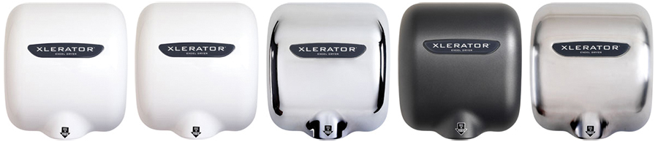



Features
Color - Standard: white (W).
Finish - Standard: epoxy/polyester powder paint.
- Optional : White polymer BMC (BW), chrome (C), graphite (GR)
or brushed stainless steel (SB).
Voltage - 110-120V, 208-240V, 1-phase.
Construction - Standard die cast zinc alloy monobloc housing.
Fan - Motor operating at 20,000 rpm.
- Air volume at high velocity of 19,000 lfm
- Adjustable motor speed.
- Includes 1.1 in. noise reduction nozzle which brings the sound level down to 71 dBA (81 dBA with hands).
Heating element - Helical coil nickel-chromium alloy wire protected by mica insulator.
- Adjustable heat control : High, Medium, Low and Off.
Control - Infrared optical sensor to activate hand dryer.
- 35 second lockout feature if hands are not removed.
Installation - Surface mounted.
Warranty - 5-year warranty against defects.
Application - Bar, school, penitentiary, restaurant, commercial mall.

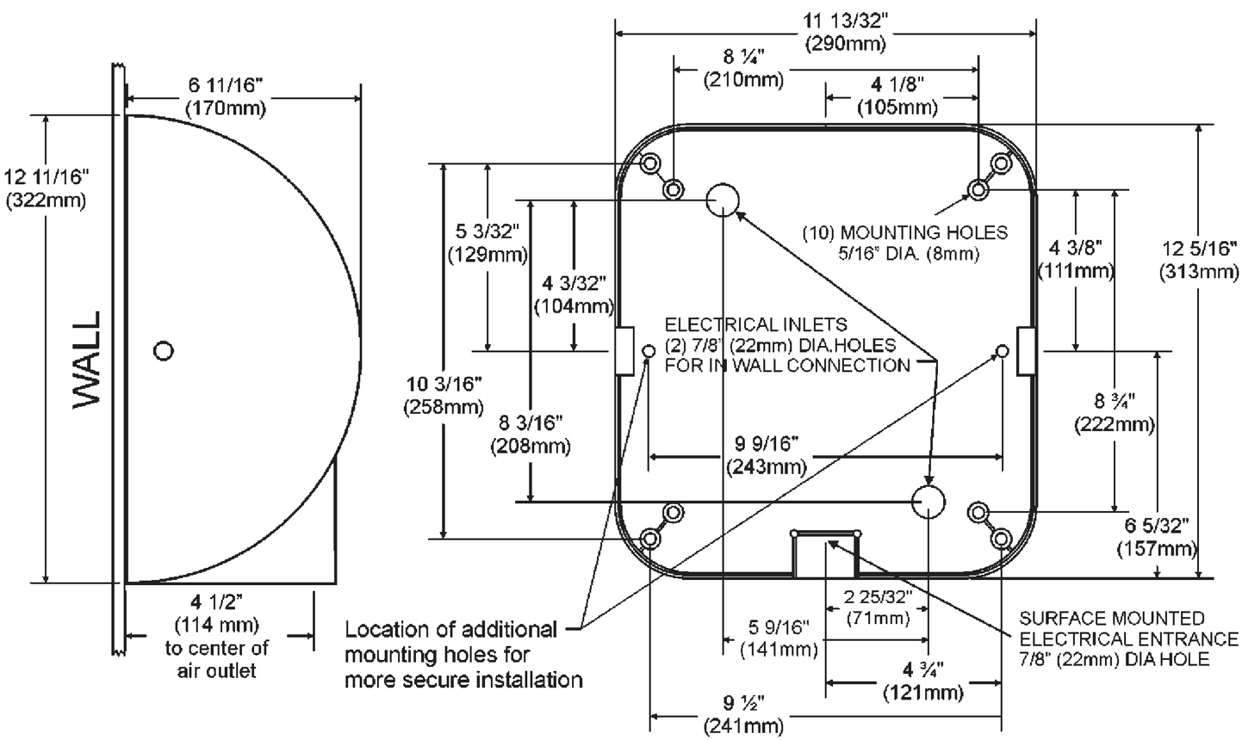

Models
Product # | Qty | Color¹ | Volts | Watts | No heat watts | Weight
 |  |  |  |  |  | lb | kg
XL-W-11N-110-120V |  | W | 110-120 | 1240-1450 | 460-530 | 17 | 7.7
XL-BW-11N-110-120V |  | BW | 110-120 | 1240-1450 | 460-530 | 15 | 6.8
XL-GR-11N-110-120V |  | GR | 110-120 | 1240-1450 | 460-530 | 17 | 7.7
XL-C-11N-110-120V |  | C | 110-120 | 1240-1450 | 460-530 | 17 | 7.7
XL-SB-11N-110-120V |  | SB | 110-120 | 1240-1450 | 460-530 | 16 | 7.3
XL-W-11N-208-240V |  | W | 208-240 | 1160-1490 | 425-500 | 17 | 7.7
XL-BW-11N-208-240V |  | BW | 208-240 | 1160-1490 | 425-500 | 15 | 6.8
XL-GR-11N-208-240V |  | GR | 208-240 | 1160-1490 | 425-500 | 17 | 7.7
XL-C-11N-208-240V |  | C | 208-240 | 1160-1490 | 425-500 | 17 | 7.7
XL-SB-11N-208-240V |  | SB | 208-240 | 1160-1490 | 425-500 | 16 | 7.3

¹ W (White), BW (White polymer BMC), GR (Graphite), C (Chrome), SB (Brushed stainless steel).
Eco model available on demand (-ECO).
Options
Product # | Qty | Description
XL-40502 |  | ADA compliant stainless steel recess
XL-89S |  | Wall guard – stainless steel, 2 per box
XLP-89B |  | Microban® anti-microbial plastic wall guard - black
XLP-89W |  | Microban® anti-microbial plastic wall guard - white

Others
Type | Quantity | Model et description  Complementary information | Volts | Phase | Watts | Length  mm/in. | Information  Color/installation

Specifications may change without prior notice
Project: | Approval  Information
Consultant Engineer: | Approval  Information
Electrician Contractor: | Approval  Information
Distributor: | Approval  Information
Date: | Approval  Information
Contact in Ouellet: | Approval  Information
Comments:

