TH1310WF
Smart thermostat – Wi-Fi for floor heating system
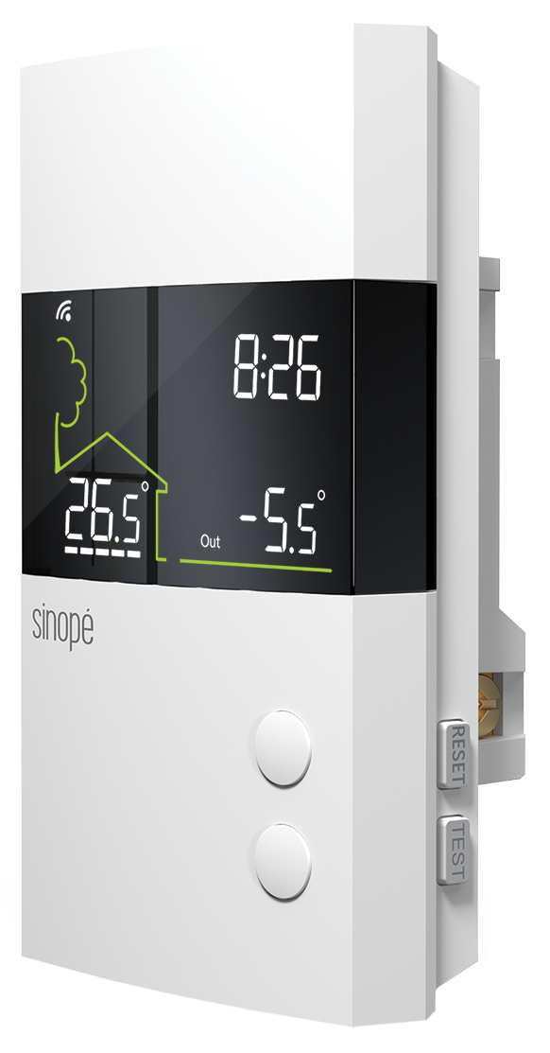
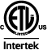

CSA-C828 Performance Standard

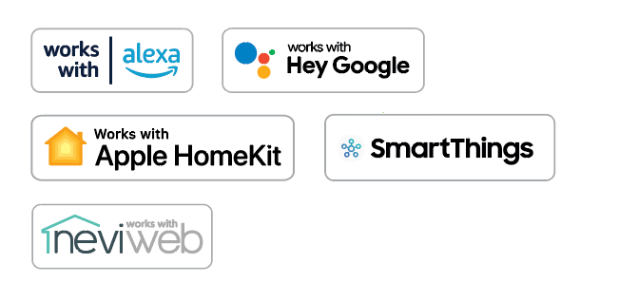

Features
Type - Programmable, electronic, double-pole, 4-wire smart thermostat for ﬂoor
heating system.
Color - Standard: white.
Voltage - 120/208/240V, 50/60Hz.
Rating - 15A at 120/208/240V.
Control - 15-minute cycle.
- Resolution and precision: ± 0.5 °C (1 °F).
- Auxiliary contact offers the possibility of controlling supplemental heat sources to be added by either using a slave module (TR1310-120-240GA) for heated floors or using a low voltage relay and a low voltage transformer for an electric heater.
Temperature control mode - A mode: Ambient temperature control and possibility of limiting the temperature of the floor using an external temperature sensor.
- F mode: Floor temperature control using and external temperature sensor and
possibility of limiting the ambient temperature.
Temperature range - Floor: 5 °C (40 °F) to 36 °C (96 °F).
- Ambient: 5 °C (40 °F) to 36 °C (96 °F).
Display - Digital display of actual and setpoint temperature (°C or °F), heating level, actual mode and clock (12 or 24-hour format).
- Outside temperature display.
- Temperature setpoint and settings are permanently recorded.
- GFCI fault indicator (ground fault circuit interrupter).
- Black backlit.
Program - Programming features are accessible only through the Neviweb app.
The connectivity requires a Wi-Fi signal.
Installation - 4-wire thermostat with ambient sensor and floor sensor.
Warranty - 3-year warranty against defects.
Models
Product # | Description | Amp. | Volts | Protection | Qty
TH1310WF^{2,3} | Smart thermostat – Wi-Fi for floor heating system | 15 | 120/208/240 | Class A  GFCI 5 mA¹
TR1310-120-240GA³ | Slave unit for floor heating system | - | - | -

¹ GFCI: Ground fault circuit interrupter.
² 15' (4.6 m) floor sensor included.
³ Standard color is white.

Use of the Works with Apple badge means that an accessory has been designed to work specifically with the technology identified in the badge and has been certified by the
developer to meet Apple performance standards. Apple is not responsible for the operation of this device or its compliance with safety and regulatory standards.
HomeKit is a trademark of Apple Inc.
Neviweb® is a registered trademark of Sinopé Technologies Inc. in Canada and the United States.
Apple and the Apple logo are trademarks of Apple Inc., registered in the U.S. and other countries.
App Store is a service mark of Apple Inc., registered in the U.S. and other countries. Google
Play and the Google Play logo are trademarks of Google Inc.
The Wi-Fi CERTIFIED™ Logo is a certification mark of Wi-Fi Alliance®.

Specifications may change without prior notice
Project: | Approval  Information
Consultant Engineer: | Approval  Information
Electrician Contractor: | Approval  Information
Distributor: | Approval  Information
Date: | Approval  Information
Contact in Ouellet: | Approval  Information
Comments:

