Series
OTH5007 Non Programmable Electronic Thermostat

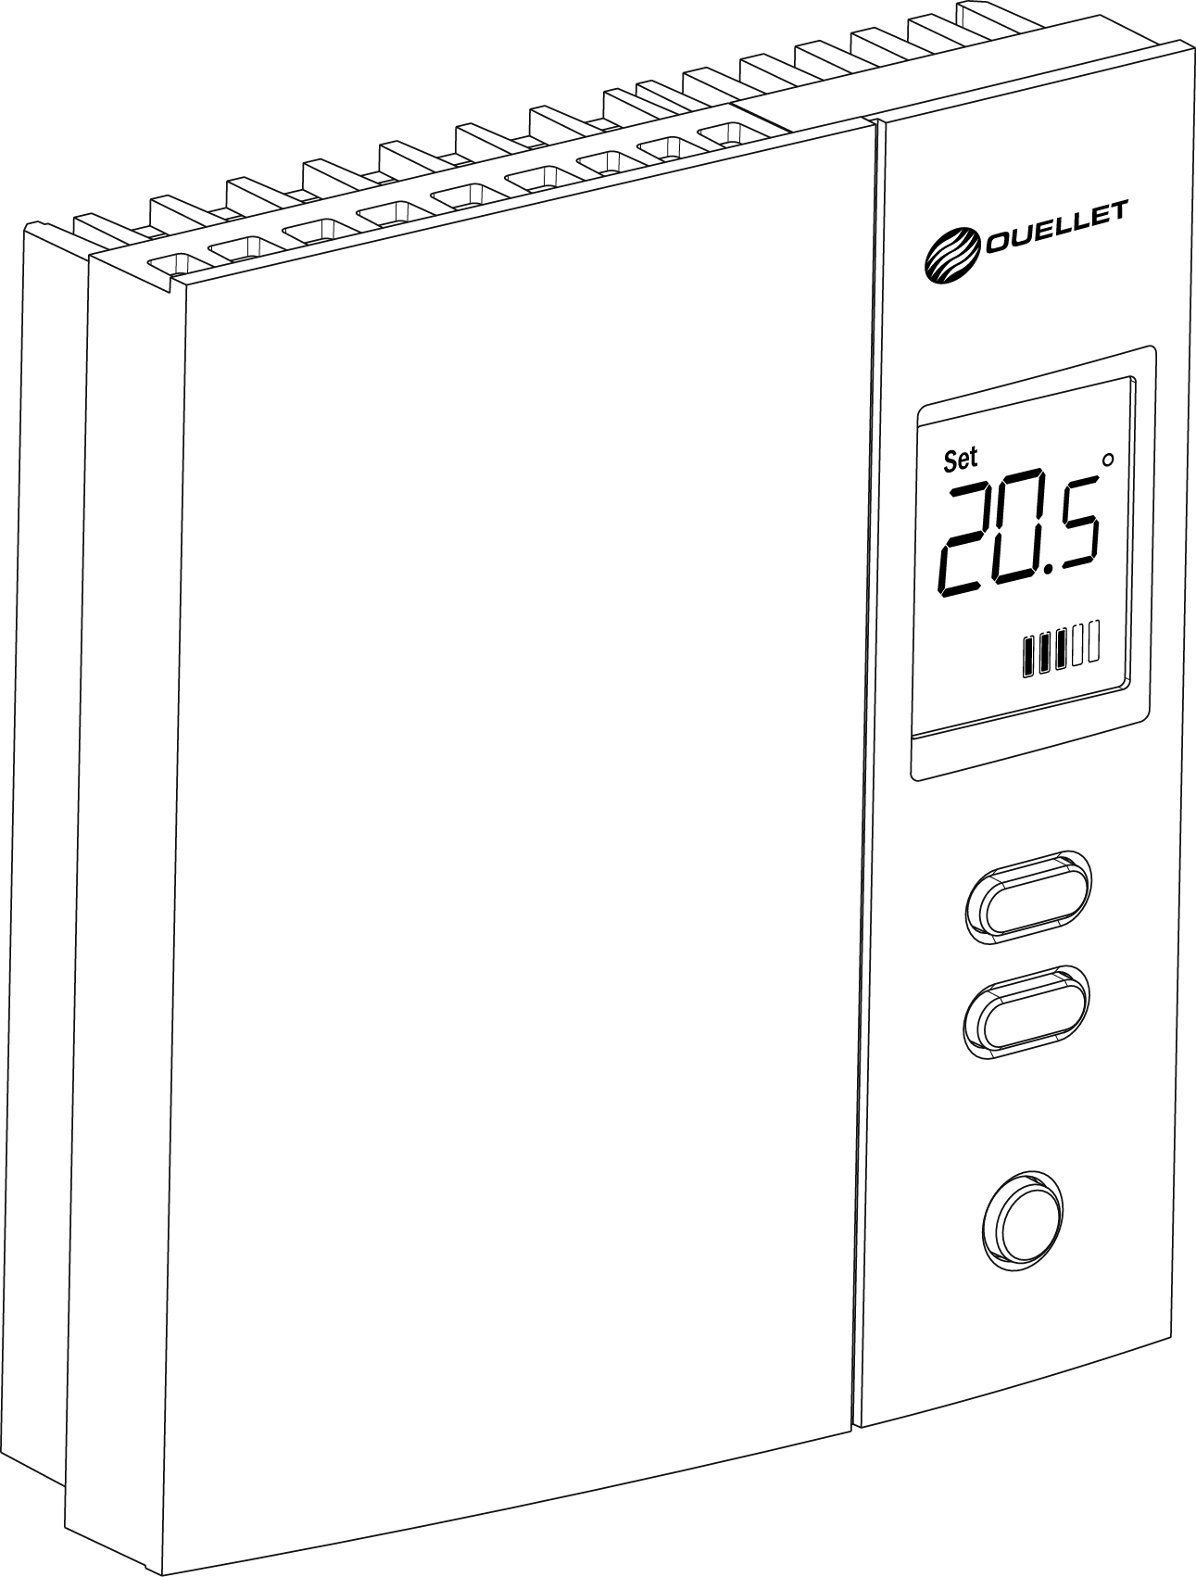



Features
Type - Non programmable electronic proportional pulsing thermostat.
Color - Standard: white.
Voltage - 277/347V, 50/60 Hz.
Rating - Maximum load: 14.4A at 277/347V.
- Minimum load: 1.25A at 277/347V.
Control - 10-minute or 15-second cycle.
- Resolution: ± 0.5 °C (1 °F).
- Precision: ± 0.15 °C (0.27 °F) on 15-second cycle.
- Precision: ± 0.5 °C (1 °F) on 10-minute cycle.
Temperature range - 5 °C (41 °F) to 30 °C (86 °F).
Display - Digital screen.
- Display ambient temperature and heating level indicator (in continuous),
setpoint temperature setting (on demand),
fan-forced heater mode and keypad lock (when activated).
Other feature - Choice of temperature display format (°C or °F).
- Temperature setpoints recorded permanently in case of a power outage.
- Ability to set minimum and maximum setpoints.
- Thermistor temperature sensing element.
Installation - 2-wire thermostat, easy to install.
- Adapter plate for 347V junction box included.
Application - Baseboard heater, radiant ceiling, radiant ﬂoor (without ﬂoor sensor),
convector (short cycle) and fan-forced convector (long cycle).
Warranty - 3-year warranty against defects.

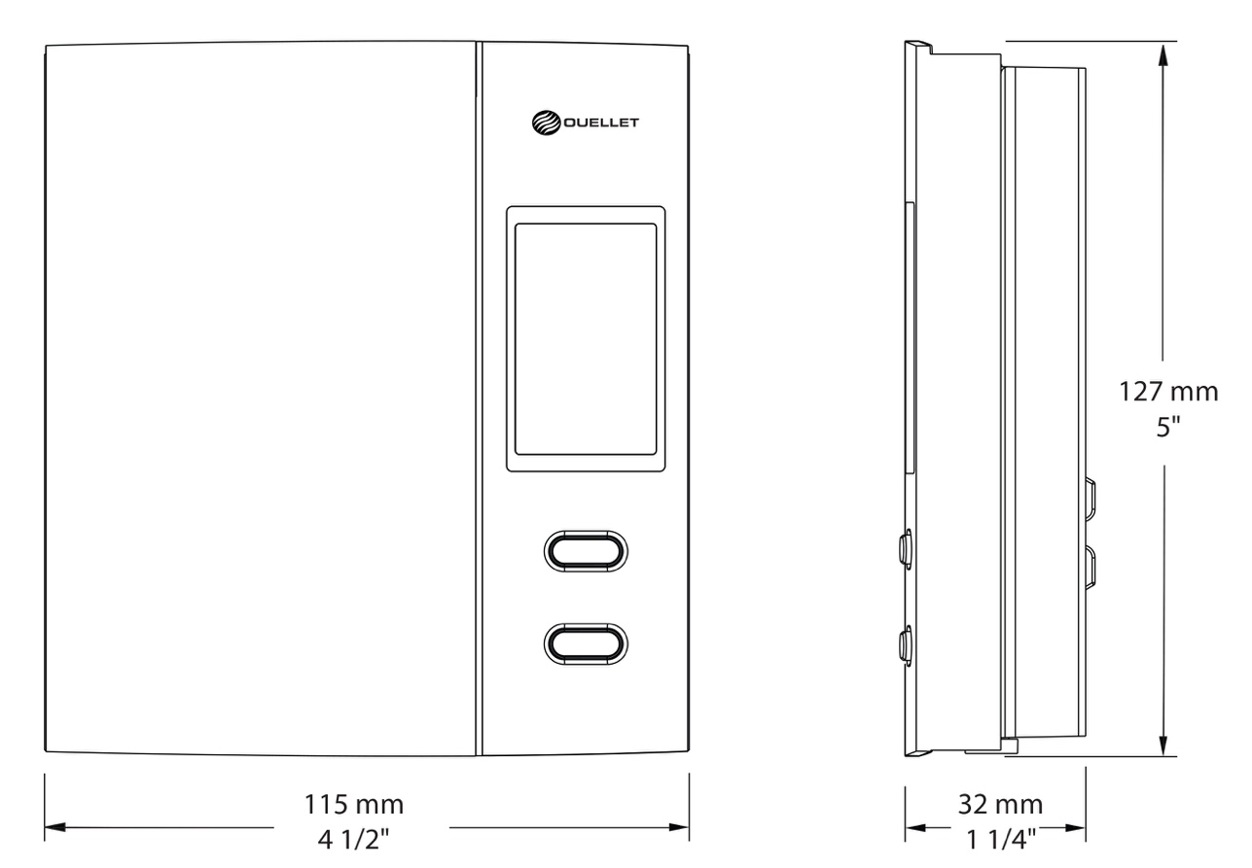

Model
Product # | Description | Volts | Watts | Qty
OTH5007 | Non programmable electronic proportional pulsing thermostat | 277/347 | 4000/5000

Standard color is white.

Specifications may change without prior notice
Project: | Approval  Information
Consultant Engineer: | Approval  Information
Electrician Contractor: | Approval  Information
Distributor: | Approval  Information
Date: | Approval  Information
Contact in Ouellet: | Approval  Information
Comments:

