Series
ETO2 Dual-zone Electronic Controller
for Heating Cables
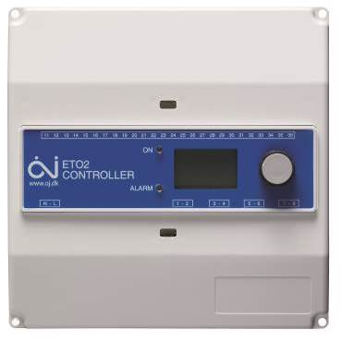

Features
Type - Dual-zone electronic controller.
- Automatic detection of humidity and temperature, in combination with a ground sensor (see available ground sensor models, sold separately).
Color - Standard : white.
Power - 120-240V, 50/60 Hz.
Rating - 1-zone: 3 output relays of 16A each.
- 2-zone: 2 output relays of 16A each.
Construction - IP20/NEMA 1 rated enclosure, for indoor installation.
Control - Dry contact relay output, NO (normally open).
Trigger temperature range - -22 °C (-7.6 °F) to 50 °C (122 °F).
Display - Backlit digital display.
Mode - 1-zone.
- 2-zone, individually controlled.
Installation - DIN-rail mounted in approved panel (not included) or wall mounted in ETO2-BOX mounting box (see options, sold separately).
- Install ground sensor inside heated surface in a clear space that will receive precipitations.
Other feature - Choice of temperature display format (°C or °F).
- Adjustment of temperature offset per zone.
- Adjustment of afterrun time per zone.
- Alarm relay ouput (5A).
Warranty - 3-year warranty against defects.
Application - For controlling snow and ice melting cable applications.
- Residential driveway, sidewalk, access ramp, underground parking ramp,
roof and gutter.

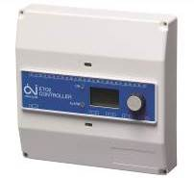 |  | 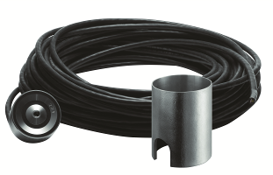 | 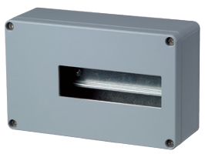
ETO2 | ETOG  (sold separately) | ETOG-56 and ETOK-1  (sold separately) | ETO2-BOX  (sold separately)
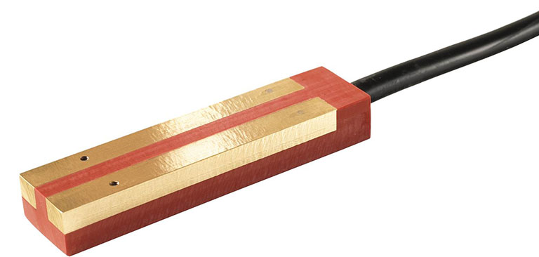
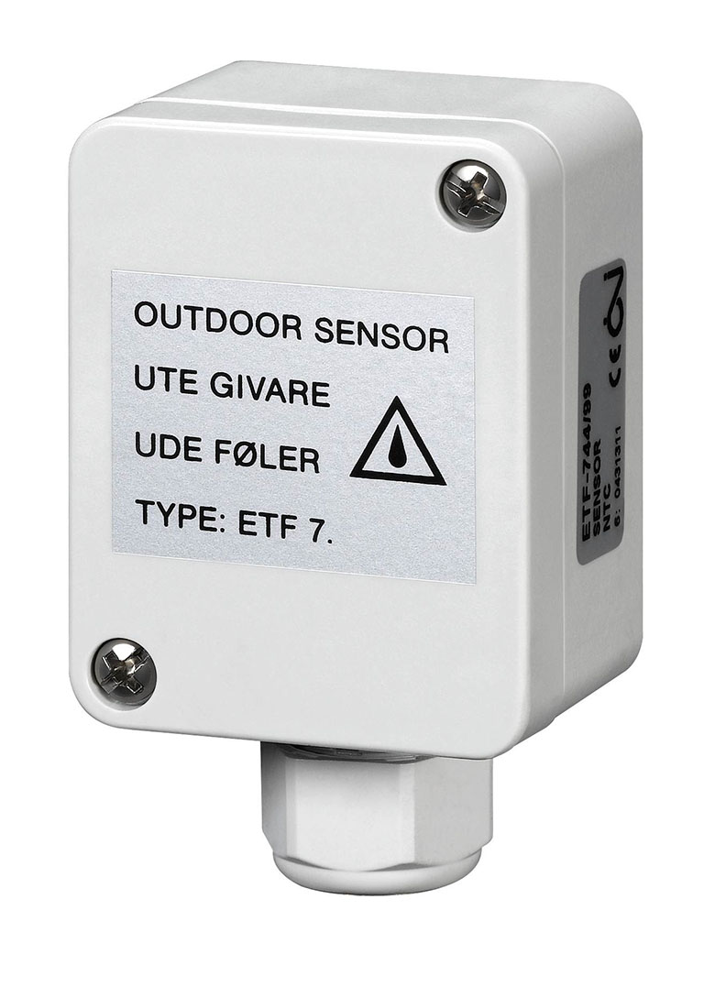
ETOR-55
ETF-744-99

Controller Model
Product # | Description | Amp. | Volts | Qté
ETO2 | Dual-zone electronic controller | 3 X 16A | 120-240
Ground Sensor Models
Product # | Description | Qté
ETOG | Ground sensor to detect humidity and temperature with 33 ft. (10 m) side entry cable
ETOG-56 | Ground sensor to detect humidity and temperature with 80 ft. (25 m) bottom entry cable
ETF-744-99 | 24V outdoor sensor fore measuring temperature
ETOR-55 | Gutter sensor to detect humidity with 33ft.(10m) cable
Options
Product #  Kit | Description | Qté
ETO2-BOX | Mounting box for dual-zone electronic controller ETO2
ETOK-1 | Mounting tube for ground sensor ETOG-56
¹ Requires a ground fault circuit interrupter (GFCI) in the electrical panel.

Specifications may change without prior notice
Project: | Approval  Information
Consultant Engineer: | Approval  Information
Electricial Contractor: | Approval  Information
Distributor: | Approval  Information
Date: | Approval  Information
Contact in Ouellet: | Approval  Information
Comments:

Requires a ground fault circuit interrupter (GFCI) in the electrical panel.

