Series
SLIM24 Hyper Heat
Central Heat Pump System and Cased Coil System
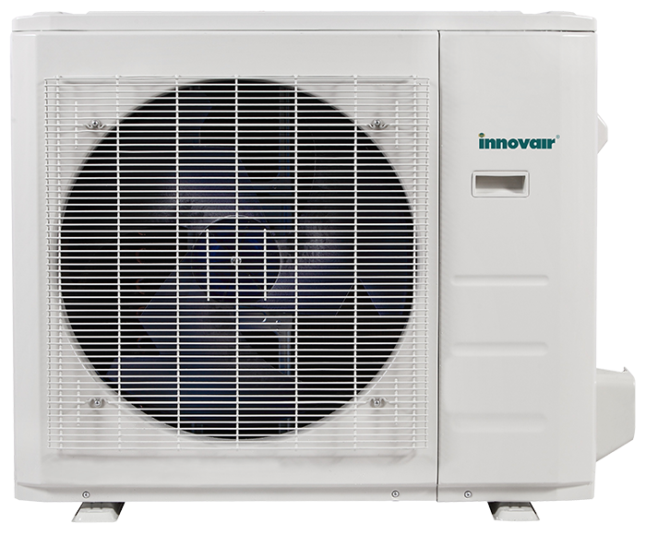
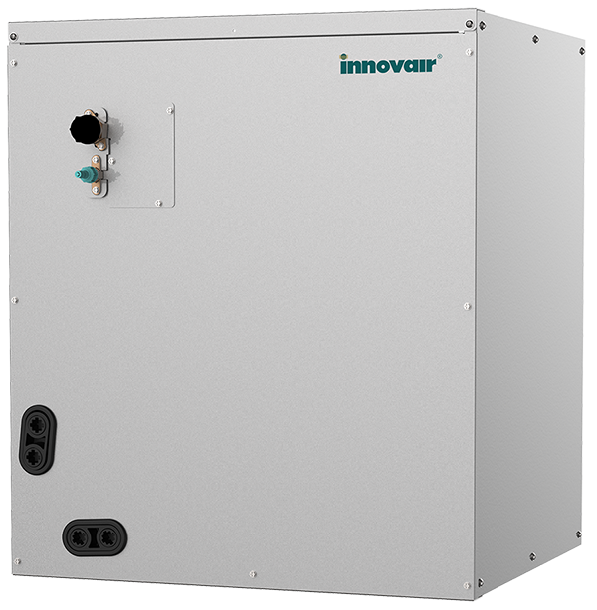
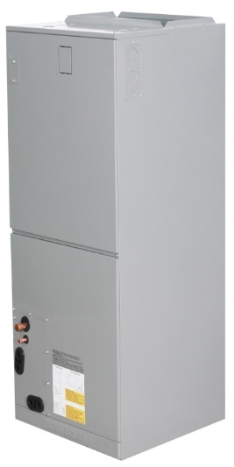




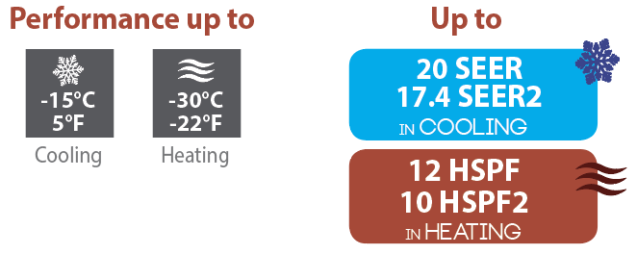

Features
Operation mode - Cooling, heating, dehumidifying, fan and auto.
Nominal capacity - 24000, 36000, 48000, 60000 BTU/hr.
Voltage - 230/208V, 60 Hz, 1-phase.
Indoor unit Air Handler
- Vertical or horizontal installation.
- Available with upflow or downflow.
- Washable filters.
Cased Coil
- Available in four casing dimensions.
- Horizontal or vertical installation.
- Can be matched with third-party gas furnace or blower.
- 24V or 485 communication mode.
Outdoor unit - DC motor.
- Variable speed rotary compressor (INVERTER), with overload protection.
- Electronic expansion valve for precise control of refrigerant flow.
- Condenser fins covered with a hydrophilic coating for improved corrosion resistance.
- Large diameter quiet axial-flow fan for more efficient heat exchange.
- Multi-hole pan with smart heater to prevent ice formation.
- Compressor blanket and preheating technology.
- Installation on aluminum wall bracket or ground stand (optional).
Connection piping - Minimum piping length of 10 ft. (3 m).
- Flared connections.
Control - Wireless remote included.
- Wi-Fi wired wall controller included.
- 24V thermostat connection available.
- Set temperature: 16 to 30 °C (61 to 86 °F).
- Temperature display format: °C or °F.
Warranty - 10-year basic warranty on parts and 10-year basic warranty on the compressor (labour not included).
- Labour warranty (sold separately) from the 1st to 10th year, on parts and labour with system replacement if the compressor fails.
Application - Detached and semi-detached home, commercial building, office building, restaurant.

Features and functions

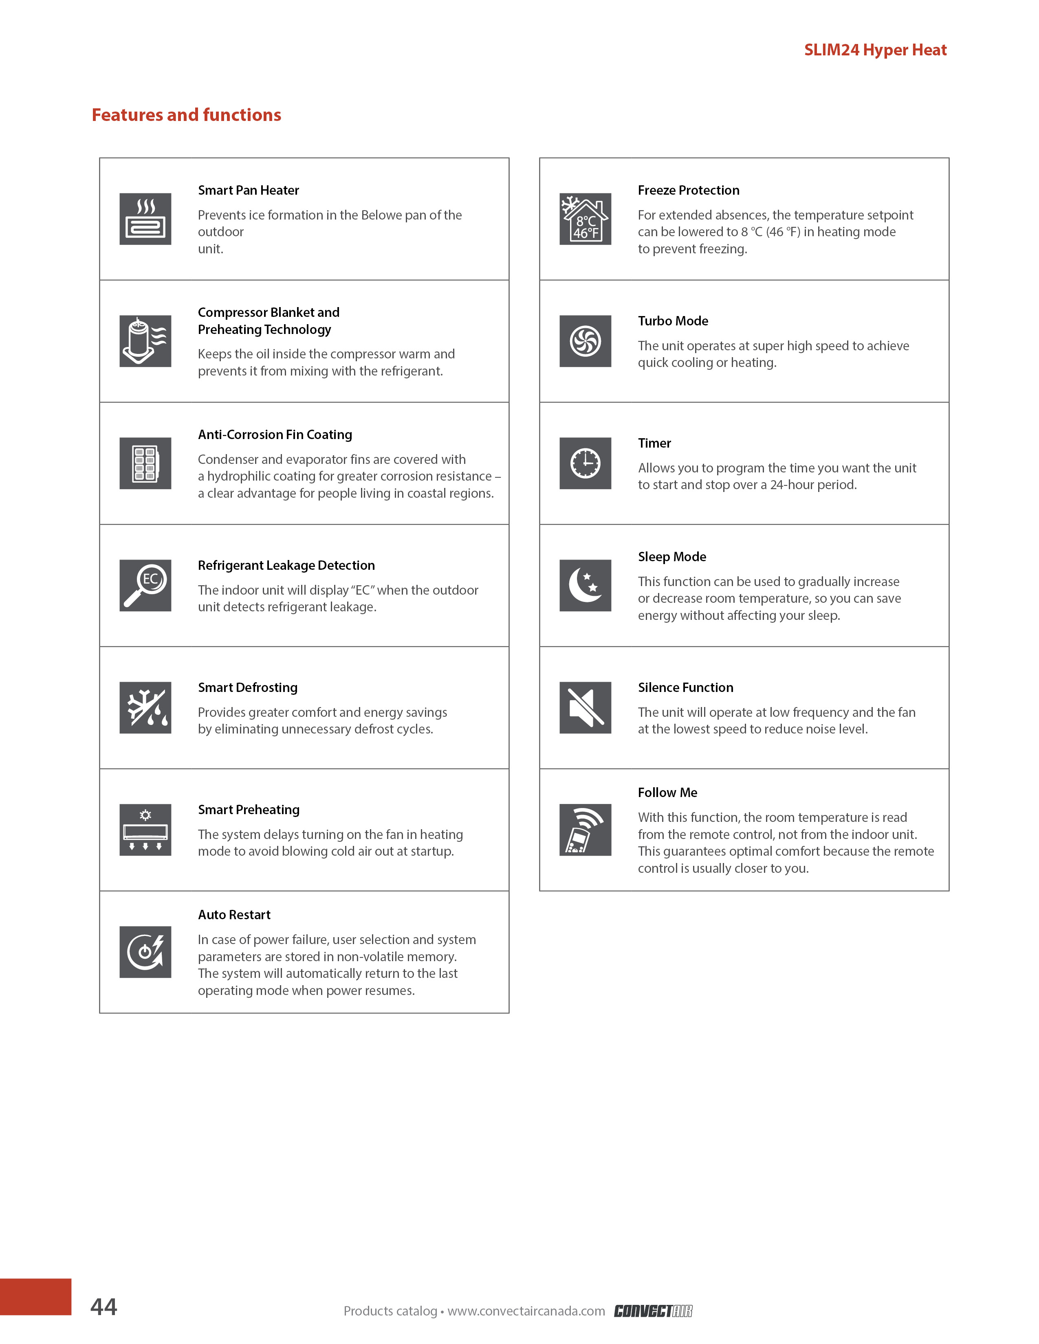

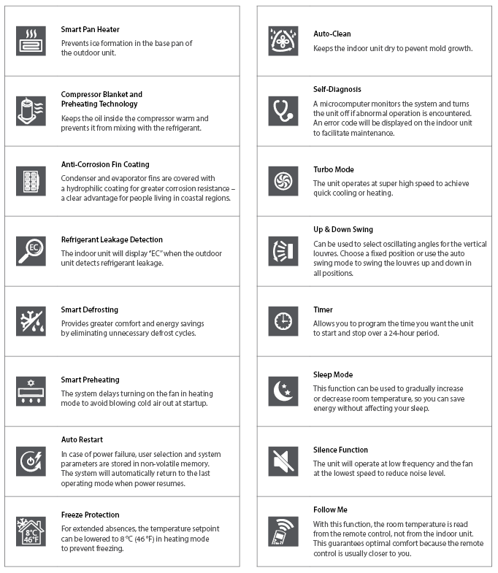
Models
Product #¹ |  | Indoor Unit |  |  | DEV24H2R19  SHV24H2R20 | DEV36H2R19  SHV36H2R20 |  | DEV48H2R19  SHV48H2R20 |  |  | DEV60H2R19  SHV60H2R20
 |  | Outdoor Unit
Qty
Technical Performance
Power supply |  |  |  | V / Ph / Hz | 230/208 / 1 / 60
Cooling capacity | Nominal |  |  | W (BTU/hr) | 7038 (24000) | 10557 (36000) |  | 13783 (47000) |  |  | 16129 (55000)
Cooling capacity | Min. – max. |  |  | W (BTU/hr) | 3225 - 7918  (11000 - 27000) | 3519 - 13900  (12000 - 47400) |  | 5279 - 14076  (18000 - 48000) |  |  | 4106 - 16422  (14000 - 56000)
Heating capacity | Nominal |  |  | W (BTU/hr) | 7038 (24000) | 11730 (40000) |  | 14663 (50000) |  |  | 17302 (59000)
Heating capacity | Min. – max. |  |  | W (BTU/hr) | 2962 – 9091  (10100 - 31000) | 3226 - 16774  (11000 - 57200) |  | 3226 - 16129  (11000 - 55000) |  |  | 3930 - 20235  (13400 - 69000)
SEER / SEER2 |  |  |  | - | 20 / 17.4 | 18 / 16 |  | 16 / 15.6 |  |  | 16.4 / 15.3
HSPF / HSPF2 |  |  |  | - | 12 / 10 | 10.5 / 9.5 |  | 10 / 9.4 |  |  | 10.5 / 9.4
EER |  |  |  | W/W | 13 | 10.5 |  | 8.5 |  |  | 9
COP |  |  |  | W/W | 3 | 1.8 |  | 1.88 |  |  | 1.92
AHRI number |  |  |  | - | 210343158 | 210343156 |  | 210343157 |  |  | 210343159
Indoor Unit (Air Handler)
Dehumidification |  |  | pt/hr (l/hr) |  | 3.48 (1.98) | 6.1 (3.49) |  | 4.96 (8.72) |  |  | 9.77 (5.55)
Air flow volume | T / H / M / L2 |  | cfm |  | 824 / 759 / 694 / 629 | 1188 / 1082 / 971 / 865 |  | 1471 / 1282 / 1094 / 906 |  |  | 1806 / 1582 / 1359 / 1135
Sound level | H / M / L2 |  | dB (A) |  | 39 / 36 / 33 | 45 / 43 / 41 |  | 50 / 47 / 43.5 |  |  | 51 / 45.5 / 41.5
Fan motor RLA |  |  | A |  | 3 | 4 |  | 6 |  |  | 7
MCOP |  |  | A |  | 15 | 15 |  | 15 |  |  | 15
External Static Pressure (ESP) | Nominal |  | inH2O |  | 0.1 | 0.15 |  | 0.2 |  |  | 0.2
External Static Pressure (ESP) | Range |  | inH2O |  | 0 - 0.8 | 0 - 0.8 |  | 0 - 0.8 |  |  | 0 - 0.8
Net weight |  |  | lb (kg) |  | 106 (48) | 129 (59) |  | 131 (59) |  |  | 163 (74)
Outdoor Unit
Air flow volume |  |  | cfm |  | 3000 | 4500 |  | 4412 |  |  | 4500
Sound level |  |  | dB (A) |  | 64 | 64 |  | 64 |  |  | 64
Compressor power input |  |  | W |  | 1945 | 3565 |  | 3565 |  |  | 3770
MCA |  |  | A |  | 20.5 | 41 |  | 42 |  |  | 42
MCOP |  |  | A |  | 35 | 50 |  | 50 |  |  | 60
Compressor RLA |  |  | A |  | 15 | 32 |  | 33 |  |  | 26.2
Fan motor power output |  |  | W |  | 120 | 85 |  | 85 |  |  | 85
Fan motor RLA |  |  | A |  | 1.35 | 1.2 |  | 1.2 |  |  | 1.2
Refrigerant volume (R410A) |  |  | oz (g) |  | 102 (2900) | 165.7 (4700) |  | 169 (4800) |  |  | 169 (4800)
Operating ambient temperature | Cooling |  | °C (°F) |  | -15 to 50 (5 to 112)
Operating ambient temperature | Heating |  | °C (°F) |  | -30 to 24 (-22 to 75)
Net weight |  |  | lb (kg) |  | 137 (62) |  | 227 (103) |  | 220 (100) | 240 (108)
Connection Piping / Refrigerant
Pre-charge length |  |  | ft. (m) |  | 25 (7.5) | 25 (7.5) |  | 25 (7.5) |  |  | 25 (7.5)
Additional refrigerant charge |  |  | oz/ft. (g/m) |  | 0.69 (65) | 0.69 (65) |  | 0.69 (65) |  |  | 0.69 (65)
Liquid pipe outer diameter |  |  | in. |  | 3/8 | 3/8 |  | 3/8 |  |  | 3/8
Gas pipe outer diameter |  |  | in. |  | 3/4 | 3/4 |  | 3/4 |  |  | 7/8
Maximum height between outdoor and indoor units |  |  | ft. in. (m) |  | 82’ (25) | 98’ 5’’ (30) |  | 98’ 5’’ (30) |  |  | 98’ 5’’ (30)
Maximum pipe length between outdoor and indoor units |  |  | ft. in. (m) |  | 164’ (50) | 213’ 3’’ (65) |  | 213’ 3’’ (65) |  |  | 213’ 3’’ (65)

¹ 1 indoor unit and 1 outdoor unit. Note that each unit is individually packaged.
² Fan Speeds: (T) Turbo / (H) High / (M) Medium / (L) Low.

Models – Indoor Unit (Cased Coil)
Product # |  |  | Indoor Unit | MAC24H1718E | MAC36H1724E | MAC36H2124E | MAC48H2124E | MAC60H2428E
 |  |  | Outdoor Unit | SHV24H2R20 | SHV36H2R20 | SHV36H2R20 | SHV48H2R20 | SHV60H2R20
Qty
Power supply |  | V / Ph / Hz |  | 208/230 / 1 / 60
Capacity | Cooling | BTU/hr |  | 24000 | 35000 | 36000 | 46000 | 53000
Capacity | Heating | BTU/hr |  | 25000 | 38000 | 39000 | 51000 | 54000
AHRI number |  | - |  | 213160473 | 213160474 | 213160476 | 213160477 | 213160478
Heating at -15 °C (5 °F) |  | SEER2 |  | 16.8 | 15.5 | 14.8 | 14.3 | 14.5
 |  | EER2 BTU/W |  | 10.7 | 10 | 9.8 | 8.6 | 8.6
 |  | HSPF2 |  | 9.5 | 8.6 | 8 | 9 | 8.6
 |  | Maximum BTU/hr |  | 20000 | 31600 | 32000 | 40000 | 46500
 |  | COP W/W |  | 1.95 | 1.85 | 2 | 1.8 | 1.8
Refrigerant piping | Liquid – Gas | in. |  | 3/8 - 3/4 | 3/8 - 3/4 | 3/8 - 3/4 | 3/8 - 3/4 | 3/8 - 7/8
Drain pipe diameter |  | in. |  | 3/4 | 3/4 | 3/4 | 3/4 | 3/4
Dimension | W x D x H | in. |  | 17 ½ x 21 x 18 | 17 ½ x 21 x 23 ½ | 21 x 21 x 24 | 21 x 21 x 24 | 24 ½ x 21 x 28
Dimension | W x D x H | mm |  | 445 x 533 x 457 | 445 x 533 x 599 | 533 x 533 x 609 | 533 x 533 x 609 | 622 x 533 x 711
Net weight |  | lb (kg) |  | 43 (19) | 60 (27) | 67 (30) | 67 (30) | 87 (39)

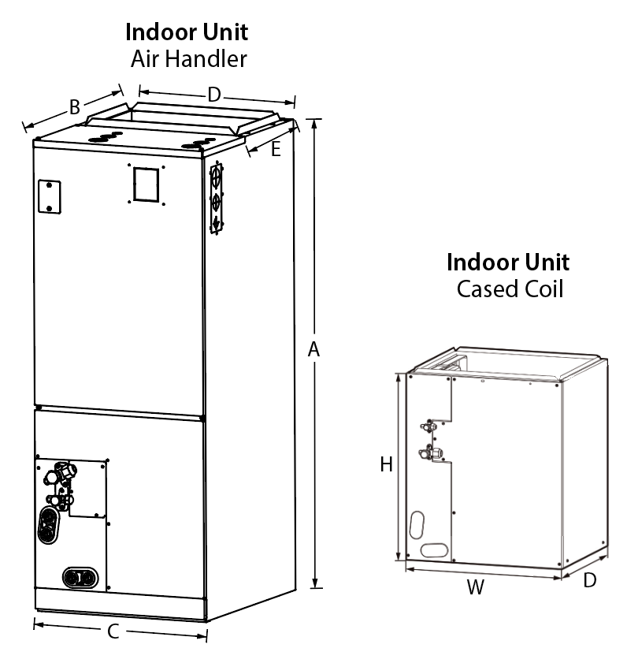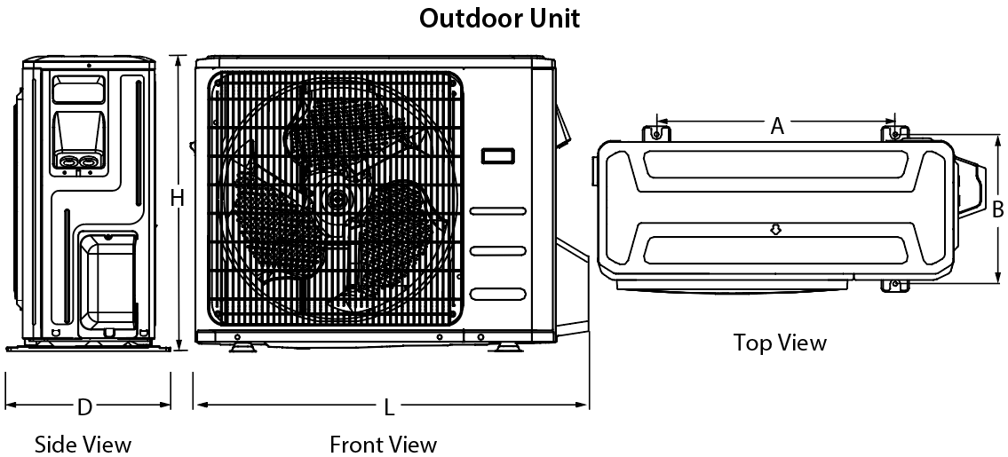

Indoor Unit  Air Handler | A |  | B |  |  | C |  | D |  | E
Indoor Unit  Air Handler | po | mm | po |  | mm | po | mm | po | mm | po | mm
DEV24H2R19 | 45 | 1143 | 21 |  | 534 | 17 1/2 | 445 | 15 3/4 | 400 | 10 1/4 | 260
DEV36H2R19 | 49 | 1245 | 21 |  | 534 | 21 | 534 | 19 1/4 | 490 | 10 1/4 | 260
DEV48H2R19 | 49 | 1245 | 21 |  | 534 | 21 | 534 | 19 1/4 | 490 | 10 1/4 | 260
DEV60H2R19 | 53 | 1346 | 21 |  | 534 | 24 1/2 | 622 | 22 7/8 | 580 | 10 1/4 | 260
Indoor Unit  Cased Coil | W |  | D |  |  |  |  | H
Indoor Unit  Cased Coil | po | mm | po |  |  | mm |  | po |  | mm
MAC24H1718E | 17 1/2 | 445 | 21 |  |  | 533 |  | 18 |  | 457
MAC36H1724E | 17 1/2 | 445 | 21 |  |  | 533 |  | 23 1/2 |  | 599
MAC36H2124E | 21 | 533 | 21 |  |  | 533 |  | 24 |  | 609
MAC48H2124E | 21 | 533 | 21 |  |  | 533 |  | 24 |  | 609
MAC60H2428E | 24 1/2 | 622 | 21 |  |  | 533 |  | 28 |  | 711
Outdoor Unit | W |  | H |  |  | D |  | A |  | B
Outdoor Unit | po | mm | po | mm |  | po | mm | po | mm | po | mm
SHV24H2R20 | 40 1/2 | 1030 | 32 | 810 |  | 17 7/8 | 455 | 26 1/2 | 673 | 15 7/8 | 404
SHV36H2R20 | 41 1/4 | 1045 | 52 1/2 | 1333 |  | 18 | 457 | 25 | 634 | 15 7/8 | 404
SHV48H2R20 | 41 1/4 | 1045 | 52 1/2 | 1333 |  | 18 | 457 | 25 | 634 | 15 7/8 | 404
SHV60H2R20 | 41 1/4 | 1045 | 52 1/2 | 1333 |  | 18 | 457 | 25 | 634 | 15 7/8 | 404

Compatibility table for electrical heating elements
Electric heater power | 24K BTU | 36K BTU | 48K BTU | 60K BTU
5kW | X | X | - | -
8kW | X | X | X | -
10kW | X | X | X | X
15kW | X | X | X | X
20kW | - | X | X | X
25kW | - | - | - | X

Options
# Produit  Kit | Description | Qty
Electric auxiliary heat module (for Air Handler only)
OTP-EAH-05B-UL | 5kW electric auxiliary heat module
OTP-EAH-10B-UL | 10KW electric auxiliary heat module
OTP-EAH-15B-UL | 15kW electric auxiliary heat module
OTP-EAH-20B-UL | 20kW electric auxiliary heat module
QOU14100JBAF | 4 poles jumper bar assy

Specifications may change without prior notice
Project: | Approval  Information
Consultant Engineer: | Approval  Information
Electrical Contractor: | Approval  Information
Distributor: | Approval  Information
Date: | Approval  Information
Contact at manufacturer: | Approval  Information
Comments:

