Series
OWF-R Floor Heating Cable for Installation with Strapping
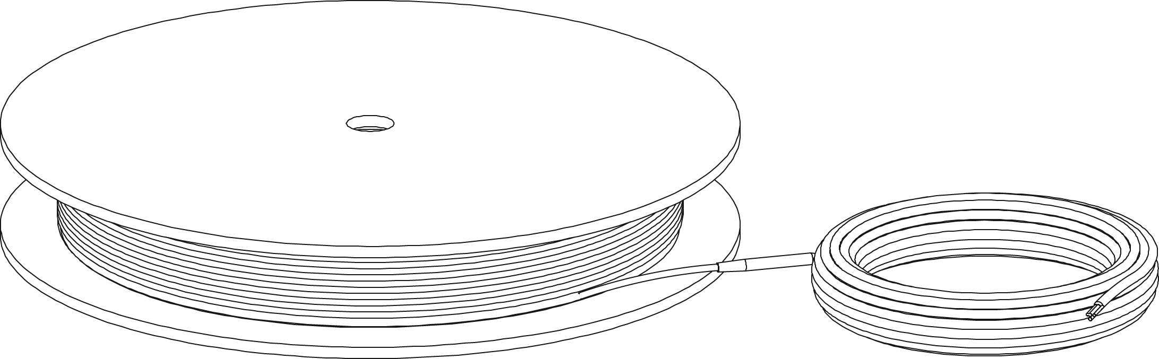

Features
Voltage - 120V, 240/208V, 1-phase.
Cold lead length - 10’ (3 m).
Construction - Heating cable made of a twin conductor for a simpler and faster installation,
with negligible magnetic field.
Watt density - 12W/sq. ft. (130W/sq. m), 3” (76 mm) spacing.
- 9W/sq. ft. (100W/sq. m), 4” (102 mm) spacing.
Control - Two types of control method possible (see instruction manual for details):
• Surface heating control with electronic thermostat in floor mode (F)
and temperature sensor.
• Ambient heating control with electronic thermostat in ambient mode
with floor limit (A or AF) and temperature sensor.
Note: A ground fault circuit interrupter (GFCI) must be used with this heating device
unless exempted by the applicable national and/or local electrical code for the area of installation.
Included materials - Plastic strapping.
- 15' (4.6 m) ﬂoor sensor.
- Measurements table label (to be placed in electrical panel).
Installation - Never cut or shorten the heating cable.
- For indoor applications only.
- On concrete slab or plywood subfloor.
Warranty - 25-year warranty on the heating cable.
Application - Kitchen, bathroom, entrance way, family room, living room.

Models
Product #  Strapping included¹ |  |  |  | Covered Surface Depending on Spacing² |  |  |  | Length |  | Strapping  length  included  (ft.) | Weight |  | Watts
 |  |  |  | Spacing 3’’ (76 mm) |  | Spacing 4’’ (102 mm)
240/208V | 120V | Cable Diameter  (mm) | Qty | 12W/  sq. ft. | 130W/  sq. m | 9W/  sq. ft. | 100W/  sq. m | ft. | m | Strapping  length  included  (ft.) | lb | kg | Watts
- | OWF-R0082 | 4.3 |  | 8 | 0.7 | 11 | 1.0 | 32 | 9.75 | 25 | - | - | 85
- | OWF-R0122 | 4.3 |  | 10 | 0.9 | 13 | 1.2 | 40 | 12.19 | 25 | - | - | 120
- | OWF-R0152 | 4.3 |  | 13 | 1.2 | 17 | 1.6 | 53 | 16.15 | 25 | - | - | 150
OWF-R0170 | OWF-R0172 | 4.3 |  | 15 | 1.4 | 20 | 1.9 | 61 | 18.59 | 25 | - | - | 170
OWF-R0240 | OWF-R0242 | 4.3 |  | 20 | 1.9 | 27 | 2.5 | 80 | 24.38 | 25 | - | - | 240
OWF-R0300 | OWF-R0302 | 4.3 |  | 25 | 2.3 | 33 | 3.1 | 101 | 30.78 | 25 | - | - | 300
OWF-R0360 | OWF-R0362 | 4.3 |  | 30 | 2.8 | 40 | 3.7 | 120 | 36.58 | 50 | - | - | 360
OWF-R0420 | OWF-R0422 | 4.3 |  | 35 | 3.3 | 47 | 4.3 | 141 | 42.98 | 50 | - | - | 420
OWF-R0475 | OWF-R0472 | 4.3 |  | 40 | 3.7 | 53 | 5.0 | 160 | 48.76 | 50 | - | - | 475
OWF-R0600 | OWF-R0602 | 4.3 |  | 50 | 4.6 | 67 | 6.2 | 200 | 60.96 | 50 | - | - | 600
OWF-R0720 | OWF-R0722 | 4.3 |  | 60 | 5.6 | 80 | 7.4 | 240 | 73.15 | 75 | - | - | 720
OWF-R0840 | OWF-R0842 | 4.3 |  | 70 | 6.5 | 93 | 8.7 | 280 | 85.34 | 75 | - | - | 840
OWF-R0960 | OWF-R0962 | 4.3 |  | 80 | 7.4 | 107 | 9.9 | 320 | 97.54 | 75 | - | - | 960
OWF-R1080 | - | 4.3 |  | 90 | 8.4 | 120 | 11.2 | 360 | 109.73 | 100 | - | - | 1080
- | OWF-R1142 | 4.3 |  | 95 | 8.8 | 127 | 11.7 | 380 | 115.82 | 100 | - | - | 1140
OWF-R1200 | - | 4.3 |  | 100 | 9.3 | 133 | 12.4 | 400 | 121.92 | 100 | - | - | 1200
- | OWF-R1322 | 4.3 |  | 110 | 10.2 | 147 | 13.6 | 440 | 134.11 | 100 | - | - | 1320
OWF-R1440 | - | 4.3 |  | 120 | 11.1 | 160 | 14.9 | 480 | 146.30 | 100 | - | - | 1440
- | OWF-R1452 | 4.3 |  | 120 | 11.1 | 160 | 14.8 | 480 | 146.30 | 100 | - | - | 1450
- | OWF-R1502 | 4.3 |  | 125 | 11.6 | 167 | 15.5 | 500 | 152.40 | 125 | - | - | 1500
OWF-R1600 | - | 4.3 |  | 140 | 13.0 | 187 | 17.4 | 560 | 170.69 | 125 | - | - | 1600
- | OWF-R1682 | 4.3 |  | 140 | 13.0 | 187 | 17.4 | 560 | 170.69 | 125 | - | - | 1680
OWF-R1920 | - | 4.3 |  | 160 | 14.9 | 213 | 19.8 | 640 | 195.07 | 125 | - | - | 1920
OWF-R2280 | - | 4.3 |  | 190 | 17.7 | 253 | 23.6 | 760 | 231.64 | 150 | - | - | 2280
OWF-R2640 | - | 4.3 |  | 220 | 20.4 | 293 | 27.2 | 880 | 268.22 | 200 | - | - | 2640
OWF-R2900 | - | 4.3 |  | 242 | 22.5 | 323 | 30.0 | 968 | 295.04 | 200 | - | - | 2900
OWF-R3000 | - | 4.3 |  | 250 | 23.2 | 333 | 30.9 | 1000 | 304.80 | 200 | - | - | 3000
OWF-R3360 | - | 4.3 |  | 280 | 26.0 | 374 | 34.7 | 1120 | 341.38 | 200 | - | - | 3360

¹ Strapping included. The length of plastic strapping included is based on a square room with strapping every 24" (610 mm).
² Does not represent the surface of the room but rather the surface covered by the floor heating system, excluding fixtures and other spaces to consider.
15’ (4.6 m) floor sensor and 10' (3 m) cold lead included.

Options
Product #  Kit | Description | Qty
OTM-CC | CableCheck - Electrical fault indicator
KIT-SP1 | Repair kit
KIT-CBL-G25 | 25 ft. (7.6 m) plastic strapping
KIT-CBL-SN | 15 ft. (4.6 m) floor sensor

Electronic Thermostats for Floor Heating System
Product # | Description | Qty | Amp. | Volts | Protection
OTH3600-GA² | Non programmable electronic thermostat  for floor heating system |  | 15 | 120/208/240 | Class A  GFCI 5 mA¹
OTH3600P-GA² | Programmable electronic thermostat  for floor heating system |  | 15 | 120/208/240 | Class A  GFCI 5 mA¹
OTH3600-GA-GT² | Wireless communication programmable electronic thermostat  for floor heating system |  | 15 | 120/208/240 | Class A  GFCI 5 mA¹

Slave Unit for Floor Heating System
Product # | Description | Qty | Amp. | Volts | Protection
TR1310-120-240GA³ | Slave unit for floor heating system |  | 15 | 120/208/240 | Class A  GFCI 5 mA¹

¹ GFCI: Ground fault circuit interrupter.
² 15’ (4.6 m) floor sensor included.
³ Compatible with OTH3600P-GA and OTH3600-GA-GT only, not compatible with the non programmable thermostat OTH3600-GA.
Standard color is white.

Others
Type | Quantity | Model et description  Complementary information | Volts | Phase | Watts | Length  mm/in. | Information  Color/installation

Specifications may change without prior notice
Project: | Approval  Information
Consultant Engineer: | Approval  Information
Eectrician Contractor: | Approval  Information
Distributor: | Approval  Information
Date: | Approval  Information
Contact in Ouellet: | Approval  Information
Comments:

