Series
OWD Wash Down Unit Heater
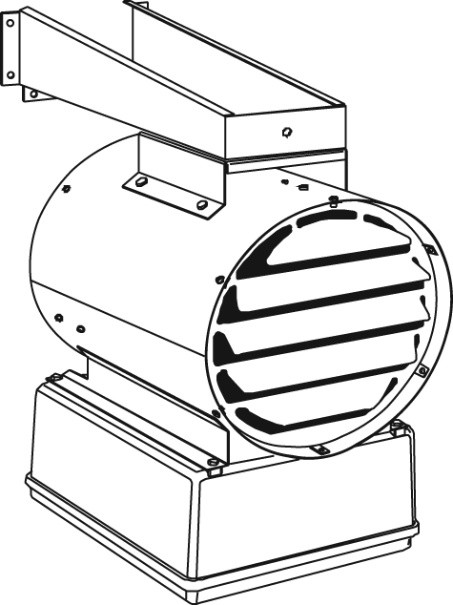

Features
Voltage - 208V, 240V, 277V, 480V, 600V, 1 or 3-phase.
Construction - 16-gauge, 304 stainless steel, moisture and corrosion resistant housing*.
- Adjustable, stainless steel outlet louvers.
- Stainless steel rear grille to protect against accidental contact with the fan blade.
- High-limit temperature control with automatic reset
(manual reset available upon request).
- NEMA 4X non-metallic electrical enclosure.
- Pilot light (power-on indicator) available.
- Optional disconnect switch with lockable handle available.
Fan - Anodized aluminum, delayed-action fan.
- Enclosed epoxy coated motor with permanently lubricated ball bearing for longer life.
- Epoxy-painted fan.
- Designed to resist moisture and corrosion.
Heating element - Sealed tubular heating element with 316* stainless steel fins.
Control - 24V control circuit with transformer and contactor.
- Built-in capillary thermostat available.
- Fan switch control available.
Installation - Electrical enclosure located at bottom of unit for ease of installation and servicing.
- Stainless steel swivel mounting bracket included, for wall or ceiling mounting.
Warranty - 1-year warranty against defects.
Application - Food industry, marine and offshore, car wash, dairy.

*Caution: Some environments can be corrosive for this type of stainless steel. Please check the application prior to installation.

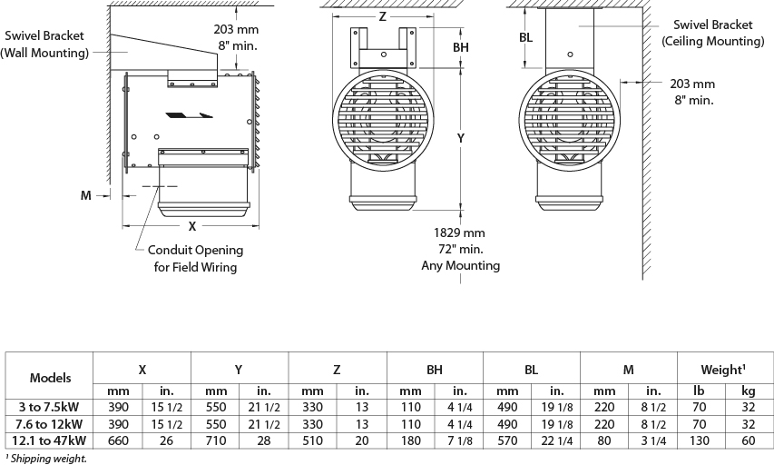

Models
kW | BTU/hr | Product # |  |  |  |  |  |  |  |  |  |  |  | cfm | Temperature Rise |  | Air Throw
kW | BTU/hr | 208V  (1 ph) | Qty | 208V  (3 ph) | Qty | 240V  (1 ph) | Qty | 240V  (3 ph) | Qty | 480V  (3 ph) | Qty | 600V  (3 ph) | Qty | cfm | ºC | ºF | ft. | m
3.0 | 10236 | OWD03008 |  | OWD03038 |  | OWD03000 |  | OWD03030 |  | OWD03034 |  | OWD03036 |  | 700 | 8 | 14 | 26 | 8
5.0 | 17060 | OWD05008 |  | OWD05038 |  | OWD05000 |  | OWD05030 |  | OWD05034 |  | OWD05036 |  | 700 | 13 | 24 | 26 | 8
7.5 | 25590 | OWD07508 |  | OWD07538 |  | OWD07500 |  | OWD07530 |  | OWD07534 |  | OWD07536 |  | 700 | 19 | 35 | 26 | 8
9.0 | 30708 | OWD09008 |  | OWD09038 |  | OWD09000 |  | OWD09030 |  | OWD09034 |  | OWD09036 |  | 1450 | 11 | 20 | 43 | 13
10.0 | 34120 | - | - | OWD10038 |  | OWD10000 |  | OWD10030 |  | OWD10034 |  | OWD10036 |  | 1450 | 12 | 22 | 43 | 13
12.0 | 40944 | - | - | OWD12038 |  | - | - | OWD12030 |  | OWD12034 |  | OWD12036 |  | 1450 | 14 | 26 | 43 | 13
12.5 | 42650 | - | - | OWD12538 |  | - | - | OWD12530 |  | OWD12534 |  | OWD12536 |  | 2400 | 9 | 17 | 50 | 15
15.0 | 51180 | - | - | OWD15038 | - | - | - | OWD15030 |  | OWD15034 |  | OWD15036 |  | 2400 | 12 | 21 | 50 | 15
20.0 | 68240 | - | - | - | - | - | - | - |  | OWD20034 | - | OWD20036 |  | 2400 | 16 | 28 | 50 | 15
25.0 | 85300 | - | - | - | - | - | - | - |  | OWD25034 | - | OWD25036 |  | 2400 | 19 | 35 | 50 | 15
30.0 | 102360 | - | - | - | - | - | - | - |  | OWD30034 | - | OWD30036 |  | 2400 | 23 | 42 | 50 | 15
35.0 | 119420 | - | - | - | - | - | - | - |  | OWD35034 | - | OWD35036 |  | 2400 | 27 | 48 | 50 | 15
38.4 | 131020 | - | - | - | - | - | - | - |  | OWD38434 | - | OWD38436 |  | 2400 | 30 | 54 | 50 | 15
47.0 | 160364 | - | - | - | - | - | - | - |  | - | - | OWD47036 |  | 2400 | 36 | 64 | 50 | 15

277V available upon request.

Options
Product #  Kit | Product #  Factory Installed* | Description | Qty
- | 120 | 120V control circuit
- | EP | Epoxy paint finish for better corrosion resistance in certain environments
- | I¹ | Disconnect switch with lockable handle available
- | L | Pilot light "power-on indicator"
- | ME1 | Monel elements, for 3 to 20kW units for better corrosion resistance in certain environments
- | ME2 | Monel elements, for 25 to 38.4kW units for better corrosion resistance in certain environments
- | PTM | High-limit temperature control with manual reset
- | S | Three-position switch: On/Standby/Fan
- | T | Thermostat
- | T2S | 2-stage thermostat
OWD-TM | - | NEMA 4X wall thermostat, range 4 °C to 43 °C (40 °F to 110 °F): 25A at 120V, 208V, 240V –  22A at 277V (Compatible avec circuit de contrôle à 24VAC)

* For factory installed options, add the option number to the product number. See the Product Code section inside the front cover.
¹ For the U.S. only: The nominal current of the unit must not exceed 80% of the capacity of the disconnect.
277V available upon request.

Others
Type | Quantity | Model et description  Complementary informations | Volts | Phase | Watts | Length  mm/in. | Informations  Color/installation

Specifications may change without prior notice
Project: | Approval  Information
Consultant Engineer: | Approval  Information
Electrician Contractor: | Approval  Information
Distributor: | Approval  Information
Date: | Approval  Information
Contact in Ouellet: | Approval  Information
Comments:

