Series
OWC-R Heating Cable for Concrete in Reel
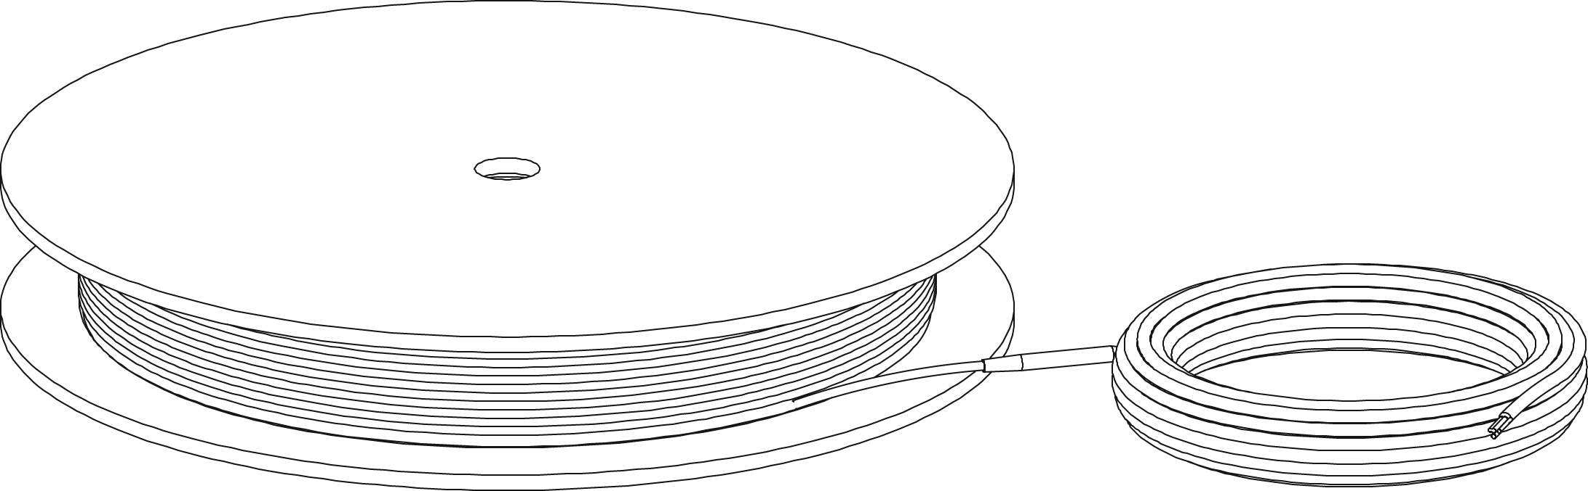

Features
Voltage - 240/208V, 1-phase.
Construction - Twin conductor heating cable with negligible magnetic field.
Watt density - 11W/sq. ft. (120W/sq. m), recommended installation – 6’’ (15 cm) spacing.
Cold lead length - 8’ 2’’ (2.5 m) cold lead included.
- Optional 50’ (15 m) cold lead available upon request.
Control - Two types of control method possible (see instruction manual for details):
• Surface heating control with electronic thermostat in floor mode (F) and temperature sensor.
• Ambient heating control with electronic thermostat in ambient mode with floor limit (A or AF) and temperature sensor.
Note: A ground fault circuit interrupter (GFCI) must be used with this heating
device unless exempted by the applicable national and/or local electrical
code for the area of installation).
Included materials - 15' (4.6 m) temperature sensor.
- Nylon ties.
- Measurement table label (to be placed in for electrical panel).
Installation - Never cut or shorten the heating cable.
- For indoor applications only, residential or commercial.
- Installs under a 4" to 6" (10 cm to 15 cm) concrete slab or under a 1 1/2’’ to 4’’
concrete topping (4 cm to 10 cm).
Note: It’s highly recommended to insulate the concrete slab in order to avoid heat loss from below (see instruction manual for all installation details).
- Requires a metallic structure or wire mesh for reinforced concrete with spacing of 6'' (15 cm) for the installation.
- Compatible with most floor coverings (check with the dealer or manufacturer).
Warranty - 20-year warranty on the heating cable.
Application - Basement, garage, bathroom, kitchen, family room, workshop, pool, shower, entrance way, hospital, hotel, factory, business, restaurant, sunroom, greenhouse, buildings used for housing animals.

Models
Watts | Product # |  | Covered Surface¹  Spacing 6’’ (15 cm) |  | Cable Length |  | Weight
 | 240/208V | Qty | sq. ft. | sq. m. | ft. | m | lb | kg
300 | OWC-R0300 |  | 28.0 | 2.6 | 56 | 17.07 | 4.0 | 1.8
500 | OWC-R0500 |  | 46.5 | 4.3 | 93 | 28.35 | 5.0 | 2.3
700 | OWC-R0700 |  | 62.5 | 5.8 | 125 | 38.10 | 7.0 | 3.1
950 | OWC-R0950 |  | 88.0 | 8.2 | 176 | 53.64 | 9.0 | 4.0
1300 | OWC-R1300 |  | 125.0 | 11.6 | 250 | 76.20 | 12.0 | 5.4
1700 | OWC-R1700 |  | 156.0 | 14.5 | 312 | 95.10 | 16.0 | 7.2
2000 | OWC-R2000 |  | 187.0 | 17.4 | 374 | 114.00 | 18.0 | 8.1
2400 | OWC-R2400 |  | 218.5 | 20.3 | 437 | 133.20 | 23.0 | 10.4
3000 | OWC-R3000 |  | 279.5 | 26.0 | 559 | 170.38 | 32.0 | 14.5
3400 | OWC-R3400 |  | 312.5 | 29.03 | 625 | 190.50 | 36.0 | 16.3
3700 | OWC-R3700² |  | 341.0 | 31.7 | 682 | 207.87 | 39.0 | 17.7
4000 | OWC-R4000² |  | 372.5 | 34.6 | 745 | 227.08 | 42.0 | 19.0

¹ Does not represent the room surface but rather the area covered by the cable while leaving a 6” (15 cm) spacing between cables and excluding fixed elements to be bypassed and any other clearance required.
² Not compatible with a floor heating thermostat rated for 15A and less. Requires relay with low voltage thermostat.
208V = 75% of wattage at 240V.

Options
Product #  Kit | Product #  Factory installed* | Description | Qty
OTM-CC¹ | - | CableCheck – Electrical indicator
KIT-WC-CLP | - | Bag of 50 plastic floor fasteners for heating cable on mat
KIT-SP2 | - | Repair kit
- | -50² | Optional 50’ (15 m) cold lead

* For factory installed options, add the option number to the product number. See the Product Code section inside the front cover.
¹ With any OWC order, the accessory OTM-CC can be added free of charge upon costumer request.
² Made to order only. Allow additional 9 to 12 weeks lead time.

GFCI control panel with contactors and 24V control transformer
Product #  Kit | H x W x D  (in.) | Description | Qty
WC-2CIR-208 | 16x14x8 | 2 circuits 208V 30A
WC-4CIR-208 | 20x16x8 | 4 circuits 208V 30A
WC-6CIR-208 | 20x16x8 | 6 circuits 208V 30A
WC-8CIR-208 | 24x24x8 | 8 circuits 208V 30A
WC-10CIR-208 | 24x24x8 | 10 circuits 208V 30A
WC-12CIR-208 | 24x24x8 | 12 circuits 208V 30A
WC-2CIR-240 | 16x14x8 | 2 circuits 240V 30A
WC-4CIR-240 | 20x16x8 | 4 circuits 240V 30A
WC-6CIR-240 | 24x20x8 | 6 circuits 240V 30A
WC-8CIR-240 | 24x20x8 | 8 circuits 240V 30A
WC-10CIR-240 | 24x24x8 | 10 circuits 240V 30A
WC-12CIR-240 | 24x24x8 | 12 circuits 240V 30A
WC-3CIR-347-347 | 16x14x8 | 3 circuits 347V 24A
WC-6CIR-347-347 | 20x16x8 | 6 circuits 347V 24A
WC-9CIR-600-347 | 30x24x8 | 9 circuits 600V 24A
WC-12CIR-600-347 | 30x24x8 | 12 circuits 600V 24A

Others
Type | Quantity | Model and description  Complementary informations | Volts | Phase | Watts | Length  mm/in. | Informations  Color/installation

Specifications may change without prior notice
Project: | Approval  Information
Consultant Engineer: | Approval  Information
Eectrician Contractor: | Approval  Information
Distributor: | Approval  Information
Date: | Approval  Information
Contact in Ouellet: | Approval  Information
Comments:

