Series
OWC-M Heating Cable for Concrete on Mat
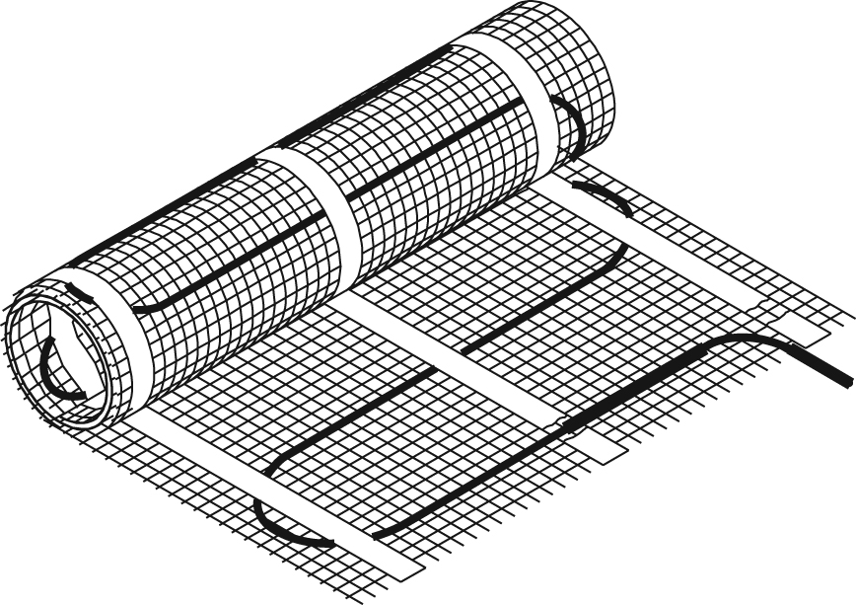

Features
Voltage - 240/208V, 347V, 1-phase.
Construction - Twin conductor heating cable attached to a plastic mat
with negligible magnetic field.
Watt density - 11W/sq. ft. (120W/sq. m), factory installed on mat at 6’’ (15 cm) spacing.
Dimension - 24’’ (0.6 m) wide mat available in several lengths.
Cold lead length - 8’ 2’’ (2.5 m) cold lead included.
Control - Two types of control method possible (see instruction manual for details):
• Surface heating control with electronic thermostat in floor mode (F) and temperature sensor.
• Ambient heating control with electronic thermostat in ambient mode with floor limit (A or AF) and temperature sensor.
Note: A ground fault circuit interrupter (GFCI) must be used with this heating
device unless exempted by the applicable national and/or local electrical
code for the area of installation.
Included materials - 15' (4.6 m) temperature sensor.
- Plastic floor fasteners (WC-CLP).
- Measurement table label (to be placed in for electrical panel).
Installation - Never cut or shorten the heating cable.
- For indoor applications only, residential or commercial.
- Installs under a 4" to 6" (10 cm to 15 cm) concrete slab or under a 1.5’’ to 4’’ concrete topping (4 cm to 10 cm).
Note: It’s highly recommended to insulate the concrete slab in order to avoid
heat loss from below (see instruction manual for all installation details).
- Compatible with most floor coverings (check with the dealer or manufacturer).
- Installation with or without metallic structure for reinforced concrete.
Warranty - 20-year warranty on the heating cable.
Application - Basement, garage, bathroom, kitchen, family room, workshop, pool, shower, entrance way, hospital, hotel, factory, business, restaurant, sunroom, greenhouse, buildings used for housing animals.

Models
Watts | Product # |  | Covered surface |  | Length |  | Weight
Watts | 240/208V | Qty | sq. ft. | sq. m | ft. in. | m | lb | kg
150 | OWC-M0150 |  | 14.0 | 1.3 | 6’ 5" | 1.9 | 3.0 | 1.4
200 | OWC-M0200 |  | 19.0 | 1.7 | 8' 4" | 2.5 | 3.7 | 1.7
300 | OWC-M0300 |  | 28.0 | 2.6 | 12’ 6" | 3.8 | 4.0 | 1.8
400 | OWC-M0400 |  | 38.0 | 3.5 | 16’ 8" | 5.1 | 4.5 | 2.0
500 | OWC-M0500 |  | 46.5 | 4.3 | 20’ 10" | 6.4 | 5.0 | 2.3
600 | OWC-M0600 |  | 56.0 | 5.2 | 25’ | 7.6 | 6.0 | 2.7
700 | OWC-M0700 |  | 65.5 | 6.1 | 29’ 2" | 8.9 | 7.0 | 3.1
850 | OWC-M0850 |  | 80.0 | 7.4 | 35’ 5" | 10.8 | 8.0 | 3.6
950 | OWC-M0950 |  | 89.0 | 8.3 | 39’ 7" | 12.1 | 9.0 | 4.0
1100 | OWC-M1100 |  | 103.0 | 9.6 | 45’ 10" | 14.0 | 10.0 | 4.5
1200 | OWC-M1200 |  | 113.0 | 10.5 | 50' | 15.2 | 11.0 | 5.0
1300 | OWC-M1300 |  | 121.5 | 11.3 | 54’ 2" | 16.5 | 12.0 | 5.4
1400 | OWC-M1400 |  | 130.5 | 12.1 | 58’ 4" | 17.8 | 13.0 | 6.0
1500 | OWC-M1500 |  | 140.5 | 13.1 | 62’ 6" | 19.1 | 14.0 | 6.4
1600 | OWC-M1600 |  | 149.5 | 13.9 | 66’ 8" | 20.3 | 17.0 | 7.8
1700 | OWC-M1700 |  | 159.0 | 14.8 | 70’ 10" | 21.6 | 16.0 | 7.2
1850 | OWC-M1850 |  | 172.5 | 16.0 | 77’ 1" | 23.5 | 17.0 | 7.8
2000 | OWC-M2000 |  | 187.5 | 17.4 | 83’ 4" | 25.4 | 18.0 | 8.1
2200 | OWC-M2200 |  | 206.0 | 19.1 | 91’ 6" | 27.9 | 21.0 | 9.5
2400 | OWC-M2400 |  | 225.0 | 20.9 | 100’ | 30.5 | 23.0 | 10.4
2550 | OWC-M2550 |  | 239.0 | 22.2 | 106’ 6" | 32.5 | 25.0 | 11.3
2700 | OWC-M2700 |  | 253.0 | 23.5 | 112’ 6" | 34.3 | 28.0 | 12.7
2850 | OWC-M2850 |  | 267.0 | 24.8 | 119’ | 36.3 | 30.0 | 13.6
3000 | OWC-M3000 |  | 281.0 | 26.1 | 125’ | 38.1 | 32.0 | 14.5
3200 | OWC-M3200 |  | 300.0 | 27.9 | 133’ 6" | 40.7 | 34.0 | 15.4
3400 | OWC-M3400 |  | 318.5 | 29.6 | 141’ 8" | 43.2 | 36.0 | 16.3
3600 | OWC-M3600 |  | 336.0 | 31.2 | 150’ | 45.7 | 38.0 | 17.2

Does not represent the room surface but rather the area covered by the cable mat including 3” (7.5 cm) spacing between the mat strips but excluding fixed elements to be bypassed and any other required clearances.
208V = 75% of wattage at 240V.

Options
Product #  Kit | Product #  Factory installed* | Description | Qty
OTM-CC¹ | - | CableCheck – Electrical indicator
KIT-WC-CLP | - | Bag of 50 plastic floor fasteners for heating cable on mat
KIT-SP2 | - | Repair kit
- | -50² | Optional 50’ (15 m) cold lead

* For factory installed options, add the option number to the product number. See the Product Code section inside the front cover.
¹ With any OWC order, the accessory OTM-CC can be added free of charge upon costumer request.
² Made to order only. Allow additional 9 to 12 weeks lead time.

GFCI control panel with contactors and 24V control transformer
Product #  Kit | H x W x D  (in.) | Description | Qty
WC-2CIR-208 | 16x14x8 | 2 circuits 208V 30A
WC-4CIR-208 | 20x16x8 | 4 circuits 208V 30A
WC-6CIR-208 | 20x16x8 | 6 circuits 208V 30A
WC-8CIR-208 | 24x24x8 | 8 circuits 208V 30A
WC-10CIR-208 | 24x24x8 | 10 circuits 208V 30A
WC-12CIR-208 | 24x24x8 | 12 circuits 208V 30A
WC-2CIR-240 | 16x14x8 | 2 circuits 240V 30A
WC-4CIR-240 | 20x16x8 | 4 circuits 240V 30A
WC-6CIR-240 | 24x20x8 | 6 circuits 240V 30A
WC-8CIR-240 | 24x20x8 | 8 circuits 240V 30A
WC-10CIR-240 | 24x24x8 | 10 circuits 240V 30A
WC-12CIR-240 | 24x24x8 | 12 circuits 240V 30A
WC-3CIR-347-347 | 16x14x8 | 3 circuits 347V 4A
WC-6CIR-347-347 | 20x16x8 | 6 circuits 347V 24A
WC-9CIR-600-347 | 30x24x8 | 9 circuits 600V 24A
WC-12CIR-600-347 | 30x24x8 | 12 circuits 600V 24A

Others
Type | Quantity | Model et description  Complementary informations | Volts | Phase | Watts | Length  mm/in. | Informations  Color/installation

Specifications may change without prior notice
Project: | Approval  Information
Consultant Engineer: | Approval  Information
Eectrician Contractor: | Approval  Information
Distributor: | Approval  Information
Date: | Approval  Information
Contact in Ouellet: | Approval  Information
Comments:

