Series
OVSP Residential Ceiling Fan Heater
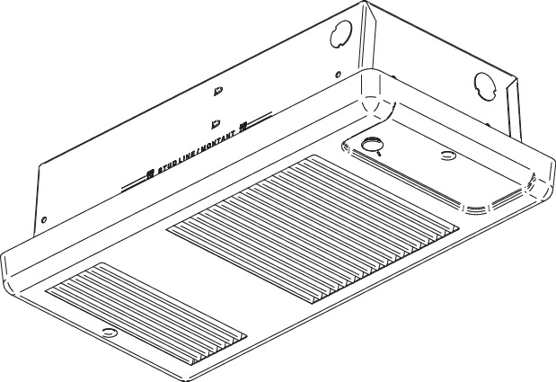

Features
Color - Standard: white, almond.
- Optional (10% upcharge): metallic silver, bronze, metallic charcoal,
aluminum, semi-gloss black.
- Custom colors available upon request.
Finish - Standard: epoxy/polyester powder paint.
Voltage - 120V, 240/208V, 1-phase.
Construction - 20-gauge steel cabinet.
- 22-gauge steel front cover.
- High-limit temperature control with automatic reset.
Fan - Quiet fan operating.
- 500W to 1000W; 40 cfm fan and 1250W to 1500W; 80 cfm fan.
- Factory-lubricated motor.
Heating element - Durable tubular heating element with fins.
- Factory sealed element upon request.
Control - Must be used with a compatible wall thermostat (not included).
Note: If an electronic thermostat is used, it must be compatible with forced-air heaters.
Installation - Ceiling installation only.
- The air outlet should be installed at least 10 in. (25.4 cm) from the wall
and should be oriented towards the center of the room.
- Quick installation with recess box mounting holes.
- Large wiring compartment.
- May be recessed in ceiling.
- Surface mounting box available.
- Tight fit with V-shaped recess box.
Warranty - 5-year warranty against defects.
Application - Entrance way, stairwell, bathroom, family room, basement.

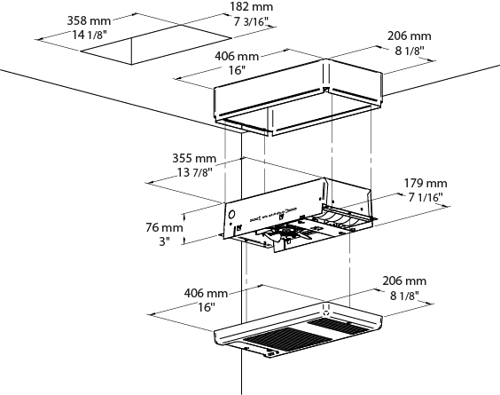

Models
# Product | Qty | Volts | Watts | Weight
 |  |  |  | lb | kg
OVSPU0502 |  | 120 | 500 | 9.0 | 4.1
OVSPU0752 |  | 120 | 750 | 9.0 | 4.1
OVSPU1002 |  | 120 | 1000 | 9.0 | 4.1
OVSPU1252 |  | 120 | 1250 | 9.0 | 4.1
OVSPU1502 |  | 120 | 1500 | 9.0 | 4.1
OVSPU0500 |  | 240/208 | 500/375 | 9.0 | 4.1
OVSPU0750 |  | 240/208 | 750/563 | 9.0 | 4.1
OVSPU1000 |  | 240/208 | 1000/750 | 9.0 | 4.1
OVSPU1250 |  | 240/208 | 1250/938 | 9.0 | 4.1
OVSPU1500 |  | 240/208 | 1500/1125 | 9.0 | 4.1

Options
Product #  Kit | Product #  Factory installed* | Description | Qty
KIT-OVS-BS | - | Surface mounting box
KIT-OVS-DIS¹ | DIS¹ | Disconnect switch, 20A at 277V max.
- | ES² | Factory sealed element

* For factory installed options, add the option number to the product number. See the Product Code section inside the front cover.
¹ For the U.S. only: The nominal current of the unit must not exceed 80% of the capacity of the disconnect.
² The option "sealed element" increases the reliability of these in humid environments. It does not completely eliminate the leakage currents of metal sheathed heating elements.
Add "BL" for white, "AM" for almond.
Optional colors shown in the color chart section are available upon request.

Others
Type | Quantity | Model et description  Complementary informations | Volts | Phase | Watts | Length  mm/in. | Informations  Color/installation

Specifications may change without prior notice
Project: | Approval  Information
Consultant Engineer: | Approval  Information
Eectrician Contractor: | Approval  Information
Distributor: | Approval  Information
Date: | Approval  Information
Contact in Ouellet: | Approval  Information
Comments:

