Series
OVR Register Wall Fan Heater
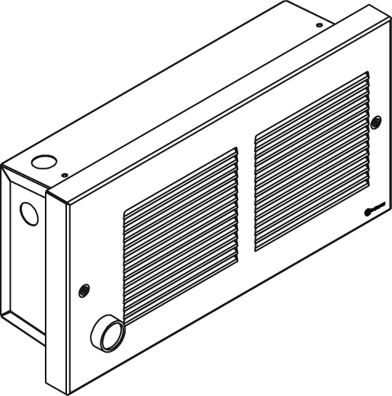

Features
Color - Standard: white, almond.
- Optional (upcharge applicable): metallic silver, bronze, metallic charcoal,
aluminum, semi-gloss black, sand.
- Custom colors available upon request.
Finish - Standard: epoxy/polyester powder paint.
Voltage - 120V, 208V, 240/208V, 1-phase.
Construction - 20-gauge steel.
- High-limit temperature control with automatic reset.
Fan - Quiet fan operating.
- 500W to 1000W; 40 cfm fan and 1250W to 2000W; 80 cfm fan.
- Factory-lubricated motor.
Heating element - Durable tubular heating element with fins.
- Factory sealed element upon request.
Control - Built-in thermostat available with a control knob or tamperproof.
Note: If an electronic thermostat is used, it must be compatible with forced-air heaters.
Installation - The air outlet should be installed at least 10 in. (25.4 cm) above ﬂoor.
- Quick installation with recess box mounting holes.
- Large wiring compartment.
- May be recessed in 2 in. x 3 in. stud partitions.
- Surface mounting box available.
- Tight fit with V-shaped recess box.
Warranty - 5-year warranty against defects.
Application - Entrance way, kitchen, bathroom, family room, basement.

Models
Product # | Qty | Volts | Watts | Weight
 |  |  |  | lb | kg
OVRU0502 |  | 120 | 500 | 9.0 | 4.1
OVRU0752 |  | 120 | 750 | 9.0 | 4.1
OVRU1002 |  | 120 | 1000 | 9.0 | 4.1
OVRU1252 |  | 120 | 1250 | 9.0 | 4.1
OVRU1502 |  | 120 | 1500 | 9.0 | 4.1
OVRU0500 |  | 240/208 | 500/375 | 9.0 | 4.1
OVRU0750 |  | 240/208 | 750/563 | 9.0 | 4.1
OVRU1000 |  | 240/208 | 1000/750 | 9.0 | 4.1
OVRU1250 |  | 240/208 | 1250/938 | 9.0 | 4.1
OVRU1500 |  | 240/208 | 1500/1125 | 9.0 | 4.1
OVRU2000 |  | 240/208 | 2000/1500 | 9.0 | 4.1
OVRU2008 |  | 208 | 2000 | 9.0 | 4.1

Options
Product #  Kit | Product #  Factory installed* | Description | Qty
KIT-OVR-BS | - | Surface mounting box
KIT-OVR-DIS³ | DIS³ | Disconnect switch, 20A at 277V max.
- | ES¹ | With sealed element factory installed
KIT-OVR-TB6 | TB6 | Single-pole bi-metal thermostat
KIT-OVR-TB26² | TB26² | Double-pole bi-metal thermostat
KIT-OVR-TB6-AV | TB6AV | Single-pole bi-metal tamperproof thermostat
KIT-OVR-TB26-AV² | TB26AV² | Double-pole bi-metal tamperproof thermostat

* For factory installed options, add the option number to the product number. See the Product Code section inside the front cover.
¹ The option "sealed element" increases the reliability of these in humid environments. It does not completely eliminate the leakage currents of metal sheathed heating elements.
² "Off" position.
³ For the U.S. only: The nominal current of the unit must not exceed 80% of the capacity of the disconnect.
Add "BL" for white, "AM" for almond.
Upcharge available for optional colors shown in the color chart section.

Others
Type | Quantity | Model et description  Complementary informations | Volts | Phase | Watts | Length  mm/in. | Informations  Color/installation

Specifications may change without prior notice
Project: | Approval  Information
Consultant Engineer: | Approval  Information
Eectrician Contractor: | Approval  Information
Distributor: | Approval  Information
Date: | Approval  Information
Contact in Ouellet: | Approval  Information
Comments:

