Series
OVOS Stylish Wall Fan Heater

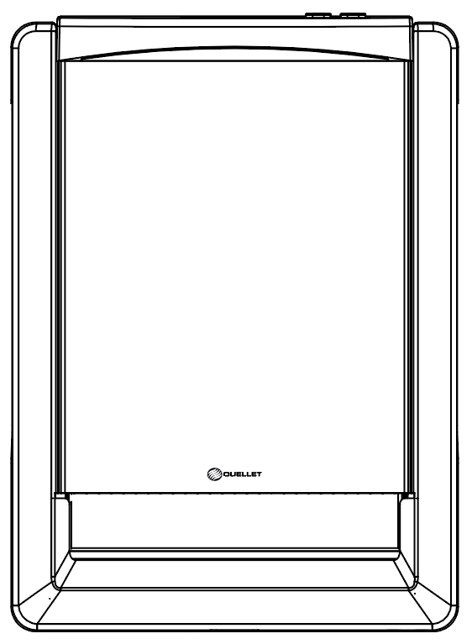

Features
Color - Standard: white.
Finish - Standard: epoxy/polyester powder paint.
Voltage - 120V, 208V, 240/208V, 1-phase.
Construction - 22-gauge steel cabinet, 20-gauge steel grille.
- High-limit temperature control with manual reset.
- Additional one-time thermal fuse.
- Highly secure façade.
Fan - Quiet fan.
Heating element - Nickel-chromium heating element provides instant heat.
Control - Built-in electronic thermostat (-TH models).
- Wall thermostat (not included, the use of an electronic thermostat is strongly recommended).
Note: If an electronic wall-mounted thermostat is used, it must be compatible with forced-air heaters.
Installation - 6 in. (150 mm) minimum clearance to ﬂoor or any adjacent surfaces.
- May be recessed or surface-mounted with optional surface mounting box.
- Quick and easy installation easily retrofits most popular models.
- Wattage can be selected onsite for models without control only.
Warranty - 5-year warranty, (3-year on electronic components).
Application - Kitchen, family room, bathroom (model with timer and thermostat), entrance way, office.

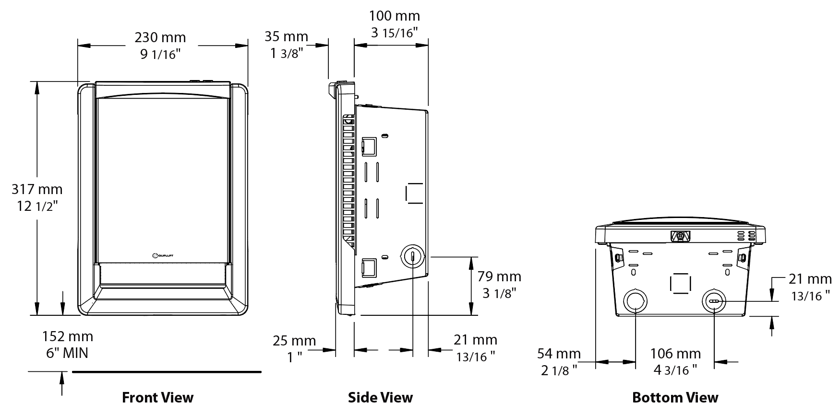
Models
Product #  Without  thermostat² | Qty | Watts¹ | BTU/hr | Product #  Built-in electronic  thermostat | Qty | Watts | Volts | BTU/hr | Weight
 |  |  |  |  |  |  |  |  | lb | kg
OVOSU1002BL |  | 1000 or 500 | 3413 or 1706 | OVOSU1002BL-TH |  | 1000 | 120 | 3413 | 7.2 | 3.3
OVOSU1502BL |  | 1500 or 750 | 5119 or 2560 | OVOSU1502BL-TH |  | 1500 | 120 | 5119 | 7.2 | 3.3
OVOSU1008BL |  | 1000 or 500 | 3413 or 1706 | OVOSU1008BL-TH |  | 1000 | 208 | 3413 | 7.2 | 3.3
OVOSU1508BL |  | 1500 or 750 | 5119 or 2560 | OVOSU1508BL-TH |  | 1500 | 208 | 5119 | 7.2 | 3.3
OVOSU1000BL |  | 1000/750 or 500/375 | 3413/2560 or 1706/1280 | OVOSU1000BL-TH |  | 1000/750 | 240/208 | 3413/2560 | 7.2 | 3.3
OVOSU1500BL |  | 1500/1125 or 750/560 | 5119/3839 or 2560/1911 | OVOSU1500BL-TH |  | 1500/1125 | 240/208 | 5119/ 3839 | 7.2 | 3.3
Standard color is white.
Add -SBE after BL for unit without back box. (Available for United States market only.)
¹ Wattage can be selected onsite for models without control only.
²Requires non pulsing wall-mounted thermostat. Please refer to the Wall Thermostats Reference Chart at the end of the catalog.

Options
Product #  Kit | Description | Qty
KIT-OVO-BB6 | Back box (6 pack)
KIT-OVO-BSBL | Surface mounting box

Others
Type | Quantity | Model et description  Complementary informations | Volts | Phase | Watts | Length  mm/in. | Informations  Color/installation

Specifications may change without prior notice
Project: | Approval  Information
Consultant Engineer: | Approval  Information
Eectrician Contractor: | Approval  Information
Distributor: | Approval  Information
Date: | Approval  Information
Contact in Ouellet: | Approval  Information
Comments:

