Series
OVO Residential Wall Fan Heater

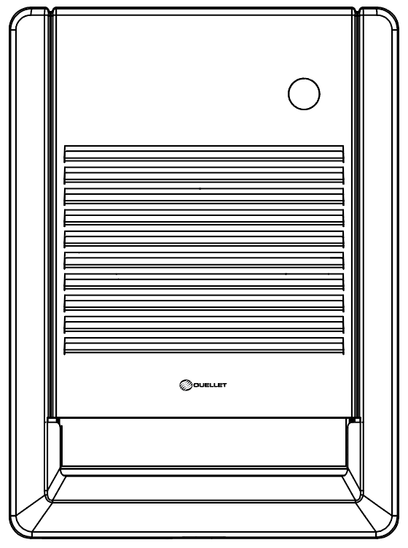

Features
Color - Standard: white.
Finish - Standard: epoxy/polyester powder paint.
Voltage - 120V, 208V, 240/208V, 1-phase.
Construction - 22-gauge steel cabinet, 20-gauge steel grille.
- High-limit temperature control with manual reset.
- Additional one-time thermal fuse.
Fan - Quiet fan.
Heating element - Nichrome heating element provides instant heat.
Control - Built-in double-pole thermostat (-T2 models).
- Built-in double-pole thermostat and timer (-T2M models).
- Built-in thermostat kit available.
- Wall thermostat (not included, the use of an electronic thermostat is strongly
recommended).
Note: If an electronic wall-mounted thermostat is used, it must be compatible with forced-air heaters.
- Controls located at the top of the unit.
Installation - 6 in. (150 mm) minimum clearance to ﬂoor or any adjacent surfaces.
- May be recessed or surface-mounted with optional surface mounting box.
- Quick and easy installation easily retrofits most popular models.
- Wattage can be selected onsite.
Warranty - 5-year warranty.
Application - Kitchen, family room, bathroom (model with timer and thermostat), entrance way, office.

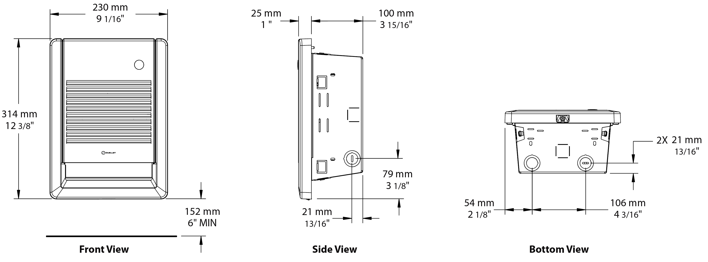
Models
Product # | Qty | Product # | Qty | Product # | Qty | Volts | Watts¹ | BTU/hr | Weight
Without thermostat² | Qty | Built-in thermostat | Qty | Built-in thermostat and timer |  |  |  |  | lb | kg
OVOU1002BL |  | OVOU1002BL-T2 |  | OVOU1002BL-T2M |  | 120 | 1000 or 500 | 3413 or 1706 | 7.4 | 3.4
OVOU1502BL |  | OVOU1502BL-T2 |  | OVOU1502BL-T2M |  | 120 | 1500 or 750 | 5119 or 2560 | 7.4 | 3.4
OVOU1008BL |  | OVOU1008BL-T2 |  | OVOU1008BL-T2M |  | 208 | 1000 or 500 | 3413 or 1706 | 7.4 | 3.4
OVOU2008BL |  | OVOU2008BL-T2 |  | OVOU2008BL-T2M |  | 208 | 2000 or 1000 | 6825 or 3413 | 7.4 | 3.4
OVOU1000BL |  | OVOU1000BL-T2 |  | OVOU1000BL-T2M |  | 240/208 | 1000/750 or 500/375 | 3413/2560 or 1706/1280 | 7.4 | 3.4
OVOU1500BL |  | OVOU1500BL-T2 |  | OVOU1500BL-T2M |  | 240/208 | 1500/1125 or 750/560 | 5119/3839 or 2560/1911 | 7.4 | 3.4
OVOU2000BL |  | OVOU2000BL-T2 |  | OVOU2000BL-T2M |  | 240/208 | 2000/1500 or 1000/750 | 6825/5119 or 3413/2560 | 7.4 | 3.4
Standard color is white.
Add -SBE after BL for unit without back box. (Available for United States market only.)
¹Wattage can be selected onsite.
²Requires non pulsing wall-mounted thermostat. Please refer to the Wall Thermostats Reference Chart at the end of the catalog.

Options
Product #  Kit | Description | Qty
KIT-OVO-BB6 | Back box (6 pack)
KIT-OVO-BSBL | Surface mounting box
KIT-OVO-T1BL | Single-pole thermostat, 120V-600V
KIT-OVO-T2BL | Double-pole thermostat, 120V-277V

Others
Type | Quantity | Model et description  Complementary informations | Volts | Phase | Watts | Length  mm/in. | Informations  Color/installation

Specifications may change without prior notice
Project: | Approval  Information
Consultant Engineer: | Approval  Information
Eectrician Contractor: | Approval  Information
Distributor: | Approval  Information
Date: | Approval  Information
Contact in Ouellet: | Approval  Information
Comments:

