Series
OVE European-Style Bathroom Fan Heater


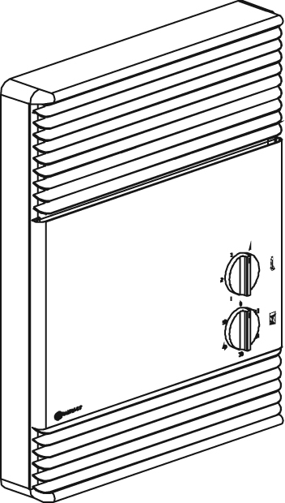

Features
Color - Standard: white, almond.
- Optional (upcharge applicable): metallic silver, bronze, metallic charcoal,
aluminum, semi-gloss black, sand.
- Custom color available upon request.
Finish - Standard: epoxy/polyester powder paint.
- Optional: stainless steel (grilles and back of the heater are painted black).
Voltage - 120V, 240/208V, 1-phase.
Construction - 20-gauge steel or 22-gauge stainless steel.
- Outlet-grille efficiently distributes warm air throughout the heated area.
- Bar grilles prevent insertion of foreign objects;
smooth-finish paint is washable and anti-yellowing.
- High-limit temperature control with automatic reset.
Fan - Whisper-quiet squirrel-cage fan.
- Factory-lubricated motor.
Heating element - Nickel-chromium alloy stitched wire protected by mica insulators.
- Heating element provides instant heat.
Control - Bulb thermostat (-T and -TM models).
- Mechanical timer, 0-60 minutes (-TM model).
Note: If an electronic wall-mounted thermostat is used, it must be compatible with forced-air heaters.
Installation - 12 in. (306 mm) minimum clearance to ﬂoor.
- May be recessed or surface-mounted without adaptor in 2 in. X 3 in. stud partitions.
- Holes for fastening and convenient knock-outs allow for easy installation
and connection (mounting screws included).
Warranty - 2-year warranty against defects.
- 5-year warranty on the heating element.
Application - Bathroom, kitchen, family room, entrance way.

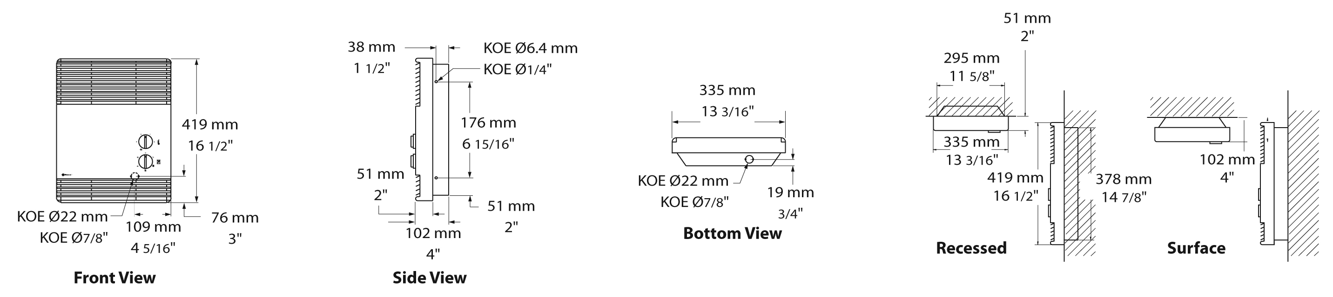
Models
# Product | Qty | Volts | Watts | Weight
 |  |  |  | lb | kg
OVEU1502¹ |  | 120 | 1500 | 14.0 | 6.4
OVEU1502-T |  | 120 | 1500 | 14.0 | 6.4
OVEU1502-TM |  | 120 | 1500 | 14.0 | 6.4
OVEU1500¹ |  | 240/208 | 1500/1125 | 14.0 | 6.4
OVEU1500-T |  | 240/208 | 1500/1125 | 14.0 | 6.4
OVEU1500-TM |  | 240/208 | 1500/1125 | 14.0 | 6.4

¹Requires non pulsing wall-mounted thermostat. Please refer to the Wall Thermostats Reference Chart at the end of the catalog.
Add "BL" for white, "AM" for almond, "SS" for stainless steel.
For almond models with -T or -TM the knobs are black.
For stainless steel models the grilles and the back of the heater are painted black.

Others
Type | Quantity | Model et description  Complementary informations | Volts | Phase | Watts | Length  mm/in. | Informations  Color/installation

Specifications may change without prior notice
Project: | Approval  Information
Consultant Engineer: | Approval  Information
Eectrician Contractor: | Approval  Information
Distributor: | Approval  Information
Date: | Approval  Information
Contact in Ouellet: | Approval  Information
Comments:

