Series
OVC Compact Electronic Fan Heater


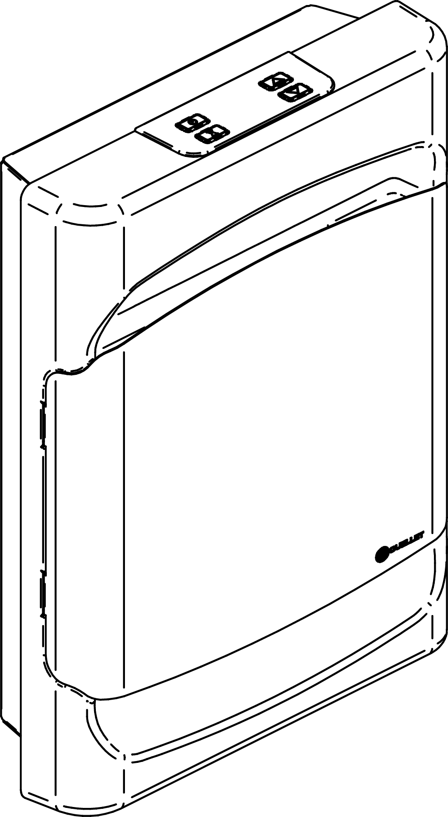

Features
Color - Standard: white.
- Optional (upcharge applicable): almond, metallic silver, bronze, metallic charcoal, aluminum,
semi-gloss black, sand.
- Custom colors available upon request.
Finish - Standard: epoxy/polyester powder paint.
Voltage - 120, 240/208V, 1-phase.
Construction - Shock-resistant cast aluminum front cover.
- 20-gauge steel.
- High-limit temperature control with automatic reset.
Fan - Whisper-quiet squirrel-cage fan.
- Factory-lubricated, two-speed motor.
Heating element - Nickel-chromium alloy stitched wire protected by mica insulators.
- Heating element provides instant heat.
Control Model (-TH)
- Operating modes adapted for all requirements (comfort, economy, frost-free mode).
- Built-in electronic digital thermostat/timer with backlit display that can be used as a
night light.
- Electronic thermostat with 2 triacs automatically switches from 750W to 1500W when needed.
- Keypad lock function that eliminates unwanted temperature adjustments and the use of the thermostat modes.
Model (-PW)
- Requires non pulsing wall-mounted thermostat (sold separately).
- Wattage must be selected at the time of wiring (750W or 1500W).
Installation - 6 in. (152 mm) minimum clearance to ﬂoor.
- May be recessed or surface-mounted without adaptor in 2 in. X 3 in. stud partitions
with gypsum.
- Easy installation and connection with mounting screws and knockouts (mounting screws included).
- Template included.
Warranty - 5-year warranty against defects.
Application - Hallways, bathrooms, shower rooms, dining rooms, kitchens, corridors.

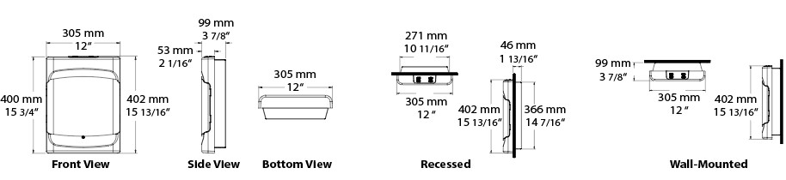
Models
Product # | Qty | Volts | Watts |  | Weight
Product # | Qty | Volts | min. | max. | lb | kg
OVC1502BL-TH |  | 120 | 750/563 | 1500/1125 | 11.5 | 5.22
OVC1500BL-TH |  | 240/208 | 750/563 | 1500/1125 | 11.5 | 5.22
OVC1500BL-PW¹ |  | 240/208 | 750/563  1500/1125 |  | 12.2 | 5.53

Options
Product #  Factory installed* | Description | Qty
DIS² | Disconnect switch, 20A at 250V
R³ | Single-pole relay, coil 24V, without transformer, 22A at 208V, 240V
RT³ | Single-pole relay, coil 24V, with transformer 208V, 240V/24V, 22A max.
TRIAC³ | Single-pole electronic relay, coil 24V, without transformer, 15A at 240V max.
TRIACT³ | Single-pole electronic relay, coil 24V, with transformer, 15A at 240V max.
* For factory installed options, add the option number to the product number. See the Product Code section inside the front cover.
¹ Requires non pulsing wall-mounted thermostat (sold separately). Please refer to the Wall Thermostats Reference Chart.
² For the U.S. only: The nominal current of the unit must not exceed 80% of the capacity of the disconnect. This option is available with built-in thermostat (option -TH) or power selector (option -PW).
³ These options must be chosen with the power selector (option -PW).
Custom colors available upon request.

Others
Type | Quantity | Model and description  Additional information | Volts | Phase | Watts | Length  mm/in. | Information  Color/installation

Specifications may change without prior notice
Project: | Approval  Information
Consultant Engineer: | Approval  Information
Electrician Contractor: | Approval  Information
Distributor: | Approval  Information
Date: | Approval  Information
Ouellet Contact: | Approval  Information
Comments:

