Series
OTS Trench insert floor convector
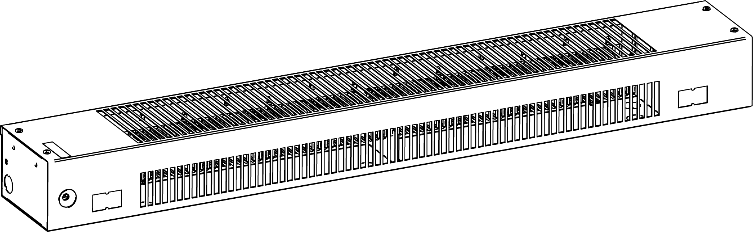



Features
Color - Standard: semi-gloss black.
- Optional (upcharge applicable): white, almond, metallic silver, bronze, metallic
charcoal, aluminum, sand.
- Custom colors available upon request.
Finish - Standard: epoxy/polyester powder paint.
Voltage - 120V, 208V, 240/208V, 277V, 347V, 480V, 600V, 1-phase.
Construction - Sturdy construction of 20-gauge steel.
- Linear high-limit temperature control with automatic reset.
- Linear high-limit temperature control with manual reset.
Heating element - Stainless steel tubular heating element with aluminum fins.
- Floating heating element on high-temperature nylon bushings
reducing expansion noises.
Watt density - Average standard watt density of 250W/ft.
- Average low density of 200W/ft., 167W/ft.
Control - Mechanical or electronic relays available (installed on the right end only).
Ouellet highly recommends using an electronic wall thermostat for greater comfort.
Installation - Must be installed inside a trench under a floor with a compatible top trench grille
(not supplied), which must cover the entire length of the heater. Please refer to the table of Models of compatible top trench grilles.
- 2 fixing holes in the bottom of the heater.
Warranty - 3-year warranty against defects.
- 10-year warranty on the heating element.
Application - Bay window, lobby, commercial building, condos, restaurants.

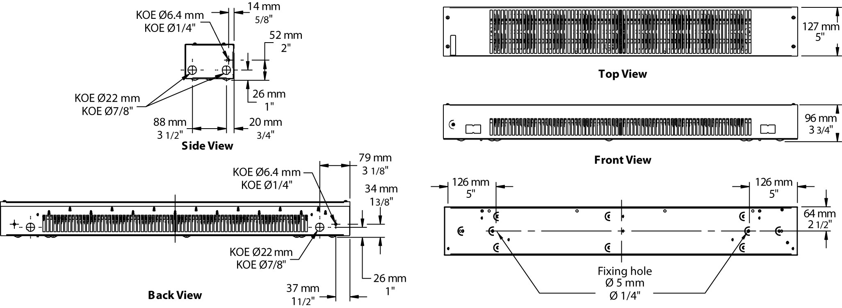
Models of compatible top trench grilles
 |  | Trench dimension - Figure 3
 |  | W: 10 in. (254 mm) minimum  D: 6 in. to 7 15/16 in. (153 mm à 202 mm)  C: 2 1/2 in. (64 mm) minimum |  |  | W: 10 in. (254 mm) minimum  D: 8 in. (204 mm) minimum  C: 2 1/2 in. (64 mm) minimum
 |  | Power per linear foot |  |  | Power per linear foot
Manufacturer | Grille Model | 167W/ft. | 200W/ft. | 250W/ft. | 167W/ft. | 200W/ft. | 250W/ft.
Nailor Industries  www.nailor.com | 49-240 | √ | ₋ | ₋ | √ | √ | ₋
Nailor Industries  www.nailor.com | 49-241 | √ | ₋ | ₋ | √ | √ | ₋
Nailor Industries  www.nailor.com | 49-243 | √ | ₋ | ₋ | √ | √ | ₋
Nailor Industries  www.nailor.com | 49-280 | √ | √ | ₋ | √ | √ | √
Nailor Industries  www.nailor.com | 49-281 | √ | √ | ₋ | √ | √ | √
Price Industries  www.priceindustries.com | LBP/LBPH 15B | √ | √ | ₋ | √ | √ | √
Price Industries  www.priceindustries.com | LBP/LBPH 16B | √ | √ | ₋ | √ | √ | √
Price Industries  www.priceindustries.com | LBP/LBPH 25C | ₋ | ₋ | ₋ | √ | ₋ | ₋
NOTE: Vanes or deflectors options with grille are prohibited.

Figure 3
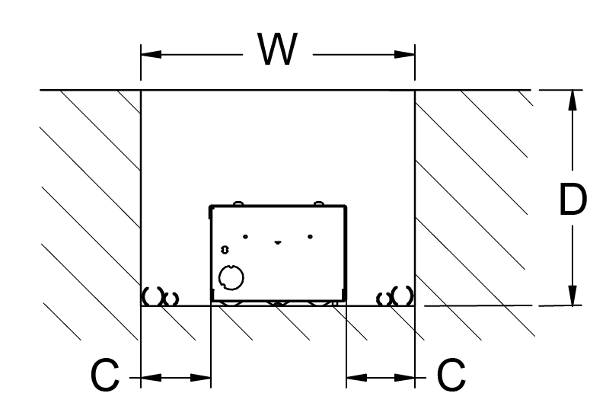

Standard Watt Density Models 250W/ft.
Watts | Watts  240/208V | # Product |  |  |  |  |  |  |  |  |  |  |  | Length |  | Weigth
Watts | Watts  240/208V | 120V | Qty | 208V | Qty | 240/208V | Qty | 277V | Qty | 347V | Qty | 600V | Qty | In | mm | lb | kg
750 | 750/563 | OTS0752 |  | OTS0758 |  | OTS0750 |  | OTS0777 |  | - | - | - | - | 36 | 915 | 8.4 | 3.8
1000 | 1000/750 | - | - | OTS1008 |  | OTS1000 |  | OTS1077 |  | OTS1007 |  | OTS1006 |  | 48 | 1220 | 10.8 | 4.9
1250 | 1250/938 | - | - | OTS1258 |  | OTS1250 |  | OTS1277 |  | OTS1257 |  | OTS1256 |  | 60 | 1525 | 13.2 | 6.0

Low Watt Density Models
Product # ¹ | Length | Weight | Average  Density W/ft. | Watts | Watts  240/208V | 120V | Qty | 208V | Qty | 240/208V | Qty | 347V | Qty | 600V | Qty
OTS050X-915 | 36’’  (915 mm) | 8.4 lb  (3.8 kg) | 167 | 500 | 500/375 | √ |  | √ |  | √ |  | ----- | ----- | ----- | -----
OTS060X-915 | 36’’  (915 mm) | 8.4 lb  (3.8 kg) | 200 | 600 | 600/450 | √ |  | √ |  | √ |  | ----- | ----- | ----- | -----
OTS066X-1220 | 48’’  (1220 mm) | 10.8 lb  (4.9 kg) | 167 | 668 | 668/502 | √ |  | √ |  | √ |  | √ |  | √
OTS080X-1220 | 48’’  (1220 mm) | 10.8 lb  (4.9 kg) | 200 | 800 | 800/600 | √ |  | √ |  | √ |  | √ |  | √
OTS083X-1525 | 60’’  (1525 mm) | 13.2 lb  (6 kg) | 167 | 835 | 835/627 | √ |  | √ |  | √ |  | √ |  | √
OTS100X-1525 | 60’’  (1525 mm) | 13.2 lb  (6 kg) | 200 | 1000 | 1000/750 | ----- | ----- | √ |  | √ |  | √ |  | √

¹ X = 2 (120V), 8 (208V), 0 (240/208V), 7 (347V), 6 (600V).

√ = Available.
Add "NL" for semi-gloss black. Upcharge applicable for optional colors shown in the color chart section.
Other voltages available upon request.

Options
Product # ¹  Kit | Product # ¹  Factory installed* | Description | Qty
KIT-OTS-DIS20 | DIS20 | Disconnect switch, 20A at 277V max.
KIT-OTS-DIS40 | - | Disconnect switch, 40A at 600V max. 120 mm height
KIT-OTS-R-347 | R | Single-pole relay, coil 24V, without transformer:  22A at 120V, 208V, 240V - 19A at 277V - 18A at 347V
KIT-OTS-R-600 | R | Single-pole relay, coil 24V, without transformer: 10A at 480V, 600V
KIT-OTS-RT-208 | RT | Single-pole relay, coil 24V, with transformer 208V/24V, 22A at 208V
KIT-OTS-RT-240 | RT | Single-pole relay, coil 24V, with transformer 240V/24V, 22A at 240V
KIT-OTS-RT-277 | RT | Single-pole relay, coil 24V, with transformer 277V/24V, 19A at 277V
KIT-OTS-RT-347 | RT | Single-pole relay, coil 24V, with transformer 347V/24V, 18A at 347V
KIT-OTS-TRIAC-347 | TRIAC | Single-pole electronic relay, coil 24V, without transformer: 10A max. at 347V max.
KIT-OTS-TRIAC-347T | TRIACT | Single-pole electronic relay, coil 24V, with transformer: 10A max. at 347V max.
KIT-OTS-TRIAC-600 | TRIAC | Single-pole electronic relay, coil 24V, without transformer: 6A at 600V max.

* For factory installed options, add the option number to the product number. See the Product Code section inside the front cover.
¹ Options installed at right end only.

Others
Type | Quantity | Model et description  Complementary information | Volts | Phase | Watts | Length  mm/in. | Information  Color/installation

Specifications may change without prior notice
Project: | Approval  Information
Consultant Engineer: | Approval  Information
Electrician Contractor: | Approval  Information
Distributor: | Approval  Information
Date: | Approval  Information
Contact in Ouellet: | Approval  Information
Comments:

