Series
OTR Floor Heating Cable for Membrane

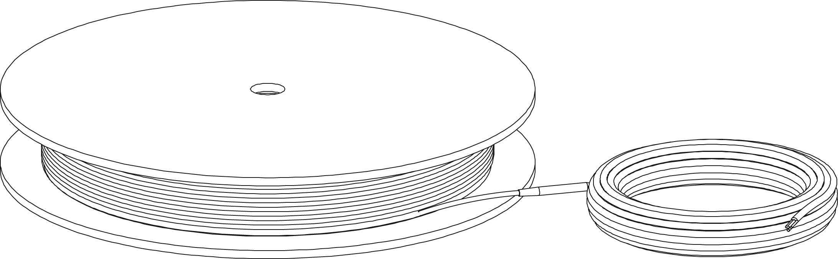

Features
Voltage - 120V, 240/208V, 1-phase.
Cold lead length - 10’ (3 m).
Construction - Heating cable made of a twin conductor for a simpler and faster installation,
compatible with uncoupling membrane systems.
Watt density - 9W/sq. ft. (97W/sq. m), 4” (102 mm) spacing.
- 10W/sq. ft. (108W/sq. m), 3 5/8” (92 mm) spacing.
Control - Two types of control method possible (see instruction manual for details):
• Surface heating control with electronic thermostat in floor mode (F)
and temperature sensor.
• Ambient heating control with electronic thermostat in ambient mode
with floor limit (A or AF) and temperature sensor.
Note: A ground fault circuit interrupter (GFCI) must be used with this heating device
unless exempted by the applicable national and/or local electrical code for the area of installation.
Included materials - 15' (4.6 m) ﬂoor sensor included.
- Measurements table label (to be placed in electrical panel).
Installation - Never cut or shorten the heating cable.
- For indoor applications only.
- On concrete slab or plywood subfloor.
- On uncoupling membrane sold in option.
- For heating cable installation on uncoupling membrane systems, consult the
membrane manufacturer’s instructions to ensure that it is compatible with the use of heating cables.
Warranty - 25-year warranty on the heating cable.
Application - Kitchen, bathroom, entrance way, family room, living room.

Models
Watts | Product #ty |  |  |  | Cable Diameter (mm) | Covered Surface Depending on Spacing¹ |  |  |  | Cable Length |  | Weight
Watts |  |  |  |  | Cable Diameter (mm) | 3 1/2’’ (88 mm)² |  | 3 3/4’’ (95 mm)
Watts | 240/208V | Qty | 120V | Qty | Cable Diameter (mm) | 10W/  sq. ft. | 108W/  sq. m | 9.6W/  sq. ft. | 103W/  sq. m | ft. | m | lb | kg
85 | - | - | OTR0082 |  | 4.3 | 9.5 | 0.9 | 10.0 | 0.9 | 32 | 9.75 | 2.6 | 0.9
120 | - | - | OTR0122 |  | 4.3 | 12.0 | 1.1 | 12.5 | 1.2 | 40 | 12.19 | 2.6 | 0.9
150 | - | - | OTR0152 |  | 4.3 | 16.0 | 1.5 | 16.5 | 1.5 | 53 | 16.15 | 3.1 | 1.4
170 | OTR0170 |  | OTR0172 |  | 4.3 | 18.5 | 1.7 | 19.0 | 1.8 | 61 | 18.59 | 3.1 | 1.4
240 | OTR0240 |  | OTR0242 |  | 4.3 | 24.0 | 2.2 | 25.0 | 2.3 | 80 | 24.38 | 3.8 | 1.6
300 | OTR0300 |  | OTR0302 |  | 4.3 | 30.5 | 2.8 | 31.5 | 2.9 | 101 | 30.78 | 4 | 1.8
360 | OTR0360 |  | OTR0362 |  | 4.3 | 36.5 | 3.4 | 37.5 | 3.5 | 120 | 36.58 | 4.2 | 1.9
420 | OTR0420 |  | OTR0422 |  | 4.3 | 42.5 | 4.0 | 44.0 | 4.1 | 141 | 42.98 | 4.9 | 2.2
475 | OTR0475 |  | OTR0472 |  | 4.3 | 48.5 | 4.5 | 50.0 | 4.6 | 160 | 48.77 | 6 | 2.7
600 | OTR0600 |  | OTR0602 |  | 4.3 | 60.5 | 5.6 | 62.5 | 5.8 | 200 | 60.96 | 6.9 | 3.1
720 | OTR0720 |  | OTR0722 |  | 4.3 | 72.5 | 6.7 | 75.0 | 7.0 | 240 | 73.15 | 7.9 | 3.6
840 | OTR0840 |  | OTR0842 |  | 4.3 | 84.5 | 7.9 | 87.5 | 8.1 | 280 | 85.34 | 8.7 | 4
960 | OTR0960 |  | OTR0962 |  | 4.3 | 96.5 | 9.0 | 100.0 | 9.3 | 320 | 97.54 | 9.3 | 4.2
1080 | OTR1080 |  | - | - | 4.3 | 109.0 | 10.1 | 112.5 | 10.5 | 360 | 109.73 | 10 | 4.6
1140 | - | - | OTR1142 |  | 4.3 | 115 | 10.66 | 119 | 11.03 | 380 | 115.82 | 11.6 | 5.2
1200 | OTR1200 |  | - | - | 4.3 | 121.0 | 11.2 | 125.0 | 11.6 | 400 | 121.92 | 11 | 5
1320 | - | - | OTR1322 |  | 4.3 | 133 | 12.35 | 137.5 | 12.77 | 440 | 134.11 | 13.7 | 6.2
1440 | OTR1440 |  | - | - | 4.3 | 145.0 | 13.5 | 150.0 | 13.9 | 480 | 146.30 | 13 | 5.9
1450 | - | - | OTR1452 |  | 4.3 | 145 | 13.5 | 150 | 13.9 | 480 | 146.30 | 16 | 7.2
1500 | - | - | OTR1502 |  | 4.3 | 151 | 14 | 156.5 | 14.5 | 500 | 152.40 | 17.4 | 7.9
1600 | OTR1600 |  | - | - | 4.3 | 169.0 | 15.7 | 175.0 | 16.3 | 560 | 170.69 | 15 | 6.8
1680 | - | - | OTR1682 |  | 4.3 | 169.5 | 15.7 | 175 | 16.3 | 560 | 170.69 | 20.3 | 9.1
1920 | OTR1920 |  | - | - | 4.3 | 193.5 | 18.0 | 200.0 | 18.6 | 640 | 195.07 | 18 | 8.2
2280 | OTR2280 |  | - | - | 4.3 | 229.5 | 21.3 | 237.5 | 22.1 | 760 | 231.65 | 22 | 10
2640 | OTR2640 |  | - | - | 4.3 | 266.0 | 24.7 | 275.0 | 25.5 | 880 | 268.22 | 26 | 11.8
2900 | OTR2900 |  | - | - | 4.3 | 292.5 | 27.2 | 302.5 | 28.1 | 968 | 295.04 | 30 | 13.6
3000 | OTR3000 |  | - | - | 4.3 | 302.0 | 28.1 | 312.5 | 29.0 | 1000 | 304.80 | 31 | 14
3360 | OTR3360 |  | - | - | 4.3 | 338.5 | 31.4 | 350 | 32.5 | 1120 | 341.38 | 36.9 | 16.8

¹ Does not represent the surface of the room but rather the surface covered by the floor heating system, excluding fixtures and other spaces to consider.
² Spacing with the NADCM membrane when the cable is installed with 3 spacing castellations.
208V = 75% of wattage at 240V.
15' (4.6 m) floor sensor and 10' (3 m) cold lead included.

Options
Product #  Kit | Description | Qty
NADCM-M-80 | Fleeceback uncoupling membrane in sheet, 2’ 6-5/16’’ X 3’ 3’’, 8.16 sq. ft., sold in box of 10 sheets
NADCM-M-150 | Fleeceback uncoupling membrane in roll, 46' 9'' x 3' 3'', 150 sq. ft.
NADCM-S-80 | Self-adhesive uncoupling membrane in sheet, 2' 6-5/16'' X 3 '3'', 8.16 sq. ft., sold in box of 10 sheets
NADCM-S-150 | Self-adhesive uncoupling membrane in roll, 46' 9'' x 3' 3'', 150 sq. ft.
OTM-CC | CableCheck - Electrical fault indicator
OTM-SA | Adhesive spray to secure the mat on concrete slab, 16.75 oz (474 g)
KIT-SP1 | Repair kit
KIT-CBL-SN | 15 ft. (4.6 m) floor sensor

Electronic Thermostats for Floor Heating System
Product # | Description | Qty | Amp. | Volts | Protection
OTH3600-GA² | Non programmable electronic thermostat  for floor heating system |  | 15 | 120/208/240 | Class A  GFCI 5 mA¹
OTH3600P-GA² | Programmable electronic thermostat  for floor heating system |  | 15 | 120/208/240 | Class A  GFCI 5 mA¹
OTH3600-GA-GT² | Wireless communication programmable electronic thermostat  for floor heating system |  | 15 | 120/208/240 | Class A  GFCI 5 mA¹

Slave Unit for Floor Heating System
Product # | Description | Qty | Amp. | Volts | Protection
TR1310-120-240GA³ | Slave unit for floor heating system |  | 15 | 120/208/240 | Class A  GFCI 5 mA¹

¹ GFCI: Ground fault circuit interrupter.
² 15’ (4.6 m) floor sensor included.
³ Compatible with OTH3600P-GA and OTH3600-GA-GT only, not compatible with the non programmable thermostat OTH3600-GA.
Standard color is white.

Others
Type | Quantity | Model et description  Complementary information | Volts | Phase | Watts | Length  mm/in. | Information  Color/installation

Specifications may change without prior notice
Project: | Approval  Information
Consultant Engineer: | Approval  Information
Eectrician Contractor: | Approval  Information
Distributor: | Approval  Information
Date: | Approval  Information
Contact in Ouellet: | Approval  Information
Comments:

