Series

OTP-P Pacific Ductless Single Zone Heat Pump


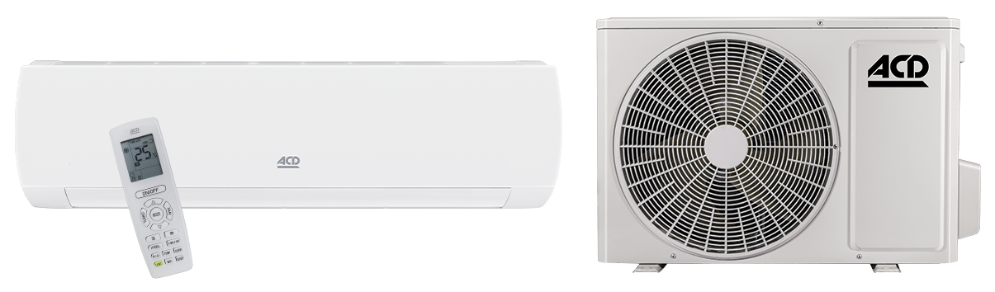
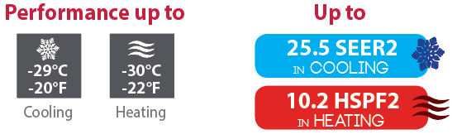

Features
Operation mode - Cooling, heating, dehumidifying, fan and auto.
Nominal capacity - 9000, 12000, 18000, 24000 BTU/hr.
Voltage - 230/208V, 60 Hz, 1-phase.
Indoor unit - High wall installation, dual side connection.
- Plastic housing, standard white.
- 7-speed cross-flow fan (auto, turbo, high, medium-high, medium, low and very low).
- Washable filters.
Outdoor unit - Variable speed rotary compressor (INVERTER), with overload protection.
- Electronic expansion valve for precise control of refrigerant flow.
- Condenser fins covered with a hydrophilic coating for improved corrosion resistance.
- Large diameter quiet axial-flow fan for more efficient heat exchange.
- Smart pan heater to prevent ice formation.
- Compressor blanket and preheating technology.
- Installation on aluminum wall bracket or ground stand (optional).
Connection piping - Minimum piping length of 10 ft. (3 m).
- Flared connections.
Control - Wireless remote included.
- Wired wall controller available.
- Wi-Fi in option.
- Set temperature: 16 to 30 °C (61 to 86 °F).
- Temperature display format: °C or °F.
Warranty - 10-year basic warranty on parts and 10-year basic warranty on the compressor (labour not included).
Application - Dining room-kitchen, living room, family room, commercial building, office building, condo, restaurant.
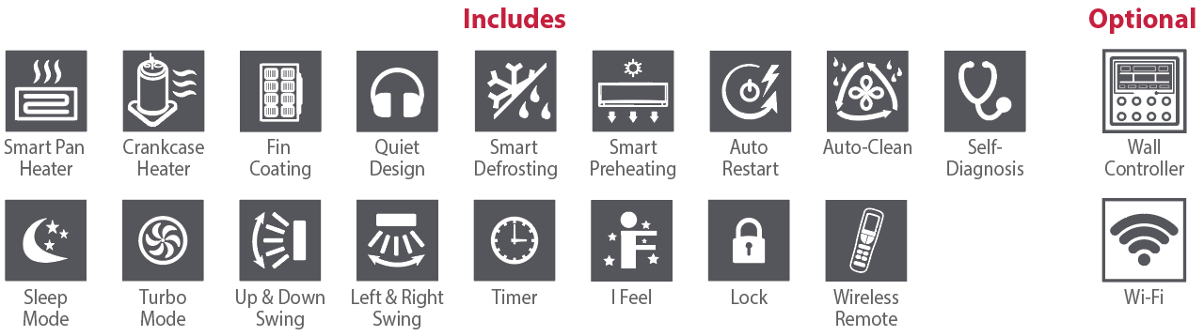

Models
Product #¹ |  |  | Indoor Unit |  | PUD09KCH25S-I  PUD09KCH25S-O | PUD12KCH24S-I  PUD12KCH24S-O | PUD18KCH23S-I  PUD18KCH23S-O | PUD24KCH24S-I  PUD24KCH24S-O | PUD30KCH20S-I  PUD30KCH20S-O | PUD36KCH20S-I  PUD36KCH20S-O
 |  |  | Outdoor Unit
Qty
Technical Performance
Voltage |  |  |  | Volts | 230/208 | 230/208 | 230/208 | 230/208 | 230/208 | 230/208
Cooling capacity |  | Nominal |  | W (BTU/hr) | 2667 (9100) | 3517 (12000) | 5275 (18000) | 6450 (22000) | 8800 (30000) | 9850 (33600)
 |  | Min. – max. |  | W (BTU/hr) | 450 - 3150  (1535 - 10748) | 900 - 4132  (3070 - 14100) | 1500 - 6200  (5118 - 21154) | 2600 - 8200  (8870 - 28000) | 2280 – 10400  (7780 – 35500) | 2200 – 10900  (7500 – 37200)
Heating capacity |  | Nominal |  | W (BTU/hr) | 3077 (10500) | 3517 (12000) | 5275 (18000) | 7040 (24000) | 8800 (30000) | 10140 (34600)
 |  | Min. – max. |  | W (BTU/hr) | 1000 - 4300  (3412 - 14671) | 900 - 4543  (3071 - 15500) | 1500 - 6200  (5118 - 21154) | 2100 - 9000  (7200 - 30708) | 2670 – 10800  (9100 – 36850) | 3000 – 11300  (10200 – 38500)
Used cooling power input |  | Nominal |  | W | 619 | 961 | 1384 | 1679 | 2667 | 3200
 |  | Min. – max. |  | W | 130 - 1013 | 220 - 1400 | 130 - 2300 | 290 - 2600 | 650 – 3600 | 670 – 4000
Used heating power input |  | Nominal |  | W | 848 | 923 | 1384 | 1870 | 2588 | 3200
 |  | Min. – max. |  | W | 228 -1343 | 220 - 1500 | 250 - 2350 | 470 - 3100 | 650 – 3900 | 600 – 3950
Used rated input |  |  |  | W | 1343 | 1500 | 2350 | 3100 | 3900 | 4000
Rated current |  |  |  | A | 4.73 | 6.30 | 11.50 | 15.30 | 19 | 20
MCA |  |  |  | A | 10 | 10 | 14 | 16 | 20 | 23
Max. over-current protection (MOCP) |  |  |  | A | 15 | 15 | 20 | 25 | 30 | 35
SEER2 (SEER) |  |  |  | - | 25.5 (25.5) | 24 (24) | 23.5 (23) | 24.5 (24) | 20 (19) | 20 (20)
HSPF2 (HSPF) |  |  |  | - | 10.2 (12) | 9 (11) | 9 (11) | 9.5 (11) | 8.5 (10) | 8.5 (9)
EER |  |  |  | W/W | 4.31 | 3.66 | 3.81 | 3.85 | 3.30 | 3.08
COP |  |  |  | W/W | 3.90 | 3.81 | 3.81 | 3.79 | 3.40 | 3.17
AHRI number |  |  |  | - | 210534142 | 210534143 | 211619266 | 210534144 | 211709659 | 211709660
ENERGY STAR |  |  |  | - | ✓ | ✓ | ✓ | ✓ | - | -
Indoor Unit
Dehumidification |  |  |  | pt/hr (l/hr) | 1.69 (0.80) | 2.96 (1.4) | 3.80 (1.8) | 5 (2.40) | 7.4 (3.50) | 7.4 (3.50)
Air flow volume |  |  |  | cfm | 353 / 323 / 294 / 264 /  235 / 176 / 158 | 400 / 364 / 329 / 288 /  264 / 247 / 229 | 589 / 500 / 441 / 412 /  383 / 353 / 324 | 736 / 588 / 530 / 471 /  441 / 412 / 383 | 912 / 736 / 706 / 647 / 588 / 530 / 471 | 736 / 588 / 530 / 471 /  441 / 412 / 383
Sound level |  |  |  | dB (A) | 50 / 47 / 45 / 42 /  39 / 36 / 35 | 53 / 48 / 46 / 44 /  42 / 40 / 37 | 59 / 53 / 51 / 50 /  47 / 43 / 39 | 62 / 54 / 52 / 49 /  48 / 46 / 44 | 66 / 60 / 57 / 55 / 52 / 50 / 47 | 62 / 54 / 52 / 49 /  48 / 46 / 44
Fan motor power output |  |  |  | W | 15 | 15 | 45 | 60 | 70 | 70
Fan motor RLA |  |  |  | A | 0.22 | 0.20 | 0.35 | 0.30 | 0.6 | 0.75
Deflector stepper motor power output |  |  |  | W | 1.5 | 1.5 | 1.5 | 1.5 | 1.5 | 1.5
Net weight |  |  |  | lb (kg) | 21 (9.5) | 21 (9.5) | 29 (13.5) | 35 (16) | 44 (24.5) | 44 (24.5)
Outdoor Unit
Air flow volume |  |  |  | m³/hr | 2200 | 2200 | 3600 | 4500 | 4500 | 4500
Sound level |  |  |  | dB (A) | 52 | 52 | 59 | 62 | 72 | 72
Compressor power input |  |  |  | W | 800 | 784 | 1196 | 1350 | 2020 | 2294
Compressor LRA |  |  |  | A | - | - | - | - | - | -
Compressor RLA |  |  |  | A | 6.50 | 6.80 | 9.25 | 11 | 14.2 | 16
Fan motor power output |  |  |  | W | 30 | 30 | 60 | 90 | 90 | 90
Fan motor RLA |  |  |  | A | 0.4 | 0.4 | 0.9 | 0.6 | 0.90 | 1.50
Refrigerant volume (R410A) |  |  |  | oz (g) | 35.28 (1000) | 42.33 (1200) | 54.70 (1550) | 60 (1700) | 74.1 (2100) | 84.7 (2400)
Net weight |  |  |  | lb (kg) | 70.5 (32) | 70.5 (32) | 98 (44.5) | 108 (49) | 113.6 (56.5) | 127.9 (58)
Operating ambient temperature | Cooling |  |  | °C (°F) | -29 to 50 (-20 to 122)
Operating ambient temperature | Heating |  |  | °C (°F) | -30 to 30 (-22 to 86)
Connection Piping/Refrigerant
Pre-charge length |  |  |  | ft. (m) | 25 (7.5) | 25 (7.5) | 25 (7.5) | 25 (7.5) | 25 (7.5) | 25 (7.5)
Additional refrigerant charge |  |  |  | oz/ft. (g/m) | 0.2 (20) | 0.2 (20) | 0.5 (50) | 0.5 (50) | 0.5 (50) | 0.5 (50)
Liquid pipe outer diameter |  |  |  | in. | 1/4 | 1/4 | 1/4 | 1/4 | 1/4 | 1/4
Gas pipe outer diameter |  |  |  | in. | 3/8 | 1/2 | 5/8 | 5/8 | 5/8 | 5/8
Maximum height difference |  |  |  | ft. (m) | 40 (12.2) | 40 (12.2) | 66 (20) | 82 (25) | 82 (25) | 82 (25)
Maximum total length |  |  |  | ft. (m) | 66 (20) | 66 (20) | 82 (25) | 131 (40) | 82 (25) | 82 (25)

¹ 1 indoor unit and 1 outdoor unit. Note that each unit is individually packaged

Capacity Variation Ratio According to Temperature
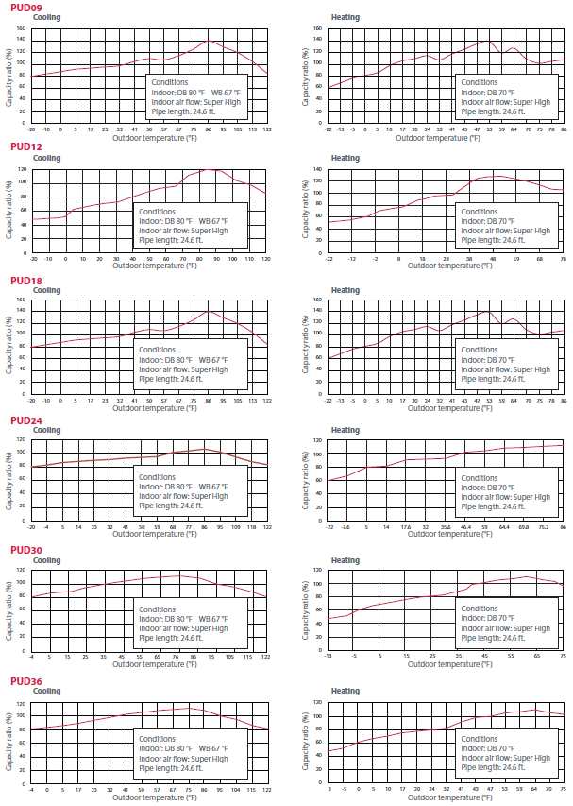

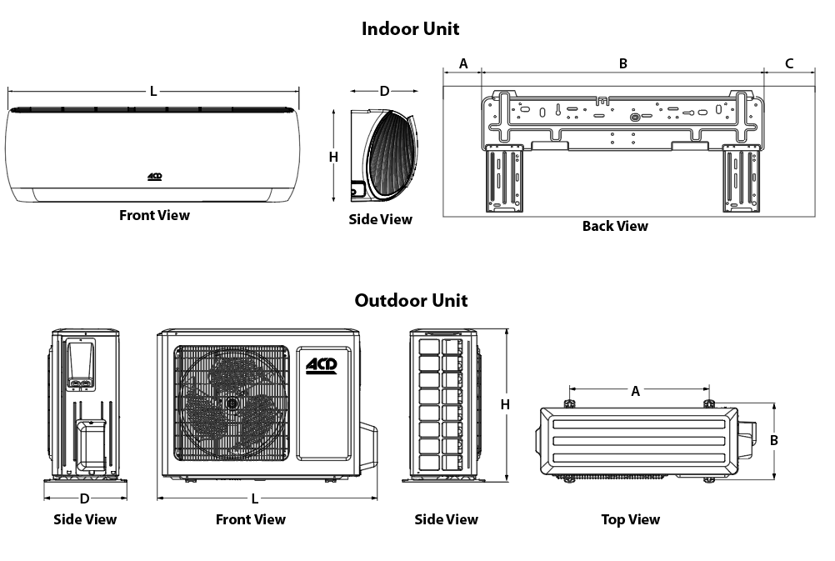

Indoor Unit | L |  | H |  | D |  | A |  | B |  | C
Indoor Unit | in. | mm | in. | mm | in. | mm | in. | mm | in. | mm | in. | mm
PUD09KCH25S-I  PUD12KCH24S-I | 32 1/2 | 825 | 11 1/2 | 293 | 7 23/32 | 196 | 5 7/8 | 149 | 21 5/16 | 542 | 8 1/32 | 204
PUD18KCH23S-I | 39 3/16 | 995 | 12 1/4 | 311 | 8 11/16 | 221 | 8 1/2 | 203 | 27 | 686 | 9 1/4 | 235
PUD24KCH24S-I | 43 1/2 | 1105 | 13 7/64 | 333 | 9 11/16 | 246 | 8 1/2 | 203 | 27 | 686 | 9 1/4 | 235
PUD30KCH20S-I  PUD36KCH20S-I | 53 5/32 | 1350 | 12 13/16 | 326 | 9 15/16 | 253 | 13 ¾ | 350 | 29 3/8 | 746 | 10 | 254

Outdoor Unit | L |  | H |  | D |  | A |  | B
Outdoor Unit | in. | mm | in. | mm | in. | in. | mm | in. | mm | in.
PUD09KCH25S-O  PUD12KCH24S-O | 31 37/64 | 802 | 21 54/64 | 555 | 13 50/64 | 350 | 20 5/32 | 512 | 13 5/64 | 332
PUD18KCH23S-O | 37 46/64 | 958 | 26 | 660 | 15 53/64 | 402 | 24 | 610 | 15 9/16 | 395
PUD24KCH24S-O | 39 6/16 | 1000 | 29 6/16 | 746 | 16 13/16 | 427 | 24 | 610 | 15 9/16 | 395
PUD24KCH24S-O  PUD30KCH20S-O  PUD36KCH20S-O | 39 6/16 | 1000 | 29 6/16 | 746 | 16 13/16 | 427 | 24 | 610 | 15 9/16 | 395

Options
See OTP Options section

Specifications may change without prior notice
Project: | Approval  Information
Consultant Engineer: | Approval  Information
Electrical Contractor: | Approval  Information
Distributor: | Approval  Information
Date: | Approval  Information
Contact at Ouellet: | Approval  Information
Comments:

