Series
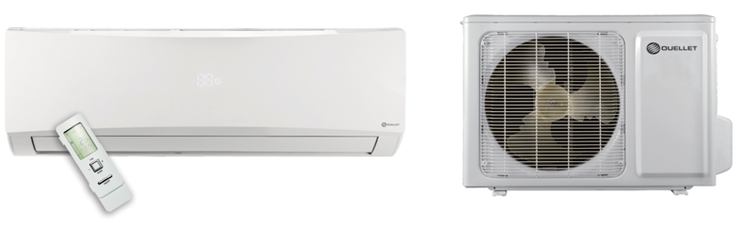
OTP-O Olympia Ductless Single Zone Heat Pump




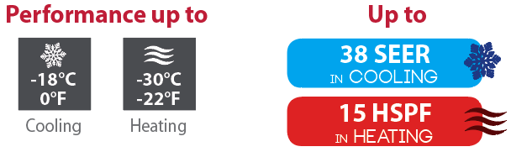
Features
Operation mode - Cooling, heating, dehumidifying, fan and auto.
Nominal capacity - 9000, 12000, 18000, 24000 BTU/hr.
Voltage - 230/208V, 60 Hz, 1-phase.
Indoor unit - High wall installation, dual side connection.
- Plastic housing, standard white.
- 7-speed cross-flow fan (turbo, high, medium-high, medium, medium-low, low and quiet).
- Washable filters.
Outdoor unit - Variable speed rotary compressor (INVERTER), with overload protection.
- Electronic expansion valve for precise control of refrigerant flow.
- Condenser fins covered with a hydrophilic coating for improved corrosion resistance.
- Large diameter quiet axial-flow fan for more efficient heat exchange.
- Smart pan heater to prevent ice formation.
- Compressor blanket and preheating technology.
- Installation on aluminum wall bracket or ground stand (optional).
Connection piping - Minimum piping length of 10 ft. (3 m).
- Flared connections.
Control - Wireless remote included.
- Wired wall controller available.
- Wi-Fi capability.
- Interface (options HP6000ZB-GE and GT130 required).
- Set temperature: 16 to 30 °C (61 to 86 °F).
- Temperature display format °C or °F.
Warranty - 10-year basic warranty on parts and 10-year basic warranty on the compressor (labour not included).
Application - Dining room-kitchen, living room, family room, commercial building, office building, condo,
restaurant.
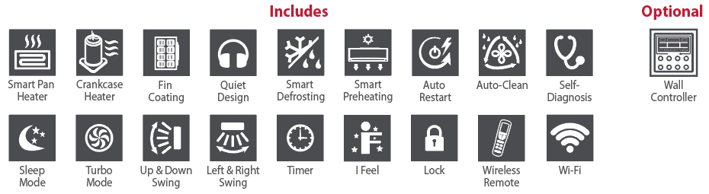

Models
Product #¹ |  |  | Indoor Unit |  |  | UHD09KCH38SB-I | UHD12KCH31S-I | UHD18KCH25S-I | UHD24KCH22S-I
 |  |  | Outdoor Unit |  |  | UHD09KCH38SB-O | UHD12KCH31S-O | UHD18KCH25S-O | UHD24KCH22S-O
Qty
Technical Performance
Voltage |  |  |  |  | Volts | 230/208 | 230/208 | 230/208 | 230/208
Cooling capacity |  | Nominal |  |  | W (BTU/hr) | 2638 (9000) | 3517 (12000) | 5276 (18000) | 6450 (22000)
 |  | Min. – max. |  |  | W (BTU/hr) | 450 - 3800  (1535 - 12966) | 850 - 4500  (2900 - 15354) | 1200 - 6400  (4094 - 21837) | 2000 - 9000  (6800 - 30700)
Heating capacity |  | Nominal |  |  | W (BTU/hr) | 2638 (9000) | 3575 (12200) | 5276 (18000) | 7000 (24000)
 |  | Min. – max. |  |  | W (BTU/hr) | 700 - 4000  (2388 - 13648) | 900 - 5500  (3071 - 18766) | 1200 - 7200  (4094 - 24566) | 2000 - 9500  (6800 - 32000)
Used cooling power input |  | Nominal |  |  | W | 540 | 785 | 1330 | 1700
 |  | Min. – max. |  |  | W | 50 - 1400 | 75 - 1500 | 350 - 2500 | 450 - 3700
Used heating power input |  | Nominal |  |  | W | 590 | 940 | 1500 | 2000
 |  | Min. – max. |  |  | W | 200-1500 | 250 - 1600 | 350 - 2500 | 380 - 3700
Used rated input |  |  |  |  | W | 1500 | 1600 | 2500 | 3700
Rated current |  |  |  |  | A | 6.2 | 6.5 | 10.8 | 16.4
MCA |  |  |  |  | A | 9 | 9 | 22 | 22
Max. over-current protection (MOCP) |  |  |  |  | A | 15 | 15 | 30 | 35
SEER |  |  |  |  | - | 38 | 30.5 | 24.5 | 21.5
HSPF |  |  |  |  | - | 15 | 14 | 12 | 12
EER |  |  |  |  | W/W | 4.84 | 4.48 | 3.97 | 3.81
COP |  |  |  |  | W/W | 4.47 | 3.8 | 3.52 | 3.5
AHRI number |  |  |  |  | - | 202110483 | 202110484 | 202110485 | 202132789
ENERGY STAR |  |  |  |  | - | ✓ | ✓ | ✓ | ✓
Indoor Unit
Dehumidification |  |  |  | pt/hr (l/hr) |  | 1.69 (0.80) | 2.96 (1.40) | 3.80 (1.80) | 5.20 (2.50)
Air flow volume |  | T / H / MH / M / ML / L / Q2 |  | cfm |  | 424 / 383 / 353 / 324 /  294 / 265 / 206 | 500 / 471 / 441 / 353 /  324 / 265 / 235 | 736 / 677 / 618 / 559 /  500 / 457 / 353 | 824 / 765 / 706 / 647 /  589 / 500 / 383
Sound level |  | T / H / MH / M / ML / L / Q2 |  | dB (A) |  | 43 / 40 / 38 / 36 / 33 / 31 / 19 | 49 / 46 / 43 / 40 / 37 / 34 / 22 | 51 / 48 / 45 / 42 / 39 / 36 / 34 | 52 / 49 / 46 / 43 / 40 / 37 / 34
Fan motor power output |  |  |  | W |  | 60 | 60 | 60 | 70
Fan motor RLA |  |  |  | A |  | 0.09 | 0.09 | 0.24 | 0.38
Deflector stepper motor power output |  |  |  | W |  | 2.5 / 1.5 | 2.5 / 1.5 | 2.5 / 1.5 | 2.5
Net weight |  |  |  | lb (kg) |  | 29.8 (13.5) | 29.8 (13.5) | 36.4 (16.5) | 36.4 (16.5)
Outdoor Unit
Air flow volume |  |  |  | cfm |  | 2400 | 2400 | 2354 | 4000
Sound level |  |  |  | dB (A) |  | 53 | 53 | 59 | 59
Compressor power input |  |  |  | W |  | 1070 | 1070 | 2443 | 2443
Compressor LRA |  |  |  | A |  | 35 | 35 | 30 | 30
Compressor RLA |  |  |  | A |  | 6.9 | 6.9 | 15.5 | 16
Fan motor power output |  |  |  | W |  | 30 | 30 | 90 | 90
Fan motor RLA |  |  |  | A |  | 0.24 | 0.24 | 0.65 | 0.65
Refrigerant volume (R410A) |  |  |  | oz (g) |  | 45.9 (1301) | 49.4 (1400) | 70.6 (2101) | 81.1 (2299)
Net weight |  |  |  | lb (kg) |  | 99.2 (45) | 99.2 (45) | 141.1 (64) | 147.7 (67)
Operating ambient temperature | Cooling |  |  | °C (°F) |  | -18 to 54 (0 to 129)
Operating ambient temperature | Heating |  |  | °C (°F) |  | -30 to 24 (-22 to 75)
Connection Piping/Refrigerant
Pre-charge length |  |  |  | ft. (m) |  | 25 (7.5) | 25 (7.5) | 25 (7.5) | 25 (7.5)
Additional refrigerant charge |  |  |  | oz/ft. (g/m) |  | 0.2 (20) | 0.2 (20) | 0.5 (505) | 0.5 (50)
Liquid pipe outer diameter |  |  |  | in. |  | 1/4 | 1/4 | 1/4 | 1/4
Gas pipe outer diameter |  |  |  | in. |  | 1/2 | 1/2 | 5/8 | 5/8
Maximum height difference |  |  |  | ft. (m) |  | 49 (15) | 49 (15) | 66 (20) | 98 (30)
Maximum total length |  |  |  | ft. (m) |  | 98 (30) | 98 (30) | 100 (30) | 164 (50)

¹ 1 indoor unit and 1 outdoor unit. Note that each unit is individually packaged.
² Cross-Flow Fan Speeds: (T) Turbo / (H) High / (MH) Medium-High / (M) Medium / (ML) Medium-Low / (L) Low / (Q) Quiet.
Capacity Variation Ratio According to Temperature

UHD09

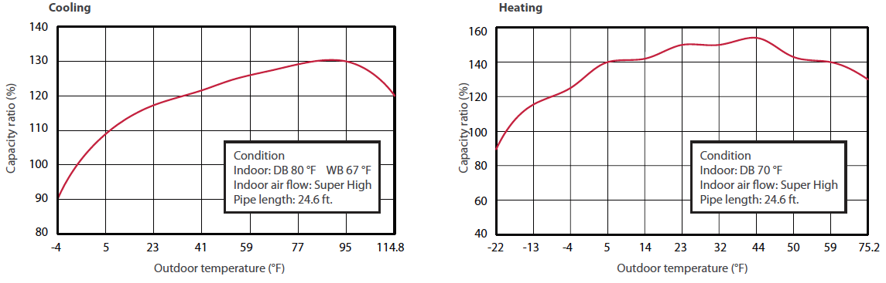

UHD12

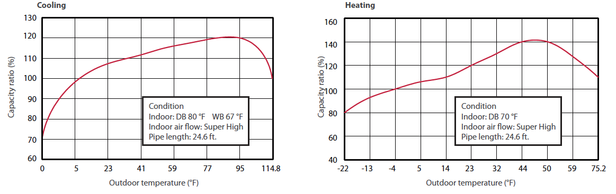

UHD18 & UHD24

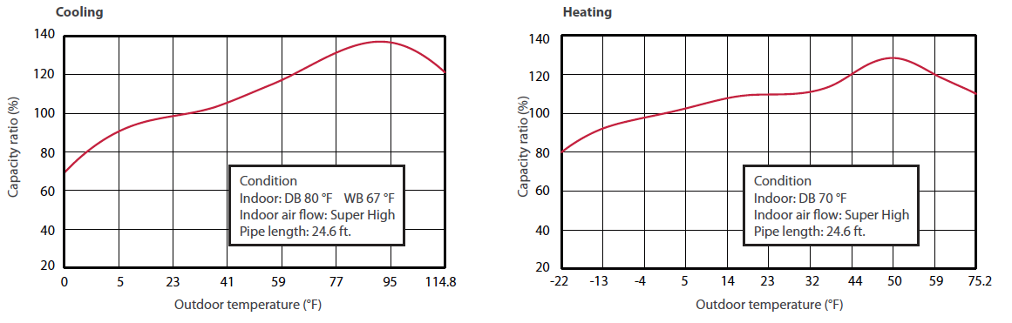
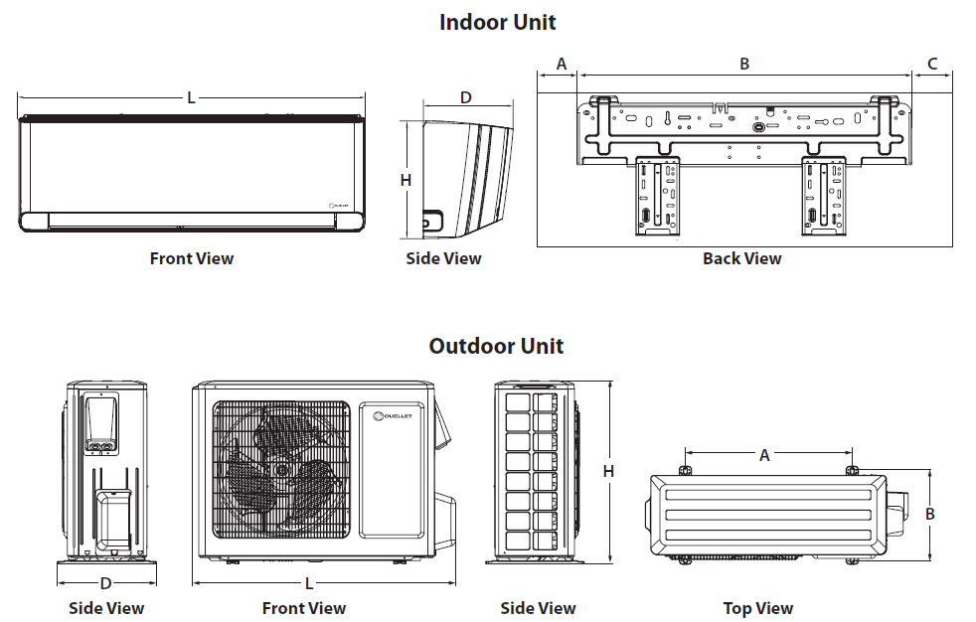

Indoor Unit | L |  | H |  | D |  | A |  | B |  | C
Indoor Unit | in. | mm | in. | mm | in. | mm | in. | mm | in. | mm | in. | mm
UHD09KCH38SB-I  UHD12KCH31S-I | 39 3/16 | 970 | 11 7/8 | 302 | 8 7/8 | 225 | 4 5/8 | 117 | 27 | 685 | 7 5/8 | 194
UHD18KCH25S-I  UHD24KCH22S-I | 43 3/8 | 1078 | 12 7/8 | 325 | 9 13/16 | 246 | 8 9/16 | 217 | 26 15/16 | 684 | 7 7/8 | 199

Outdoor Unit | L |  | H |  | D |  | A |  | B
Outdoor Unit | in. | mm | in. | mm | in. | mm | in. | mm | in. | mm
UHD09KCH38SB-O | 35 3/8 | 899 | 23 1/2 | 596 | 14 7/8 | 378 | 21 11/16 | 550 | 13 1/2 | 343
UHD12KCH31S-O
UHD18KCH25S-O | 38 5/8 | 1000 | 31 1/8 | 790 | 16 13/16 | 427 | 24 | 610 | 15 9/16 | 395
UHD24KCH22S-O

Options
See OTP Options section

Specifications may change without prior notice
Project: | Approval  Information
Consultant Engineer: | Approval  Information
Electrical Contractor: | Approval  Information
Distributor: | Approval  Information
Date: | Approval  Information
Contact at Ouellet: | Approval  Information
Comments:

