Series



OTP-H Harmony Ductless Single Zone Heat Pump
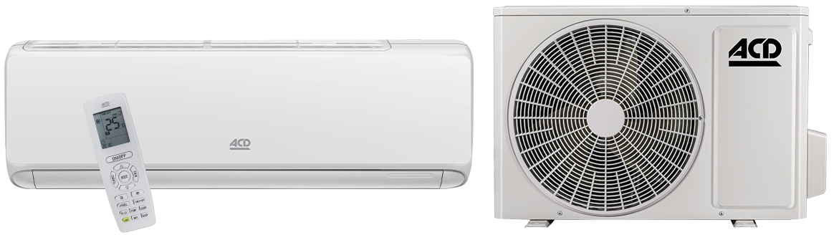
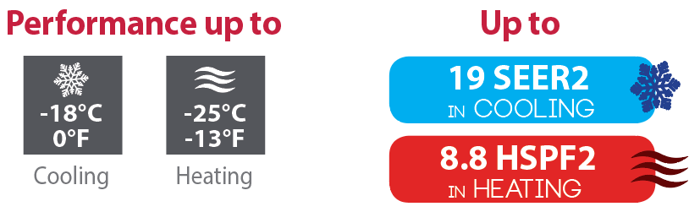

Features
Operation mode - Cooling, heating, dehumidifying, fan and auto.
Nominal capacity - 9000, 12000, 18000, 24000 BTU/hr.
Voltage - 230/208V, 60 Hz, 1-phase.
Indoor unit - High wall installation, dual side connection.
- Plastic housing, standard white.
- 7-speed cross-flow fan (auto, turbo, high, medium-high, medium, low and very low).
- Washable filters.
Outdoor unit - Variable speed rotary compressor (INVERTER), with overload protection.
- Electronic expansion valve for precise control of refrigerant flow.
- Condenser fins covered with a hydrophilic coating for improved corrosion resistance.
- Large diameter quiet axial-flow fan for more efficient heat exchange.
- Smart pan heater to prevent ice formation.
- Compressor blanket and preheating technology.
- Installation on aluminum wall bracket or ground stand (optional).
Connection piping - Minimum piping length of 10 ft. (3 m).
- Flared connections.
Control - Wireless remote included.
- Wired wall controller available.
- Wi-Fi.
- Set temperature: 16 to 30 °C (61 to 86 °F).
- Temperature display format: °C or °F.
Warranty - 10-year basic warranty on parts and 10-year basic warranty on the compressor (labour not included).
- Labour warranty (sold separately) from the 1st to 10th year, on parts and labour with system replacement if the compressor fails.
Application - Dining room-kitchen, living room, family room, commercial building, office building, condo, restaurant.
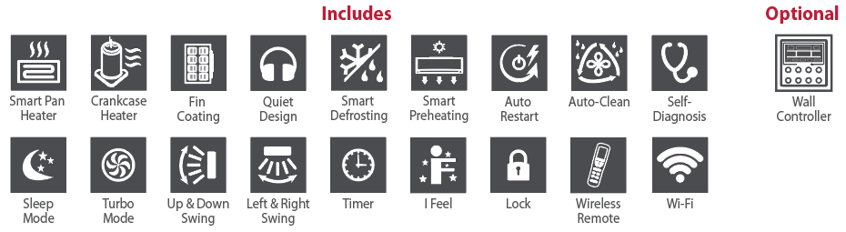

Models
Product #¹ |  |  | Indoor Unit |  |  | CHD09KCH19S-I  CHD09KCH19S-O | CHD12KCH17S-I  CHD12KCH17S-O | CHD18KCH17S-I  CHD18KCH17S-O | CHD24KCH18S-I  CHD24KCH18S-O
 |  |  | Outdoor Unit
Qty
Technical Performance
Voltage |  |  |  |  | Volts | 230/208 | 230/208 | 230/208 | 230/208
Cooling capacity |  | Nominal |  |  | W (BTU/hr) | 2667 (9100) | 3517 (12000) | 5159 (17600) | 6450 (22000)
 |  | Min. – max. |  |  | W (BTU/hr) | 820 - 3018  (2800 - 10300) | 700 - 3700  (2388 - 13307) | 1100 - 5850  (3753 - 19960) | 2000 - 7400  (6824 - 25249)
Heating capacity |  | Nominal |  |  | W (BTU/hr) | 2931 (10000) | 3517 (12000) | 5598 (19100) | 7040 (24000)
 |  | Min. – max. |  |  | W (BTU/hr) | 655 - 3575  (2200 - 12200) | 700 - 4400  (2388 - 15013) | 800 - 6600  (2730 - 22519) | 1750 - 8000  (5971 - 27296)
Used cooling power input |  | Nominal |  |  | W | 805 | 1334 | 1750 | 1896
 |  | Min. – max. |  |  | W | 180 - 1350 | 180 - 1500 | 200 - 2300 | 340 - 2350
Used heating power input |  | Nominal |  |  | W | 781 | 1004 | 1750 | 2051
 |  | Min. – max. |  |  | W | 150 -1450 | 260 - 1650 | 260 - 2300 | 370 - 2400
Used rated input |  |  |  |  | W | 1450 | 1650 | 2300 | 2400
Rated current |  |  |  |  | A | 6.5 | 6.7 | 9.5 | 12
MCA |  |  |  |  | A | 9 | 11 | 14 | 15
Max. over-current protection (MOCP) |  |  |  |  | A | 15 | 15 | 20 | 20
SEER2 (SEER) |  |  |  |  | - | 19.5 (19.5) | 17.5 (17.5) | 17.5 (17.5) | 18 (18)
HSPF2 (HSPF) |  |  |  |  | - | 8.8 (10) | 8.5 (10) | 8.5 (9) | 8.5 (10)
EER |  |  |  |  | W/W | 3.30 | 2.64 | 2.95 | 3.40
COP |  |  |  |  | W/W | 3.75 | 3.50 | 3.20 | 3.43
AHRI number |  |  |  |  | - | 210410121 | 210410122 | 210410123 | 210410124
ENERGY STAR |  |  |  |  | - | - | - | - | -
Indoor Unit
Dehumidification |  |  |  | pt/hr (l/hr) |  | 1.69 (0.80) | 2.96 (1.40) | 3.8 (1.80) | 5.28 (2.50)
Air flow volume |  |  |  | cfm |  | 353 / 282.5 / 264.8 / 229.5 /  211.86 / 194.2 / 158.8 | 424 / 353 / 324 / 277 /  247 / 224 / 182 | 618 / 512 / 471 / 436 /  395 / 336 / 283 | 677 / 588 / 559 / 500 /  471 / 441 / 412
Sound level |  |  |  | dB (A) |  | 51 / 47 / 44 / 42 /  41 / 38 / 36 | 57 / 49 / 48 / 45 /  43 / 42 / 37 | 60 / 56 / 54 / 52 /  50 / 46 / 42 | 61 / 57 / 55 / 52 /  50 / 48 / 46
Fan motor power output |  |  |  | W |  | 20 | 15 | 45 | 60
Fan motor RLA |  |  |  | A |  | 0.30 | 0.40 | 0.70 | 0.45
Deflector stepper motor power output |  |  |  | W |  | 1.5 | 1.5 | 2.5 | 2.5
Net weight |  |  |  | lb (kg) |  | 19.8 (9) | 19.8 (9) | 28.7 (13) | 33 (18)
Outdoor Unit
Air flow volume |  |  |  | m³/hr |  | 1950 | 1950 | 2520 | 3200
Sound level |  |  |  | dB (A) |  | 51 | 52 | 57 | 57
Compressor power input |  |  |  | W |  | 756 | 587 | 1295 | 1330
Compressor LRA |  |  |  | A |  | - | - | 25 | 35
Compressor RLA |  |  |  | A |  | 5.20 | 7.30 | 9.35 | 10.45
Fan motor power output |  |  |  | W |  | 30 | 30 | 30 | 60
Fan motor RLA |  |  |  | A |  | 0.4 | 0.6 | 0.9 | 0.6
Refrigerant volume (R410A) |  |  |  | oz (g) |  | 24.7 (700) | 27.5 (750) | 44.1 (1150) | 52.9 (1500)
Net weight |  |  |  | lb (kg) |  | 56.22 (25.5) | 57.33 (26) | 71.70 (32.5) | 97 (44)
Operating ambient temperature | Cooling |  |  | °C (°F) |  | -18 to 46 (0 to 115)
Operating ambient temperature | Heating |  |  | °C (°F) |  | -20 to 24 (-4 to 75)
Connection Piping/Refrigerant
Pre-charge length |  |  |  | ft. (m) |  | 25 (7.5) | 25 (7.5) | 25 (7.5) | 25 (7.5)
Additional refrigerant charge |  |  |  | oz/ft. (g/m) |  | 0.2 (20) | 0.2 (20) | 0.2 (20) | 0.5 (50)
Liquid pipe outer diameter |  |  |  | in. |  | 1/4 | 1/4 | 1/4 | 1/4
Gas pipe outer diameter |  |  |  | in. |  | 3/8 | 3/8 | 1/2 | 5/8
Maximum height difference |  |  |  | ft. (m) |  | 40 (12.2) | 40 (12.2) | 66 (20) | 82 (25)
Maximum total length |  |  |  | ft. (m) |  | 66 (20) | 66 (20) | 82 (25) | 131 (40)

¹ 1 indoor unit and 1 outdoor unit. Note that each unit is individually packaged
Capacity Variation Ratio According to Temperature

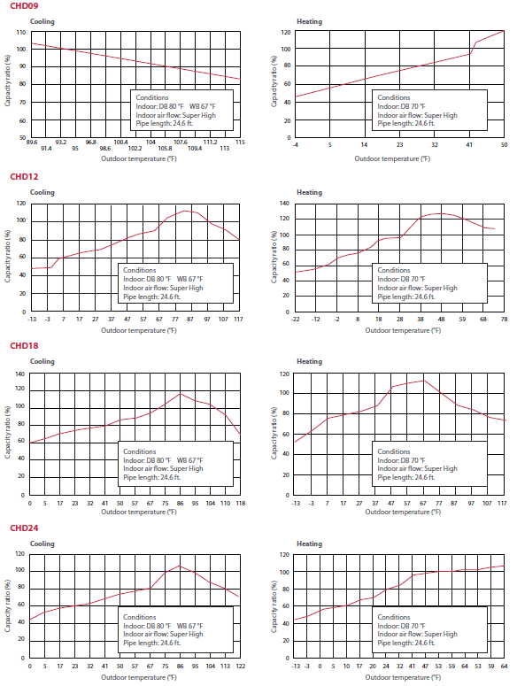

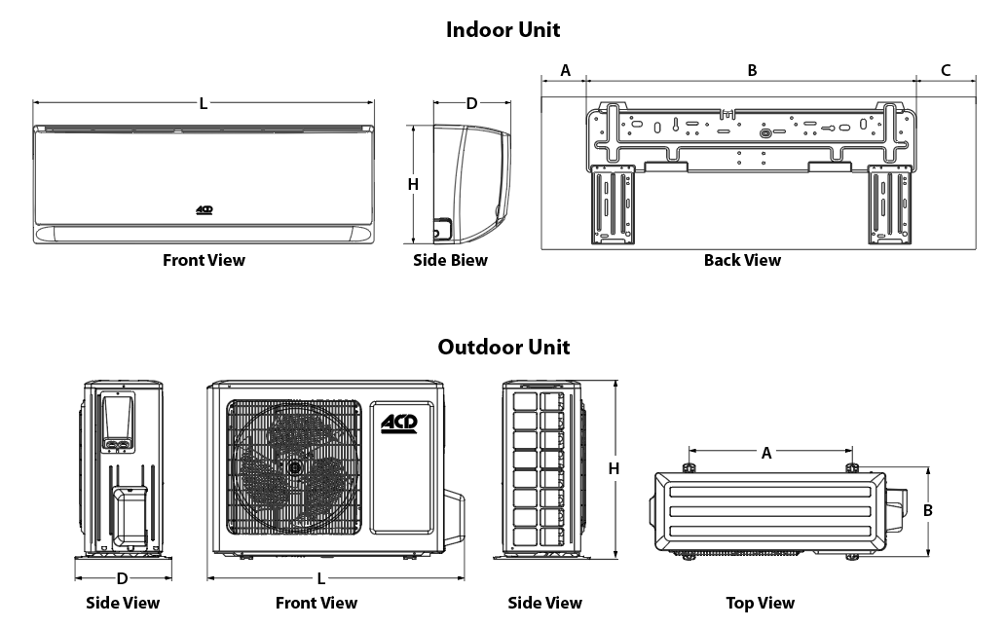

Indoor Unit | L |  | H |  | D |  | A |  | B |  | C
Indoor Unit | in. | mm | in. | mm | in. | mm | in. | mm | in. | mm | in. | mm
CHD09KCH19S-I  CHD12KCH17S-I | 32 7/8 | 835 | 10 7/8 | 275 | 7 7/8 | 200 | 7 1/16 | 119 | 18 5/32 | 542 | 7 11/16 | 184
CHD18KCH17S-I | 37 1/8 | 943 | 13 1/8 | 333 | 9 11/16 | 246 | 7 17/32 | 102 | 22 1/16 | 686 | 7 1/2 | 183
CHD24KCH18S-I | 42 7/16 | 1078 | 13 1/8 | 333 | 9 11/16 | 246 | 10 3/16 | 206 | 22 1/16 | 686 | 10 5/32 | 186

Outdoor Unit | L |  | H |  | D |  | A |  | B
Outdoor Unit | in. | mm | in. | mm | in. | in. | mm | in. | mm | in.
CHD09KCH19S-O  CHD12KCH17S-O | 28 13/16 | 732 | 21 54/64 | 555 | 13 | 330 | 17 15/16 | 540 | 12 3/16 | 286
CHD18KCH17S-O | 31 37/64 | 802 | 21 54/64 | 555 | 13 50/64 | 350 | 20 5/32 | 559 | 13 2/32 | 364
CHD24KCH18S-O | 37 3/4 | 958 | 26 | 660 | 15 53/64 | 402 | 22 13/32 | 610 | 14 19/32 | 395

Options
See OTP Options section

Specifications may change without prior notice
Project: | Approval  Information
Consultant Engineer: | Approval  Information
Electrical Contractor: | Approval  Information
Distributor: | Approval  Information
Date: | Approval  Information
Contact at Ouellet: | Approval  Information
Comments:

