Series

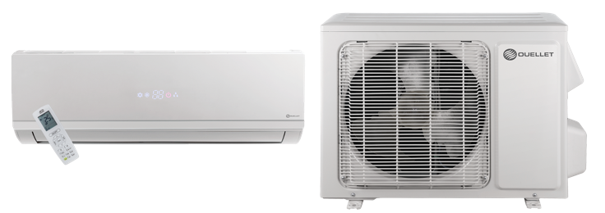
OTP-E Eagle Ductless Single Zone Heat Pump




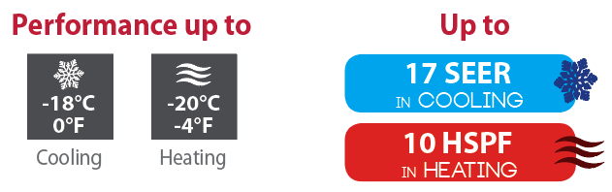

Features
Operation mode - Cooling, heating, dehumidifying, fan and auto.
Nominal capacity - 9000, 12000, 18000, 24000 BTU/hr.
Voltage - 230/208V, 60 Hz, 1-phase.
Indoor unit - High wall installation, dual side connection.
- Plastic housing, standard white.
- 4-speed cross-flow fan (auto, high, medium and low).
- Washable filters.
Outdoor unit - Variable speed rotary compressor (INVERTER), with overload protection.
- Electronic expansion valve for precise control of refrigerant flow.
- Condenser fins covered with a hydrophilic coating for improved corrosion resistance.
- Large diameter quiet axial-flow fan for more efficient heat exchange.
- Smart pan heater to prevent ice formation.
- Installation on aluminum wall bracket or ground stand (optional).
Connection piping - Minimum piping length of 10 ft. (3 m).
- External liquid pipe diameter: 1/4”.
- External gas pipe diameter: 3/8” to 5/8”.
- Flared connections.
Control - Wireless remote included.
- Wired wall controller available.
- Wi-Fi capability (option KIT-WIFI required).
- Interface (options HP6000ZB-GE and GT130 required).
- Set temperature: 16 to 30 °C (61 to 86 °F).
- Temperature display format: °C or °F.
Warranty - 10-year basic warranty on parts and 10-year basic warranty on the compressor (labour not included).
Application - Dining room-kitchen, living room, family room, commercial building, office building, condo, restaurant.
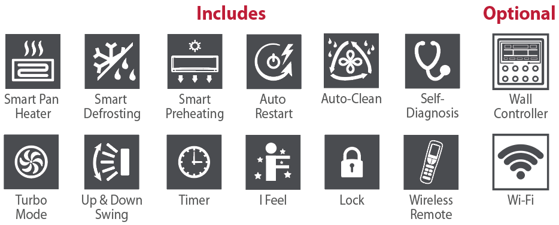

Models
Product #¹ |  |  | Indoor Unit |  |  | SED09KCH17S-I  SED09KCH17S-O | SED12KCH17S-I  SED12KCH17S-O | SED18KCH16S-I  SED18KCH16S-O | SED24KCH19S-I  SED24KCH19S-O
 |  |  | Outdoor Unit
Qty
Technical Performance
Voltage |  |  |  |  | Volts | 230/208 | 230/208 | 230/208 | 230/208
Cooling capacity |  | Nominal |  |  | W (BTU/hr) | 2667 (9100) | 3517 (12000) | 5100 (17400) | 6450 (22000)
 |  | Min. – max. |  |  | W (BTU/hr) | 720 - 2814  (2457 - 9600) | 300 - 3700  (1024 - 12624) | 1200 - 5800  (4094 - 20000) | 1730 - 7400  (5900 - 25200)
Heating capacity |  | Nominal |  |  | W (BTU/hr) | 2784 (9500) | 3810 (13000) | 5275 (18000) | 7034 (24000)
 |  | Min. – max. |  |  | W (BTU/hr) | 720 – 3371  (2457 - 11500) | 700 - 4000  (2388 - 13648) | 1200 – 6200  (4100 - 21000) | 1310 - 7600  (4500 - 25900)
Used cooling power input |  | Nominal |  |  | W | 889 | 1297 | 2040 | 1950
 |  | Min. – max. |  |  | W | 185 - 1100 | 180 - 1500 | 200 - 2300 | 360 - 3000
Used heating power input |  | Nominal |  |  | W | 774 | 1172 | 1758 | 2070
 |  | Min. – max. |  |  | W | 170-1350 | 260 - 1450 | 300 - 2400 | 330 - 2900
Used rated input |  |  |  |  | W | 1350 | 1500 | 2400 | 2900
Rated current |  |  |  |  | A | 6.3 | 6.5 | 10 | 11
MCA |  |  |  |  | A | 10 | 9 | 15 | 19
Max. over-current protection (MOCP) |  |  |  |  | A | 15 | 15 | 20 | 30
SEER |  |  |  |  | - | 17 | 17 | 16 | 19
HSPF |  |  |  |  | - | 9 | 9 | 9 | 10
EER |  |  |  |  | W/W | 3 | 2.71 | 2.5 | 3.31
COP |  |  |  |  | W/W | 3.6 | 3.25 | 3 | 3.4
AHRI number |  |  |  |  | - | 205782700 | 205782701 | 205782702 | 205782703
Indoor Unit
Dehumidification |  |  |  | pt/hr (l/hr) |  | 1.69 (0.80) | 2.96 (1.4) | 3.8 (1.80) | 4.23 (2.00)
Air flow volume |  | T / H / M / L2 |  | cfm |  | 294 / 271 / 235 / 182 | 371 / 294 / 235 / 182 | 471 / 412 / 383 / 335 | 677 / 588 / 471 / 412
Sound level |  | T / H / M / L2 |  | dB (A) |  | 49 / 47 / 43 / 36 | 52 / 49 / 44 / 38 | 57 / 54 / 50 / 45 | 59 / 55 / 51 / 47
Fan motor power output |  |  |  | W |  | 20 | 20 | 60 | 30
Fan motor RLA |  |  |  | A |  | 0.22 | 0.31 | 0.4 | 0.55
Deflector stepper motor power output |  |  |  | W |  | 1.5 | 1.5 | 2.5 | 2.5
Net weight |  |  |  | lb (kg) |  | 19.8 (9) | 22 (10) | 30 (13.5) | 37.5 (17)
Outdoor Unit
Air flow volume |  |  |  | cfm |  | - | - | - | -
Sound level |  |  |  | dB (A) |  | 60 | 60 | 66 | 69
Compressor power input |  |  |  | W |  | 790 | 1023 | 1440 | 1635
Compressor LRA |  |  |  | A |  | 18 | 18 | 25 | 25
Compressor RLA |  |  |  | A |  | 6.6 | 6.6 | 10.2 | 13
Fan motor power output |  |  |  | W |  | 30 | 30 | 60 | 60
Fan motor RLA |  |  |  | A |  | 0.37 | 0.37 | 0.7 | 0.65
Refrigerant volume (R410A) |  |  |  | oz (g) |  | 24 (680) | 28.2 (800) | 42.3 (1200) | 52.9 (1500)
Net weight |  |  |  | lb (kg) |  | 58.4 (26.5) | 63 (28.5) | 87 (39.5) | 97 (44)
Operating ambient temperature | Cooling |  |  | °C (°F) |  | -18 to 46 (0 to 115)
Operating ambient temperature | Heating |  |  | °C (°F) |  | -20 to 24 (-4 to 75)
Connection Piping/Refrigerant
Pre-charge length |  |  |  | ft. (m) |  | 25 (7.5) | 25 (7.5) | 25 (7.5) | 25 (7.5)
Additional refrigerant charge |  |  |  | oz/ft. (g/m) |  | 0.2 (20) | 0.2 (20) | 0.2 (20) | 0.5 (50)
Liquid pipe outer diameter |  |  |  | in. |  | 1/4 | 1/4 | 1/4 | 1/4
Gas pipe outer diameter |  |  |  | in. |  | 3/8 | 3/8 | 1/2 | 5/8
Maximum height difference |  |  |  | ft. (m) |  | 33 (10) | 33 (10) | 33 (10) | 33 (10)
Maximum total length |  |  |  | ft. (m) |  | 49 (15) | 66 (20) | 82 (25) | 82 (25)

¹ 1 indoor unit and 1 outdoor unit. Note that each unit is individually packaged.
² Cross-Flow Fan Speeds: (T) Turbo / (H) High / (M) Medium / (L) Low.

Capacity Variation Ratio According to Temperature

SED09
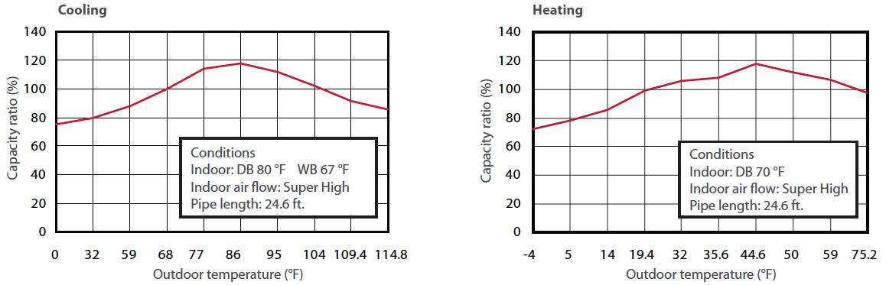
SED12
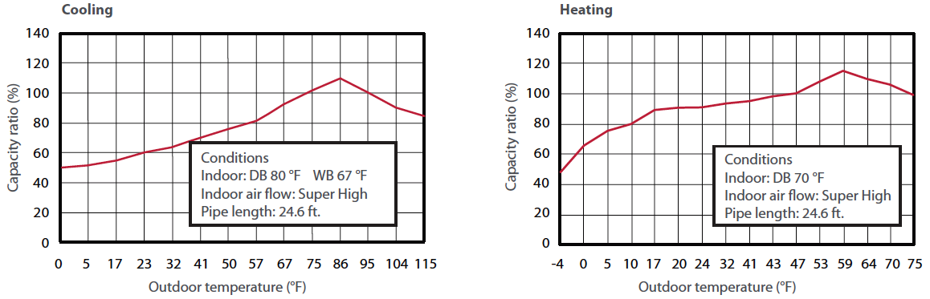
SED18
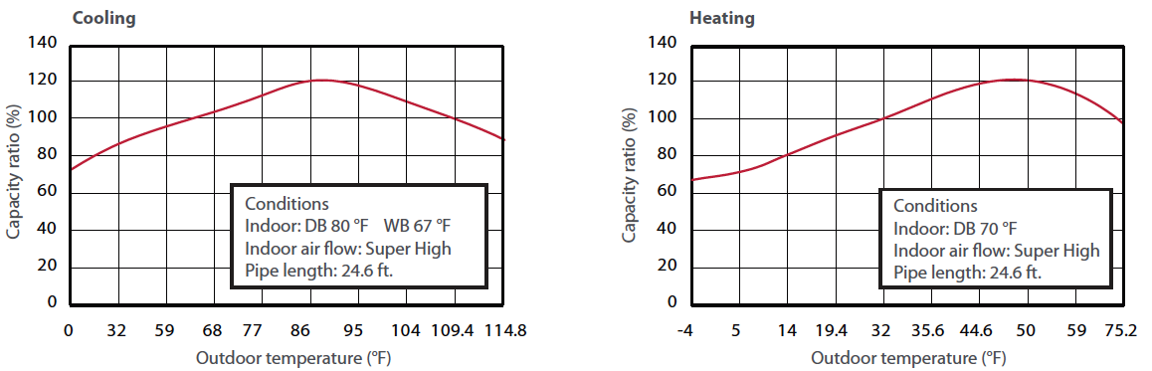
SED24

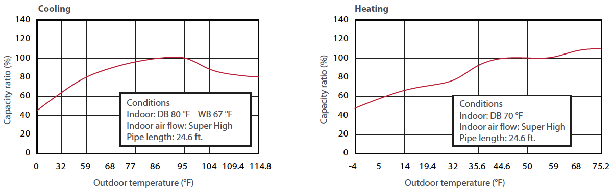
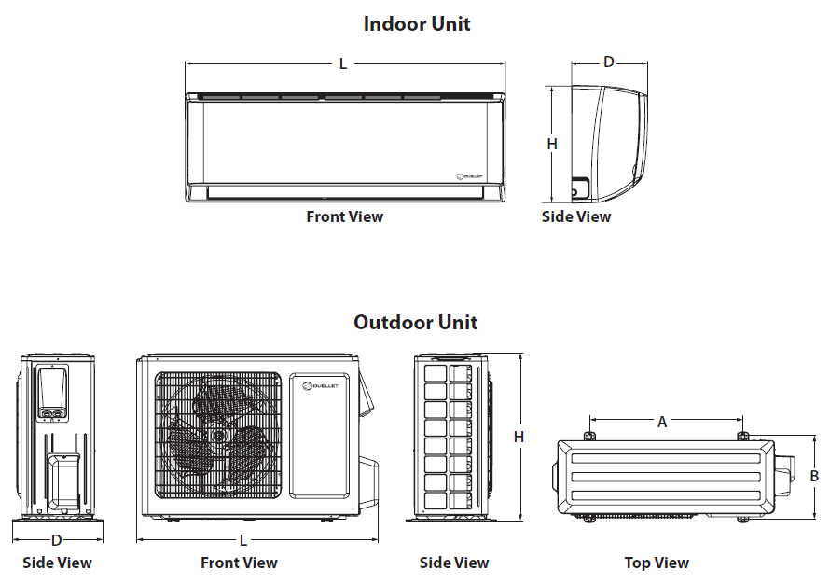

Indoor Unit | L |  | H |  | D
Indoor Unit | in. | mm | in. | mm | in. | mm
SED09KCH17S-I | 31 1/8 | 790 | 10 13/16 | 275 | 7 7/8 | 200
SED12KCH17S-I | 33 1/4 | 845 | 11 3/8 | 289 | 7 7/8 | 209
SED18KCH16S-I | 38 3/16 | 970 | 11 13/16 | 300 | 8 13/16 | 224
SED24KCH19S-I | 42 7/16 | 1078 | 12 13/16 | 325 | 9 11/16 | 246

Outdoor Unit | L |  | H |  | D |  | A |  | B
Outdoor Unit | in. | mm | in. | mm | in. | mm | in. | mm | in. | mm
SED09KCH17S-O | 30 13/16 | 782 | 21 1/4 | 540 | 12 5/8 | 320 | 21 1/4 | 540 | 11 1/4 | 286
SED12KCH17S-O | 30 13/16 | 782 | 21 1/4 | 540 | 12 5/8 | 320 | 21 1/4 | 540 | 11 1/4 | 286
SED18KCH16S-O | 35 15/16 | 912 | 25 7/16 | 646 | 14 11/16 | 373 | 22 | 559 | 14 5/16 | 364
SED24KCH19S-O | 38 9/16 | 980 | 31 1/8 | 790 | 16 13/16 | 427 | 24 | 610 | 15 9/16 | 395

Options
See OTP Options section

Specifications may change without prior notice
Project: | Approval  Information
Consultant Engineer: | Approval  Information
Electrical Contractor: | Approval  Information
Distributor: | Approval  Information
Date: | Approval  Information
Contact at Ouellet: | Approval  Information
Comments:

