Series

OTP-C Champagne Ductless Single Zone Heat Pump
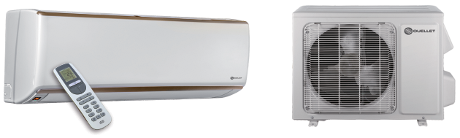


(except
OCD30 & OCD36)
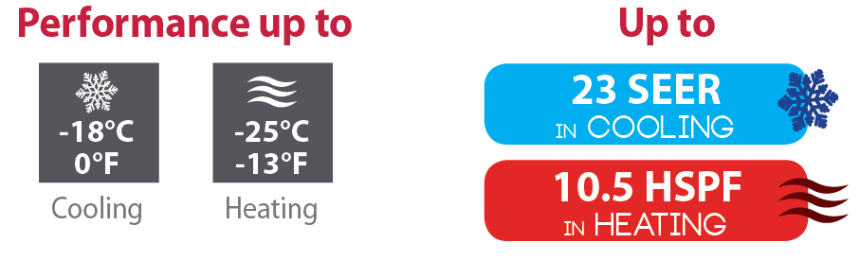


Features
Operation mode - Cooling, heating, dehumidifying, fan and auto.
Nominal capacity - 9000, 12000, 15000, 18000, 24000, 30000, 36000 BTU/hr.
Voltage - 230/208V, 60 Hz, 1-phase.
Indoor unit - High wall installation, dual side connection.
- Plastic housing, standard white.
- 4-speed cross-flow fan (turbo, high, medium and low).
- Washable filters.
Outdoor unit - Variable speed rotary compressor (INVERTER), with overload protection.
- Electronic expansion valve for precise control of refrigerant flow.
- Condenser fins covered with a hydrophilic coating for improved corrosion resistance.
- Large diameter quiet axial-flow fan for more efficient heat exchange.
- Smart pan heater to prevent ice formation.
- Compressor blanket and preheating technology.
- Installation on aluminum wall bracket or ground stand (optional).
Connection piping - Minimum piping length of 10 ft. (3 m).
- Flared connections.
Control - Wireless remote included.
- Wired wall controller available.
- Wi-Fi capability (option KIT-WIFI required).
- Interface (options HP6000ZB-GE and GT130 required).
- Set temperature: 16 to 30 °C (61 to 86 °F).
- Temperature display format: °C or °F.
Warranty - 10-year basic warranty on parts and 10-year basic warranty on the compressor (labour not
included).
Application - Dining room-kitchen, living room, family room, commercial building, office building, condo,
restaurant.

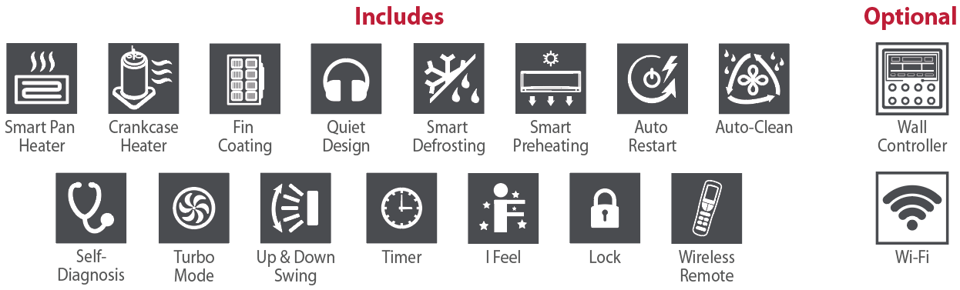

OCD09, OCD12, OCD15, OCD18 Models
Product #¹ |  |  | Indoor Unit |  |  | OCD09KCH23S-I  OCD09KCH23S-O | OCD12KCH22S-I  OCD12KCH22S-O | OCD15KCH20S-I  OCD15KCH20S-O | OCD18KCH20S-I  OCD18KCH20S-O
 |  |  | Outdoor Unit
Qty
Technical Performance
Voltage |  |  |  |  | Volts | 230/208 | 230/208 | 230/208 | 230/208
Cooling capacity |  | Nominal |  |  | W (BTU/hr) | 2638 (9000) | 3517 (12000) | 4400 (15000) | 5275 (18000)
 |  | Min. – max. |  |  | W (BTU/hr) | 909 - 2813 (3100 - 9600) | 909 - 3810 (3100 - 13000) | 2000 - 5860 (6800 - 20000) | 1993 - 5861  (6800 - 20000)
Heating capacity |  | Nominal |  |  | W (BTU/hr) | 3224 (11000) | 3810 (13000) | 4700 (16000) | 5803 (19800)
 |  | Min. – max. |  |  | W (BTU/hr) | 560 - 3517 (1911 - 12000) | 703 - 4103 (2400 - 14000) | 2150 - 6890 (7340 - 23500) | 2151 - 6887  (7340 - 23500)
Used cooling power input |  | Nominal |  |  | W | 630 | 960 | 1189 | 1435
 |  | Min. – max. |  |  | W | 160 - 1300 | 200 - 1350 | 750 - 2150 | 450 - 2150
Used heating power input |  | Nominal |  |  | W | 1020 | 1100 | 1382 | 1730
 |  | Min. – max. |  |  | W | 160-1350 | 400 - 1400 | 580 - 2600 | 580 - 2600
Used rated input |  |  |  |  | W | 1350 | 1400 | 3000 | 3000
Rated current |  |  |  |  | A | 6 | 6.3 | 12.56 | 12.56
MCA |  |  |  |  | A | 9 | 9 | 16 | 16
Max. over-current protection (MOCP) |  |  |  |  | A | 15 | 15 | 25 | 25
SEER |  |  |  |  | - | 23 | 22 | 20 | 20
HSPF |  |  |  |  | - | 10.5 | 11 | 11 | 10
EER |  |  |  |  | W/W | 4.19 | 3.66 | 3.7 | 3.68
COP |  |  |  |  | W/W | 3.16 | 3.46 | 3.4 | 3.35
AHRI number |  |  |  |  | - | 201863350 | 201863351 | - | 201863352
ENERGY STAR |  |  |  |  | - | ✓ | ✓ | ✓ | ✓
Indoor Unit
Dehumidification |  |  |  | pt/hr (l/hr) |  | 1.69 (0.80) | 2.96 (1.4) | 3.8 (1.8) | 3.8 (1.80)
Air flow volume |  | T / H / M / L2 |  | cfm |  | 377 / 288 / 241 / 170 | 400 / 288 / 241 / 171 | 559 / 488 / 412 / 335 | 559 / 488 / 412 / 335
Sound level |  | T / H / M / L2 |  | dB (A) |  | 43 / 39 / 35 / 29 | 45 / 39 / 35 / 29 | 49 / 44 / 41 / 36 | 47 / 43 / 40 / 39
Fan motor power output |  |  |  | W |  | 20 | 20 | 60 | 60
Fan motor RLA |  |  |  | A |  | 0.09 | 0.09 | 0.24 | 0.24
Deflector stepper motor power output |  |  |  | W |  | 1.5 | 1.5 | 2.5 | 2.5
Net weight |  |  |  | lb (kg) |  | 22 (10) | 22 (10) | 30 (13.5) | 28 (12.5)
Outdoor Unit
Air flow volume |  |  |  | cfm |  | 1800 | 2000 | 3200 | 3200
Sound level |  |  |  | dB (A) |  | 53 | 54 | 58 | 55
Compressor power input |  |  |  | W |  | 845 | 845 | 1440 | 1440
Compressor LRA |  |  |  | A |  | - | - | 25 | 25
Compressor RLA |  |  |  | A |  | 4 | 4 | 12.08 | 12.08
Fan motor power output |  |  |  | W |  | 30 | 30 | 60 | 60
Fan motor RLA |  |  |  | A |  | - | 0.36 | 0.49 | 0.49
Refrigerant volume (R410A) |  |  |  | oz (g) |  | 45.9 (1301) | 47.6 (1349) | 56.44 (1600) | 56.44 (1600)
Net weight |  |  |  | lb (kg) |  | 78 (35.5) | 86 (39) | 106 (48) | 106 (48)
Operating ambient temperature | Cooling |  |  | °C (°F) |  | -18 to 46 (0 to 115)
Operating ambient temperature | Heating |  |  | °C (°F) |  | -25 to 24 (-13 to 75)
Connection Piping/Refrigerant
Pre-charge length |  |  |  | ft. (m) |  | 25 (7.5) | 25 (7.5) | 25 (7.5) | 25 (7.5)
Additional refrigerant charge |  |  |  | oz/ft. (g/m) |  | 0.2 (20) | 0.2 (20) | 0.2 (20) | 0.2 (20)
Liquid pipe outer diameter |  |  |  | in. |  | 1/4 | 1/4 | 1/4 | 1/4
Gas pipe outer diameter |  |  |  | in. |  | 3/8 | 1/2 | 5/8 | 5/8
Maximum height difference |  |  |  | ft. (m) |  | 33 (10) | 33 (10) | 33 (10) | 33 (10)
Maximum total length |  |  |  | ft. (m) |  | 49 (15) | 66 (20) | 82 (25) | 82 (25)

¹ 1 indoor unit and 1 outdoor unit. Note that each unit is individually packaged.
² Cross-Flow Fan Speeds: (T) Turbo / (H) High / (M) Medium / (L) Low.

OCD24, OCD30, OCD36 Models
Product #¹ |  |  | Indoor Unit |  |  | OCD24KCH20S-I  OCD24KCH20S-O | OCD30KCH18S-I  OCD30KCH18S-O | OCD36KCH18S-I  OCD36KCH18S-O
 |  |  | Outdoor Unit |  |  | OCD24KCH20S-I  OCD24KCH20S-O | OCD30KCH18S-I  OCD30KCH18S-O | OCD36KCH18S-I  OCD36KCH18S-O
Qty
Voltage |  |  |  |  | Volts | 230/208 | 230/208 | 230/208
Cooling capacity |  | Nominal |  |  | W (BTU/hr) | 6448 (22000) | 8200 (28000) | 9850 (33600)
 |  | Min. – max. |  |  | W (BTU/hr) | 2000 - 8000 (6824 - 27296) | 2780 - 8800 (9485 - 30026) | 2170 - 10550 (7404 - 35997)
Heating capacity |  | Nominal |  |  | W (BTU/hr) | 6741 (23000) | 8320 (28400) | 10140 (34600)
 |  | Min. – max. |  |  | W (BTU/hr) | 2000 - 9000 (6824 - 30708) | 2930 - 9670 (9997 - 32994) | 4390 - 10550 (14979 - 35997)
Used cooling power input |  | Nominal |  |  | W | 1760 | 2700 | 4100
 |  | Min. – max. |  |  | W | 450 - 3000 | 600 - 3900 | 450 - 4300
Used heating power input |  | Nominal |  |  | W | 2000 | 2800 | 3800
 |  | Min. – max. |  |  | W | 450 - 3000 | 650 - 4000 | 560 - 4300
Used rated input |  |  |  |  | W | 3000 | 4000 | 4300
Rated current |  |  |  |  | A | 14.5 | 17 | 20
MCA |  |  |  |  | A | 20 | 20 | 24
Max. over-current protection (MOCP) |  |  |  |  | A | 30 | 30 | 40
SEER |  |  |  |  | - | 20 | 18 | 18
HSPF |  |  |  |  | - | 10 | 9 | 9
EER |  |  |  |  | W/W | 3.66 | 3.04 | 2.4
COP |  |  |  |  | W/W | 3.37 | 2.97 | 2.67
AHRI number |  |  |  |  | - | 201863353 | 202110509 | 202110510
ENERGY STAR |  |  |  |  | - | ✓ | - | -
Indoor Unit
Dehumidification |  |  |  | pt/hr (l/hr) |  | 4.23 (2.00) | 6.34 (3.00) | 7.4 (3.5)
Air flow volume |  | T / H / M / L2 |  | cfm |  | 706 / 647 / 589 / 530 | 706 / 618 / 530 / 412 | 736 / 647 / 530 / 412
Sound level |  | T / H / M / L2 |  | dB (A) |  | 48 / 44 / 40 / 36 | - | -
Fan motor power output |  |  |  | W |  | 60 | 70 | 70
Fan motor RLA |  |  |  | A |  | 0.38 | 0.4 | 0.4
Deflector stepper motor power output |  |  |  | W |  | 2.5 | 1.5 | 1.5
Net weight |  |  |  | lb (kg) |  | 34 (15.5) | 42 (19) | 42 (19)
Outdoor Unit
Air flow volume |  |  |  | cfm |  | 4000 | 4000 | 4400
Sound level |  |  |  | dB (A) |  | 59 | 62 | 65
Compressor power input |  |  |  | W |  | 2550 | 2450 | 3010
Compressor LRA |  |  |  | A |  | 25 | 4 | 67
Compressor RLA |  |  |  | A |  | 11.5 | 13.45 | 17.5
Fan motor power output |  |  |  | W |  | 92 | 120 | 170
Fan motor RLA |  |  |  | A |  | 0.65 | 0.45 | 0.73
Refrigerant volume (R410A) |  |  |  | oz (g) |  | 77.6 (2200) | 84.66 (2.4) | 91.71 (2.6)
Net weight |  |  |  | lb (kg) |  | 142 (65.5) | 154.5 (70) | 161 (73)
Operating ambient temperature | Cooling |  |  | °C (°F) |  | -18 to 46 (0 to 115)
Operating ambient temperature | Heating |  |  | °C (°F) |  | -25 to 24 (-13 to 75)
Pre-charge length |  |  |  | ft. (m) |  | 25 (7.5) | 25 (7.5) | 25 (7.5)
Additional refrigerant charge |  |  |  | oz/ft. (g/m) |  | 0.5 (50) | 0.5 (50) | 0.5 (50)
Liquid pipe outer diameter |  |  |  | in. |  | 1/4 | 1/4 | 1/4
Gas pipe outer diameter |  |  |  | in. |  | 5/8 | 5/8 | 5/8
Maximum height difference |  |  |  | ft. (m) |  | 33 (10) | 33 (10) | 33 (10)
Maximum total length |  |  |  | ft. (m) |  | 82 (25) | 98 (30) | 98 (30)

¹ 1 indoor unit and 1 outdoor unit. Note that each unit is individually packaged.
² Cross-Flow Fan Speeds: (T) Turbo / (H) High / (M) Medium / (L) Low.

Capacity Variation Ratio According to Temperature

OCD09 & OCD12
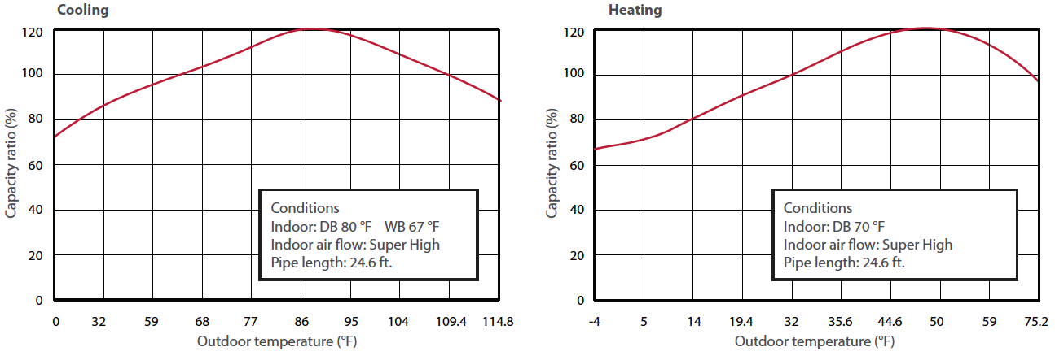

OCD15, OCD18 & OCD24
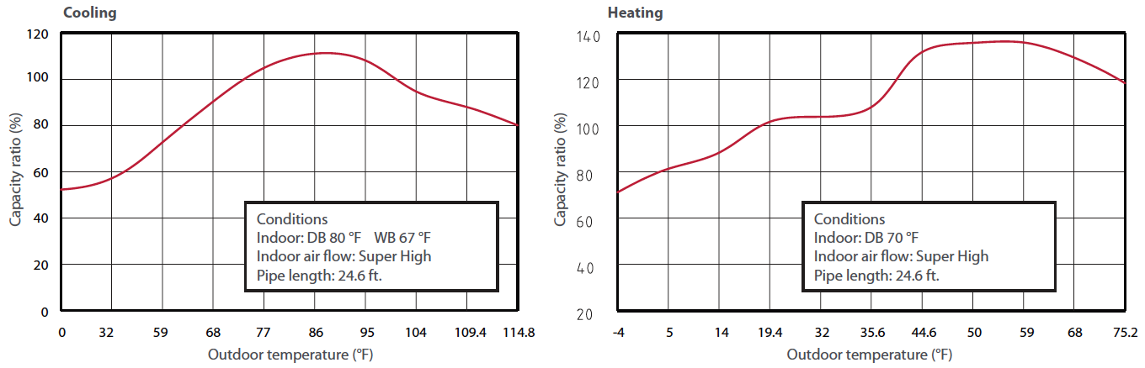

OCD30 & OCD36
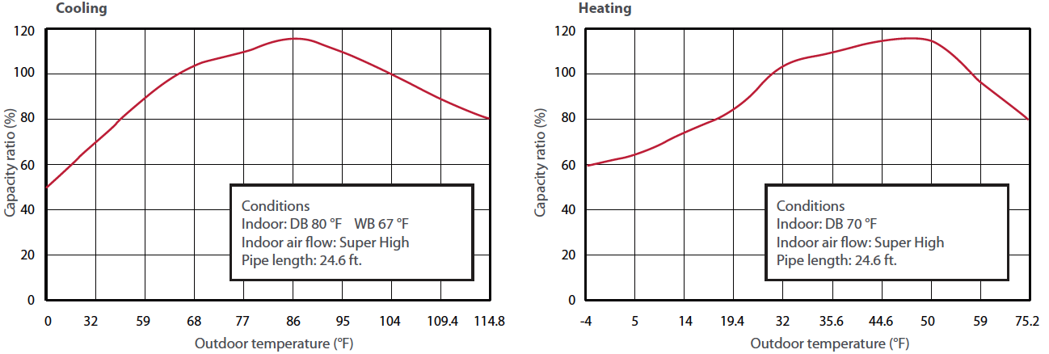

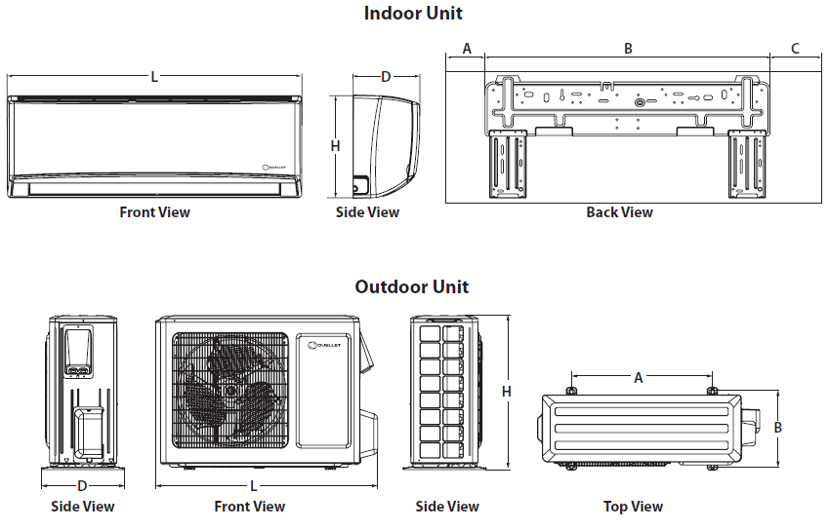

Indoor Unit | L |  | H |  | D |  | A |  | B |  | C
Indoor Unit | in. | mm | in. | mm | in. | mm | in. | mm | in. | mm | in. | mm
OCD09KCH23S-I  OCD12KCH22S-I | 33 1/4 | 845 | 11 3/8 | 289 | 8 1/4 | 209 | 4 11/16 | 119 | 21 5/16 | 542 | 7 1/4 | 184
OCD15KCH20S-I | 38 3/16 | 970 | 11 13/16 | 300 | 8 13/16 | 224 | 4 | 102 | 27 | 686 | 7 3/16 | 183
OCD18KCH20S-I | 38 3/16 | 970 | 11 13/16 | 300 | 8 13/16 | 224 | 4 | 102 | 27 | 686 | 7 3/16 | 183
OCD24KCH20S-I | 42 7/16 | 1078 | 12 13/16 | 325 | 9 11/16 | 246 | 8 1/8 | 206 | 27 | 686 | 7 5 /16 | 186
OCD30KCH18S-I | 53 1/8 | 1350 | 12 13/16 | 325 | 9 31/32 | 253 | 8 1/8 | 206 | 27 | 686 | 7 5 /16 | 186
OCD36KCH18S-I | 53 1/8 | 1350 | 12 13/16 | 325 | 9 31/32 | 253 | 8 1/8 | 206 | 27 | 686 | 7 5 /16 | 186

Outdoor Unit | L |  | H |  | D |  | A |  | B
Outdoor Unit | in. | mm | in. | mm | in. | in. | mm | in. | mm | in.
OCD09KCH23S-O | 33 3/8 | 848 | 21 1/4 | 540 | 12 5/8 | 320 | 21 1/4 | 540 | 11 1/4 | 286
OCD12KCH22S-O | 33 3/8 | 848 | 23 5/16 | 592 | 12 5/8 | 320 | 21 1/4 | 540 | 11 1/4 | 286
OCD15KCH20S-O | 37 5/8 | 955 | 27 9/16 | 700 | 15 9/16 | 396 | 22 | 559 | 14 5/16 | 364
OCD18KCH20S-O | 37 5/8 | 955 | 27 9/16 | 700 | 15 9/16 | 396 | 22 | 559 | 14 5/16 | 364
OCD24KCH20S-O | 38 9/16 | 980 | 31 1/8 | 790 | 16 13/16 | 427 | 24 | 610 | 15 9/16 | 395
OCD30KCH18S-O | 38 9/16 | 980 | 31 1/8 | 790 | 16 13/16 | 427 | 24 | 610 | 15 9/16 | 395
OCD36KCH18S-O | 38 9/16 | 980 | 31 1/8 | 790 | 16 13/16 | 427 | 24 | 610 | 15 9/16 | 395

Options
See OTP Options section

Specifications may change without prior notice
Project: | Approval  Information
Consultant Engineer: | Approval  Information
Electrical Contractor: | Approval  Information
Distributor: | Approval  Information
Date: | Approval  Information
Contact at manufacturer: | Approval  Information
Comments:

