Series
OTM Floor Heating Cable on Mat

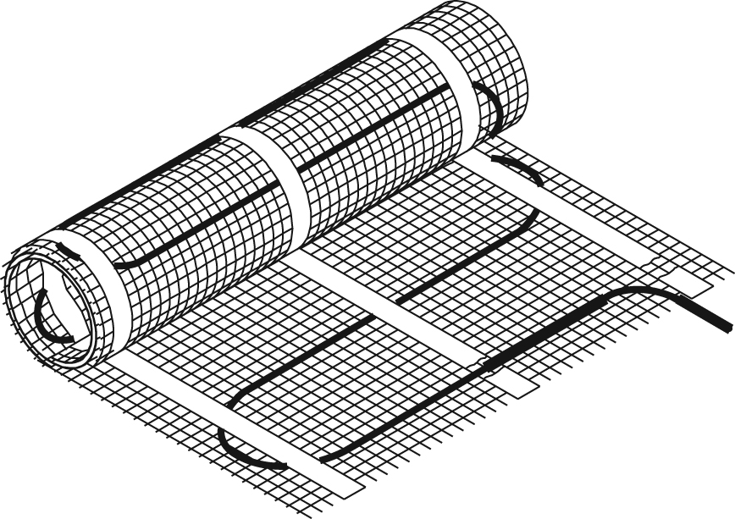

Features
Voltage - 120V, 240/208V, 1-phase.
Cold lead length - 10’ (3 m).
Construction - Heating cable made of a twin conductor fastened to an adhesive fibreglass mat for a simpler and faster installation with negligible magnetic field.
Watt density - 12W/sq. ft. (130W/sq. m), 3” (76 mm) spacing.
Dimension - Mats of 18 in. (0.46 m) in width offered in several lengths.
Control - Two types of control method possible (see instruction manual for details):
• Surface heating control with electronic thermostat in floor mode (F)
and temperature sensor.
• Ambient heating control with electronic thermostat in ambient mode
with floor limit (A or AF) and temperature sensor.
Note: A ground fault circuit interrupter (GFCI) must be used with this heating device
unless exempted by the applicable national and/or local electrical code for the area of installation.
Included materials - 15' (4.6 m) ﬂoor sensor.
- Measurements table label (to be placed in electrical panel).
Installation - Never cut or shorten the heating cable.
- For indoor applications only.
- On concrete slab or plywood subfloor.
Warranty - 25-year warranty on the heating cable.
Application - Kitchen, bathroom, entrance way, family room, living room.

Models
Product #  240/208V | Qty | Product #  120V | Qty | Cable Diameter (mm) | Covered Surface¹  Spacing 3” (76 mm) |  | Length |  | Weight |  | Watts
 |  |  |  |  | sq. ft. | sq. m | ft. in. | m | lb | kg | Watts
- | - | FHM120-60 |  | 3.2 | 5 | 0.5 | 3’ 4’’ | 0.9 | 2.0 | 0.9 | 60
FHM240-120 | - | FHM120-120 |  | 3.2 | 10 | 0.9 | 6’ 8’’ | 1.8 | 2.0 | 0.9 | 120
- | - | FHM120-180 |  | 3.2 | 15 | 1.4 | 10’ | 3.0 | 3.0 | 1.4 | 180
FHM240-240 |  | FHM120-240 |  | 3.2 | 20 | 1.9 | 13’ 4’’ | 4 | 3.0 | 1.4 | 240
- | - | FHM120-300 |  | 3.2 | 25 | 2.4 | 16’ 8’’ | 4.9 | 4.0 | 1.8 | 300
FHM240-360 |  | FHM120-360 |  | 3.2 | 30 | 2.8 | 20’ | 6.1 | 4.0 | 1.8 | 360
- | - | FHM120-420 |  | 3.2 | 35 | 3.3 | 23’ 4’’ | 7 | 5.0 | 2.3 | 420
FHM240-480 |  | FHM120-480 |  | 3.2 | 40 | 3.8 | 26’ 8’’ | 7.9 | 5.0 | 2.3 | 480
- | - | FHM120-540 |  | 3.2 | 45 | 4.2 | 30’ | 9.2 | 6.0 | 2.7 | 540
FHM240-600 |  | FHM120-600 |  | 3.2 | 50 | 4.7 | 33’ 4’’ | 10.1 | 7.0 | 3.2 | 600
FHM240-720 |  | FHM120-720 |  | 3.2 | 60 | 5.6 | 40’ | 12.2 | 7.0 | 3.2 | 720
FHM240-840 |  | FHM120-840 |  | 3.2 | 70 | 6.5 | 46’ 8’’ | 14.0 | 9.0 | 4.1 | 840
FHM240-960 |  | FHM120-960 |  | 3.2 | 80 | 7.4 | 53’ 4’’ | 16.2 | 10.0 | 4.5 | 960
FHM240-1080 |  | - | - | 3.2 | 90 | 8.4 | 60’ | 18.3 | 11.0 | 5.0 | 1080
FHM240-1200 |  | - | - | 3.2 | 100 | 9.3 | 66’ 8’’ | 20.1 | 11.0 | 5.0 | 1200
FHM240-1440 |  | - | - | 3.2 | 120 | 11.2 | 80’ | 24.4 | 13.0 | 5.9 | 1440

¹Does not represent the surface of the room but rather the surface covered by the floor heating system, excluding the fixtures and other spaces to consider.
208V = 75% of wattage at 240V.
15' (4.6 m) floor sensor and 10' (3 m) cold lead included.
The color of the mesh may be different.

Options
Product #  Kit | Description | Qty
OTM-CC | CableCheck - Electrical fault indicator
OTM-SA | Adhesive spray to secure the mat on concrete slab, 16.75 oz (474 g)
KIT-SP1 | Repair kit
KIT-CBL-SN | 15 ft. (4.6 m) floor sensor

Electronic Thermostats for Floor Heating System
Product # | Description | Qty | Amp. | Volts | Protection
OTH3600-GA² | Non programmable electronic thermostat  for floor heating system |  | 15 | 120/208/240 | Class A  GFCI 5 mA¹
OTH3600P-GA² | Programmable electronic thermostat  for floor heating system |  | 15 | 120/208/240 | Class A  GFCI 5 mA¹
OTH3600-GA-GT² | Wireless communication programmable electronic thermostat  for floor heating system |  | 15 | 120/208/240 | Class A  GFCI 5 mA¹

Slave Unit for Floor Heating System
Product # | Description | Qty | Amp. | Volts | Protection
TR1310-120-240GA³ | Slave unit for floor heating system |  | 15 | 120/208/240 | Class A  GFCI 5 mA¹

¹ GFCI: Ground fault circuit interrupter.
² 15’ (4.6 m) floor sensor included.
³ Compatible with OTH3600P-GA and OTH3600-GA-GT only, not compatible with the non programmable thermostat OTH3600-GA.
Standard color is white.

Others
Type | Quantity | Model et description  Complementary informations | Volts | Phase | Watts | Length  mm/in. | Informations  Color/installation

Specifications may change without prior notice
Project: | Approval  Information
Consultant Engineer: | Approval  Information
Eectrician Contractor: | Approval  Information
Distributor: | Approval  Information
Date: | Approval  Information
Contact in Ouellet: | Approval  Information
Comments:

