Series
OSM-VD VERDEdriTM Slim Profile High Velocity Hand Dryer


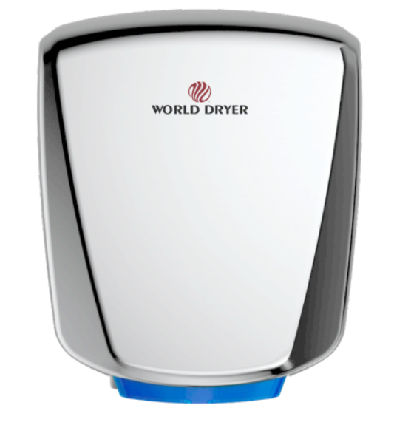

Features
Color - Standard: white.
- Optional: black, brushed stainless steel.
Voltage - Universal voltage 110 to 277V, 1-phase.
Construction - Die cast aluminum housing.
- HEPA filter eliminates 99.97% of particles 0.3µm or larger.
- Antimicrobial technology protects the treated surfaces on
the dryer by inhibiting the growth of bacteria, mold and
fungus that can cause stains, odors or deterioration
- - IP24 rating — protection against harmful water ingress.
Sound level - 69 dBA without hands in airstream.
Heating element - Nichochrome wire construction, 475 watts, with auto-reset thermal protector so
power is disconnected if air is not flowing.
Control - 3 speed selector switch.
- Automatic touch-free infrared activation with 45 second vandal-resistant
lock out feature.
- 12 second drying time (adjustable).
Installation - ADA compliant surface-mounted.
- Cover attached with tamper-resistant screws; security wrench included.
Warranty - 10-year warranty against defects.

Models
Product # | Qty | Color | Watts | Volts | Weight
 |  |  |  |  | lb | kg
Q-974A2 |  | White | 950 to 1150 | 110 to 277 | 8.3 | 3.7
Q-162A2 |  | Black | 950 to 1150 | 110 to 277 | 8.3 | 3.7
Q-973A2 |  | Stainless steel | 950 to 1150 | 110 to 277 | 9.9 | 4.4

Others
Type | Quantity | Model et description  Complementary information | Volts | Phase | Watts | Length  mm/in. | Information  Color/installation

Specifications may change without prior notice
Project: | Approval  Information
Consultant Engineer: | Approval  Information
Electrician Contractor: | Approval  Information
Distributor: | Approval  Information
Date: | Approval  Information
Contact in Ouellet: | Approval  Information
Comments:

