Series
OSM-VD VERDEdriTM Slim Profil High Velocity Hand Dryer
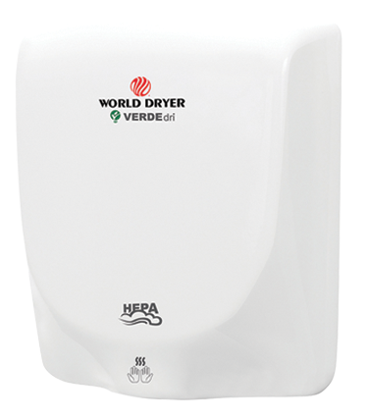



Features
Color - Standard: white.
- Optional: black, brushed stainless steel.
Voltage - Universal voltage 110 to 240V, 1-phase.
Construction - Die cast aluminum housing.
- Optional Hepa filter.
Sound level - 87 dBA with hands high speed.
- 70 dBA with hands low speed.
Heating element - No heating element.
Control - Adjustable two speed controls to customize drying time,
sound level and energy savings.
Installation - ADA compliant surface-mounted.
Warranty - 5-year warranty against defects.

Models
Product # | Qty | Color | Watts | Volts | Weight
 |  |  |  |  | lb | kg
Q-974A |  | White | 950 | 110 to 240 | 9.8 | 4.4
Q-162A |  | Black | 950 | 110 to 240 | 9.8 | 4.4
Q-973A |  | Stainless steel | 950 | 110 to 240 | 11.3 | 5.1

Option
Product #  Kit | Qty | Description
93-10292 |  | Hepa filter

Others
Type | Quantity | Model et description  Complementary information | Volts | Phase | Watts | Length  mm/in. | Information  Color/installation

Specifications may change without prior notice
Project: | Approval  Information
Consultant Engineer: | Approval  Information
Electrician Contractor: | Approval  Information
Distributor: | Approval  Information
Date: | Approval  Information
Contact in Ouellet: | Approval  Information
Comments:

