Series
OSM-AT AirTempest Hand Dryer




Features
Color - Standard: white, stainless steel.
Finish - Standard: epoxy paint.
- Optional: stainless steel.
Voltage - Automatically adjusts itself to all power conditions, from 120V to 240V.
Construction - Epoxy painted steel, stainless steel.
Fan - Thermally-protected universal type, 1/8 HP, 4800 RPM.
Sound level - 67dBa without hands.
Heating element - Nichrome wire construction, 1200 watts, and auto-reset thermal-protector so power
is disconnected if air is not ﬂowing.
Control - Automatic touch-free infrared sensor.
Installation - Surface-mounted with security screws to prevent vandalism (tool supplied).
Warranty - 5-year warranty against defects.

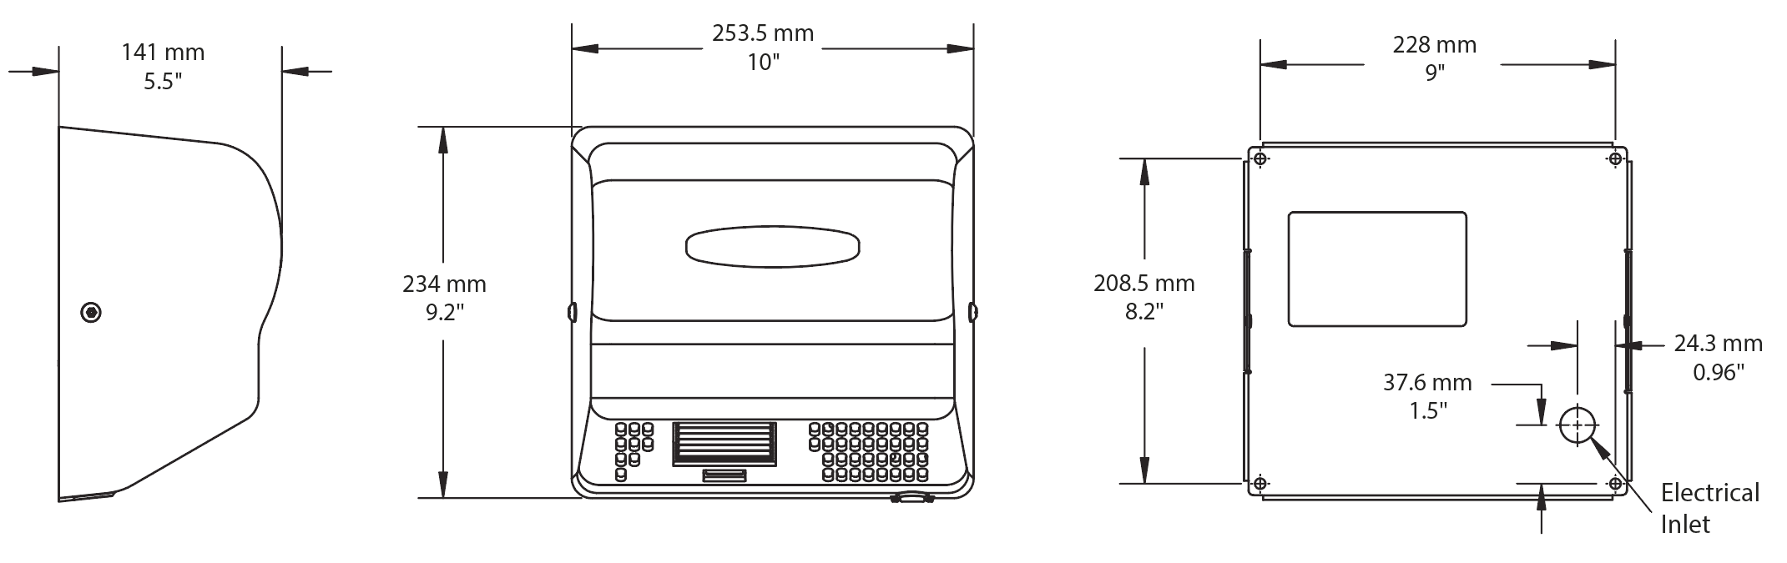

Model
Product # | Color | Qty | Volts | Watts | Weight
 |  |  |  |  | lb | kg
OAM90BL | White |  | 120 to 240 | 400-1400 (120V)  350-1250 (240 V) | 9.4 | 4.2
OAM90SS | Stainless steel |  | 120 to 240 | 400-1400 (120V)  350-1250 (240 V) | 9.4 | 4.2

Standard color is white.

Others
Type | Quantity | Model et description  Complementary information | Volts | Phase | Watts | Length  mm/in. | Information  Color/installation

Specifications may change without prior notice
Project: | Approval  Information
Consultant Engineer: | Approval  Information
Electrician Contractor: | Approval  Information
Distributor: | Approval  Information
Date: | Approval  Information
Contact in manufacturer: | Approval  Information
Comments:

