Series
OSM-AF AirForceTM Multi Nozzle High Velocity Hand Dryer



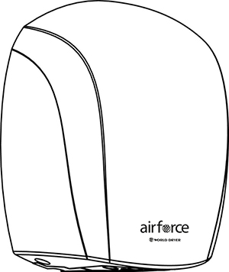

Features
Color - Standard: white.
Finish - Standard: epoxy paint incorporated with SteriTouch® antimicrobial additive.
- Optional: chrome plating.
Voltage - 120V, 240V, 1-phase.
Construction - Die cast aluminum housing.
- Warm air multi-jet technology (11 high velocity exit nozzles).
Fan - Universal brush type motor, thermally protected, operating at 34,000 rpm.
- Delivers 105 cfm of air volume at high velocity of 19,360 lfm (85.1 dBA with hands).
Heating element - No heating element. Drying power comes from redirection of motor heat.
Control - Activated by an automatic active infrared sensor controlled by a circuit board with 1-second run-on time and 30 second vandal shut-off.
Installation - Surface-mounted with security screws to prevent vandalism (tool supplied).
Warranty - 5-year warranty against defects.
Application - Bar, school, penitentiary, restaurant, commercial mall.

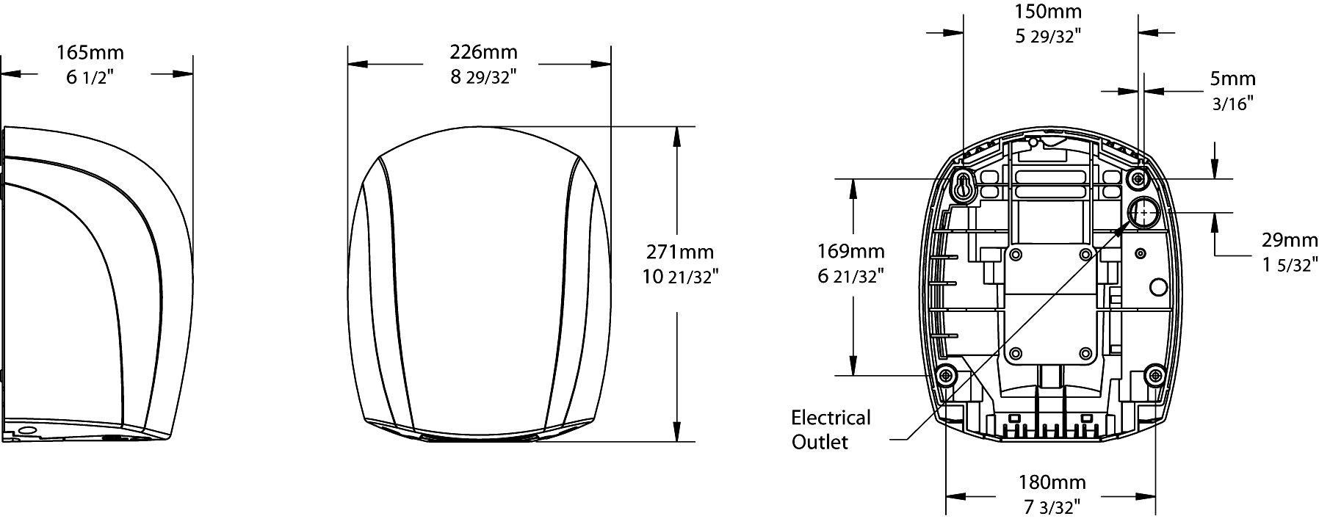

Models
Product # | Qty | Volts | Watts | Weight
 |  |  |  | lb | kg
J-974 |  | 120 | 1100 | 7.0 | 3.2
J4-974 |  | 240 | 1100 | 7.0 | 3.2
J-970 |  | 120 | 1100 | 7.0 | 3.2
J4-970 |  | 240 | 1100 | 7.0 | 3.2

Standard color is white. "BL" for white, "CR" for chrome.

Others
Type | Quantity | Model et description  Complementary information | Volts | Phase | Watts | Length  mm/in. | Information  Color/installation

Specifications may change without prior notice
Project: | Approval  Information
Consultant Engineer: | Approval  Information
Electrician Contractor: | Approval  Information
Distributor: | Approval  Information
Date: | Approval  Information
Contact in Ouellet: | Approval  Information
Comments:

