Series
OSM-AD AirDuo Hand and Hair Dryer

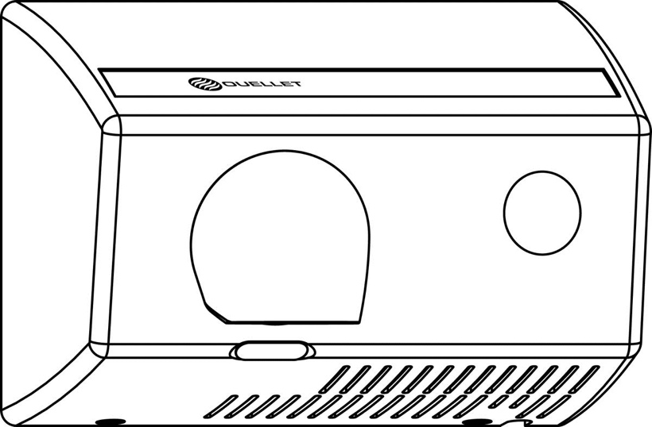



Features
Color - Standard: white.
Finish - Standard: epoxy paint.
Voltage - 120V, 240/208V, 1-phase.
Construction - Die cast aluminum housing.
- 360° revolving die cast aluminum nozzle finished in bright chrome plating. Nozzle can be locked to fixed position in the field.
Fan - Brushless type motor, thermally protected, operating at 3200 rpm.
- Delivers 148 cfm of air volume and 4700 lfm of air velocity (74 dBA with hands).
Heating element - Helical coil nickel-chromium alloy wire protected by mica insulator.
Control - Pushbutton with micro-switch activated timer. Time cycle setting can be adjusted in the field from 15 seconds to 3 minutes.
Installation - Surface-mounted with security screws to prevent vandalism (tool supplied).
Warranty - 5-year warranty against defects.
Application - School, gymnasium, health center, pool.

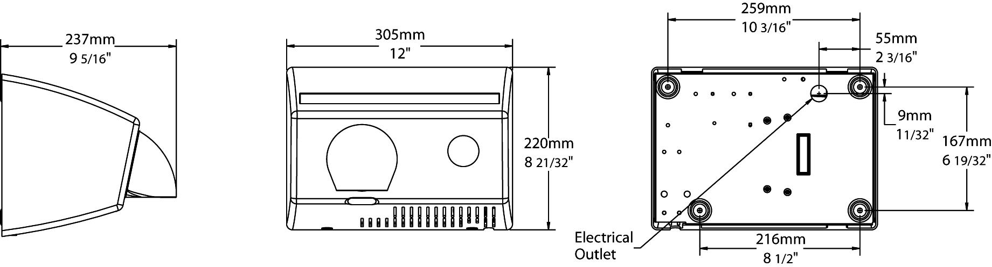

Models
Product # | Qty | Volts | Watts | Weight
 |  |  |  | lb | kg
OAD1802BL |  | 120 | 1800 | 18.0 | 8.2
OAD1800BL |  | 240/208 | 1800/1350 | 18.0 | 8.2

Standard color is white.

Others
Type | Quantity | Model et description  Complementary information | Volts | Phase | Watts | Length  mm/in. | Information  Color/installation

Specifications may change without prior notice
Project: | Approval  Information
Consultant Engineer: | Approval  Information
Electrician Contractor: | Approval  Information
Distributor: | Approval  Information
Date: | Approval  Information
Contact in Ouellet: | Approval  Information
Comments:

