
Surface Frame Installation Guide

Included in kit: 2 ends, 2 sides, and 8 white screws.

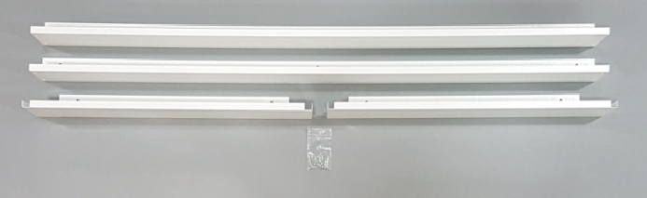

Step #1: Identify the ends

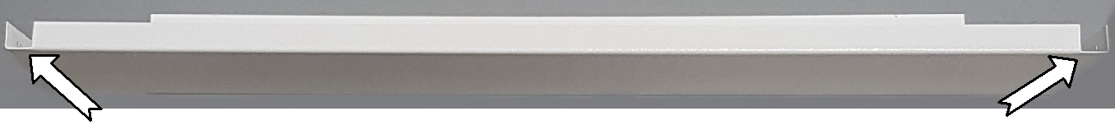
.

The ends have notches in the painted lip and angle brackets built-in.

Step #2: Using 4 white screws per side, install the side pieces onto the pre-angled ends. The side piece sits on the outside edge of the angle bracket.

Step #3: Starting at one corner, line up the edges of the frame pieces and tighten both screws. Repeat for other three corners.
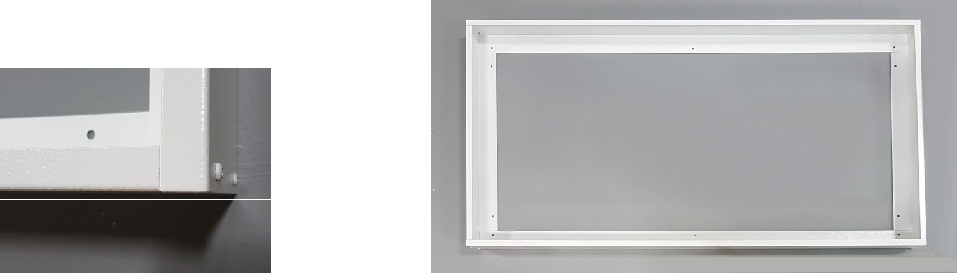

Your frame is now assembled.

Step #4: Mount the assembled frame to the ceiling using the pre-drilled holes on the back of the frame to the ceiling framing using screws (not provided). Make sure to secure all four sides of the frame to properly support the weight of the heater.
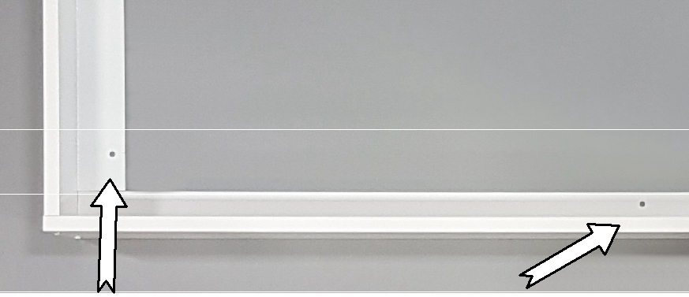

Pre-drilled mounting holes

Step #5: Remove one end of the frame. Connect the heater then insert it into the frame. Replace the frame end.

2019-07-17

