

Plaster Frame Installation Guide
The PF frame is mandatory.

Included in kit: 2 ends with angle brackets built-in, 2 sides and 8 white screws.

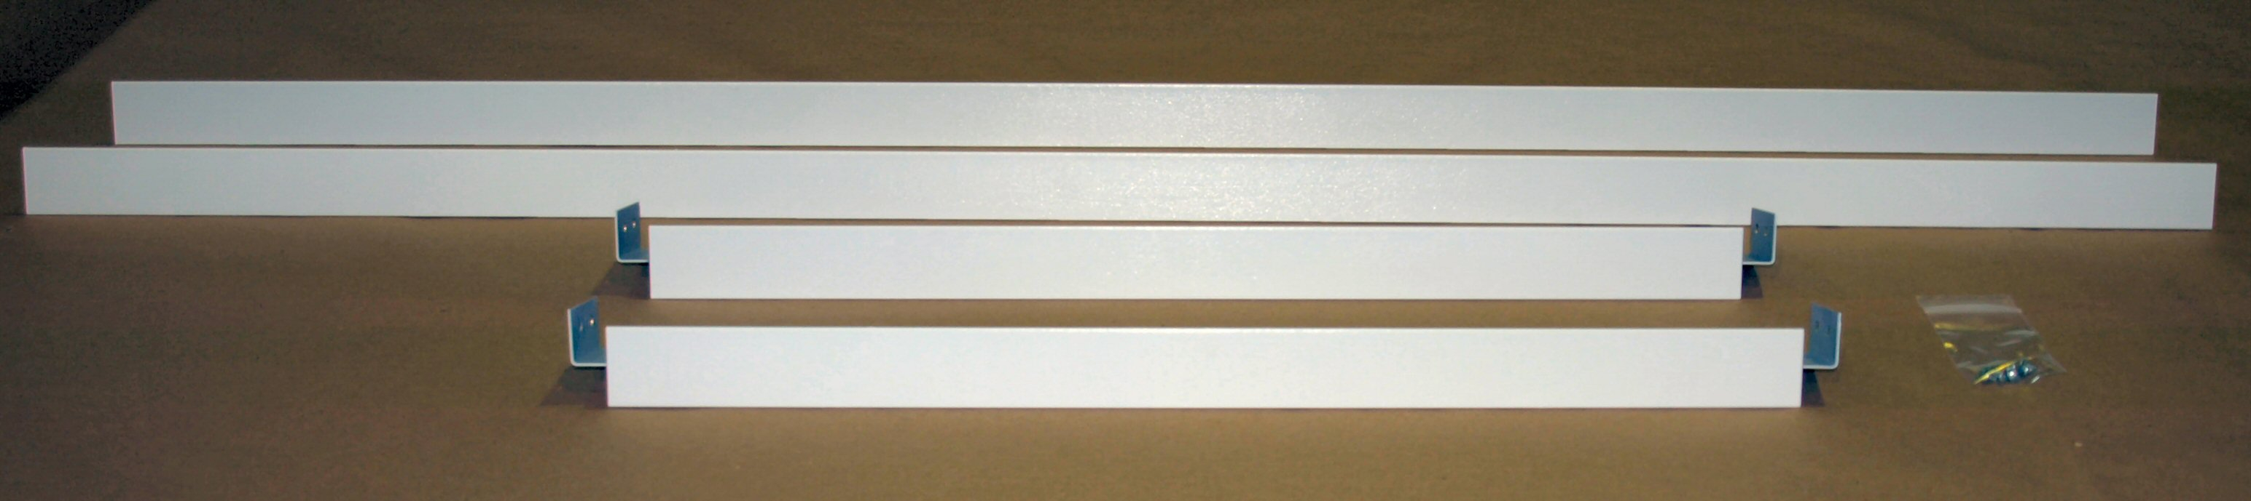

Step #1: Identify the ends.

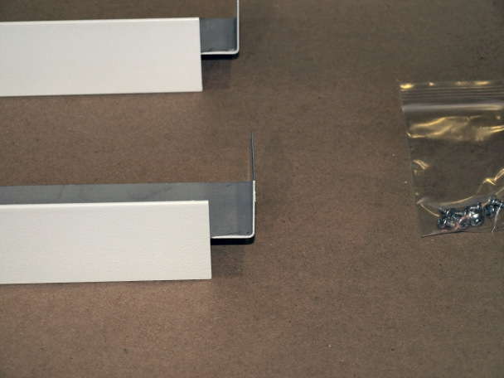

(The ends have angle brackets)

Step #2: Identify the inside edge of all the frame pieces and the outside edge of the frame pieces. The frame sides and ends have a double metal fold. The double metal fold points inwards toward the heater with the thin end pointing outwards to cover the sheetrock edge.

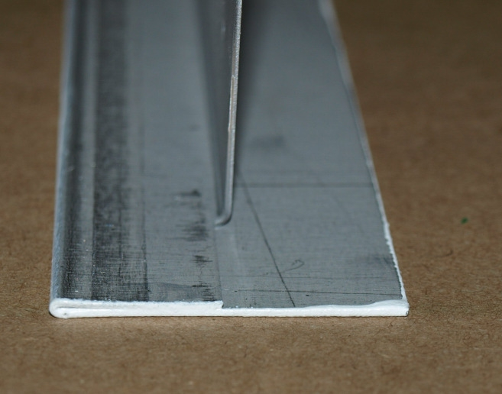

Inside edge Outside edge

Step #3: With the frame placed paint side down, assemble one side to one end using 2 of the screws provided for each corner. The side piece goes on the outside of the angle bracket on the end piece, holes lined up and the screws are installed from the inside of the frame going to the outside. See pictures below.

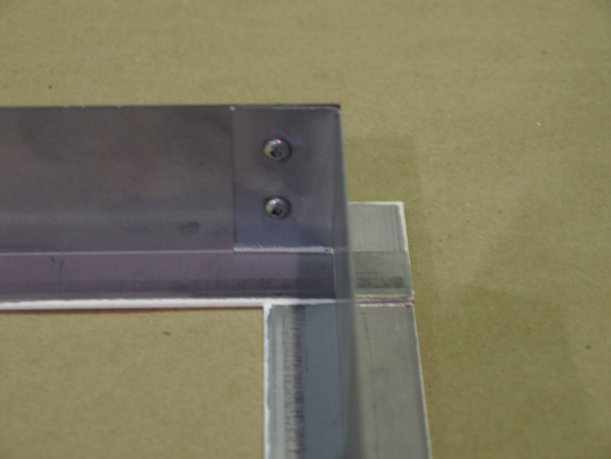

Step #4: Starting at one corner, line up the edges of the frame pieces and tighten both screws. Repeat for other three corners.

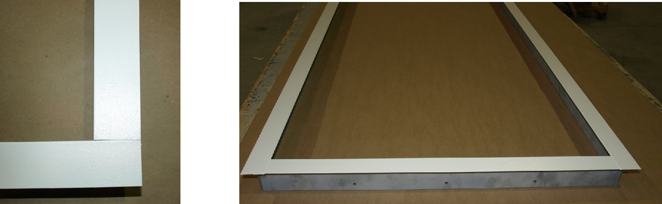

Your frame is now assembled.

Step #5: Mount the assembled frame in the recess in the ceiling using the pre-drilled holes on the sides and ends of the frame to the ceiling framing using screws (not provided). A minimum installation height of 8 pi. (2.4 m) from the floor and a minimum clearance of 2 in. (5.08 cm) above the panel is required, however a clearance of 16 '' (406.4mm) above the panel is recommended for an easy installation. Make sure to secure all four sides of the frame to properly support the weight of the heater.

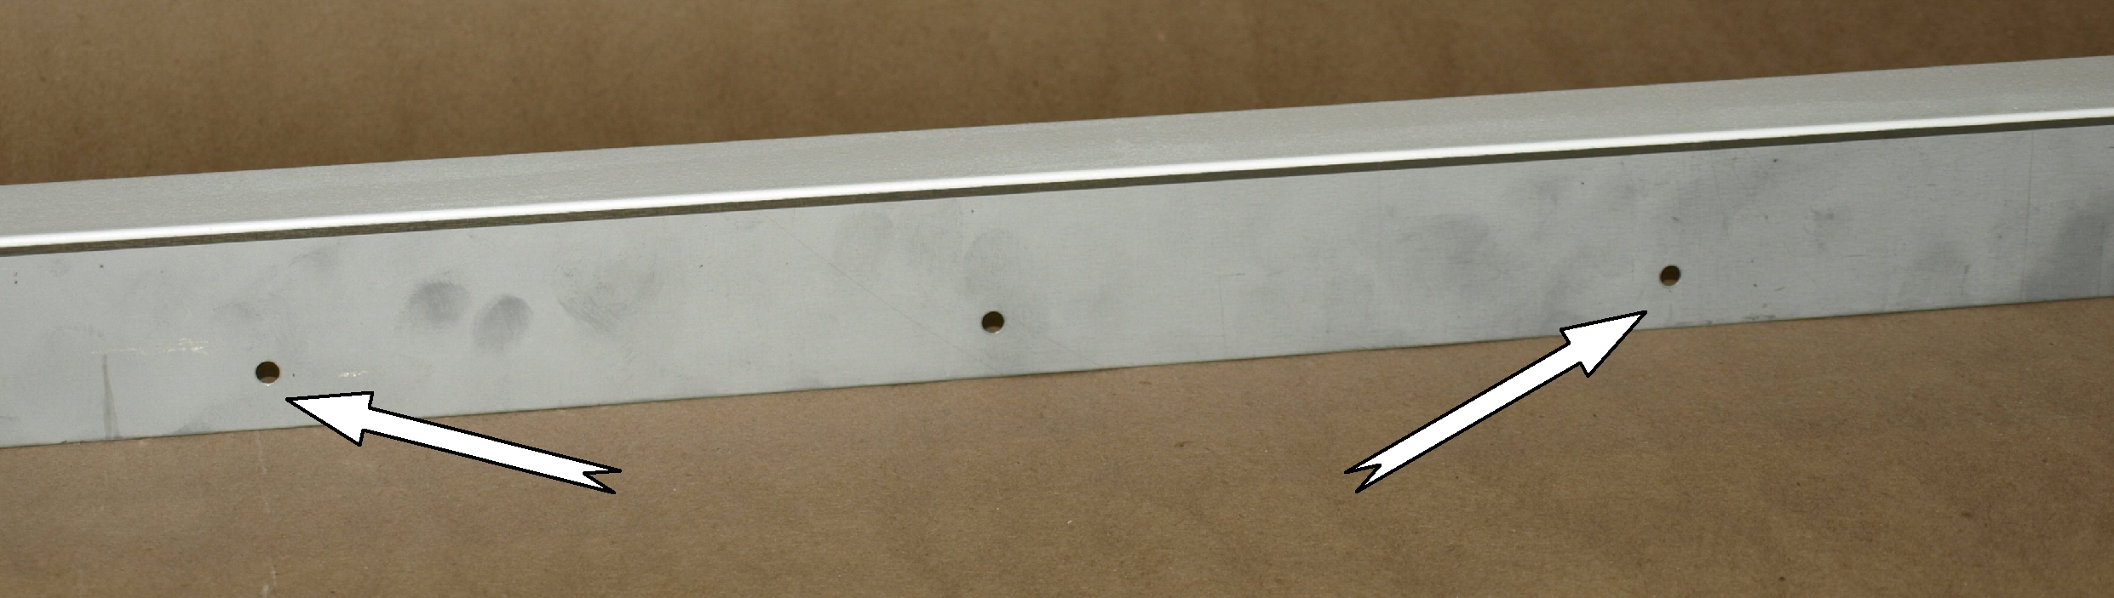

Pre-drilled mounting holes

Revised June 20, 2019

