Series
ORP Architectural Radiant Panel
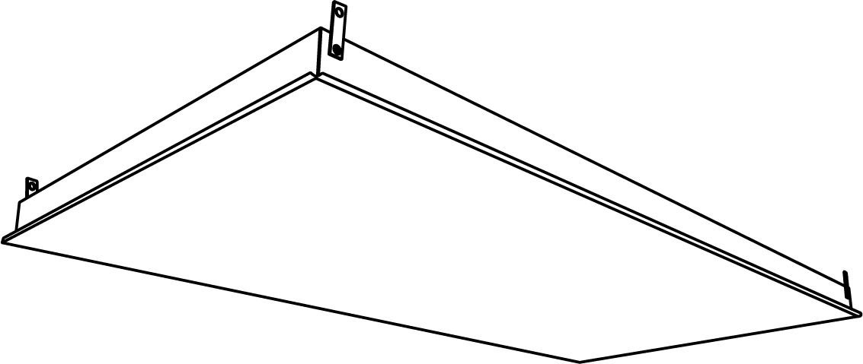




Features
Color - Standard: polar white PW.
- Optional (upcharge applicable): Black Therma Ray PB-0218-HT -SP.
Finish - High-temperature polyester powder paint.
Voltage - 120V, 208V, 240V, 277V, 347V.
Construction - Reflective foil used to adhere to the panel heating elements.
- High-temperature mineral wool insulation, 4 PSF density, 2" (50.8 mm) thick.
- 22-gauge galvanized steel panel frame and front.
- Internal junction box with cover.
- Optional external junction box.
- Suspension clips in all four corners of the panel (suspension wires not included).
- Custom sizes available upon request.
Heating element - Nickel-chrome alloy resistance wire, PTFE insulation evenly distributed over the panel.
Density - 65 to 95W/sq. ft. at rated voltage.
Control - Line voltage control circuit for thermostat, timer or switch (not included, must be compatible with the selected voltage and wattage of the heater).
Ouellet highly recommends using an electronic wall thermostat for greater comfort.
Certification - CSA STD C22.2 No.46.
Installation - Suspended from a ceiling or inserted into a T-Bar suspended ceiling.
- Variety of accessories available for surface installation with the SF frame on a gypsum ceiling or recessed with the PF frame.
- 2 in. (50.8 mm) minimum clearance above the panel.
- Minimum installation height from floor: 7 ft. (2.13 m).
- Relocation possible.
Warranty - 1-year on the paint.
- 10-year on the heating element.
Application - Commercial building, office building, hospital, school, daycare, private residence.

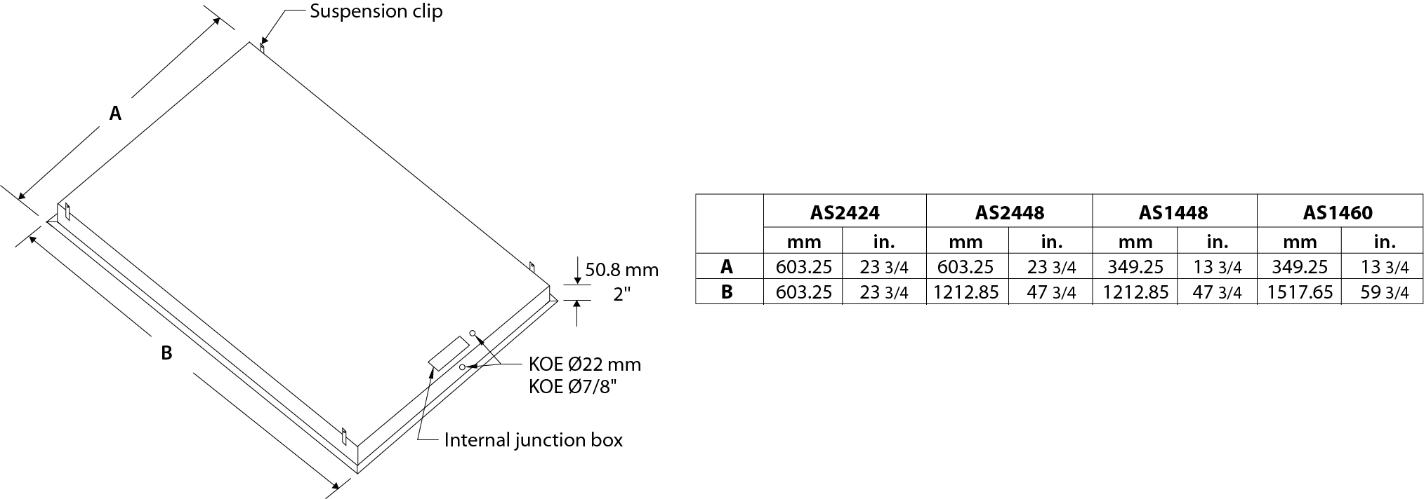

Models¹
Watts | Product # |  |  |  |  |  |  |  | Weight
Watts | 120V | Qty | 208V | Qty | 240V | Qty | 347V | Qty |  | lb | kg
23-3/4'' x 23-3/4'' Panel
250 | AS2424-250-120PW |  | - |  | AS2424-250-240PW |  | AS2424-250-347PW |  |  | 15 | 6.8
300 | - |  | - |  | - |  | AS2424-300-347PW |  |  | 15 | 6.8
310 | - |  | AS2424-310-208PW |  | AS2424-310-240PW |  | - |  |  | 15 | 6.8
335 | AS2424-335-120PW |  | - |  | - |  | - |  |  | 15 | 6.8
375 | AS2424-375-120PW |  | AS2424-375-208PW |  | - |  | AS2424-375-347PW |  |  | 15 | 6.8
23-3/4'' x 47-3/4'' Panel
500 | AS2448-500-120PW |  | - |  | AS2448-500-240PW |  | AS2448-500-347PW |  |  | 30 | 13.6
535 | - |  | AS2448-535-208PW |  | - |  | - |  |  | 30 | 13.6
625 | AS2448-625-120PW |  | AS2448-625-208PW |  | AS2448-625-240PW |  | - |  |  | 30 | 13.6
650 | - |  | - |  | - |  | AS2448-650-347PW |  |  | 30 | 13.6
700 | - |  | - |  | - |  | AS2448-700-347PW |  |  | 30 | 13.6
725 | - |  | - |  | AS2448-725-240PW |  | - |  |  | 30 | 13.6
750 | AS2448-750-120PW |  | AS2448-750-208PW |  | - |  | AS2448-750-347PW |  |  | 30 | 13.6
13-3/4'' x 47-3/4'' Panel
300 | - |  | - |  | AS1448-300-240PW |  | - |  |  | 18 | 8.2
350 | AS1448-350-120PW |  | - |  | - |  | - |  |  | 18 | 8.2
400 | - |  | AS1448-400-208PW |  | - |  | AS1448-400-347PW |  |  | 18 | 8.2
435 | - |  | AS1448-435-208PW |  | AS1448-435-240PW |  | - |  |  | 18 | 8.2
13-3/4'' x 59-3/4'' Panel
350 | AS1460-350-120PW |  | - |  | - |  | - |  |  | 22 | 10
375 | - |  | - |  | AS1460-375-240PW |  | - |  |  | 22 | 10
450 | - |  | AS1460-450-208PW |  | - |  | - |  |  | 22 | 10
540 | - |  | - |  | - |  | AS1460-540-347PW |  |  | 22 | 10
550 | - |  | - |  | AS1460-550-240PW |  | - |  |  | 22 | 10

¹ Allow a maximum of approximately 6 weeks of production lead time.
Standard color is polar white PW.
To order the optional color Black Therma Ray PB-0218-HT, replace the PW at the end of the part number by -SP. Ex.: As2448-750-120-SP.

Options
Product #  Kit | Product #  Factory installed* | Description | Qty
- | FC48 | 48 in. (121.92 cm) flexible conduit
PF-1448PW | - | Frame for recessed installation on gypsum ceiling, 14 1/14" x 48 1/48"
PF-1460PW | - | Frame for recessed installation on gypsum ceiling, 14 1/14" x 60 1/48"
PF-22PW | - | Frame for recessed installation on gypsum ceiling, 24 1/14" x 24 1/48"
PF-24PW | - | Frame for recessed installation on gypsum ceiling, 24 1/14" x 48 1/48"
- | WT | Silicone seams, including a 36 in. (91.44 cm) Sealtite® conduit
SF-1448PW | - | Frame for surface installation on gypsum ceiling, 14" x 48"
SF-1460PW | - | Frame for surface installation on gypsum ceiling, 14" x 60"
SF-22PW | - | Frame for surface installation on gypsum ceiling, 24" x 24"
SF-24PW | - | Frame for surface installation on gypsum ceiling, 24" x 48"

* For factory installed options, add the option number to the product number. See the Product Code section inside the front cover.
Variety of control panel available upon request.

Others
Type | Quantity | Model and description  Complementary informations | Volts | Phase | Watts | Length  mm/in. | Informations  Color/installation

Specifications may change without prior notice
Project: | Approval  Information
Consultant Engineer: | Approval  Information
Eectrician Contractor: | Approval  Information
Distributor: | Approval  Information
Date: | Approval  Information
Contact in Ouellet: | Approval  Information
Comments:

