Series

ORF-P

120V Preassembled Constant Wattage Heating Cable for Pipes

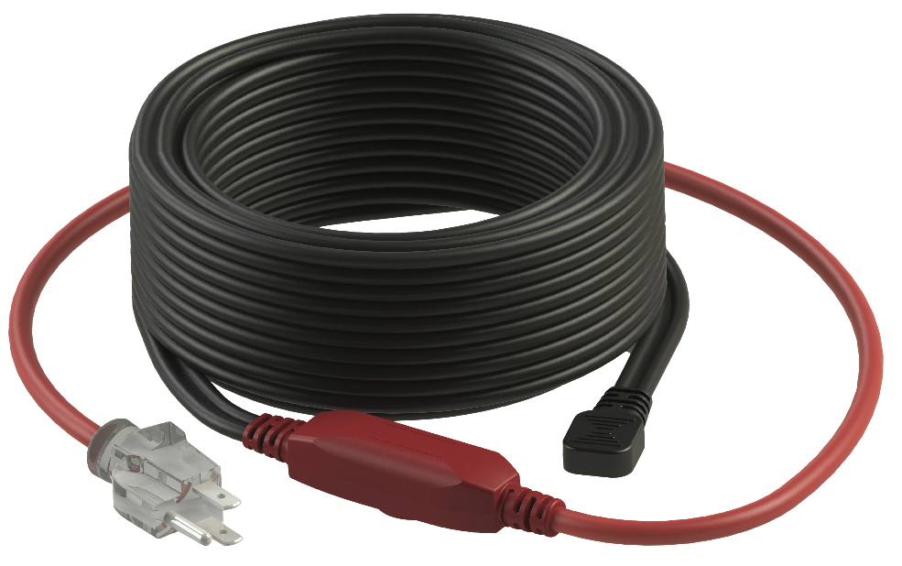



Features

Nominal voltage - 120V.

Linear density - 7 Watts per foot.

Cold lead length - 30 in. (0.76 m).

Outer jacket - PVC.

Bus wire - Nickel plated copper.

Minimum bend radius - 5/16 in. (8 mm).

Included hardware - Built-in bi-metal thermostat energizes the cable when temperature falls   
below 4 °C (40 °F).

* Grounded 3-pronged plug with indicator light to show when the cable is on.

Installation - **Never cut or shorten the heating cable.**

* Installation under the insulation of the pipe.
* For indoor and outdoor applications.
* Minimum installation temperature: 0 °C (34 °F).

Warranty - 1-year basic warranty on the heating cable.

Application - Metallic and non-metallic pipes.

* Helps to prevent damage caused by frozen pipes.

**Models**

|  |  |  |  |  |
| --- | --- | --- | --- | --- |
| **Product #1** | **Length** | | **Watts** | **Qty** |
| **ft.** | **m** |
| **ORF-P003** | 3 | 0.9 | 21 |  |
| **ORF-P006** | 6 | 1.8 | 42 |  |
| **ORF-P009** | 9 | 2.7 | 63 |  |
| **ORF-P012** | 12 | 3.7 | 84 |  |
| **ORF-P015** | 15 | 4.6 | 105 |  |
| **ORF-P018** | 18 | 5.5 | 126 |  |
| **ORF-P024** | 24 | 7.3 | 168 |  |
| **ORF-P030** | 30 | 9.0 | 210 |  |
| **ORF-P040** | 40 | 12.2 | 280 |  |
| **ORF-P060** | 60 | 18.3 | 420 |  |
| **ORF-P080** | 80 | 24.4 | 560 |  |

*1 Must be plugged into a 120V outlet fitted with ground fault protection device (GFCI).*

**Options**

|  |  |  |
| --- | --- | --- |
| **Product #**  **Kit** | **Description** | **Qty** |
| **ELB-02B** | Self-adhesive glass fiber tape, max. temp. = 90 °C (194 °F), 50 m (165 ft.) |  |
| **ELB-06C** | Self-adhesive aluminum tape, max. temp. = 80 °C (176 °F), 50 m (165 ft.) |  |

**Specifications may change without prior notice**

|  |  |
| --- | --- |
| Project: | Approval  Information |
| Consultant Engineer: |
| Electrician Contractor: |
| Distributor: |
| Date: |
| Contact in Ouellet: |
| Comments: | |