Series
ORA-C C Range Commercial Air Curtain

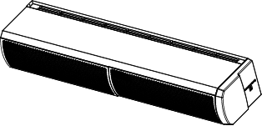

Features
Model - Electric heat.
- No heat.
Color - Standard: white.
- Custom colors available upon request (RAL Chart).
Voltage - 208V, 240/208V, 480V, 600V, 60 Hz.
Construction - Steel casing with resistant plastic end caps.
- Quick access to the internal components thanks to the front panel which facilitate maintenance and connection.
- High-limit temperature control with automatic reset.
Fan - Tangential fans.
Heating element - Element provides instant heat (electric model).
Control - Ecopower control included (20 ft. (6 m) RJ9 control included).
- Door switch included.
- Compatible with a Building Management System (Bacnet MS/TP, Modbus RTU or dry contact).
- Personalize programing of the air curtain.
Installation - Minimum height installation: 6 ft. (1.8 m).
- Maximum height installation:
- Surface-mounted: 9.84 ft. (3 m) above the floor.
- Recessed: 9 ft. (2.75 m) above the floor.
- Surface-mounted: brackets included.
- Ceiling hanging: fixings are included for 1/4 in. x 20 UNC threaded rods (rods not supplied).
- Recessed: hinged core grilles included for easy installation and maintenance.
- Joining kit, available in option, for connecting multiple surface mounted units.
Warranty - 2-year warranty against defects.
Application - Vestibule, commercial building, entrance way, service door, hospital.

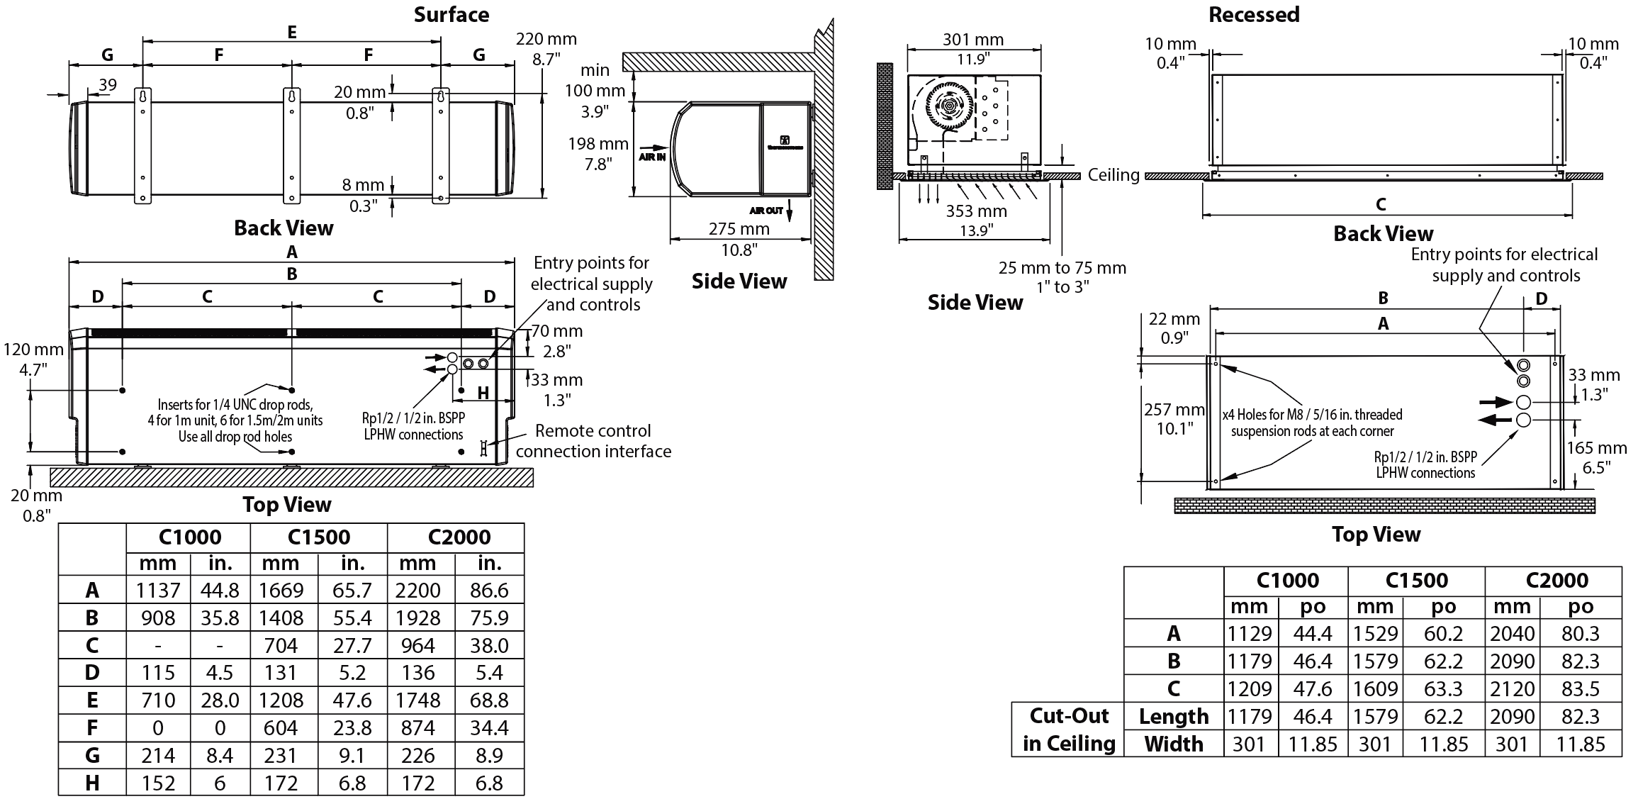

IMPORTANT: 600V and 480V models need 2 power sources (E.g.: 600V+208V or 230V) or an external transformer (E.g.: 600V/240V).
The VA requirement varies between models: C1000 = 200VA, C1500 and C2000 = 350VA.

Models
Product # | Qty | Volts (ph) |  |  | kW  Lo/Hi | Amp. |  | cfm |  | Max velocity (ft./min) | dBA at 3 m | Effective width  of air stream |  | Weight
 |  |  |  |  |  |  |  |  |  |  |  | in. | mm | lb | kg
Surface-mounted
Electric heat
C1000ESEC600V |  | 600 (3) + 208 or 240² |  | 4.5/9 |  | 9.3+0.5 | 740 |  | 1770 |  | 55.0 | 36 | 933 | 35 | 16
C1500ESEC600V |  | 600 (3) + 208 or 240² |  | 6/12 |  | 12.8+0.7 | 1060 |  | 1770 |  | 55.0 | 56 | 1430 | 51 | 23
C2000ESEC600V |  | 600 (3) + 208 or 240² |  | 9/18 |  | 18.6+1.0 | 1470 |  | 1770 |  | 56.0 | 78 | 1996 | 73 | 33
C1000ESEC480V |  | 480 (3) + 208 or 240² |  | 4.5/9 |  | 10.9+0.5 | 740 |  | 1770 |  | 55.0 | 36 | 933 | 35 | 16
C1500ESEC480V |  | 480 (3) + 208 or 240² |  | 6/12 |  | 14.5+0.7 | 1060 |  | 1770 |  | 55.0 | 56 | 1430 | 51 | 23
C2000ESEC480V |  | 480 (3) + 208 or 240² |  | 9/18 |  | 21.7+1.0 | 1470 |  | 1770 |  | 56.0 | 78 | 1996 | 73 | 33
C1000ESEC208V |  | 208 (3)³ |  | 4.32/8.64 |  | 24.5 | 740 |  | 1770 |  | 55.0 | 36 | 933 | 35 | 16
C1500ESEC208V |  | 208 (3)³ |  | 5.77/11.53 |  | 32.7 | 1060 |  | 1770 |  | 55.0 | 56 | 1430 | 51 | 23
C2000ESEC208V |  | 208 (3)³ |  | 8.64/17.28 |  | 49.0 | 1470 |  | 1770 |  | 56.0 | 78 | 1996 | 73 | 33
No heat
C1000ASEC208-230V |  | 208/240 (1)³ | - |  |  | 0.5 |  | 740 |  | 1770 | 55.0 | 36 | 933 | 33 | 15
C1500ASEC208-230V |  | 208/240 (1)³ | - |  |  | 0.7 |  | 1060 |  | 1770 | 55.0 | 56 | 1430 | 46 | 21
C2000ASEC208-230V |  | 208/240 (1)³ | - |  |  | 1 |  | 1470 |  | 1770 | 56.0 | 78 | 1996 | 68 | 31
Recessed
Electric heat
C1000EREC600V |  | 600 (3) + 208 or 240² | 4.5/9 |  |  | 9.3+0.5 |  | 740 |  | 1770 | 55.0 | 45 | 1145 | 44 | 20
C1500EREC600V |  | 600 (3) + 208 or 240² | 6/12 |  |  | 12.8+0.7 |  | 1060 |  | 1770 | 55.0 | 60 | 1545 | 60 | 27
C2000EREC600V |  | 600 (3) + 208 or 240² | 9/18 |  |  | 18.6+1.0 |  | 1470 |  | 1770 | 56.0 | 80 | 2055 | 82 | 37
C1000EREC480V |  | 480 (3) + 208 or 240² | 4.5/9 |  |  | 10.9+0.5 |  | 740 |  | 1770 | 55.0 | 45 | 1145 | 44 | 20
C1500EREC480V |  | 480 (3) + 208 or 240² | 6/12 |  |  | 14.5+0.7 |  | 1060 |  | 1770 | 55.0 | 60 | 1545 | 51 | 23
C2000EREC480V |  | 480 (3) + 208 or 240² | 9/18 |  |  | 21.7+1.0 |  | 1470 |  | 1770 | 56.0 | 80 | 2055 | 73 | 33
C1000EREC208V |  | 208 (3)³ | 4.32/8.64 |  |  | 24.5 |  | 740 |  | 1770 | 55.0 | 45 | 1145 | 44 | 20
C1500EREC208V |  | 208 (3)³ | 5.77/11.53 |  |  | 32.7 |  | 1060 |  | 1770 | 55.0 | 60 | 1545 | 60 | 27
C2000EREC208V |  | 208 (3) ³ | 8.64/17.28 |  |  | 49.0 |  | 1470 |  | 1770 | 56.0 | 80 | 2055 | 82 | 37
No heat
C1000AREC208V |  | 208/240 (1)³ | - |  |  | 0.5 |  | 740 |  | 1770 | 55.0 | 45 | 1145 | 42 | 19
C1500AREC208V |  | 208/240 (1)³ | - |  |  | 0.7 |  | 1060 |  | 1770 | 55.0 | 60 | 1545 | 55 | 25
C2000AREC208V |  | 208/240 (1)³ | - |  |  | 1 |  | 1470 |  | 1770 | 56.0 | 80 | 2055 | 77 | 35

¹ To order any custom colors from the R.A.L. chart, add “-SP” at the end of the Product # and specify RAL color # on the order. Contact our customer service department
for lead times.
² IMPORTANT: 600V and 480V models need 2 power sources (E.g.: 600V+208V or 230V) or an external transformer (E.g.: 600V/240V). The VA requirement varies between models:
C1000 = 200VA, C1500 and C2000 = 350VA.
³ Maximum installation height when connected to 208V is 8.53 ft. (2.6 m).

Options
Product # | Description | Qty

Others
Type | Quantity | Model et description  Complementary informations | Volts | Phase | Watts | Length  mm/in. | Informations  Color/installation

Specifications may change without prior notice
Project: | Approval  Information
Consultant Engineer: | Approval  Information
ELectrician Contractor: | Approval  Information
Distributor: | Approval  Information
Date: | Approval  Information
Contact in Ouellet: | Approval  Information
Comments:

