Series
OPX Explosion-Proof Sloped Top Convector Heater
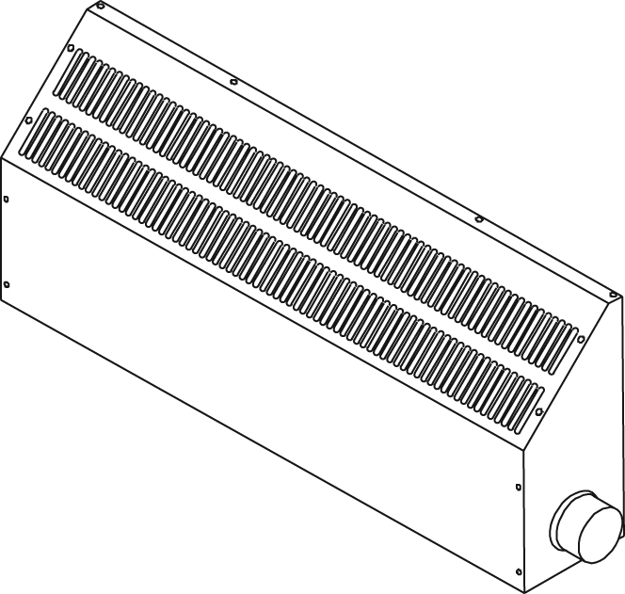

Features
Color - Standard: beige.
Voltage - 120V, 208V, 240V, 347V, 480V, 600V, 1 or 3-phase.
Construction - Sloped top, 18-gauge steel cabinet.
- Low temperature convection.
- Linear high-limit temperature control with automatic reset.
- Sealed junction box.
Heating element - Cooper tubular heating element with aluminum fins.
Watt density - Varies according to temperature code.
Control - Built-in or wall thermostat available.
Installation - Built-in wall brackets.
- Minimum mounting height of 6 in. (152 mm) above the ﬂoor.
Warranty - 1-year warranty against defects.
Application - Paint room, chemical storage, petrochemical plant, oil refinery, dry cleaning plant,
coal handling facility.
Maximum room temperature: 40 °C (104 °F).
Consult the Electrical Code in your area before installing this unit.

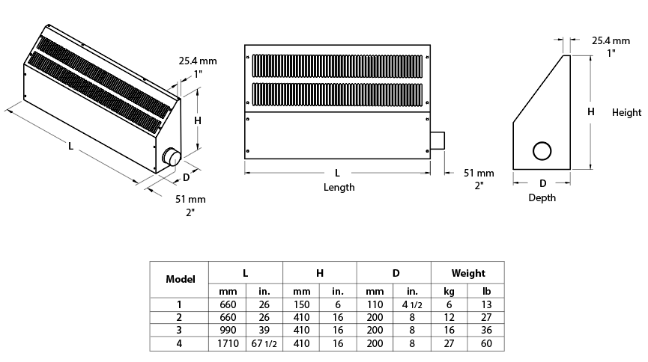
Models
Watts | Product # |  |  |  |  |  |  |  |  |  |  |  | Tº Code² | Unit  Size
Watts | 120V  (1 ph) | Qté | 208V  (1 ph) | Qté | 208V  (3 ph) | Qté | 240V  (1 ph) | Qté | 347V  (1 ph) | Qté | 600V  (3 ph) | Qté
Classe I, Groupes B³, C et D, Divisions 1 et 2
500 | OPX2A0502 |  | OPX2A0508 |  | - | - | OPX2A0500 |  | - | - | - | - | T2A | 1¹
1000 | OPX2A1002 |  | OPX2A1008 |  | - | - | OPX2A1000 |  | OPX2A1007 |  | - | - | T2A | 1¹
1800 | OPX2A1802 |  | OPX2A1808 |  | - | - | OPX2A1800 |  | OPX2A1807-CTT |  | OPX2A1836-CTT |  | T2A | 2
2500 | - | - | OPX2A2508 |  | OPX2A2538-CTT |  | OPX2A2500 |  | OPX2A2507-CTT |  | OPX2A2536-CTT |  | T2A | 2
3600 | - | - | OPX2A3608 |  | OPX2A3638-CTT |  | OPX2A3600 |  | OPX2A3607-CTT |  | OPX2A3636-CTT |  | T2A | 3
4400 | - | - | - | - | OPX2A4438-CTT |  | OPX2A4400 |  | OPX2A4407-CTT |  | OPX2A4436-CTT |  | T2A | 3
6500 | - | - | - | - | OPX2A6538-CTT |  | OPX2A6500-CTT |  | OPX2A6507-CTT |  | OPX2A6536-CTT |  | T2A | 4
7500 | - | - | - | - | OPX2A7538-CTT |  | OPX2A7500-CTT |  | OPX2A7507-CTT |  | OPX2A7536-CTT |  | T2A | 4
9500 | - | - | - | - | OPX2A9538-CTT |  | OPX2A9500-CTT |  | OPX2A9507-CTT |  | OPX2A9536-CTT |  | T2A | 4
Classe I, Groupes B³, C et D, Divisions 1 et 2
500 | OPX3A0502 |  | OPX3A0508 |  | - | - | OPX3A0500 |  | - | - | - | - | T3A | 1¹
1400 | OPX3A1402 |  | OPX3A1408 |  | - | - | OPX3A1400 |  | OPX3A1407-CTT |  | - | - | T3A | 2
2300 | OPX3A2302 |  | OPX3A2308 |  | OPX3A2338-CTT |  | OPX3A2300 |  | OPX3A2307-CTT |  | OPX3A2336-CTT |  | T3A | 3
3200 | - | - | OPX3A3208 |  | OPX3A3238-CTT |  | OPX3A3200 |  | OPX3A3207-CTT |  | OPX3A3236-CTT |  | T3A | 4
5000 | - | - | - | - | OPX3A5038-CTT |  | OPX3A5000 |  | OPX3A5007-CTT |  | OPX3A5036-CTT |  | T3A | 4
Classe II, Groupes E, F et G, Divisions 1 et 2
500 | OPX3C0502 |  | OPX3C0508 |  | - | - | OPX3C0500 |  | - | - | - | - | T3C | 1¹
1000 | OPX3C1002 |  | OPX3C1008 |  | - | - | OPX3C1000 |  | OPX3C1007-CTT |  | - | - | T3C | 2
1700 | OPX3C1702 |  | OPX3C1708 |  | - | - | OPX3C1700 |  | OPX3C1707-CTT |  | OPX3C1736-CTT |  | T3C | 3
3200 | - | - | OPX3C3208 |  | OPX3C3238-CTT |  | OPX3C3200 |  | OPX3C3207-CTT |  | OPX3C3236-CTT |  | T3C | 4

Options
Product # | Description | Factory  Installed | Kit | Qty
C1-1⁴ | Galvanized steel cabinet wet area approved (Type 3), model 1 | √ | -
C1-2⁴ | Galvanized steel cabinet wet area approved (Type 3), model 2 | √ | -
C1-3⁴ | Galvanized steel cabinet wet area approved (Type 3), model 3 | √ | -
C1-4⁴ | Galvanized steel cabinet wet area approved (Type 3), model 4 | √ | -
C2-1⁴ | 304 stainless steel cabinet corrosion and wet area approved (Type 3), model 1 | √ | -
C2-2⁴ | 304 stainless steel cabinet corrosion and wet area approved (Type 3), model 2 | √ | -
C2-3⁴ | 304 stainless steel cabinet corrosion and wet area approved (Type 3), model 3 | √ | -
C2-4⁴ | 304 stainless steel cabinet corrosion and wet area approved (Type 3), model 4 | √ | -
CTT | 24V contactor and control transformer | √ | -
T | Class I and II, Groups C, D, E, F and G single-pole thermostat | √ | -
TGRB | Class I and II, Groups B, C, D, E, F and G single-pole thermostat | √ | -
XB-TM | Explosion-proof wall thermostat, range -18 °C to 40 °C (0 °F to 100 °F): 15A at 600V, 25A at 277V | - | √

¹ No factory installed option available for size 1 model.
² Temperature code: T2A = 280 °C (536 °F), T3A = 180 °C (356 °F), T3C = 160 °C (320 °F).
³ For Group B applications, if the convector requires a built-in thermostat, use the TGRB option.
⁴ See features below.
For any other ratings and risk areas, contact our customer service.
Standard color is beige.

Features of the C1 Option
Galvanized steel cabinet wet area approved with a baked on powder coating.
Elements with a chromate coating.
A gasketed terminal box cover (O-ring).
The option C1 is not available with the T option and the TGRB option. Allow a 4 weeks production lead time.

Features of the C2 Option
304 stainless steel cabinet corrosion and wet area (Type 3) approved with a baked on powder coating.
Elements with a chromate coating.
A gasketed terminal box cover (O-ring).
ONLY the cabinet is upgraded to stainless steel.
The option C2 is not available with the T option and the TGRB option. Allow a 4 weeks production lead time.

Others
Type | Quantity | Model et description  Complementary informations | Volts | Phase | Watts | Length  mm/in. | Informations  Color/installation

Specifications may change without prior notice
Project: | Approval  Information
Consultant Engineer: | Approval  Information
Electrician Contractor: | Approval  Information
Distributor: | Approval  Information
Date: | Approval  Information
Contact in Ouellet: | Approval  Information
Comments:

