Series
OPR Heavy-Duty Steel Baseboard Heater
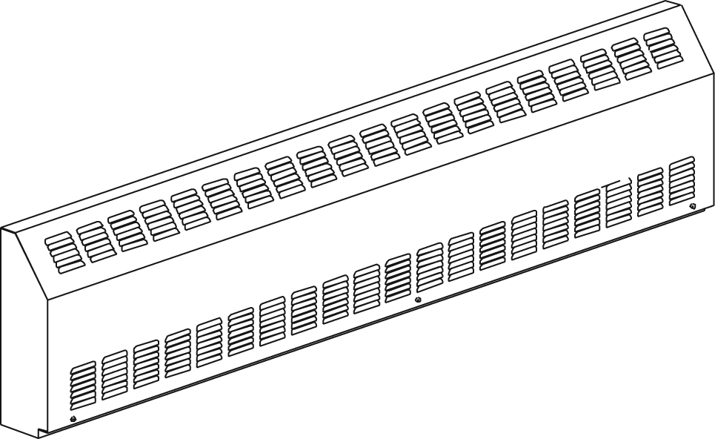

Features
Color - Standard: white, almond.
- Optional (upcharge applicable): metallic silver, bronze, metallic charcoal,
aluminum, semi-gloss black, sand.
- Custom colors available upon request.
Finish - Standard: epoxy/polyester powder paint.
Voltage - 120V, 208V, 240/208V, 277V, 347V, 600V, 1-phase.
Construction - 16-gauge steel front.
- 18-gauge steel cabinet.
- Full length built-in wireway.
- Interior parts protected by a louvre grille.
- Pencil-proof openings less than 1/4 in. (6.4 mm).
- Clean back available (-BD).
- Linear high-limit temperature control with automatic reset.
Heating element - Stainless steel tubular heating element with aluminum ﬁns.
- Floating heating element on high-temperature nylon bushings
reducing expansion noises.
Watt density - Average standard watt density of 275W/ft.
- Average low watt density of 100W/ft., 150W/ft., 200W/ft.
Control - Built-in thermostat available with a control knob
or tamperproof (installed on the left end only).
- Mechanical or electronic relays available (installed on the left end only).
Ouellet highly recommends to use an electronic wall thermostat for greater comfort.
Installation - Wall or ﬂoor mounted installation.
- Mounting holes spaced at 2 in. (51 mm) intervals for ease of installation.
- Variety of accessories available for wall-to-wall installation.
- Pedestal kit available.
Warranty - 3-year warranty against defects.
Application - Commercial building, office building, hospital, daycare center,
private residence, penal institution.

Average Standard Watt Density Models 275W/ft.
Watts | Watts  240/208V¹ | Product # |  |  |  |  |  |  |  |  |  | Length |  | Weight
Watts | Watts  240/208V¹ | 120V | Qty | 208V | Qty | 240/208V | Qty | 347V | Qty | 600V | Qty | in. | mm | lb | kg
300 | 300/225 | OPR0302 |  | OPR0308 |  | OPR0300 |  | - | - | - | - | 20 _{9/16} | 522 | 10.4 | 4.7
500 | 500/375 | OPR0502 |  | OPR0508 |  | OPR0500 |  | OPR0507 |  | - | - | 25 _{1/2} | 647 | 14.0 | 6.4
750 | 750/563 | OPR0752 |  | OPR0758 |  | OPR0750 |  | OPR0757 |  | OPR0756 |  | 35 _{1/2} | 901 | 20.0 | 9.1
1000 | 1000/750 | OPR1002 |  | OPR1008 |  | OPR1000 |  | OPR1007 |  | OPR1006 |  | 45 _{3/4} | 1162 | 26.0 | 11.8
1250 | 1250/938 | OPR1252 |  | OPR1258 |  | OPR1250 |  | OPR1257 |  | OPR1256 |  | 55 _{1/4} | 1403 | 32.0 | 14.6
1500 | 1500/1125 | OPR1502 |  | OPR1508 |  | OPR1500 |  | OPR1507 |  | OPR1506 |  | 63 _{15/16} | 1624 | 37.0 | 16.8
1750 | 1750/1313 | - | - | OPR1758 |  | OPR1750 |  | OPR1757 |  | OPR1756 |  | 73 _{1/4} | 1861 | 43.0 | 19.6
2000 | 2000/1500 | - | - | OPR2008 |  | OPR2000 |  | OPR2007 |  | OPR2006 |  | 82 _{1/16} | 2084 | 47.5 | 21.6
2250 | 2250/1688 | - | - | OPR2258 |  | OPR2250 |  | OPR2257 |  | OPR2256 |  | 90 _{15/16} | 2309 | 53.5 | 24.3
2500 | 2500/1875 | - | - | OPR2508 |  | OPR2500 |  | OPR2507 |  | OPR2506 |  | 100 | 2541 | 58.4 | 26.6

Average Low Watt Density Models
Product #² | Length | Weight | Average  Density  W/pi | Watts | Watts  240/208V¹ | 120V | Qty | 208V | Qty | 240/  208V | Qty | 347V | Qty | 600V | Qty
OPR020X-647 | 25 1/2"  (647 mm) | 14.0 lb  (6.4 kg) | 100 | 200 | 200/150 | √ |  | √ |  | √ |  | ----- | ----- | ----- | -----
OPR030X-647 | 25 1/2"  (647 mm) | 14.0 lb  (6.4 kg) | 150 | 300 | 300/225 | √ |  | √ |  | √ |  | ----- | ----- | ----- | -----
OPR040X-647 | 25 1/2"  (647 mm) | 14.0 lb  (6.4 kg) | 200 | 400 | 400/300 | √ |  | √ |  | √ |  | √ |  | -----
OPR030X-901 | 35 1/2"  (901 mm) | 20.0 lb  (9.1 kg) | 100 | 300 | 300/225 | √ |  | √ |  | √ |  | √ |  | ----- | -----
OPR045X-901 | 35 1/2"  (901 mm) | 20.0 lb  (9.1 kg) | 150 | 450 | 450/338 | √ |  | √ |  | √ |  | √ |  | ----- | -----
OPR060X-901 | 35 1/2"  (901 mm) | 20.0 lb  (9.1 kg) | 200 | 600 | 600/450 | √ |  | √ |  | √ |  | √ |  | ----- | -----
OPR040X-1162 | 45 3/4"  (1162 mm) | 26.0 lb  (11.8 kg) | 100 | 400 | 400/300 | √ |  | √ |  | √ |  | √ |  | ----- | -----
OPR060X-1162 | 45 3/4"  (1162 mm) | 26.0 lb  (11.8 kg) | 150 | 600 | 600/450 | √ |  | √ |  | √ |  | √ |  | ----- | -----
OPR080X-1162 | 45 3/4"  (1162 mm) | 26.0 lb  (11.8 kg) | 200 | 800 | 800/600 | √ |  | √ |  | √ |  | √ |  | √
OPR050X-1403 | 55 1/4"  (1403 mm) | 32.0 lb  (14.6 kg) | 100 | 500 | 500/375 | √ |  | √ |  | √ |  | √ |  | ----- | -----
OPR075X-1403 | 55 1/4"  (1403 mm) | 32.0 lb  (14.6 kg) | 150 | 750 | 750/563 | √ |  | √ |  | √ |  | √ |  | √
OPR100X-1403 | 55 1/4"  (1403 mm) | 32.0 lb  (14.6 kg) | 200 | 1000 | 1000/750 | √ |  | √ |  | √ |  | √ |  | √
OPR060X-1624 | 63 15/16"  (1624 mm) | 37.0 lb  (16.8 kg) | 100 | 600 | 600/450 | √ |  | √ |  | √ |  | √ |  | √
OPR090X-1624 | 63 15/16"  (1624 mm) | 37.0 lb  (16.8 kg) | 150 | 900 | 900/675 | √ |  | √ |  | √ |  | √ |  | √
OPR120X-1624 | 63 15/16"  (1624 mm) | 37.0 lb  (16.8 kg) | 200 | 1200 | 1200/900 | √ |  | √ |  | √ |  | √ |  | √
OPR070X-1861 | 73 1/4"  (1861 mm) | 43.0 lb  (19.6 kg) | 100 | 700 | 700/525 | √ |  | √ |  | √ |  | √ |  | √
OPR105X-1861 | 73 1/4"  (1861 mm) | 43.0 lb  (19.6 kg) | 150 | 1050 | 1050/788 | √ |  | √ |  | √ |  | √ |  | √
OPR140X-1861 | 73 1/4"  (1861 mm) | 43.0 lb  (19.6 kg) | 200 | 1400 | 1400/1050 | √ |  | √ |  | √ |  | √ |  | √
OPR080X-2084 | 82 1/16"  (2084 mm) | 47.5 lb  (21.6 kg) | 100 | 800 | 800/600 | √ |  | √ |  | √ |  | √ |  | √
OPR120X-2084 | 82 1/16"  (2084 mm) | 47.5 lb  (21.6 kg) | 150 | 1200 | 1200/900 | √ |  | √ |  | √ |  | √ |  | √
OPR160X-2084 | 82 1/16"  (2084 mm) | 47.5 lb  (21.6 kg) | 200 | 1600 | 1600/1200 | √ |  | √ |  | √ |  | √ |  | √
OPR090X-2309 | 90 15/16"  (2309 mm) | 53.5 lb  (24.3 kg) | 100 | 900 | 900/675 | √ |  | √ |  | √ |  | √ |  | √
OPR135X-2309 | 90 15/16"  (2309 mm) | 53.5 lb  (24.3 kg) | 150 | 1350 | 1350/1013 | ----- | ----- | √ |  | √ |  | √ |  | √
OPR180X-2309 | 90 15/16"  (2309 mm) | 53.5 lb  (24.3 kg) | 200 | 1800 | 1800/1350 | ----- | ----- | √ |  | √ |  | √ |  | √
OPR100X-2541 | 100"  (2541 mm) | 58.4 lb  (26.6 kg) | 100 | 1000 | 1000/750 | √ |  | √ |  | √ |  | √ |  | √
OPR150X-2541 | 100"  (2541 mm) | 58.4 lb  (26.6 kg) | 150 | 1500 | 1500/1125 | ----- | ----- | √ |  | √ |  | √ |  | √
OPR200X-2541 | 100"  (2541 mm) | 58.4 lb  (26.6 kg) | 200 | 2000 | 2000/1500 | ----- | ----- | √ |  | √ |  | √ |  | √

¹ 208V = 75% of wattage at 240V.

² X = 2 (120V), 8 (208V), 0 (240V/208V), 7 (347V), 6 (600V).

√ = Available.

Add "BL" for white, "AM" for almond.
Other colors, accessories and finishes are available upon request. Please contact your customer service representative.
Other voltages available upon request.

Options
Product #  Kit | Product #  Factory installed* | Description | Qty
Finish
- | BD | Clean back
KIT-OPR-BR | - | Relay section, 5 in. (127 mm)
KIT-OPR-CE | - | Outside corner, 5 in. (127 mm)
KIT-OPR-CI | - | Inside corner, 5 in. (127 mm)
KIT-OPR-JT | - | Splice plate, 3 1/8 in. (80 mm)
KIT-OPR-PE | - | Round pedestal kit (2), 3 in. (76 mm)
KIT-OPR-PEC | - | Square-shape pedestal kit (2), 3 in. (76 mm)
OPR-SV-XX | - | Empty cabinet length of XX mm (minimum: 154 mm, maximum: 2541 mm)
Controls
KIT-OPR-R-347 | R | Single-pole relay, coil 24V, without transformer: 22A at 120V, 208V, 240V - 19A at 277V - 18A at 347V
KIT-OPR-R-600 | R | Single-pole relay, coil 24V, without transformer, 10A at 600V
KIT-OPR-RT-120 | RT | Single-pole relay, coil 24V, with transformer 120V/24V, 22A at 120V
KIT-OPR-RT-208 | RT | Single-pole relay, coil 24V, with transformer 208V/24V, 22A at 208V
KIT-OPR-RT-240 | RT | Single-pole relay, coil 24V, with transformer 240V/24V, 22A at 240V
KIT-OPR-RT-277 | RT | Single-pole relay, coil 24V, with transformer 277V/24V, 19A at 277V
KIT-OPR-RT-347 | RT | Single-pole relay, coil 24V, with transformer 347V/24V, 18A at 347V
KIT-OPR-RT-600¹ | RT¹ | Single-pole relay, coil 24V, with transformer 600V/24V, 10A at 600V (2 wire only)
KIT-OPR-T | T | Single-pole thermostat: 30A at 120V, 208V, 240V - 15A at 277V, 347V, 600V
KIT-OPR-T2² | T2² | Double-pole thermostat: 30A at 120V, 208V, 240V - 15A at 277V, 347V, 600V
KIT-OPR-T-AV | TAV | Single-pole tamperproof thermostat: 30A at 120V, 208V, 240V - 15A at 277V, 347V, 600V
KIT-OPR-T2-AV² | T2AV² | Double-pole tamperproof thermostat : 30A à 120V, 208V, 240V - 15A à 277V, 347V, 600V
KIT-OPR-TRIAC-347 | TRIAC | Single-pole electronic relay, coil 24V, without transformer, 15A at 347V max.
KIT-OPR-TRIAC-347T | TRIACT | Single-pole electronic relay, coil 24V, with transformer: 15A at 208V, 240V, 347V
KIT-OPR-TRIAC-600 | TRIAC | Single-pole electronic relay, coil 24V, without transformer, 6A at 600V max.

* For factory installed options, add the option number to the product number. See the Product Code section inside the front cover.
¹ These 2-wire relays with transformer can't supply of 3-wire low voltage thermostats.
² "Off" position.

Others
Type | Quantity | Model et description  Complementary informations | Volts | Phase | Watts | Length  mm/in. | Informations  Color/installation

Specifications may change without prior notice
Project: | Approval  Information
Consultant Engineer: | Approval  Information
Eectrician Contractor: | Approval  Information
Distributor: | Approval  Information
Date: | Approval  Information
Contact in Ouellet: | Approval  Information
Comments:

