Series
OPP Patio Door Baseboard Heater
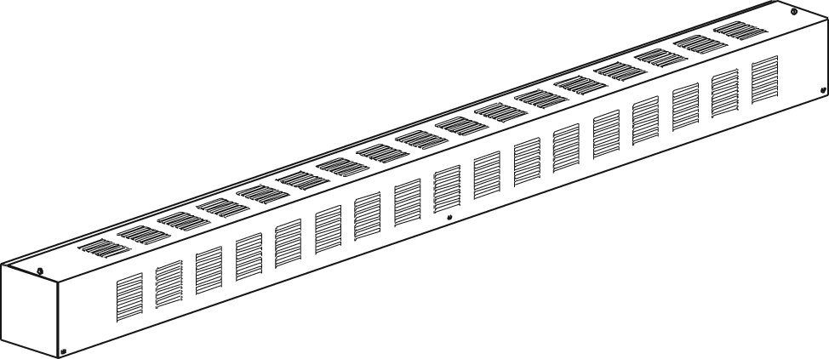

Features
Color - Standard: white, almond.
- Optional (upcharge applicable): metallic silver, bronze, metallic charcoal,
aluminum, semi-gloss black, sand.
- Custom colors available upon request.
Finish - Standard: epoxy/polyester powder paint.
Voltage - 208V, 240/208V, 347V, 600V, 1-phase.
Construction - So sturdy, it can be used as a step (18-gauge steel).
- Linear high-limit temperature control with automatic reset.
Heating element - Stainless steel tubular heating element with aluminum fins.
- Floating heating element on high-temperature nylon bushings
reducing expansion noises.
Watt density - Average standard watt density of 209W/ft.
Control - Built-in thermostat available with control knob or tamperproof
(installed on the right end only).
- Mechanical or electronic relays available (installed on the right end only).
Ouellet highly recommends using an electronic wall thermostat for greater confort.
Installation - Mounting holes spaced on 2 in. (51 mm) intervals for ease of installation.
- Variety of accessories available for wall-to-wall installation.
- Pedestal kit available.
Warranty - 3-year warranty against defects.
- 10-year warranty on the heating element.
Application - Patio door, bay window, commercial building, office building,
condo, restaurant.

Average Standard Watt Density Models 209W/ft.
Watts | Watts  240/208V | Product # |  |  |  |  |  |  |  | Length |  | Weight
Watts | Watts  240/208V | 208V | Qty | 240/208V | Qty | 347V | Qty | 600V | Qty | in. | mm | lb | kg
500 | 500/375 | OPP0508 |  | OPP0500 |  | OPP0507 |  | - | - | 33 _{1/2} | 855 | 13.0 | 5.9
750 | 750/563 | OPP0758 |  | OPP0750 |  | OPP0757 |  | OPP0756 |  | 48 | 1219 | 17.0 | 7.7
1000 | 1000/750 | OPP1008 |  | OPP1000 |  | OPP1007 |  | OPP1006 |  | 60 | 1525 | 20.0 | 9.1
1250 | 1250/938 | OPP1258 |  | OPP1250 |  | OPP1257 |  | OPP1256 |  | 72 | 1830 | 26.0 | 11.8
1500 | 1500/1125 | OPP1508 |  | OPP1500 |  | OPP1507 |  | OPP1506 |  | 86 _{3/4} | 2204 | 31.0 | 14.1
1750 | 1750/1313 | OPP1758 |  | OPP1750 |  | OPP1757 |  | OPP1756 |  | 100 | 2542 | 38.0 | 17.3
2000 | 2000/1500 | OPP2008 |  | OPP2000 |  | OPP2007 |  | OPP2006 |  | 113 _{5/16} | 2879 | 41.0 | 18.6

Options
Product #  Kit | Product #  Factory installed* | Description | Qty
- | BD | Clean back
KIT-OPP-CIBR | - | Corner (inside and outside), 4 in. (102 mm). Relay section.
KIT-OPP-JT | - | Splice plate, 2 in. (51 mm)
KIT-OPP-JT-PE | - | Contour splice plate for heaters with pedestals, 2 in. (51 mm)
KIT-OPP-PE | - | Round pedestal kit (2), 3 in. (76 mm)
KIT-OPP-PEC | - | Square-shaped pedestal kit (2), 2 in. (51 mm)
KIT-OPP-R-347¹ | R¹ | Single-pole relay, coil 24V, without transformer: 22A at 208V, 240V - 18A at 347V
KIT-OPP-R-600¹ | R¹ | Single-pole relay, coil 24V, without transformer, 10A at 600V
KIT-OPP-RT-208¹ | RT¹ | Single-pole relay, coil 24V, with transformer 208V/24V, 22A at 208V
KIT-OPP-RT-240¹ | RT¹ | Single-pole relay, coil 24V, with transformer 240V/24V, 22A at 240V
KIT-OPP-RT-347¹ | RT¹ | Single-pole relay, coil 24V, with transformer 347V/24V, 18A at 347V
KIT-OPP-RT-600^{1,2} | RT^{1,2} | Single-pole relay, coil 24V, with transformer 600V/24V, 10A at 600V
OPP-SV-XX | - | Empty cabinet length of XX mm (minimum: 154 mm, maximum: 2879 mm)
KIT-OPP-TB1¹ | TB1¹ | Single-pole thermostat: 30A at 120V, 208V, 240V - 15A at 347V, 600V
KIT-OPP-TB2^{1,3} | TB2^{1,3} | Double-pole thermostat: 30A at 120V, 208V, 240V - 15A at 347V, 600V
KIT-OPP-TB1-AV¹ | TB1AV¹ | Single-pole thermostat, tamperproof: 30A at 120V, 208V, 240V - 15A at 347V, 600V
KIT-OPP-TB2-AV^{1,3} | TB2AV^{1,3} | Double-pole thermostat, tamperproof: 30A at 120V, 208V, 240V - 15A at 347V, 600V
KIT-OPP-TRIAC-347¹ | TRIAC¹ | Single-pole electronic relay, coil 24V, without transformer: 10A max. at 347V max.
KIT-OPP-TRIAC-347T¹ | TRIACT¹ | Single-pole electronic relay, coil 24V, with transformer: 10A max. at 208V, 240V, 347V
KIT-OPP-TRIAC-600¹ | TRIAC¹ | Single-pole electronic relay, coil 24V, without transformer,6A at 600V max.

* For factory installed options, add the option number to the product number. See the Product Code section inside the front cover.
¹ Options installed at right end only.
² These 2-wire relays with transformer can't supply low voltage thermostats.
³ "Off" position.
Add "BL" for white, "AM" for almond. Upcharge available for optional colors shown in the color chart section.

Others
Type | Quantity | Model et description  Complementary informations | Volts | Phase | Watts | Length  mm/in. | Informations  Color/installation

Specifications may change without prior notice
Project: | Approval  Information
Consultant Engineer: | Approval  Information
Eectrician Contractor: | Approval  Information
Distributor: | Approval  Information
Date: | Approval  Information
Contact in Ouellet: | Approval  Information
Comments:

