Series
OPH Plenum Rated Unit Heater

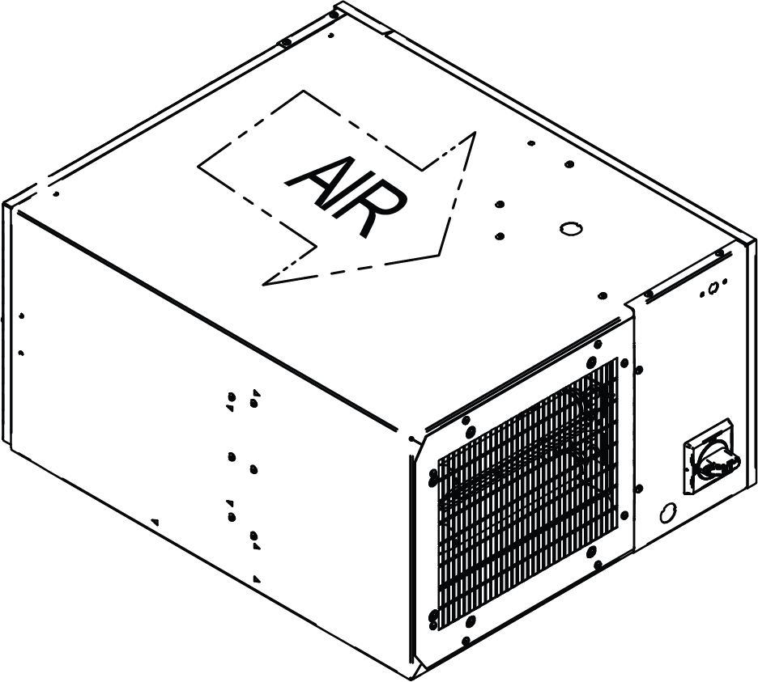
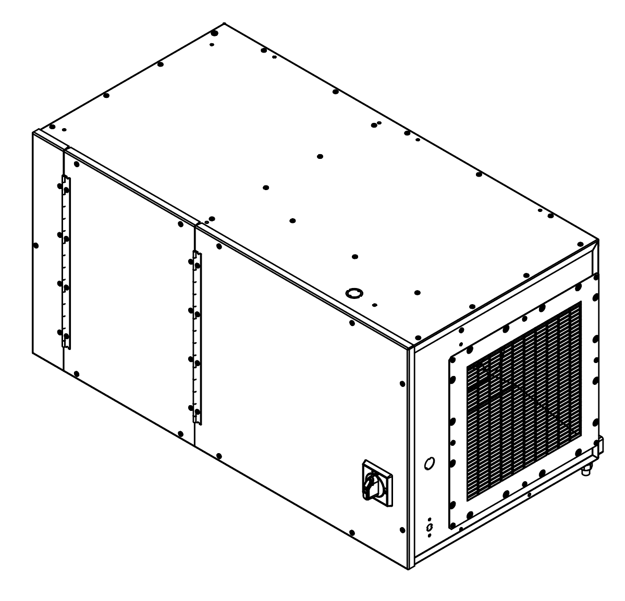


Features
Color - Standard: aluminum.
Finish - Standard: epoxy/polyester powder paint.
Voltage - 208V, 240V, 277V, 347V, 480V, 600V, 1 or 3-phase.
Construction - 18 and 20-gauge steel.
- Adjustable louver for air flow direction available.
- Automatic reset and manual reset high-limit temperature control.
- One contactor per high-limit temperature control, on independent circuit.
Fan - Direct drive, selectable speed squirrel-cage fan.
- Fan delay.
Motor - Totally enclosed standard factory-lubricated motor.
- Thermally protected motor mounted in cold compartment.
- Constant torque motor (ECM), 1/3 HP max., 1050 rpm max., available.
Heating element - Three tubular heating elements with ﬁns (for 3.1kW-5kW-7.5kW models).
- Six tubular heating elements with fins (for 10kW-12kW-15kW models).
Control - Factory-installed contactor and 240/208V control circuit standard.*
- Factory-installed disconnect switch.
- 24V control circuit, with transformer available.*
- 120V control circuit with transformer available.*
- Built-in thermostat available.
- Optional 2-stage thermostat (for 10kW-12kW-15kW models).
Ouellet highly recommends to use a wall thermostat for greater comfort.
Any remote thermostat or relay must be connected to the heater control terminal block.
*Two stage heat with 2-stage thermostat available for 10kW to 15kW models.
Installation - Horizontal mounting with free air discharge or ducted installation.
- Vertical mounting in the upwards air flow position with ducted installation only
(3.1kW and 5kW models only).
- 27 °C (80 °F) maximum operating ambient temperature.
- Zero clearance approved when installed in concealed space.
Warranty - 3-year warranty against defects.
Application - This heater is designed to be used in the space between a structural ceiling
and a suspended ceiling, plenum space or plenum.
- Crawl space, commercial vestibule, office, commercial building, warehouse, stairwell,
underground parking.

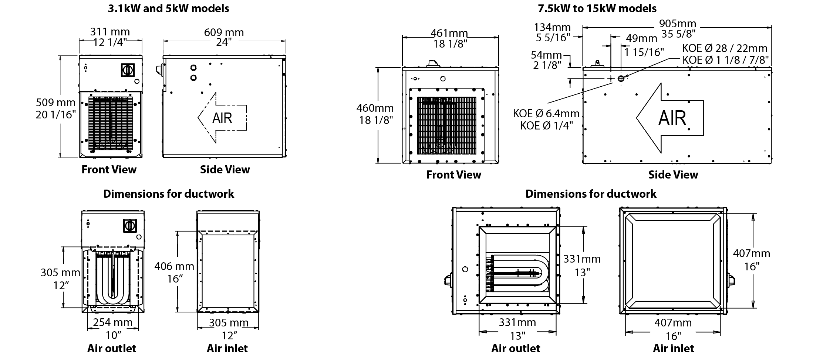

Models
Product # | Qty | Volts | Phase | kW (BTU/hr) | cfm min.¹ |  | Temperature Rise² |  | Motor |  | Weight
 |  |  |  |  | Low Speed | High Speed | ºC | ºF | HP | rpm | lb | kg
OPH03108AL-DIS40 |  | 208 | 1 | 3.1 (10578) | 430 | 460 | 12 | 22 | 1/3 | 1075 | 65 | 29.6
OPH03138AL-DIS40 |  | 208 | 3 | 3.1 (10578) | 430 | 460 | 12 | 22 | 1/3 | 1075 | 65 | 29.6
OPH03100AL-DIS40 |  | 240 | 1 | 3.1 (10578) | 430 | 460 | 12 | 22 | 1/3 | 1075 | 65 | 29.6
OPH03130AL-DIS40 |  | 240 | 3 | 3.1 (10578) | 430 | 460 | 12 | 22 | 1/3 | 1075 | 65 | 29.6
OPH03177AL-DIS40 |  | 277 | 1 | 3.1 (10578) | 430 | 460 | 12 | 22 | 1/3 | 1075 | 65 | 29.6
OPH03107AL-DIS40 |  | 347 | 1 | 3.1 (10578) | 430 | 460 | 12 | 22 | 1/3 | 1075 | 77 | 35.0
OPH03104AL-DIS40 |  | 480 | 1 | 3.1 (10578) | 430 | 460 | 12 | 22 | 1/3 | 1075 | 77 | 35.0
OPH03134AL-DIS40 |  | 480 | 3 | 3.1 (10578) | 430 | 460 | 12 | 22 | 1/3 | 1075 | 77 | 35.0
OPH03106AL-DIS40 |  | 600 | 1 | 3.1 (10578) | 430 | 460 | 12 | 22 | 1/3 | 1075 | 77 | 35.0
OPH03136AL-DIS40 |  | 600 | 3 | 3.1 (10578) | 430 | 460 | 12 | 22 | 1/3 | 1075 | 77 | 35.0
OPH05008AL-DIS40 |  | 208 | 1 | 5 (17060) | 430 | 460 | 21 | 37 | 1/3 | 1075 | 65 | 29.6
OPH05038AL-DIS40 |  | 208 | 3 | 5 (17060) | 430 | 460 | 21 | 37 | 1/3 | 1075 | 65 | 29.6
OPH05000AL-DIS40 |  | 240 | 1 | 5 (17060) | 430 | 460 | 21 | 37 | 1/3 | 1075 | 65 | 29.6
OPH05030AL-DIS40 |  | 240 | 3 | 5 (17060) | 430 | 460 | 21 | 37 | 1/3 | 1075 | 65 | 29.6
OPH05077AL-DIS40 |  | 277 | 1 | 5 (17060) | 430 | 460 | 21 | 37 | 1/3 | 1075 | 65 | 29.6
OPH05007AL-DIS40 |  | 347 | 1 | 5 (17060) | 430 | 460 | 21 | 37 | 1/3 | 1075 | 77 | 35.0
OPH05004AL-DIS40 |  | 480 | 1 | 5 (17060) | 430 | 460 | 21 | 37 | 1/3 | 1075 | 77 | 35.0
OPH05034AL-DIS40 |  | 480 | 3 | 5 (17060) | 430 | 460 | 21 | 37 | 1/3 | 1075 | 77 | 35.0
OPH05006AL-DIS40 |  | 600 | 1 | 5 (17060) | 430 | 460 | 21 | 37 | 1/3 | 1075 | 77 | 35.0
OPH05036AL-DIS40 |  | 600 | 3 | 5 (17060) | 430 | 460 | 21 | 37 | 1/3 | 1075 | 77 | 35.0
OPH07508AL-DIS80 |  | 208 | 1 | 7.5 (25591) | 1100 | 1200 | 14 | 25 | 1/3 | 1075 | 100 | 45.5
OPH07538AL-DIS40 |  | 208 | 3 | 7.5 (25591) | 1100 | 1200 | 14 | 25 | 1/3 | 1075 | 100 | 45.5
OPH07500AL-DIS40 |  | 240 | 1 | 7.5 (25591) | 1100 | 1200 | 14 | 25 | 1/3 | 1075 | 100 | 45.5
OPH07530AL-DIS40 |  | 240 | 3 | 7.5 (25591) | 1100 | 1200 | 14 | 25 | 1/3 | 1075 | 100 | 45.5
OPH07577AL-DIS40 |  | 277 | 1 | 7.5 (25591) | 1100 | 1200 | 14 | 25 | 1/3 | 1075 | 100 | 45.5
OPH07507AL-DIS40 |  | 347 | 1 | 7.5 (25591) | 1100 | 1200 | 14 | 25 | 1/3 | 1075 | 100 | 45.5
OPH07504AL-DIS40 |  | 480 | 1 | 7.5 (25591) | 1100 | 1200 | 14 | 25 | 1/3 | 1075 | 100 | 45.5
OPH07534AL-DIS40 |  | 480 | 3 | 7.5 (25591) | 1100 | 1200 | 14 | 25 | 1/3 | 1075 | 100 | 45.5
OPH07506AL-DIS40 |  | 600 | 1 | 7.5 (25591) | 1100 | 1200 | 14 | 25 | 1/3 | 1075 | 100 | 45.5
OPH07536AL-DIS40 |  | 600 | 3 | 7.5 (25591) | 1100 | 1200 | 14 | 25 | 1/3 | 1075 | 100 | 45.5
OPH10038AL-DIS40 |  | 208 | 3 | 10 (34121) | 1100 | 1200 | 18 | 32 | 1/3 | 1075 | 100 | 45.5
OPH10000AL-DIS80 |  | 240 | 1 | 10 (34121) | 1100 | 1200 | 18 | 32 | 1/3 | 1075 | 100 | 45.5
OPH10030AL-DIS40 |  | 240 | 3 | 10 (34121) | 1100 | 1200 | 18 | 32 | 1/3 | 1075 | 100 | 45.5
OPH10077AL-DIS80 |  | 277 | 1 | 10 (34121) | 1100 | 1200 | 18 | 32 | 1/3 | 1075 | 100 | 45.5
OPH10007AL-DIS40 |  | 347 | 1 | 10 (34121) | 1100 | 1200 | 18 | 32 | 1/3 | 1075 | 100 | 45.5
OPH10004AL-DIS40 |  | 480 | 1 | 10 (34121) | 1100 | 1200 | 18 | 32 | 1/3 | 1075 | 100 | 45.5
OPH10034AL-DIS40 |  | 480 | 3 | 10 (34121) | 1100 | 1200 | 18 | 32 | 1/3 | 1075 | 100 | 45.5
OPH10006AL-DIS40 |  | 600 | 1 | 10 (34121) | 1100 | 1200 | 18 | 32 | 1/3 | 1075 | 100 | 45.5
OPH10036AL-DIS40 |  | 600 | 3 | 10 (34121) | 1100 | 1200 | 18 | 32 | 1/3 | 1075 | 100 | 45.5
OPH12038AL-DIS80 |  | 208 | 3 | 12 (40945) | 1100 | 1200 | 22 | 40 | 1/3 | 1075 | 100 | 45.5
OPH12030AL-DIS40 |  | 240 | 3 | 12 (40945) | 1100 | 1200 | 22 | 40 | 1/3 | 1075 | 100 | 45.5
OPH12007AL-DIS80 |  | 347 | 1 | 12 (40945) | 1100 | 1200 | 22 | 40 | 1/3 | 1075 | 100 | 45.5
OPH12004AL-DIS40 |  | 480 | 1 | 12 (40945) | 1100 | 1200 | 22 | 40 | 1/3 | 1075 | 100 | 45.5
OPH12034AL-DIS40 |  | 480 | 3 | 12 (40945) | 1100 | 1200 | 22 | 40 | 1/3 | 1075 | 100 | 45.5
OPH12006AL-DIS40 |  | 600 | 1 | 12 (40945) | 1100 | 1200 | 22 | 40 | 1/3 | 1075 | 100 | 45.5
OPH12036AL-DIS40 |  | 600 | 3 | 12 (40945) | 1100 | 1200 | 22 | 40 | 1/3 | 1075 | 100 | 45.5
OPH15038AL-DIS80 |  | 208 | 3 | 15 (51182) | 1100 | 1200 | 27 | 49 | 1/3 | 1075 | 100 | 45.5
OPH15030AL-DIS80 |  | 240 | 3 | 15 (51182) | 1100 | 1200 | 27 | 49 | 1/3 | 1075 | 100 | 45.5
OPH15004AL-DIS40 |  | 480 | 1 | 15 (51182) | 1100 | 1200 | 27 | 49 | 1/3 | 1075 | 112 | 50.9
OPH15034AL-DIS40 |  | 480 | 3 | 15 (51182) | 1100 | 1200 | 27 | 49 | 1/3 | 1075 | 112 | 50.9
OPH15006AL-DIS40 |  | 600 | 1 | 15 (51182) | 1100 | 1200 | 27 | 49 | 1/3 | 1075 | 112 | 50.9
OPH15036AL-DIS40 |  | 600 | 3 | 15 (51182) | 1100 | 1200 | 27 | 49 | 1/3 | 1075 | 112 | 50.9

¹ Tested at 0.2’’ water column (static pressure).
² Tested at low speed.
Standard color is aluminum.

Options
Product #  Kit | Product #  Factory installed* | Description | Qty
- | 24 | 24V control circuit
- | 120¹ | 120V control circuit
- | OL | Power indicator light
- | ECM² | Constant torque motor (ECM), 1/3 HP max., 1050 rpm max.
KIT-OPH-3-5KW-FI | FI | Pleated air filter for 3-5kW models
KIT-OPH-3-5KW-FIW | FIW | Washable air filter for 3-5kW models
KIT-OPH-3-5KW-LR | LR | Louver kit for 3-5kW models
KIT-OPH-3-5KW-T | T | Built-in thermostat for 3-5kW models
KIT-OPH-7-15KW-FI | FI | Pleated air filter for 7-15kW models
KIT-OPH-7-15KW-FIW | FIW | Washable air filter for 7-15kW models
KIT-OPH-7-15KW-LR | LR | Louver kit for 7-15kW models
KIT-OPH-7-15KW-T | T | Built-in thermostat for 7-15kW models
KIT-OPH-T2S | T2S | Built-in 2-stage thermostat for 10-15kW models only

¹ With basic control or with the option «-120», the fan will work at low speed only.
² Built-in transformer and contactor for 24V are required, add « -24 » to the product number.
* For factory installed options, add the option number to the product number. See the Product Code section inside the front cover.

Others
Type | Quantity | Model et description  Complementary informations | Volts | Phase | Watts | Length  mm/in. | Informations  Color/installation

Specifications may change without prior notice
Project: | Approval  Information
Consultant Engineer: | Approval  Information
Electrician Contractor: | Approval  Information
Distributor: | Approval  Information
Date: | Approval  Information
Contact in Ouellet: | Approval  Information
Comments:

