Series
OPA Architectural Cabinet Convector
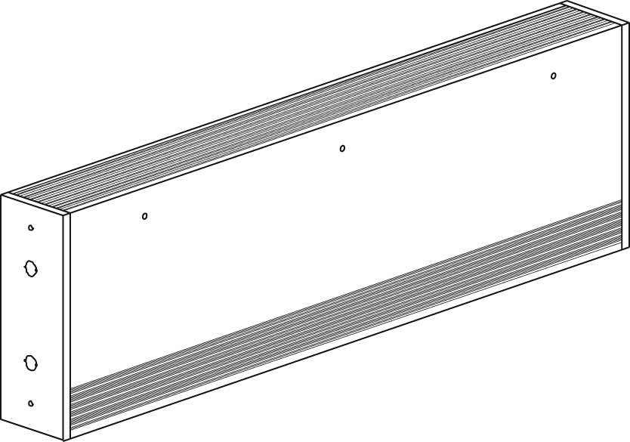

Features
Color - Standard: white, almond.
- Optional (upcharge applicable): metallic silver, bronze, metallic charcoal,
aluminum, semi-gloss black, sand.
- Custom colors available upon request.
Finish - Standard: epoxy/polyester powder paint.
Voltage - 208V, 240/208V, 277V, 347V, 600V, 1-phase.
Construction - 20-gauge steel cabinet.
- 16-gauge steel front cover.
- Extruded aluminum bar grilles prevent insertion of foreign objects.
- Front fresh air inlet; top warm air outlet.
- Front warm air outlet available (-FR).
- Clean back available (-BD).
- Linear high-limit temperature control with automatic reset.
Heating element - Two stainless steel tubular heating elements with aluminum ﬁns.
- Floating elements on high-temperature nylon bushings
reducing expansion noises.
Watt density - Average standard watt density of 500W/ft.
- Average low watt density of 375W/ft.
Control - Built-in tamperproof thermostat available.
- Mechanical, electronic or pneumatic relays available.
Ouellet highly recommends use of an electronic wall thermostat for greater comfort.
Installation - Not for residential use in the United States.
- Wall or ﬂoor mounted installation.
- Front outlet -FR models may be recessed.
- Mounting holes spaced on 2 in. (51 mm) intervals for ease of installation.
- Variety of accessories available for wall-to-wall installation.
- Pedestal kit or sub-base available.
Warranty - 1-year warranty against defects.
Application - Commercial building, office building, hospital, daycare center.

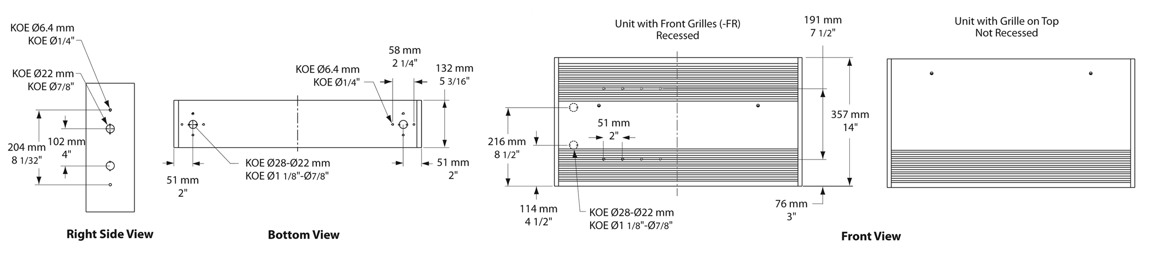
Standard Watt Density Models
Watts | Watts | Product # |  |  |  |  |  | Length |  | Weight
Watts | 240/208V | 208V | Qty | 240/208V | Qty | 277V | Qty | in. | mm | lb | kg
1000 | 1000/750 | OPA1008 |  | OPA1000 |  | OPA1077 |  | 27 _{3/16} | 690 | 30.0 | 13.6
1500 | 1500/1125 | OPA1508 |  | OPA1500 |  | OPA1577 |  | 37 _{3/16} | 944 | 46.0 | 20.9
2000 | 2000/1500 | OPA2008 |  | OPA2000 |  | OPA2077 |  | 47 _{3/16} | 1198 | 57.0 | 25.9
2500 | 2500/1875 | OPA2508 |  | OPA2500 |  | OPA2577 |  | 57 _{3/16} | 1452 | 66.0 | 29.9
3000 | 3000/2250 | OPA3008 |  | OPA3000 |  | OPA3077 |  | 65 _{3/16} | 1655 | 75.0 | 34.0
3500 | 3500/2625 | OPA3508¹ |  | OPA3500 |  | OPA3577 |  | 75 _{3/16} | 1909 | 80.0 | 36.3
4000 | 4000/3000 | OPA4008¹ |  | OPA4000¹ |  | OPA4077 |  | 83 _{1/8} | 2112 | 89.0 | 40.4

Low Watt Density Models
Watts | Product # |  |  |  |  |  | Length |  | Weight
Watts | 208V | Qty | 240V | Qty | 277V | Qty | in. | mm | lb | kg
800 | OPA0808-690 |  | OPA0800-690 |  | OPA0877-690 |  | 27 _{3/16} | 690 | 30.0 | 13.6
1000 | OPA1008-944 |  | OPA1000-944 |  | OPA1077-944 |  | 37 _{3/16} | 944 | 46.0 | 20.9
1500 | OPA1508-1198 |  | OPA1500-1198 |  | OPA1577-1198 |  | 47 _{3/16} | 1198 | 57.0 | 25.9
1750 | OPA1758-1452 |  | OPA1750-1452 |  | OPA1777-1452 |  | 57 _{3/16} | 1452 | 66.0 | 29.9
2000 | OPA2008-1655 |  | OPA2000-1655 |  | OPA2077-1655 |  | 65 _{3/16} | 1655 | 75.0 | 34.0
2500 | OPA2508-2112 |  | OPA2500-2112 |  | OPA2577-2112 |  | 83 _{1/8} | 2112 | 89.0 | 40.4
2750 | OPA2758-2112 |  | OPA2750-2112 |  | OPA2777-2112 |  | 83 _{1/8} | 2112 | 89.0 | 40.4

¹If the control option "24V electronic relay" is required, these products need two electronic relays.
Add "BL" for white, "AM" for almond. Optional colors shown in the color chart section are available upon request.
Other colors, accessories and finishes are available upon request. Please contact your customer service representative.
Other voltages available upon request.
Other low watt density models available upon request.

Options
Product #  Kit | Product #  Factory installed* | Description | Qty
Finish
- | BD | Clean back
KIT-OPA-CI | - | Corner (inside and outside)
KIT-OPA-CR-27 | - | Recess trim kit, 27 3/16 in. (690 mm)
KIT-OPA-CR-37 | - | Recess trim kit, 37 3/16 in. (944 mm)
KIT-OPA-CR-47 | - | Recess trim kit, 47 3/16 in. (1198 mm)
KIT-OPA-CR-57 | - | Recess trim kit, 57 3/16 in. (1452 mm)
KIT-OPA-CR-65 | - | Recess trim kit, 65 3/16 in. (1655 mm)
KIT-OPA-CR-75 | - | Recess trim kit, 75 3/16 in. (1909 mm)
KIT-OPA-CR-83 | - | Recess trim kit, 83 1/8 in. (2112 mm)
KIT-OPA-CTR | - | Relay box, 12 in. (305 mm)
- | FR | Front warm air outlet
KIT-OPA-PEC | - | Square-shaped pedestal kit (2), 3 in. (76 mm)
KIT-OPA-SO-27 | - | Sub-base, 27 3/16 in. (690 mm)
KIT-OPA-SO-37 | - | Sub-base, 37 3/16 in. (944 mm)
KIT-OPA-SO-47 | - | Sub-base, 47 3/16 in. (1198 mm)
KIT-OPA-SO-57 | - | Sub-base, 57 3/16 in. (1452 mm)
KIT-OPA-SO-65 | - | Sub-base, 65 3/16 in. (1655 mm)
KIT-OPA-SO-75 | - | Sub-base, 75 3/16 in. (1909 mm)
KIT-OPA-SO-83 | - | Sub-base, 83 1/8 in. (2112 mm)
KIT-OPA-SV-27 | - | Empty cabinet, 27 3/16 in. (690 mm)
KIT-OPA-SV-37 | - | Empty cabinet, 37 3/16 in. (944 mm)
KIT-OPA-SV-47 | - | Empty cabinet, 47 3/16 in. (1198 mm)
KIT-OPA-SV-57 | - | Empty cabinet, 57 3/16 in. (1452 mm)
KIT-OPA-SV-65 | - | Empty cabinet, 65 3/16 in. (1655 mm)
KIT-OPA-SV-75 | - | Empty cabinet, 75 3/16 in. (1909 mm)
KIT-OPA-SV-83 | - | Empty cabinet, 83 1/8 in. (2112 mm)
Controls
- | CTT | Single-pole relay, coil 240V: 25A at 240V, 10A at 600V
- | CTT2 | Double-pole relay, coil 240V: 25A at 240V, 10A at 600V
- | DIS40² | Disconnect switch, triple-pole, 40A at 600V
- | PM | Pneumatic relay, 20A at 600V
KIT-OPA-R | R | Single-pole relay, coil 24V, without transformer: 22A at 208V, 240V - 18A at 347V
KIT-OPA-R2 | R2 | Double-pole relay, coil 24V, without transformer: 25A at 240V - 10A at 600V
KIT-OPA-RT-208 | RT | Single-pole relay, coil 24V, with transformer 208V/24V, 4500W, 22A at 208V
KIT-OPA-RT-240 | RT | Single-pole relay, coil 24V, with transformer 240V/24V, 5200W, 22A at 240V
KIT-OPA-RT-277 | RT | Single-pole relay, coil 24V, with transformer 277V/24V, 5200W, 19A at 277V
KIT-OPA-RT-347 | RT | Single-pole relay, coil 24V, with transformer 347V/24V, 6000W, 18A at 347V
KIT-OPA-RT-600¹ | RT¹ | Single-pole relay, coil 24V, with transformer 600V/24V, 6000W, 10A at 600V (2-wire only)
KIT-OPA-T-AV | TAV | Single-pole tamperproof thermostat: 30A at 250V max. - 15A at 600V max.
KIT-OPA-T2-AV | T2AV | Double-pole tamperproof thermostat: 30A at 250V max. - 15A at 600V max.
- | TRIAC | Single-pole electronic relay, coil 24V, without transformer, 15A at 347V max.
- | TRIACT | Single-pole electronic relay, coil 24V, with transformer: 15A at 208V, 240V, 347V
- | TRIAC | Single-pole electronic relay, coil 24V, without transformer, 6A at 600V max.
Transformers
- | TRF24 | Transformer 24V, 50VA
- | TRF240 | Transformer 240V, 50VA

* For factory installed options, add the option number to the product number. See the Product Code section inside the front cover.
¹ These 2-wire relays with transformer can't supply of 3-wire low voltage thermostats.
² For the U.S. only: The nominal current of the unit must not exceed 80% of the capacity of the disconnect.

Others
Type | Quantity | Model et description  Complementary informations | Volts | Phase | Watts | Length  mm/in. | Informations  Color/installation

Specifications may change without prior notice
Project: | Approval  Information
Consultant Engineer: | Approval  Information
Eectrician Contractor: | Approval  Information
Distributor: | Approval  Information
Date: | Approval  Information
Contact in Ouellet: | Approval  Information
Comments:

