Series
ONC Standard Convector


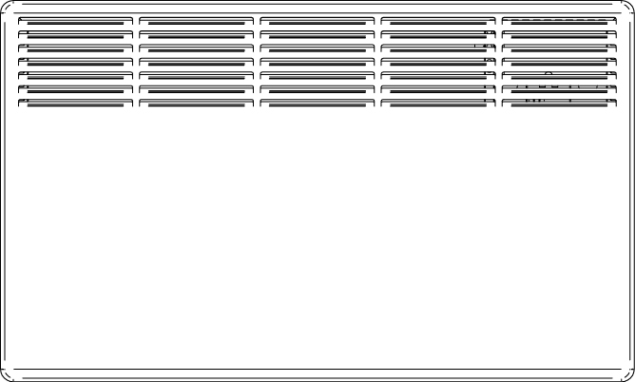

Features
Color - Standard: white.
- Optional (upcharge applicable): almond, metallic silver, bronze, aluminum,
semi-gloss black, metallic charcoal, sand.
- Custom colors available upon request.
Finish - Standard: epoxy/polyester powder paint.
Voltage - 120V, 208V, 240/208V, 277V, 347V, 480V, 600V, 60 Hz, 1-phase.
Construction - 20-gauge steel.
- Warm air outlet that directs the air to the centre of the room.
- Bar grilles prevent insertion of foreign objects.
- High-limit temperature control with automatic reset.
Heating element - 2 stainless steel tubular heating elements with aluminum fins.
- Floating heating element on high-temperature nylon bushings reducing expansion noises.
Watt density - 700W/ft. (2320W/m).
Control - Built-in non programmable electronic thermostat for the 120V to 240V models (-TH models).
- Wall thermostat (not included).
Installation - 4 in. (102 mm) minimum clearance to ﬂoor and from an adjacent wall.
- Quick surface-mounted installation, with the included wall mounting bracket.
Warranty - 5-year warranty against defects.
Ouellet highly recommends the use of an electronic wall thermostat for greater comfort.
Application - Kitchen, living room, family room, bedroom, basement.
Models
Product # |  |  |  | Volts | Watts | Length |  | Weight
Without thermostat | Qty | Built-in thermostat | Qty | Volts | Watts | po | mm | lb | kg
ONC0502BL |  | ONC0502BL-TH |  | 120 | 500 | 18 | 457 | 13 | 6
ONC1002BL |  | ONC1002BL-TH |  | 120 | 1000 | 23 9/16 | 598 | 16.7 | 7.6
ONC1502BL |  | ONC1502BL-TH |  | 120 | 1500 | 29 1/16 | 739 | 20 | 9.12
ONC0508BL |  | ONC0508BL-TH |  | 208 | 500 | 18 | 457 | 13 | 6
ONC1008BL |  | ONC1008BL-TH |  | 208 | 1000 | 23 9/16 | 598 | 16.7 | 7.6
ONC1508BL |  | ONC1508BL-TH |  | 208 | 1500 | 29 1/16 | 739 | 20 | 9.12
ONC2008BL |  | ONC2008BL-TH |  | 208 | 2000 | 34 5/8 | 880 | 24 | 10.9
ONC0500BL |  | ONC0500BL-TH |  | 240/208 | 500/375 | 18 | 457 | 13 | 6
ONC1000BL |  | ONC1000BL-TH |  | 240/208 | 1000/750 | 23 9/16 | 598 | 16.7 | 7.6
ONC1500BL |  | ONC1500BL-TH |  | 240/208 | 1500/1125 | 29 1/16 | 739 | 20 | 9.12
ONC2000BL |  | ONC2000BL-TH |  | 240/208 | 2000/1500 | 34 5/8 | 880 | 24 | 10.9
ONC0507BL |  | - |  | 347 | 500 | 18 | 457 | 13 | 6
ONC1007BL |  | - |  | 347 | 1000 | 23 9/16 | 598 | 16.7 | 7.6
ONC1507BL |  | - |  | 347 | 1500 | 29 1/16 | 739 | 20 | 9.12
ONC2007BL |  | - |  | 347 | 2000 | 34 5/8 | 880 | 24 | 10.9
ONC1006BL |  | - |  | 600 | 1000 | 23 9/16 | 598 | 16.7 | 7.6
ONC1506BL |  | - |  | 600 | 1500 | 29 1/16 | 739 | 20 | 9.12
ONC2006BL |  | - |  | 600 | 2000 | 34 5/8 | 880 | 24 | 10.9
Standard color is white.

Options
Produit #  Kit | Produit #  Factory installed* | Description | Qty
KIT-ONC-TRIAC-347 | TRIAC | Single-pole electronic relay, coil 24V, without transformer: 15A at 347V max.
KIT-ONC-TRIAC-347T | TRIACT | Single-pole electronic relay, coil 24V, with transformer: 15A at 208V, 240V, 277V, 347V
KIT-ONC-TRIAC-600 | TRIAC | Single-pole electronic relay, coil 24V, without transformer: 6A at 600V max.
* For factory installed options, add the option number to the product number. See the Product Code section inside the front cover.
Other voltages available upon request.

Others
Type | Quantity | Model and description  Complementary informations | Volts | Phase | Watts | Length  mm/in. | Informations  Color/installation

Specifications may change without prior notice
Project: | Approval  Information
Consultant Engineer: | Approval  Information
Eectrician Contractor: | Approval  Information
Distributor: | Approval  Information
Date: | Approval  Information
Contact in Ouellet: | Approval  Information
Comments:

