Series
OMP Mini Aluminum Electric Baseboard Heater
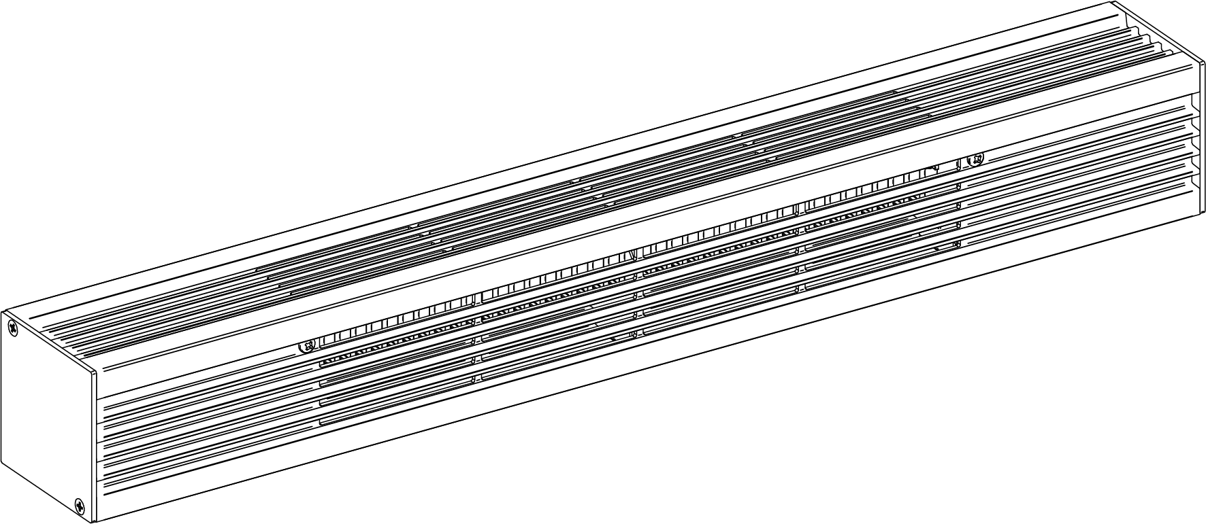

Features
Color - Standard: white, almond.
- Optional (upcharge applicable): metallic silver, bronze, metallic charcoal,
aluminum, semi-gloss black, sand.
- Custom colors available upon request.
Finish - Standard: epoxy/polyester powder paint.
- Optional: anodized aluminum.
Voltage - 120V, 208V, 240/208V, 277V, 347V, 480V, 600V, 1-phase.
Construction - Robust, 18-gauge cold rolled steel cabinet.
- 14-gauge (0.0787 in. [2 mm]) aluminum front and top.
- Pencil-proof openings 1/4 in. (6.4 mm).
- 3 in. x 3 in. (76 mm x 76 mm) compact profile.
- Linear high-limit temperature control with automatic reset.
Heating element - Stainless steel tubular heating element with aluminum fins.
- Floating heating element on high-temperature nylon bushings
reducing expansion noises.
Watt density - Average standard watt density of 152W/ft.
Control - Built-in tamperproof thermostat available (installed on the left end only).
- Mechanical or electronic relays available (installed on the right end only).
Ouellet highly recommends using an electronic wall thermostat for greater comfort.
Installation - 2 rows of mounting holes, every 2 in. (51 mm), for ease of installation.
- Variety of accessories available for wall-to-wall installation.
- Pedestal kit available.
Warranty - 3-year warranty against defects.
- 10-year warranty on the heating element.
Application - Patio door, bay window, commercial building, office building, condos, restaurant.

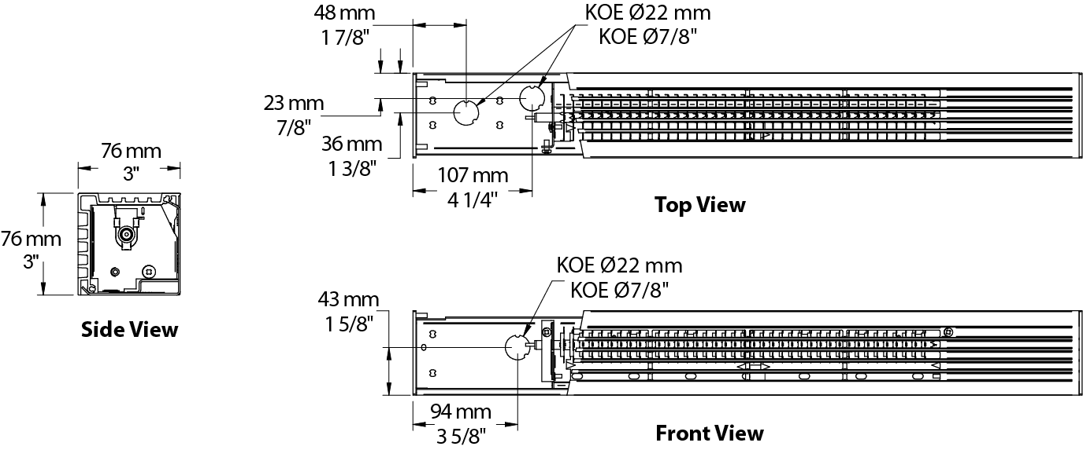

Average Standard Watt Density Models 152W/ft.
Watts | Watts  240/208V | Product # |  |  |  |  |  |  |  |  |  | Length |  | Weight
Watts | Watts  240/208V | 120V | Qty | 208V | Qty | 240/208V | Qty | 347V | Qty | 600V | Qty | in. | mm | lb | kg
300 | 300/225 | OMP0302 |  | OMP0308 |  | OMP0300 |  | - | - | - | - | 23 _{5/8} | 600 | 5.3 | 2.4
450 | 450/338 | OMP0452 |  | OMP0458 |  | OMP0450 |  | OMP0457 |  | - | - | 35 _{7/16} | 900 | 9.5 | 4.3
600 | 600/450 | OMP0602 |  | OMP0608 |  | OMP0600 |  | OMP0607 |  | - | - | 47 _{1/4} | 1200 | 12.2 | 5.5
750 | 750/563 | OMP0752 |  | OMP0758 |  | OMP0750 |  | OMP0757 |  | OMP0756 |  | 59 _{1/16} | 1500 | 15.0 | 6.8
900 | 900/675 | OMP0902 |  | OMP0908 |  | OMP0900 |  | OMP0907 |  | OMP0906 |  | 70 _{7/8} | 1800 | 17.8 | 8.1
1050 | 1050/788 | OMP1052 |  | OMP1058 |  | OMP1050 |  | OMP1057 |  | OMP1056 |  | 82 _{11/16} | 2100 | 20.6 | 9.3
1200 | 1200/900 | OMP1202 |  | OMP1208 |  | OMP1200 |  | OMP1207 |  | OMP1206 |  | 94 _{1/2} | 2400 | 23.4 | 10.6
1350 | 1350/1013 | OMP1352 |  | OMP1358 |  | OMP1350 |  | OMP1357 |  | OMP1356 |  | 106 _{5/16} | 2700 | 26.2 | 11.9

Options
Product #  Kit | Product #  Factory installed* | Description | Qty
- | BD | Clean back
KIT-OMP-CE | - | Outside corner, 4 in. (102 mm)
KIT-OMP-CI | - | Inside corner, 4 in. (102 mm)
KIT-OMP-JT | - | Splice plate, 2 in. (51 mm)
KIT-OMP-JT-PE | - | Contour splice plate for BD option and/or heater with pedestals, 2 in. (51 mm)
KIT-OMP-PE | - | Round pedestal kit (2), 3 in. (76 mm)
KIT-OMP-PEC | - | Square-shaped pedestal kit (2), 2 in. (51 mm)
KIT-OMP-R-347¹ | R¹ | Single-pole relay, coil 24V, without transformer:  22A at 120V, 208V, 240V - 19A at 277V - 18A at 347V
KIT-OMP-R-600¹ | R¹ | Single-pole relay, coil 24V, without transformer: 10A at 480V, 600V
OMP-SV-XX | - | Empty cabinet with length of XX mm (minimum: 154 mm, maximum: 2632 mm)
KIT-OMP-TB6-AV² | TB6AV² | Single-pole bi-metal tamperproof thermostat:  25A at 120V, 208V, 240V, 277V - 10A at 347V, 480V, 600V
KIT-OMP-TB26-AV^{2,3} | TB26AV^{2,3} | Double-pole bi-metal tamperproof thermostat:  25A at 120V, 208V, 240V, 277V - 10A at 347V, 480V, 600V
KIT-OMP-TRIAC-347¹ | TRIAC¹ | Single-pole electronic relay, coil 24V, without transformer: 9A at 347V max.
KIT-OMP-TRIAC-347T¹ | TRIACT¹ | Single-pole electronic relay, coil 24V, with transformer: 9A max. (208V, 240V, 347V)
KIT-OMP-TRIAC-600¹ | TRIAC¹ | Single-pole electronic relay, coil 24V, without transformer: 6A at 600V max.

* For factory installed options, add the option number to the product number. See the Product Code section inside the front cover.
¹ Options installed at right end only.
² Options installed at left end only.
³ "Off" position.
Add "BL" for white, "AM" for almond. Upcharge applicable for optional colors shown in the color chart section.
Other voltages available upon request.

Others
Type | Quantity | Model et description  Complementary information | Volts | Phase | Watts | Length  mm/in. | Information  Color/installation

Specifications may change without prior notice
Project: | Approval  Information
Consultant Engineer: | Approval  Information
Electrician Contractor: | Approval  Information
Distributor: | Approval  Information
Date: | Approval  Information
Contact in Ouellet: | Approval  Information
Comments:

