Series
OMB Mini Aluminum Draft Barrier
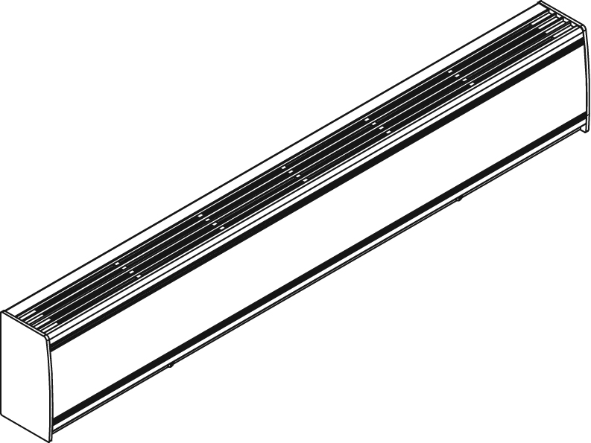

Features
Color - Standard: white, almond.
- Optional (upcharge applicable): metallic silver, bronze, metallic charcoal, aluminum,
semi-gloss black, sand.
- Custom colors available upon request.
Finish - Standard: epoxy/polyester powder paint.
- Optional: anodized aluminum.
Voltage - 208V, 240/208V, 277V, 347V, 600V, 50/60 Hz, 1-phase.
Construction - 14-gauge (0.0787 in. [2 mm]) aluminum front cover.
- 18-gauge satin coat steel cabinet.
- Screw assembly for added strength.
- Full length built-in wireway.
- Separate low voltage wireway (-WW) available.
- Pencil-proof openings less than 1/4 in. (6.4 mm).
- Bottom fresh air inlet; top warm air outlet.
- Clean back available (-BD).
- Linear high-limit temperature control with automatic reset.
High altitude version available (-HA).
- End caps included.
Heating element - Stainless steel tubular heating element with aluminum fins.
- Floating heating element on high-temperature nylon bushings
reducing expansion noises.
Watt density - Average standard watt density of 175W/ft.
- Average low watt density of 100W/ft., 150W/ft.
Control - Built-in thermostat available with a control knob or tamperproof.
- Mechanical, electronic or pneumatic relays available (installed on the right end only).
Ouellet highly recommends to use an electronic wall thermostat for greater comfort.
Installation - Not for residential use in the United States.
- Heater must be installed at least 2 in. (51 mm) from finished floor.
- Mounting holes spaced on 4 in. (102 mm) intervals for ease of installation.
- Installation on wall or ﬂoor mounted with pedestals.
- Variety of accessories available for wall-to-wall installation.
- Pedestal kit available.
Warranty - 3-year warranty against defects.
Application - Commercial building, office building, hospital, daycare center private residence.

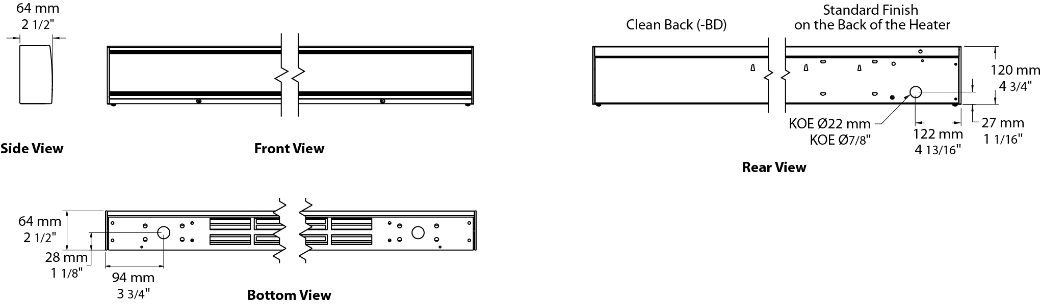

Average Standard Watt Density Models 175W/ft.
Watts | Watts  240/208V¹ | Product # |  |  |  |  |  |  |  | Length |  | Weight
Watts | Watts  240/208V¹ | 208V | Qty | 240/208V | Qty | 347V | Qty | 600V | Qty | in. | mm | lb | kg
350 | 350/263 | OMB0358 |  | OMB0350 |  | - | - | - | - | 27 _{9/16} | 700 | 7.0 | 3.2
525 | 525/394 | OMB0528 |  | OMB0520 |  | OMB0527 |  | - | - | 35 _{7/16} | 900 | 8.3 | 3.8
700 | 700/526 | OMB0708 |  | OMB0700 |  | OMB0707 |  | - | - | 47 _{1/4} | 1200 | 10.2 | 4.6
875 | 875/657 | OMB0878 |  | OMB0870 |  | OMB0807 |  | OMB0876 |  | 59 _{1/16} | 1500 | 12.0 | 5.5
1050 | 1050/789 | OMB1058 |  | OMB1050 |  | OMB1057 |  | OMB1056 |  | 70 _{7/8} | 1800 | 13.9 | 6.3
1225 | 1225/920 | OMB1228 |  | OMB1220 |  | OMB1227 |  | OMB1226 |  | 82 _{11/16} | 2100 | 15.8 | 7.2
1400 | 1400/1052 | OMB1408 |  | OMB1400 |  | OMB1407 |  | OMB1406 |  | 94 _{1/2} | 2400 | 17.6 | 8.0

Average Low Watt Density Models
Product #² | Length | Weight | Average  Density W/ft. | Watts | Watts  240/208V¹ | 208V | Qty | 240/208V | Qty | 347V | Qty | 600V | Qty
OMB030X-700 | 27 9/16"  (700 mm) | 7.0 lb  (3.2 kg) | 150 | 300 | 300/225 | √ |  | √ |  | ----- | ----- | ----- | -----
OMB030X-900 | 35 7/16"  (900 mm) | 8.3 lb  (3.8 kg) | 100 | 300 | 300/225 | √ |  | √ |  | ----- | ----- | ----- | -----
OMB045X-900 | 35 7/16"  (900 mm) | 8.3 lb  (3.8 kg) | 150 | 450 | 450/338 | √ |  | √ |  | √ |  | ----- | -----
OMB040X-1200 | 47 1/4"  (1200 mm) | 10.2 lb  (4.6 kg) | 100 | 400 | 400/300 | √ |  | √ |  | √ |  | ----- | -----
OMB060X-1200 | 47 1/4"  (1200 mm) | 10.2 lb  (4.6 kg) | 150 | 600 | 600/450 | √ |  | √ |  | √ |  | ----- | -----
OMB050X-1500 | 59 1/16"  (1500 mm) | 12.0 lb  (5.5 kg) | 100 | 500 | 500/375 | √ |  | √ |  | √ |  | √
OMB075X-1500 | 59 1/16"  (1500 mm) | 12.0 lb  (5.5 kg) | 150 | 750 | 750/563 | √ |  | √ |  | √ |  | √
OMB060X-1800 | 70 7/8"  (1800 mm) | 13.9 lb  (6.3 kg) | 100 | 600 | 600/450 | √ |  | √ |  | √ |  | √
OMB090X-1800 | 70 7/8"  (1800 mm) | 13.9 lb  (6.3 kg) | 150 | 900 | 900/675 | √ |  | √ |  | √ |  | √
OMB070X-2100 | 82 11/16"  (2100 mm) | 15.8 lb  (7.2 kg) | 100 | 700 | 700/525 | √ |  | √ |  | √ |  | √
OMB105X-2100 | 82 11/16"  (2100 mm) | 15.8 lb  (7.2 kg) | 150 | 1050 | 1050/788 | √ |  | √ |  | √ |  | √
OMB080X-2400 | 94 1/2"  (2400 mm) | 17.6 lb  (8.0 kg) | 100 | 800 | 800/600 | √ |  | √ |  | √ |  | √
OMB120X-2400 | 94 1/2"  (2400 mm) | 17.6 lb  (8.0 kg) | 150 | 1200 | 1200/900 | √ |  | √ |  | √ |  | √

¹ 208V = 75% of wattage at 240V.
² X = 8 (208V), 0 (240/208V), 7 (347V), 6 (600V).
√ = Available.
Add "BL" for white, "AM" for almond.
Other colors, accessories and finishes are available upon request. Please contact your customer service representative.
Other voltages available upon request.

Options
Product #  Kit | Product #  Factory installed* | Description | Qty
Finish
- | BD³ | Clean back
KIT-OMB-CE | - | Outside corner, 4 in. (102 mm)
KIT-OMB-CI | - | Inside corner, 4 in. (102 mm)
KIT-OMB-JT | - | Splice plate, 2 in. (51 mm)
KIT-OMB-JT-PE | - | Contour splice plate for BD option and1or heater with pedestals, 2 in. (51 mm)
KIT-OMB-PE | - | Round pedestal kit (2), 3 in. (76 mm)
KIT-OMB-PEC | - | Square-shaped pedestal kit (2), 2 in. (51 mm)
OMB-SV-XX | - | Empty cabinet with length of XX mm (minimum: 154 mm, maximum: 2400 mm)
Controls
KIT-OMB-DIS20⁴ | DIS20⁴ | Disconnect switch, 20A at 277V max.
- | HA | Linear high-limit temperature control for high altitude (3000 ft. to 8200 ft.)
- | PM | Pneumatic relay, 20A at 600V max.
KIT-OMB-R-347 | R | Single-pole relay, coil 24V, without transformer: 22A at 208V, 240V - 19A at 277V - 18A at 347V
KIT-OMB-R-600 | R | Single-pole relay, coil 24V, without transformer, 10A at 600V
KIT-OMB-RT-208 | RT | Single-pole relay, coil 24V, with transformer 208V/24V, 22A at 208V
KIT-OMB-RT-240 | RT | Single-pole relay, coil 24V, with transformer 240V/24V, 22A at 240V
KIT-OMB-RT-277 | RT | Single-pole relay, coil 24V, with transformer 277V/24V, 19A at 277V
KIT-OMB-RT-347 | RT | Single-pole relay, coil 24V, with transformer 347V/24V, 18A at 347V
KIT-OMB-RT-600² | RT² | Single-pole relay, coil 24V, with transformer 600V/24V, 10A at 600V (2-wire only)
KIT-OMB-TB6 | TB6 | Single-pole bi-metal thermostat: 25A at 208V, 240V, 277V - 10A at 347V, 480V, 600V
KIT-OMB-TB26¹ | TB26¹ | Double-pole bi-metal thermostat: 25A at 208V, 240V, 277V - 10A at 347V, 480V, 600V
KIT-OMB-TB6-AV | TB6AV | Single-pole bi-metal tamperproof thermostat: 25A at 208V, 240V, 277V - 10A at 347V, 480V, 600V
KIT-OMB-TB26-AV¹ | TB26AV¹ | Double-pole bi-metal tamperproof thermostat: 25A at 208V, 240V, 277V - 10A at 347V, 480V, 600V
KIT-OMB-TRIAC-347 | TRIAC | Single-pole electronic relay, coil 24V, without transformer, 10A max. at 347V max.
KIT-OMB-TRIAC-347T | TRIACT | Single-pole electronic relay, coil 24V, with transformer: 10A max. at 208V, 240V, 347V
KIT-OMB-TRIAC-600 | TRIAC | Single-pole electronic relay, coil 24V, without transformer, 6A at 600V max.
- | WW | 24V wireway

* For factory installed options, add the option number to the product number. See the Product Code section inside the front cover.
¹ "Off" position.
² These 2-wire relays with transformer can't supply of 3-wire low voltage thermostats.
³ For anodized aluminum heaters, the clean back option will be fixed with visible rivets.
⁴ For the U.S. only: The nominal current of the unit must not exceed 80% of the capacity of the disconnect.

Others
Type | Quantity | Model et description  Complementary informations | Volts | Phase | Watts | Length  mm/in. | Informations  Color/installation

Specifications may change without prior notice
Project: | Approval  Information
Consultant Engineer: | Approval  Information
Eectrician Contractor: | Approval  Information
Distributor: | Approval  Information
Date: | Approval  Information
Contact in Ouellet: | Approval  Information
Comments:

