Series
OLA High Density Architectural Cabinet Convector
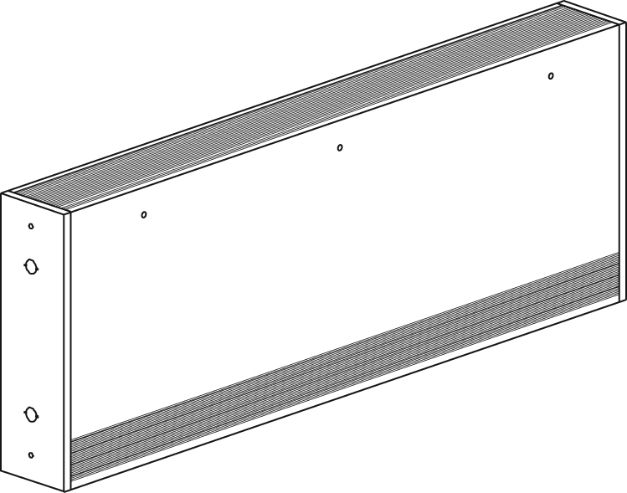

Features
Color - Standard: white, almond.
- Optional (upcharge available): metallic silver, bronze, metallic charcoal,
aluminum, semi-gloss black, sand.
- Custom colors available upon request.
Finish - Standard: epoxy/polyester powder paint.
Voltage - 208V, 240V, 277V, 347V, 600V, 1 or 3-phase.
Construction - 20-gauge steel cabinet.
- 16-gauge steel front cover.
- Extruded aluminum bar grilles prevent insertion of foreign objects.
- Front fresh air inlet; top warm air outlet.
- Front warm air outlet available (-FR).
- Clean back available (-BD).
- Linear high-limit temperature control with automatic reset.
Heating element - Three stainless steel tubular heating elements with aluminum ﬁns.
- Floating heating elements on high-temperature bushings,
reducing expansion noises.
Watt density - Average standard watt density of 1000W/ft.
- Average low watt density of 500W/ft., 750W/ft.
Control - Built-in tamperproof thermostat available.
- Mechanical, electronic or pneumatic relays available.
Note: Single-pole thermostat is for 1 phase model only.
Ouellet highly recommends to use an electronic wall thermostat for greater comfort.
Installation - Not for residential use in the United States.
- Wall or ﬂoor mounted installation.
- Front outlet -FR models may be recessed.
- Mounting holes spaced on 2 in. (51 mm) intervals for ease of installation.
- Variety of accessories available for wall-to-wall installation.
- Pedestal kit or sub-base available.
Warranty - 1-year warranty against defects.
Application - Commercial building, hospital, daycare center.

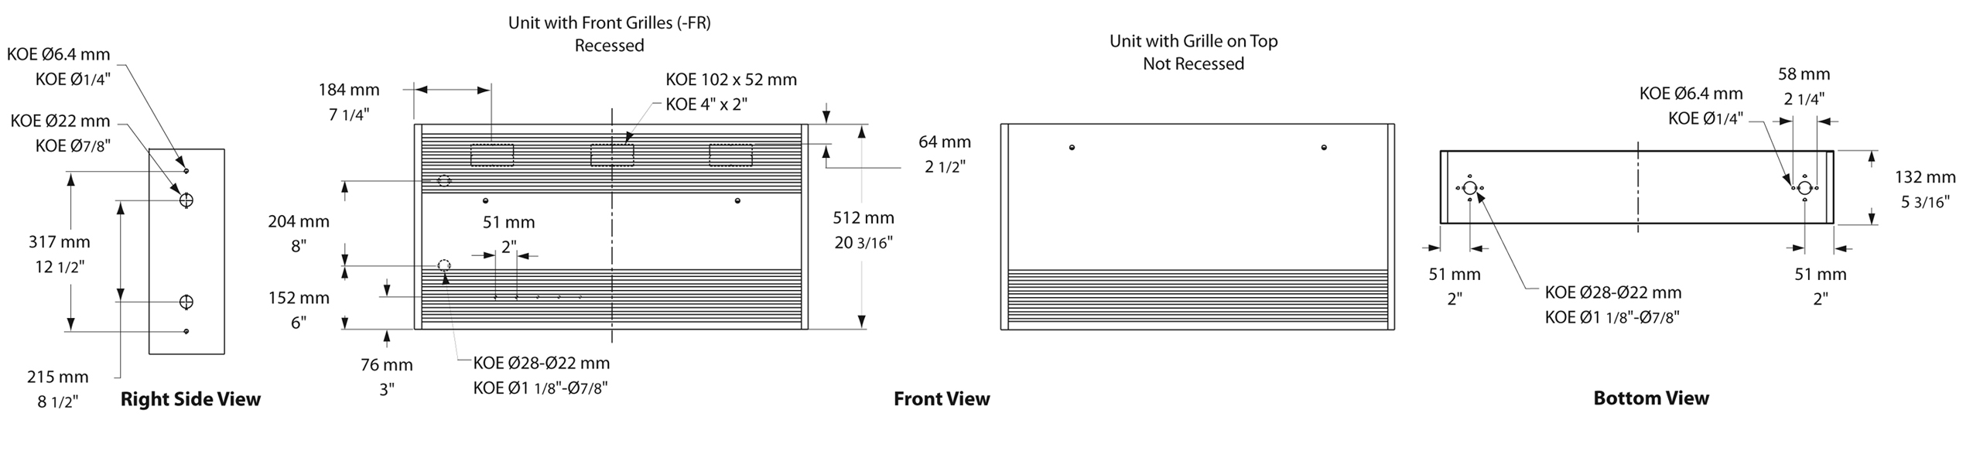
Standard Watt Density Models
Watts | Watts  240/208V | Product # |  |  |  |  |  |  |  | Length |  | Weight
Watts | Watts  240/208V | 208V  (1 ph) | Qty | 208V  (3 ph) | Qty | 240/208V | Qty | 277V | Qty | in. | mm | lb | kg
2000 | 2000/1500 | OLA2008 |  | OLI20381 |  | OLA2000 |  | OLA2077 |  | 27 _{3/16} | 690 | 37.0 | 16.8
3000 | 3000/2250 | OLA3008 |  | OLI30381 |  | OLA3000 |  | OLA3077 |  | 37 _{3/16} | 944 | 47.0 | 21.3
4000 | 4000/3000 | OLI40081 |  | OLI40381 |  | OLI40001 |  | OLA4077 |  | 47 _{3/16} | 1198 | 57.0 | 25.9
5000 | 5000/3750 | OLI50082 |  | OLI50381 |  | OLI50001 |  | OLI50771 |  | 57 _{3/16} | 1452 | 67.0 | 30.4
6000 | 6000/4500 | OLI60082 |  | OLI60382 |  | OLI60002 |  | OLI60771 |  | 65 _{3/16} | 1655 | 79.0 | 35.8

Average Low Watt Density Models
Product #³ | Length | Weight | AverageDensity W/ft. | Watts | 208V  (1 ph) | Qty | 208V  (3 ph) | Qty | 240V | Qty | 277V | Qty
OLA10XX-690 | 27 3/16"  (690 mm) | 37.0 lb  (16.8 kg) | 500 | 1000 | √ |  | √ |  | √ |  | √
OLA15XX-690 | 27 3/16"  (690 mm) | 37.0 lb  (16.8 kg) | 750 | 1500 | √ |  | √ |  | √ |  | √
OLA15XX-944 | 37 3/16"  (944 mm) | 47.0 lb  (21.3 kg) | 500 | 1500 | √ |  | √ |  | √ |  | √
OLA22XX-944 | 37 3/16"  (944 mm) | 47.0 lb  (21.3 kg) | 750 | 2250 | √ |  | √ |  | √ |  | √
OLA20XX-1198 | 47 3/16"  (1198 mm) | 57.0 lb  (25.9 kg) | 500 | 2000 | √ |  | √ |  | √ |  | √
OLA30XX-1198 | 47 3/16"  (1198 mm) | 57.0 lb  (25.9 kg) | 750 | 3000 | √ |  | √ |  | √ |  | √
OLA25XX-1452 | 57 3/16"  (1452 mm) | 67.0 lb  (30.4 kg) | 500 | 2500 | √ |  | √ |  | √ |  | √
OLA37XX-1452 | 57 3/16"  (1452 mm) | 67.0 lb  (30.4 kg) | 750 | 3750 | √ |  | √ |  | √ |  | √
OLA30XX-1655 | 65 3/16"  (1655 mm) | 79.0 lb  (35.8 kg) | 500 | 3000 | √ |  | √ |  | √ |  | √
OLA45XX-1655 | 65 3/16"  (1655 mm) | 79.0 lb  (35.8 kg) | 750 | 4500 | √ |  | √ |  | √ |  | √

1 If the control option "24V electronic relay" is required, these products need two electronic relays.
2 If the control option "24V electronic relay" is required, these products need three electronic relays.
³ XX = 08 (208V, 1 ph), 38 (208V, 3 ph), 00 (240V), 30 (240V, 3PH), 77 (277V), 07 (347V), 04 (480V, 1PH), 34 (480V, 3PH), 06 (600V, 1 ph), 36 (600V, 3 ph).
√ = Available.
Add "BL" for white, "AM" for almond.
Other colors, accessories and finishes are available upon request. Please contact your customer service representative.
Other voltages available upon request.

Options
Product #  Kit | Product #  Factory installed* | Description | Qty
Finish
- | BD | Clean back
KIT-OLA-CI | - | Corner (Inside and outside)
KIT-OLA-CR-27 | - | Recess trim kit, 27 3/16 in. (690 mm)
KIT-OLA-CR-37 | - | Recess trim kit, 37 3/16 in. (944 mm)
KIT-OLA-CR-47 | - | Recess trim kit, 47 3/16 in. (1198 mm)
KIT-OLA-CR-57 | - | Recess trim kit, 57 3/16 in. (1452 mm)
KIT-OLA-CR-65 | - | Recess trim kit, 65 3/16 in. (1655 mm)
KIT-OLA-CTR | - | Relay box, 12 in. (305 mm)
- | FR | Front warm air outlet
KIT-OLA-PEC | - | Square-shaped pedestal kit (2), 3 in. (76 mm)
KIT-OLA-SO-27 | - | Sub-base, 27 3/16 in. (690 mm)
KIT-OLA-SO-37 | - | Sub-base, 37 3/16 in. (944 mm)
KIT-OLA-SO-47 | - | Sub-base, 47 3/16 in. (1198 mm)
KIT-OLA-SO-57 | - | Sub-base, 57 3/16 in. (1452 mm)
KIT-OLA-SO-65 | - | Sub-base, 65 3/16 in. (1655 mm)
KIT-OLA-SV-27 | - | Empty cabinet, 27 3/16 in. (690 mm)
KIT-OLA-SV-37 | - | Empty cabinet, 37 3/16 in. (944 mm)
KIT-OLA-SV-47 | - | Empty cabinet, 47 3/16 in. (1198 mm)
KIT-OLA-SV-57 | - | Empty cabinet, 57 3/16 in. (1452 mm)
KIT-OLA-SV-65 | - | Empty cabinet, 65 3/16 in. (1655 mm)
Controls
- | CTT | Single-pole relay, coil 240V: 25A at 240V, 10A at 600V
- | CTT2 | Double-pole relay, coil 240V: 25A at 240V, 10A at 600V
- | DIS40³ | Disconnect switch, triple-pole, 40A at 600V
- | PM | Pneumatic relay, 20A at 600V
KIT-OLA-R | R | Single-pole relay, coil 24V, without transformer: 22A at 208V, 240V - 18A at 347V
KIT-OLA-R2 | R2 | Double-pole relay, coil 24V, without tranformer: 25A at 240V - 10A at 600V
KIT-OLA-R2-30 | R230 | Double-pole relay, coil 24V, without transformer, 30A at 600V max.
KIT-OLA-RT-208 | RT | Single-pole relay, coil 24V, with transformer 208V/24V, 4500W, 22A at 208V
KIT-OLA-RT-240 | RT | Single-pole relay, coil 24V, with transformer 240V/24V, 5200W, 22A at 240V
KIT-OLA-RT-277 | RT | Single-pole relay, coil 24V, with transformer 277V/24V, 5200W, 19A at 277V
KIT-OLA-RT-347 | RT | Single-pole relay, coil 24V, with transformer 347V/24V, 6000W, 18A at 347V
KIT-OLA-RT-600¹ | RT¹ | Single-pole relay, coil 24V, with transformer 600V/24V, 6000W, 10A at 600V (2-wire only)
KIT-OLA-T-AV² | TAV² | Single-pole tamperproof thermostat: 30A at 250V max. - 15A at 600V max.
KIT-OLA-T2-AV | T2AV | Double-pole tamperproof thermostat: 30A at 250V max. - 15A at 600V max.
- | TRIAC | Single-pole electronic relay, coil 24V, without transformer, 15A at 347V max.
- | TRIACT | Single-pole electronic relay, coil 24V, with transformer, 15A at 208V, 240V, 347V
- | TRIAC | Single-pole electronic relay, coil 24V, without transformer, 6A at 600V max.
Transformers
- | TRF24 | Transformer 24V, 50VA
- | TRF240 | Transformer 240V, 50VA

* For factory installed options, add the option number to the product number. See the Product Code section inside the front cover.
¹ These 2-wire relays with transformer can't supply of 3-wire low voltage thermostats.
² For 1-phase model only.
³ For the U.S. only: The nominal current of the unit must not exceed 80% of the capacity of the disconnect.
Electronic relay (1 or 3-phase) available upon request.

Others
Type | Quantity | Model et description  Complementary informations | Volts | Phase | Watts | Length  mm/in. | Informations  Color/installation

Specifications may change without prior notice
Project: | Approval  Information
Consultant Engineer: | Approval  Information
Eectrician Contractor: | Approval  Information
Distributor: | Approval  Information
Date: | Approval  Information
Contact in Ouellet: | Approval  Information
Comments:

