Series
OKB Infrared Radiant Heater
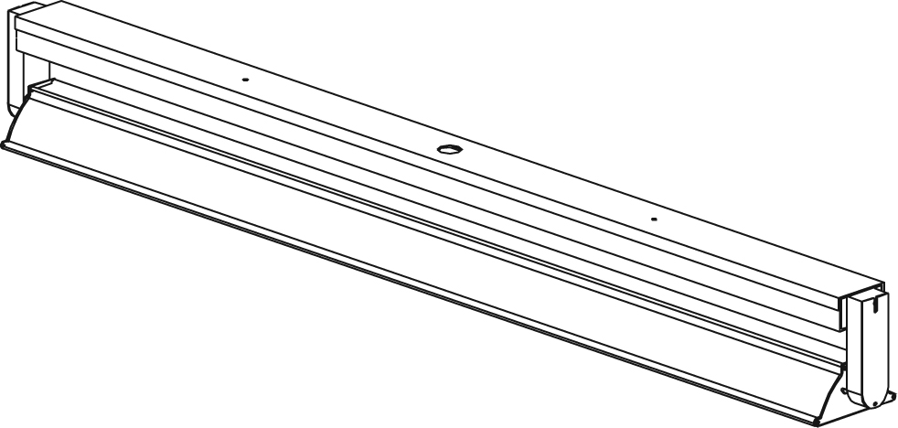

Features
Finish - Anodized aluminum.
Voltage - 120V, 208V, 240V, 480V, 600V, 1-phase.
- Other voltages available upon request.
Construction - No visible light is emitted by the heater.
- Built-in adjustable directional system.
Heating element - Incoloy stainless steel tubular heating element with 60° standard radiation angle (optional 45°).
- Quartz element with 60° standard radiation angle.
Installation - Vertical or horizontal mounting for stainless steel element models.
- Horizontal mounting for Quartz element models.
- Surface-mounted to connection box (on non-combustible surface)
or suspended by chains and eyelets (chains not included).
- Must be connected only to a circuit protected by suitable ground fault protection.
- 90 °C (194 °F) wiring is sufficient.
- Recommended installation height: 8 to 10 ft. (2.4 to 3 m).
Warranty - 1-year warranty against defects.
Application - Factory, warehouse, workshop, church.

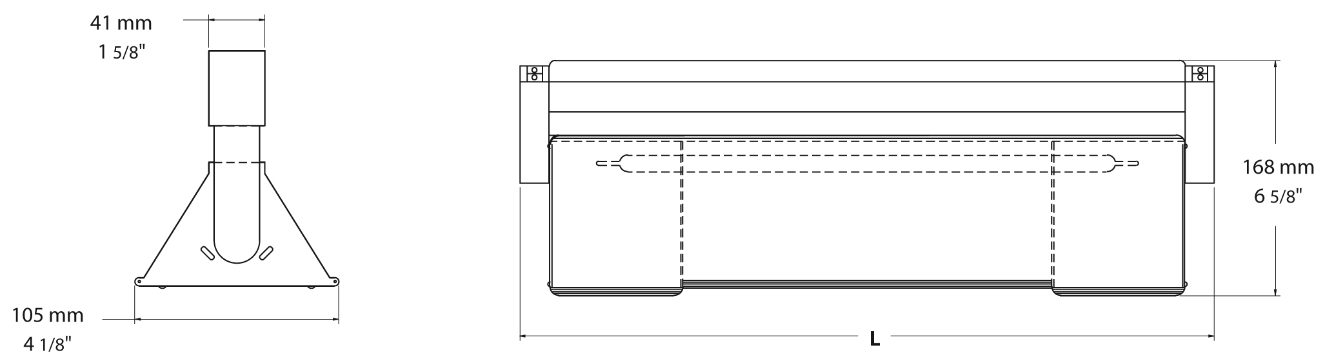
Models
Watts |  | Product # |  |  |  |  |  |  |  |  |  |  |  | Over-All Length |  |  | Heating Section |  |  |  | Weight
 |  | 120V | Qty |  |  | 208V | Qty |  | 240V |  | Qty |  | in. |  | mm |  | in. |  | mm |  | lb |  | kg
Incoloy stainless steel tubular heating element with 60° standard radiation angle (optional 45°)¹
950 | OKB299C611 |  |  |  |  | OKB299C621 |  |  |  | OKB299C631 |  |  |  | 31 _{1/2} |  | 800 |  | 20 |  | 508 | 5,1 | 2,3
1500 | OKB411C611 |  |  |  |  | OKB411C621 |  |  |  | OKB411C631 |  |  |  | 43 _{1/2} |  | 1105 |  | 32 |  | 813 | 6,8 | 3,1
1900 | OKB471C611 |  |  |  |  | OKB471C621 |  |  |  | OKB471C631 |  |  |  | 49 _{1/2} |  | 1257 |  | 38 |  | 965 | 8,0 | 3,6
2000 | - |  |  |  | - | OKB412C621 |  |  |  | OKB412C631 |  |  |  | 43 _{1/2} |  | 1105 |  | 32 |  | 813 | 7,2 | 3,3
2300 | - |  |  |  | - | OKB472C621 |  |  |  | OKB472C631 |  |  |  | 49 _{1/2} |  | 1257 |  | 38 |  | 965 | 8,1 | 3,7
3000 | - |  |  |  | - | OKB593C621 |  |  |  | OKB593C631 |  |  |  | 61 _{1/2} |  | 1562 |  | 50 |  | 1270 | 9,9 | 4,5
3800 | - |  |  |  | - | OKB713C621 |  |  |  | OKB713C631 |  |  |  | 73 _{1/2} |  | 1867 |  | 62 |  | 1575 | 11,7 | 5,3
Quartz element with 60° standard radiation angle
800 | OKB258T611 |  |  |  |  | OKB258T621 |  |  |  | OKB258T631 |  |  |  | 271/2 |  | 800 |  | 16 |  | 406 | 4,9 | 2,2
1600 | OKB411T611 |  |  |  |  | OKB411T621 |  |  |  | OKB411T631 |  |  |  | 43 _{½} |  | 1105 |  | 32 |  | 813 | 7,1 | 3,2
2500 | - |  |  | - |  | OKB592T621 |  |  |  | OKB592T631 |  |  |  | 611/2 |  | 1562 |  | 50 |  | 1270 | 9,7 | 4,4
3100 | - |  |  | - |  | OKB713T621 |  |  |  | OKB713T631 |  |  |  | 721/2 |  | 1867 |  | 62 |  | 1575 | 11,3 | 5,1

Options
Product #  Kit | Description | Qty
WGA040 | Wire guard for heated section of 16’’ (406 mm)
WGA050 | Wire guard for heated section of 20’’ (508 mm)
WGA081 | Wire guard for heated section of 32’’ (813 mm)
WGA096 | Wire guard for heated section of 38’’ (965 mm)
WGA127 | Wire guard for heated section of 50’’ (1270 mm)
WGA157 | Wire guard for heated section of 62’’ (1575 mm)

¹45° spread available upon request. Remember to change the 6 for 4 when ordering. E.g.: OKB299C621 becomes OKB299C421.
Other voltages available upon request.

Others
Type | Quantity | Model et description  Complementary informations | Volts | Phase | Watts | Length  mm/in. | Informations  Color/installation

Specifications may change without prior notice
Project: | Approval  Information
Consultant Engineer: | Approval  Information
Eectrician Contractor: | Approval  Information
Distributor: | Approval  Information
Date: | Approval  Information
Contact in Ouellet: | Approval  Information
Comments:

