Series
OHY Convection and Fan Heater


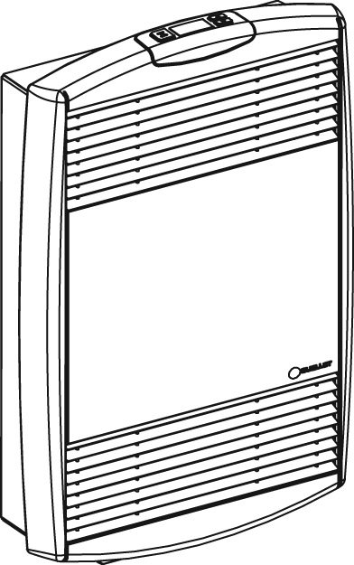

Features
Color - Standard: white, almond.
- Optional (upcharge applicable): metallic silver, bronze, metallic charcoal,
aluminum, semi-gloss black, sand.
- Custom colors available upon request.
Finish - Standard: epoxy/polyester powder paint.
Voltage - 240V, 1-phase.
Construction - Cast aluminum front cover.
- Steel bar grilles prevent the insertion of foreign objects;
smooth-ﬁnish paint is washable and anti-yellowing.
- Automatic reset safety device.
- Built-in white LED night light.
Fan - Whisper-quiet squirrel-cage fan.
- Factory-lubricated motor.
Heating element - Helical coil nickel-chromium alloy wire protected by ceramic insulators.
- Heating element provides instant heat.
Control - Built-in electronic digital thermostat/timer.
- Thermostat mode: pulse modulation: automatic convection
to fan-forced switch-over at 1000W.
- Timer mode: 5-30 minutes full power fan-forced boost.
Installation - 4 in. (102 mm) minimum clearance to ﬂoor.
- May be surface-mounted or recessed in 2 in. X 3 in. stud partitions.
- Mounting holes for ease of installation.
- Large wiring compartment.
Warranty - 5-year warranty against defects.
Application - Bathroom, kitchen, family room, entrance way.

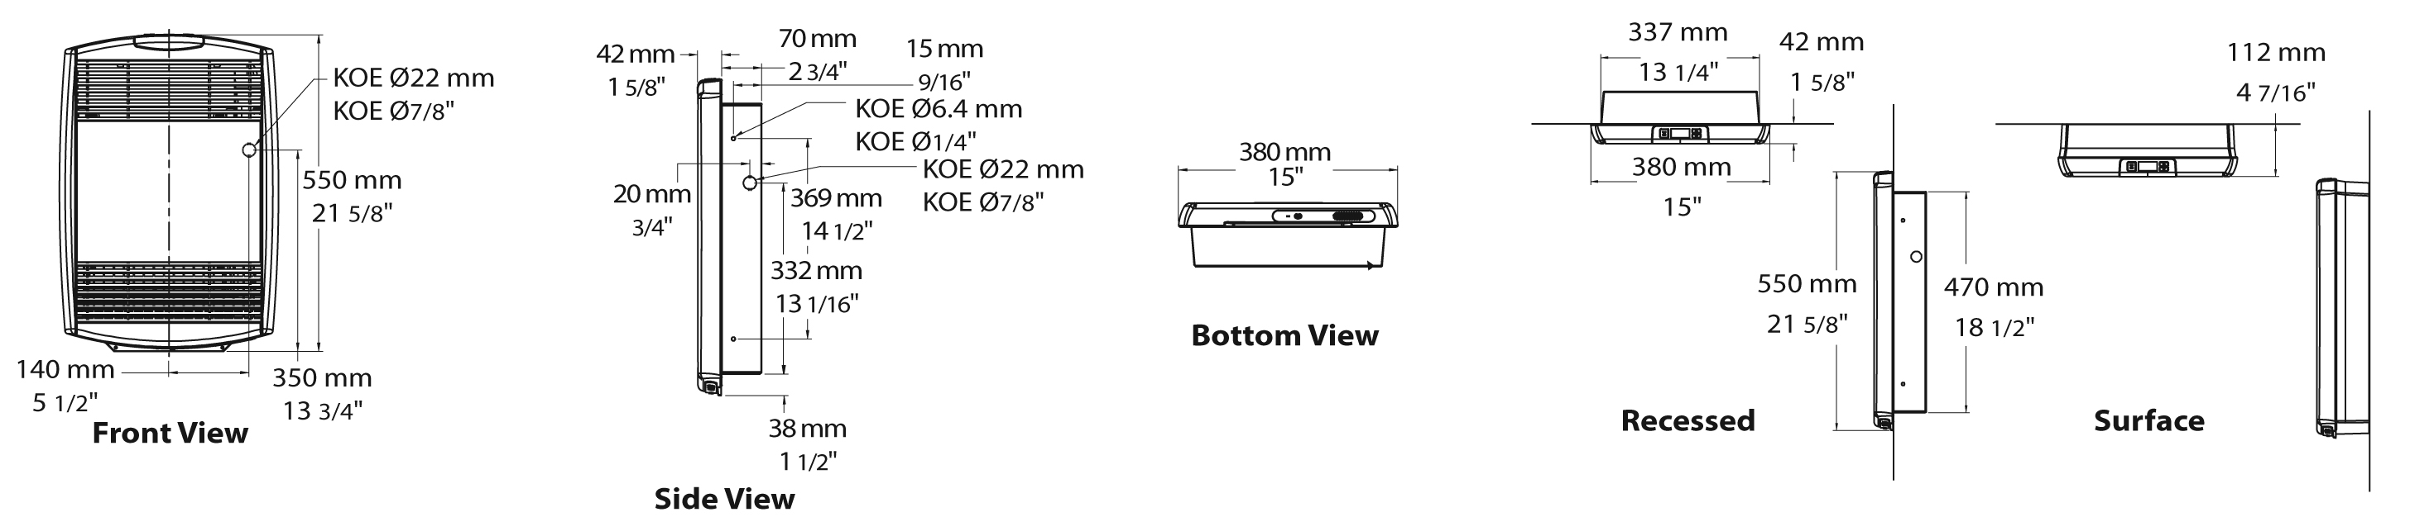

Models
Product # | Qty | Volts | Watts | Weight
 |  |  |  | lb | kg
OHY2000-TH¹ |  | 240 | 2000 | 22.75 | 10.3

Option
Product #  Kit | Product #  Factory installed* | Description | Qty
KIT-OHY-DIS² | DIS² | Disconnect switch, 20A at 250V

* For factory installed options, add the option number to the product number. See the Product Code section inside the front cover.
¹BEWARE: Not available for 208V.
² For the U.S. only: The nominal current of the unit must not exceed 80% of the capacity
of the disconnect.
Add"BL" for white, "AM" for almond.
Electronic thermostat available in grey only.

Others
Type | Quantity | Model et description  Complementary informations | Volts | Phase | Watts | Length  mm/in. | Informations  Color/installation

Specifications may change without prior notice
Project: | Approval  Information
Consultant Engineer: | Approval  Information
Eectrician Contractor: | Approval  Information
Distributor: | Approval  Information
Date: | Approval  Information
Contact in Ouellet: | Approval  Information
Comments:

