Series
OHX Explosion-Proof Unit Heater


Features
Color - Standard: red.
Finish - Standard: epoxy/polyester powder paint.
Voltage - 208V, 240V, 480V, 600V, 1 or 3-phase.
Construction - 14-gauge steel cabinet.
- Adjustable anodized aluminum louvers.
- Cast aluminum control and element enclosure lids NEMA Type 7 and 9 with O-ring.
- Fan Guard: multiple horizontal and vertical stiffening wires.
Protection - Stainless steel high temperature pressure relief device.
- Two high-limit temperature controls: one with automatic
reset and one with manual reset.
Fan - Explosion-proof, thermally protected, permanently lubricated ball bearing motor.
- 3 to 20kW: 1/4 HP, 1725 rpm.
- 25 to 35kW: 1/2 HP, 1725 rpm.
Heat exchanger - High grade metal-sheathed elements ﬁns with ethylene glycol/water solution.
- Long-life, low watt density.
- Evacuated and sealed, carbon steel tube core with 10 aluminum ﬁns per inch.
Temperature code - Division System: 5 to 30kW = T3B 165 °C (329 °F), 3kW/35kW = T3A 180 °C
(356 °F).
- Zone System T3 200 °C (392 °F).
Control - 120VAC control (standard).
- Optional 24VAC control (recommended due to safer voltage). Required for use with electronic thermostat.
- Optional built-in or wall thermostat (bi-metal or electronic).
- Optional built-in or wall disconnect switch.
Additional Options - Pilot light.
- Continuous fan.
- Heresite coatings.
Installation - Accessories available.
Warranty - 3-year warranty against defects.
Application - Paint storage area, petrochemical plant, reﬁnery, chemical plant, mining industry, sawmill.

Consult the Electrical Code in your area before installing this unit.

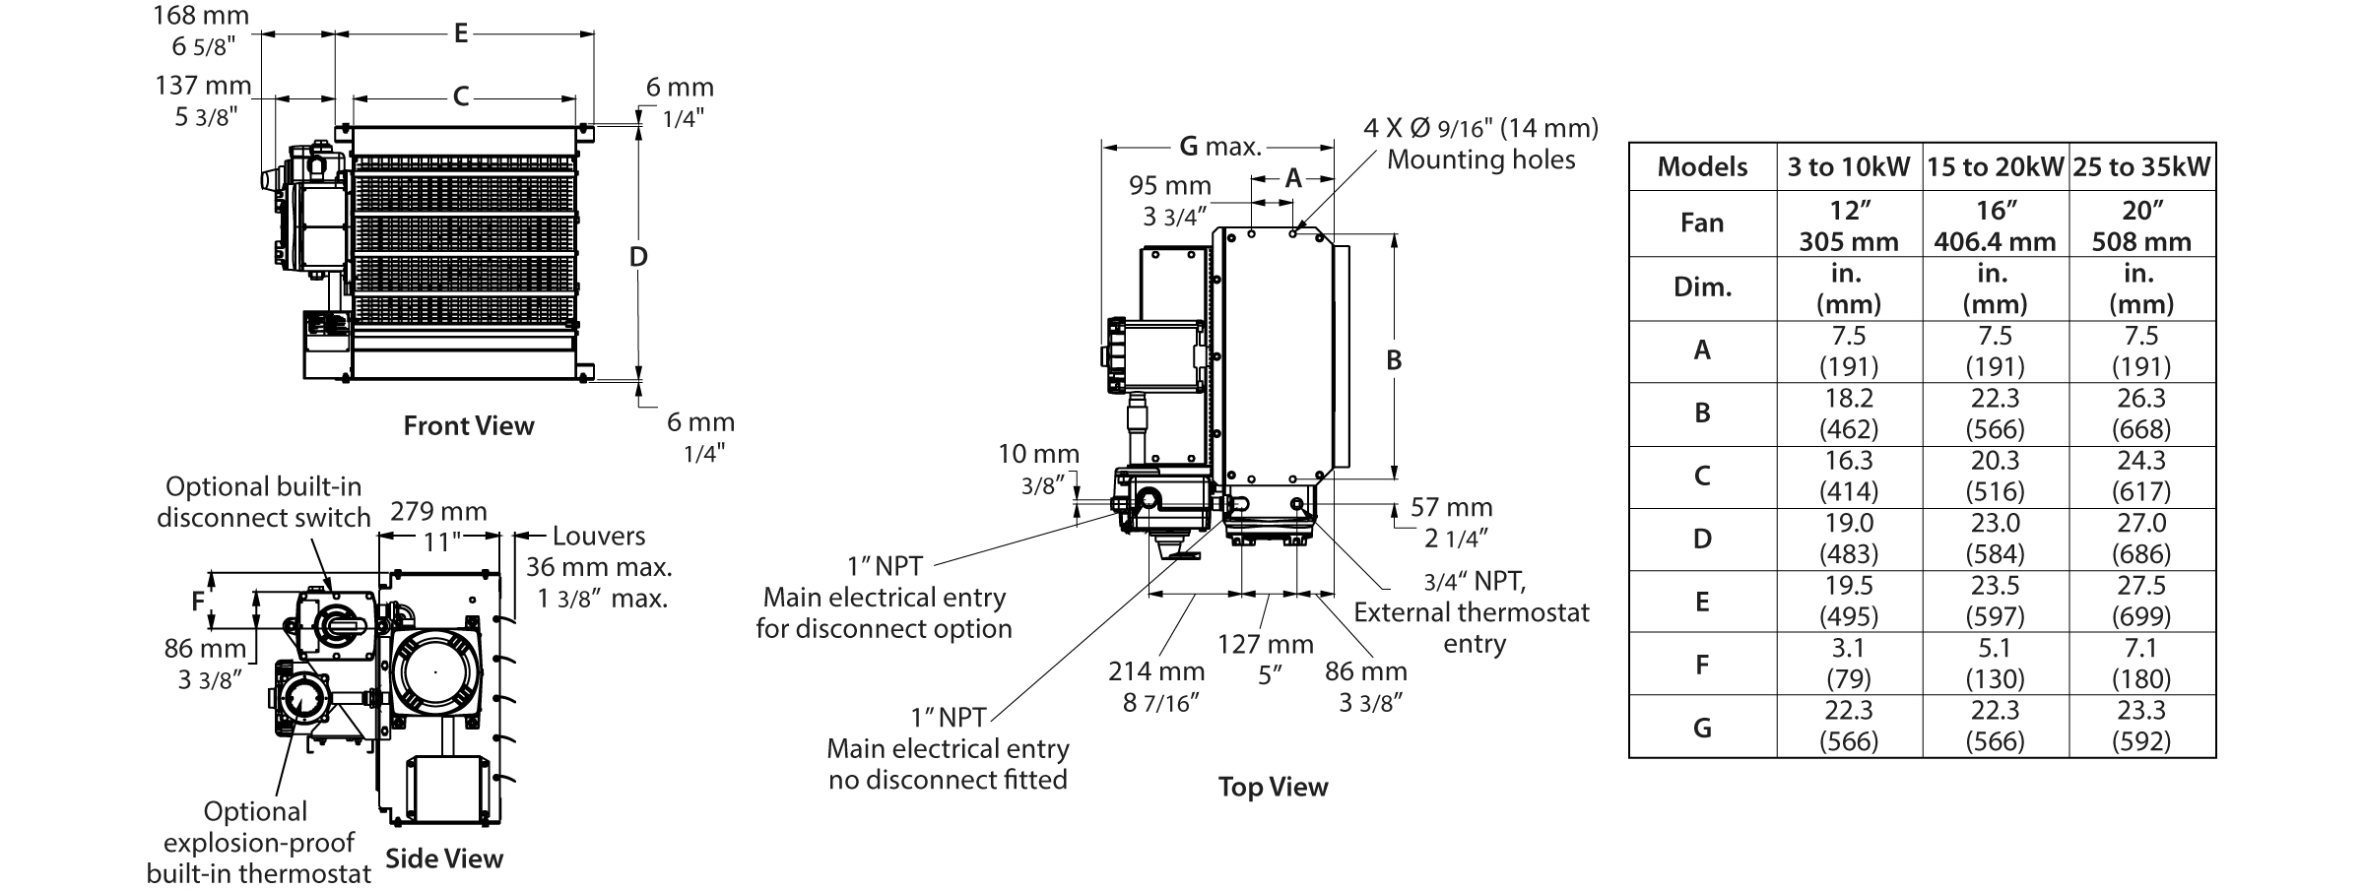

Models
kW | BTU/hr | Product # |  |  |  |  |  |  |  |  |  |  |  | cfm | T° Rise |  | T° Code² | Weight¹
kW | BTU/hr | 208V  (1 ph) | Qty | 208V  (3 ph) | Qty | 240V  (1 ph) | Qty | 240V  (3 ph) | Qty | 480V  (3 ph) | Qty | 600V  (3 ph) | Qty | cfm | ºC | ºF | T° Code² | lb | kg
3.0 | 10236 | OHX03008 |  | OHX03038 |  | OHX03000 |  | OHX03030 |  | OHX03034 |  | OHX03036 |  | 350 | 18.0 | 32.2 | T3A | 188 | 85.3
5.0 | 17060 | OHX05008 |  | OHX05038 |  | OHX05000 |  | OHX05030 |  | OHX05034 |  | OHX05036 |  | 400 | 24.5 | 44.0 | T3B | 188 | 85.3
7.5 | 25590 | OHX07508 |  | OHX07538 |  | OHX07500 |  | OHX07530 |  | OHX07534 |  | OHX07536 |  | 600 | 23.7 | 42.5 | T3B | 188 | 85.3
10.0 | 34120 | - | - | OHX10038 |  | OHX10000 |  | OHX10030 |  | OHX10034 |  | OHX10036 |  | 800 | 23.2 | 41.8 | T3B | 192 | 87.1
15.0 | 51180 | - | - | OHX15038 |  | - | - | OHX15030 |  | OHX15034 |  | OHX15036 |  | 1200 | 22.6 | 40.6 | T3B | 224 | 101.6
20.0 | 68240 | - | - | - | - | - | - | - | - | OHX20034 |  | OHX20036 |  | 1700 | 21.1 | 38.0 | T3B | 224 | 101.6
25.0 | 85300 | - | - | - | - | - | - | - | - | OHX25034 |  | OHX25036 |  | 2100 | 21.8 | 39.1 | T3B | 261 | 118.4
30.0 | 102360 | - | - | - | - | - | - | - | - | OHX30034 |  | OHX30036 |  | 3000 | 18.2 | 32.6 | T3B | 261 | 118.4
35.0 | 119420 | - | - | - | - | - | - | - | - | OHX35034 |  | OHX35036 |  | 3000 | 20.1 | 37.9 | T3A | 261 | 118.4

Options
Product #  Kit | Product #  Factory installed* |  | Description | Qty
Product #  Kit | Ouellet | Reference | Description | Qty
- | 24 | B | Transformer and contactor for 24VAC (required for use with built-in or wall mount electronic thermostat)
- | DIS | D | Built-in disconnect switch
- | T1 | - | Explosion-proof built-in bi-metal thermostat, range 5 °C (40 °F) to 25 °C (80 °F)
- | T2³ | - | Explosion-proof, electronic thermostat (low voltage), 5 °C (40 °F) to 25 °C (80 °F) (suitable for 24 volt control circuit only)
- | L | P | Pilot light “heat on”
- | FC | F | Continuous fan operation
OUE-BTX2-15A-W-N-A | - | - | Explosion-proof, wall mount bi-metal thermostat, 5 °C (40 °F) to 25 °C (80 °F) (suitable for 24VAC or 120VAC control circuit)
OUE-XET1-1-W-N-A³ | - | - | Explosion-proof, electronic wall mount thermostat (low voltage), 5 °C (40 °F) to 25 °C (80 °F), (suitable for 24 volt control circuit only)
OUE-BLK1-W-N-A | - | - | Thermostat conversion kit allowing interchangeability from built-in thermostat to wall mount configuration
OUE-XDC-01 | - | - | Explosion-proof wall mount disconnect switch, 600V, 50A max
OHX-MS | - | - | Hanging mounting bracket, all models. Ideal and economical if adequate overhead structure exists. Requires 1/2 in. (12.5 mm) pipe, cut and threaded (min. Sch. 40) not supplied.
OHX-MBX⁴ | - | - | Basic mounting bracket. Can be bolted or welded directly to structural steel or concrete.
OHX-MMX⁴ | - | - | Wall mounting bracket. Use in buildings that have substantial walls. The Z sections provide additional support where necessary.
OHX-MTX⁴ | - | - | Pipe mounting bracket. For buildings with insufficient strength to use other types of mounting brackets. Requires 3 in. (75 mm) pipe (3 1/2 in. [87.5 mm] O.D., min. Sch. 40) not supplied.
- | HCCX^{4, 5} | H1 | Heresite P-413 baked phenolic coating of heat exchanger core only
⁻ | HCBX^{4, 5} | H2 | Heresite P-413 baked phenolic coating of louvers, fan blade, fan guard & cabinet parts
- | HCUX^{4, 5} | H3 | Heresite P-413 baked phenolic coating of heat exchanger core, louvers, fan blade,  fan guard & cabinet parts

* For factory installed options, add the option number to the product number. See the Product Code section inside the front cover.
¹ Shipping weight
² Temperature code: T3B = 165 °C (329 °F), T3A = 180 °C (356 °F).
³ Built-in transformer and contactor for 24VAC are required, add « -24 » to the product number.
⁴ X= 1 (3 to 10kW units), 2 (15 to 20kW units), 3 (25 to 35kW units).
⁵ We do not Heresite coat the explosion-proof motor, control enclosure, aluminium conduit or any options such as disconnect or integral thermostat.
Allow additional 4 to 6 weeks lead time.
Standard color is red.

Approved locations
Class I, Divisions 1 and 2, Groups C and D.
Class II, Divisions 1 and 2, Groups F and G.
Temperature code: T3B (5 to 30kW), T3A (3kW/35kW).

Class I, Zones 1 & 2, Groups IIA & IIB, T3.

Temperature limitations
Ambient temperature: -40 °C to 40 °C (-40 °F to 104 °F).
Maximum altitude: 3048 m (10000 ft.) above sea level.

Others
Type | Quantity | Model et description  Complementary informations | Volts | Phase | Watts | Length  mm/in. | Informations  Color/installation

Specifications may change without prior notice
Project: | Approval  Information
Consultant Engineer: | Approval  Information
Electrician Contractor: | Approval  Information
Distributor: | Approval  Information
Date: | Approval  Information
Contact in Ouellet: | Approval  Information
Comments:

