Series
OHV-CC Commercial Portable Unit Heater
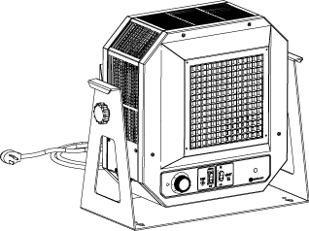

Features
Color - Standard: red and black.
Finish - Standard: epoxy/polyester powder paint.
Voltage - 240/208V, 1 phase.
Construction - Positive off, double-pole, single-throw thermostat.
- Fan on/auto switch.
- Two level finger tip - high/low heat selector switch.
- Manual-reset over temperature protector.
- Specially designed outlet diffuser prevents foreign objects from entering heater.
- 18 and 20 gauge steel.
- Motor - totally enclosed - thermally protected.
- Draw-through design permits greater heat transfer.
Installation - Versatile stand for floor or wall mount.
- Adjustable bracket/knobs allows all angle rotation.
- 20A cordset (NEMA 6-20P) on 4kW heater.
- 30A cordset (NEMA 6-30P) on 5kW heater.
Warranty - 1-year warranty against defects.
Application - Construction job site, garage, workshop, unheated area.

Models
Product #¹ | Volts | Phase | kW | Amp. | Air Flow |  | Temperature Rise |  | Weight |  | Plug | Qty
 |  |  |  |  | fpm | cfm | °C | °F | lb | kg | Plug | Qty
OHVU04000ROCC-F1-HL-T5 | 240/208 | 1 | 4/3 | 16.7/14.4 | 800 | 310 | 23 | 41 | 42 | 19 | NEMA 6-20P
OHVU05000ROCC-F1-HL-T5 | 240/208 | 1 | 5/3.75 | 20.8/18 | 800 | 310 | 28 | 51 | 42 | 19 | NEMA 6-30P

Standard color is red and black.
¹ Units come standard with hi-lo heat setting, fan only switch, integral thermostat and combination wall/ceiling/floor mounting bracket.

Others
Type | Quantity | Model et description  Complementary informations | Volts | Phase | Watts | Length  mm/in. | Informations  Color/installation

Specifications may change without prior notice
Project: | Approval  Information
Consultant Engineer: | Approval  Information
Electrician Contractor: | Approval  Information
Distributor: | Approval  Information
Date : | Approval  Information
Contact in Ouellet: | Approval  Information
Comments:

