Series
OHB High Density Aluminum Draft Barrier
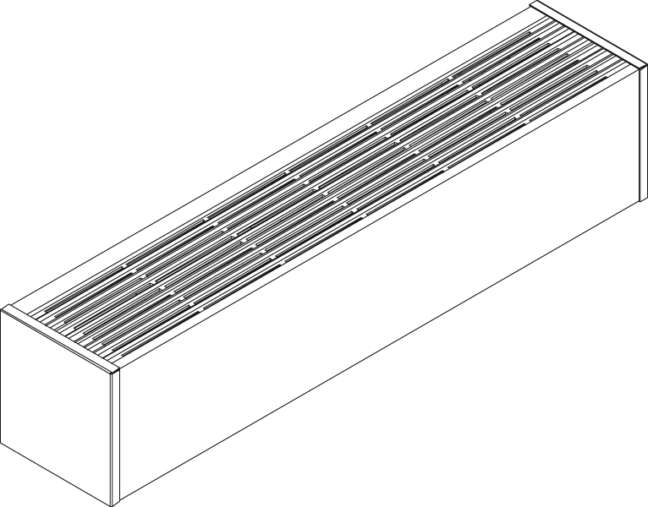

Features
Color - Standard: white, almond.
- Optional (upcharge applicable): metallic silver, bronze, metallic charcoal,
aluminum, semi-gloss black, sand.
- Custom colors available upon request.
Finish - Standard: epoxy/polyester powder paint.
- Optional: anodized aluminum.
Voltage - 208V, 240/208V, 277V, 347V, 600V, 50/60 Hz, 1-phase.
Construction - 14-gauge (0.0787 in. [2 mm]) aluminum front cover.
- 18-gauge satin coat steel cabinet.
- Screw assembly for added strength.
- Full length built-in wireway.
- Separate low voltage wireway (-WW) available.
- Pencil-proof openings less than 1/4 in. (6.4 mm).
- Bottom fresh air inlet, top warm air outlet.
- Clean back available (-BD).
- Linear high-limit temperature control with automatic reset.

High altitude version available (-HA).
- End caps included.
Heating element - Two stainless steel tubular heating elements with aluminum fins.
- Floating heating elements on high-temperature nylon bushings
reducing expansion noises.
Watt density - Average standard watt density 355W/ft.
- Average low watt density 175W/ft, 250W/ft.
- Average high watt density 500W/ft.
Control - Built-in thermostat available with a control knob or tamperproof.
- Mechanical, electronic or pneumatic relays available.
Ouellet highly recommends to use an electronic wall thermostat for greater comfort.
Installation - Not for residential use in the United States.
- Heater must be installed at least 3 in. (76 mm) from ﬁnished ﬂoor.
- Mounting holes spaced on 2 in. (51 mm) intervals for ease of installation.
- Installation on wall or ﬂoor mounted with pedestals.
- Pedestal kit available.
- Variety of accessories available for wall-to-wall installation.
Warranty - 3-year warranty against defects.
Applications - Commercial building, office building, hospital, daycare center, private residence.

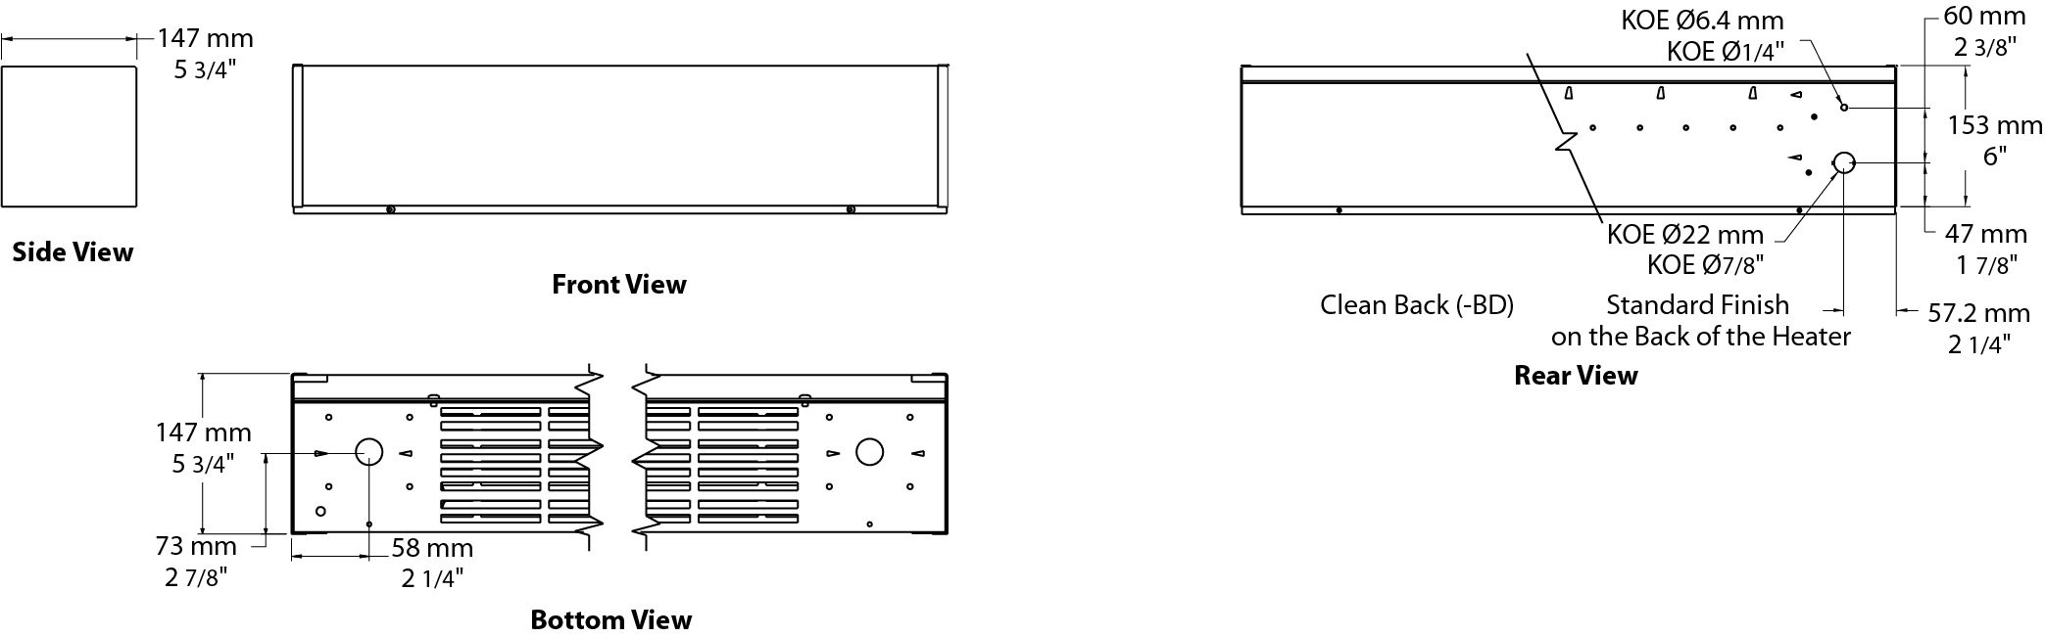

Average Standard Watt Density Models 355W/ft.
Watts | Watts | Product # |  |  |  |  |  |  |  | Length |  | Weight
Watts | 240/208V¹ | 208V | Qty | 240/208V | Qty | 347V | Qty | 600V | Qty | in. | mm | lb | kg
750 | 750/563 | OHB0758 |  | OHB0750 |  | OHB0757 |  | - | - | 23 _{5/8} | 600 | 10.7 | 4.8
1000 | 1000/750 | OHB1008 |  | OHB1000 |  | OHB1007 |  | - | - | 35 _{7/16} | 900 | 14.1 | 6.4
1400 | 1400/1050 | OHB1408 |  | OHB1400 |  | OHB1407 |  | OHB1406 |  | 47 _{1/4} | 1200 | 17.6 | 8.0
1750 | 1750/1313 | OHB1758 |  | OHB1750 |  | OHB1757 |  | OHB1756 |  | 59 _{1/16} | 1500 | 21.1 | 9.6
2100 | 2100/1577 | OHB2108 |  | OHB2100 |  | OHB2107 |  | OHB2106 |  | 70 _{7/8} | 1800 | 24.6 | 11.1
2450 | 2450/1840 | OHB2458 |  | OHB2450 |  | OHB2457 |  | OHB2456 |  | 82 _{11/16} | 2100 | 28.0 | 12.7
2800 | 2800/2103 | OHB2808 |  | OHB2800 |  | OHB2807 |  | OHB2806 |  | 94 _{1/2} | 2400 | 31.5 | 14.3

Average Low Watt Density Models
Product # | Length | Weight | Average Density W/ft. | Watts | Watts  240/208V | 208V | Qty | 240/208V¹ | Qty | 347V | Qty | 600V | Qty
OHB037X-600 | 23 5/8"  (600 mm) | 10.7 lb  (4.8 kg) | 175 | 375 | 375/281 | √ |  | √ |  | - | - | - | -
OHB050X-600 | 23 5/8"  (600 mm) | 10.7 lb  (4.8 kg) | 250 | 500 | 500/375 | √ |  | √ |  | - | - | - | -
OHB050X-900 | 35 7/16"  (900 mm) | 14.1 lb  (6.4 kg) | 175 | 500 | 500/375 | √ |  | √ |  | √ |  | - | -
OHB075X-900 | 35 7/16"  (900 mm) | 14.1 lb  (6.4 kg) | 250 | 750 | 750/563 | √ |  | √ |  | √ |  | - | -
OHB070X-1200 | 47 1/4"  (1200 mm) | 17.6 lb  (8.0 kg) | 175 | 700 | 700/525 | √ |  | √ |  | √ |  | √
OHB100X-1200 | 47 1/4"  (1200 mm) | 17.6 lb  (8.0 kg) | 250 | 1000 | 1000/750 | √ |  | √ |  | √ |  | √
OHB087X-1500 | 59 1/16"  (1500 mm) | 21.1 lb  (9.6 kg) | 175 | 875 | 875/656 | √ |  | √ |  | √ |  | √
OHB125X-1500 | 59 1/16"  (1500 mm) | 21.1 lb  (9.6 kg) | 250 | 1250 | 1250/938 | √ |  | √ |  | √ |  | √
OHB105X-1800 | 70 7/8"  (1800 mm) | 24.6 lb  (11.1 kg) | 175 | 1050 | 1050/788 | √ |  | √ |  | √ |  | √
OHB150X-1800 | 70 7/8"  (1800 mm) | 24.6 lb  (11.1 kg) | 250 | 1500 | 1500/1125 | √ |  | √ |  | √ |  | √
OHB122X-2100 | 82 11/16"  (2100 mm) | 28.0 lb  (12.7 kg) | 175 | 1225 | 1225/919 | √ |  | √ |  | √ |  | √
OHB175X-2100 | 82 11/16"  (2100 mm) | 28.0 lb  (12.7 kg) | 250 | 1750 | 1750/1313 | √ |  | √ |  | √ |  | √
OHB140X-2400 | 94 1/2"  (2400 mm) | 31.5 lb  (14.3 kg) | 175 | 1400 | 1400/1050 | √ |  | √ |  | √ |  | √
OHB200X-2400 | 94 1/2"  (2400 mm) | 31.5 lb  (14.3 kg) | 250 | 2000 | 2000/1500 | √ |  | √ |  | √ |  | √

Average High Watt Density Models 500W/ft.
Watts | Watts  240/208V¹ | Product # |  |  |  |  |  |  |  | Length |  | Weight
Watts | Watts  240/208V¹ | 208V | Qty | 240/208V | Qty | 347V | Qty | 600V | Qty | in. | mm | lb | kg
1000 | 1000/750 | OHBH1008 |  | OHBH1000 |  | OHBH1007 |  | OHBH1006 |  | 23 _{5/8} | 600 | 10.7 | 4.8
1500 | 1500/1125 | OHBH1508 |  | OHBH1500 |  | OHBH1507 |  | OHBH1506 |  | 35 _{7/16} | 900 | 14.1 | 6.4
2000 | 2000/1500 | OHBH2008 |  | OHBH2000 |  | OHBH2007 |  | OHBH2006 |  | 47 _{1/4} | 1200 | 17.6 | 8.0
2500 | 2500/1875 | OHBH2508 |  | OHBH2500 |  | OHBH2507 |  | OHBH2506 |  | 59 _{1/16} | 1500 | 21.1 | 9.6
3000 | 3000/2250 | OHBH3008 |  | OHBH3000 |  | OHBH3007 |  | OHBH3006 |  | 70 _{7/8} | 1800 | 24.6 | 11.1
3500 | 3500/2625 | OHBH3508³ |  | OHBH3500 |  | OHBH3507 |  | OHBH3506 |  | 82 _{11/16} | 2100 | 28.0 | 12.7
4000 | 4000/3000 | OHBH4008³ |  | OHBH4000³ |  | OHBH4007 |  | OHBH4006 |  | 94 _{1/2} | 2400 | 31.5 | 14.3
¹ 208V = 75% of wattage at 240V.
² X = 8 (208V), 0 (240/208V), 7 (347V), 6 (600V).
³ If the control option "24V electronic relay" is required, these products need two electronic relays.
√ = Available.
Add "BL" for white, "AM" for almond.
Other colors, accessories and finishes are available upon request. Please contact your customer service representative.
Other voltages available upon request.

Options
Product #  Kit | Product #  Factory installed* | Description | Qty
Finish
- | BD¹ | Clean back
KIT-OHB-CE | - | Outside corner, 8 in. (203 mm)
KIT-OHB-CI | - | Inside corner, 8 in. (203 mm)
KIT-OHB-JT | - | Splice plate, 2 in. (51 mm)
KIT-OHB-JT-PE | - | Contour splice plate for BD option and/or heater with pedestals, 2 in. (51 mm)
KIT-OHB-PEC | - | Square-shaped pedestal kit (2), 3 in. (76 mm)
OHB-SV-XX | - | Empty cabinet with length of XX mm (minimum: 154 mm, maximum: 2400 mm)
Controls
KIT-OHB-DIS20³ | DIS20³ | Disconnect switch, 20A at 277V max.
KIT-OHB-DIS40³ | DIS40³ | Disconnect switch, 40A at 600V max.
- | HA | Linear high-limit temperature control for high altitude (3000 ft. to 8200 ft.)
- | PM | Pneumatic relay, 20A at 600V max.
KIT-OHB-R-347 | R | Single-pole relay, coil 24V, without transformer: 22A at 208V, 240V - 19A at 277V - 18A at 347V
KIT-OHB-R-600 | R | Single-pole relay, coil 24V, without transformer, 10A at 600V
KIT-OHB-RT-208 | RT | Single-pole relay, coil 24V, with transformer 208V/24V, 22A at 208V
KIT-OHB-RT-240 | RT | Single-pole relay, coil 24V, with transformer 240V/24V, 22A at 240V
KIT-OHB-RT-277 | RT | Single-pole relay, coil 24V, with transformer 277V/24V, 19A at 277V
KIT-OHB-RT-347 | RT | Single-pole relay, coil 24V, with transformer 347V/24V, 18A at 347V
KIT-OHB-RT-600² | RT² | Single-pole relay, coil 24V, with transformer 600V/24V, 10A at 600V (2-wire only)
KIT-OHB-T | T | Single-pole thermostat: 25A at 208V, 240V - 10A at 277V, 347V, 480V, 600V
KIT-OHB-T2⁴ | T2⁴ | Double-pole thermostat: 30A at 208V, 240V - 15A at 277V, 347V, 600V
KIT-OHB-T-AV | TAV | Single-pole tamperproof thermostat: 25A at 208V, 240V - 10A at 277V, 347V, 480V, 600V
KIT-OHB-T2-AV⁴ | T2AV⁴ | Double-pole tamperproof thermostat: 30A at 208V, 240V - 15A at 277V, 347V, 600V
KIT-OHB-TRIAC-347 | TRIAC | Single-pole electronic relay, coil 24V, without transformer, 15A at 347V max.
KIT-OHB-TRIAC-347T | TRIACT | Single-pole electronic relay, coil 24V, with transformer: 15A at 208V, 240V, 347V
KIT-OHB-TRIAC-600 | TRIAC | Single-pole electronic relay, coil 24V, without transformer, 6A at 600V max.
- | WW | 24V wireway includes high temperature wiring

* For factory installed options, add the option number to the product number. See the Product Code section inside the front cover.
¹ For anodized aluminum heaters, the clean back option will be fixed with visible rivets.
² These 2-wire relays with transformer can't supply a 3-wire low voltage thermostats.
³ For the U.S. only: The nominal current of the unit must not exceed 80% of the capacity of the disconnect.
⁴ "Off" position.

Others
Type | Quantity | Model et description  Complementary informations | Volts | Phase | Watts | Length  mm/in. | Informations  Color/installation

Specifications may change without prior notice
Project: | Approval  Information
Consultant Engineer: | Approval  Information
Eectrician Contractor: | Approval  Information
Distributor: | Approval  Information
Date: | Approval  Information
Contact in Ouellet: | Approval  Information
Comments:

