Series
OFM Standard Baseboard Heater
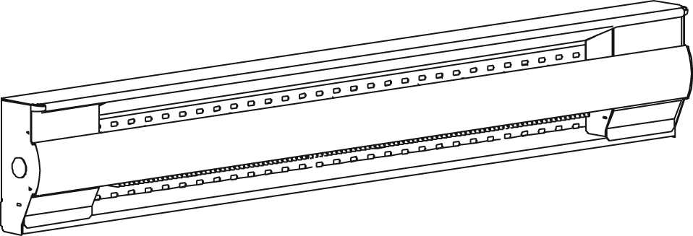

Features
Color - Standard: white, almond.
- Optional (upcharge applicable): metallic silver, bronze, metallic charcoal,
aluminum, semi-gloss black, sand.
- Custom colors available upon request.
Finish - Standard: epoxy/polyester powder paint.
- May be repainted with any interior paint.
Voltage - 120V, 208V, 240/208V, 277V, 347V, 480V, 600V, 1-phase.
Construction - 20-gauge steel connection box.
- 22-gauge steel body.
- 20-gauge steel front panel.
- Rounded upper corners.
- Linear high-limit temperature control with automatic reset.
Heating element - Stainless steel tubular heating element with aluminum ﬁns.
- Floating heating element on high-temperature nylon bushings
reducing expansion noises.
Watt density - Average standard watt density of 275W/ft.
- Average low watt density of 200W/ft.
Control - Built-in electronic thermostat installed in the right-hand junction box only.
Only compatible with devices manufactured after 14-10-2019.
- Built-in thermostat kit can be installed at either end.
- Baseboard section with built-in electronic thermostat can be installed at left end only
(240V only).
- Built-in relay kit fits in the right end box only.
- A compartment for low voltage connections (located directly under the junction box) facilitates the installation of low voltage relay in electric baseboard.
Ouellet highly recommends to use an electronic wall thermostat for greater comfort.
Installation - Installation directly on the floor.
- Connection box at both ends of the heater.
- Single-screw built-in wire holder.
- Optional kit for installing an AC90 type electrical cable (BX).
- Raceway for ease of installation.
- Two rows of mounting holes spaced on 1 in. (25.4 mm)
intervals for ease of installation.
- Variety of accessories available for wall-to-wall installation.
Warranty - 5-year warranty against defects.
- Heating element has a lifetime warranty for the initial end user.
Application - Kitchen, living room, family room, bedroom, bay window, basement.
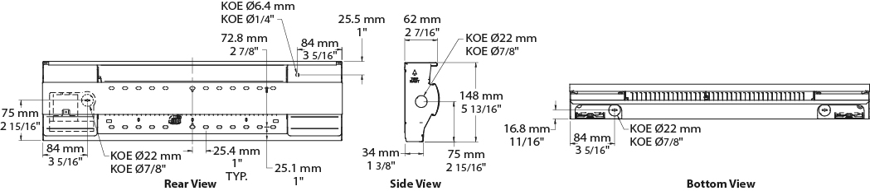

Average Standard Watt Density Models 275W/ft. (900W/m)
Watts | Watts  240/208V | Product # |  |  |  |  |  |  |  |  |  | Length |  | Weight
Watts | Watts  240/208V | 120V | Qty | 208V | Qty | 240/208V | Qty | 347V | Qty | 600V | Qty | in. | mm | lb | kg
300 | 300/225 | OFM0302 |  | OFM0308 |  | OFM0300 |  | - | - | - | - | 22 _{5/16} | 566 | 4.5 | 2.0
500 | 500/375 | OFM0502 |  | OFM0508 |  | OFM0500 |  | OFM0507 |  | - | - | 27 _{3/16} | 691 | 5.5 | 2.5
750 | 750/563 | OFM0752 |  | OFM0758 |  | OFM0750 |  | OFM0757 |  | OFM0756 |  | 37 _{3/16} | 945 | 7.3 | 3.3
1000 | 1000/750 | OFM1002 |  | OFM1008 |  | OFM1000 |  | OFM1007 |  | OFM1006 |  | 47 _{1/2} | 1206 | 9.0 | 4.0
1250 | 1250/938 | OFM1252 |  | OFM1258 |  | OFM1250 |  | OFM1257 |  | OFM1256 |  | 57 | 1447 | 10.5 | 4.8
1500 | 1500/1125 | OFM1502 |  | OFM1508 |  | OFM1500 |  | OFM1507 |  | OFM1506 |  | 65 _{11/16} | 1668 | 12.0 | 5.5
1750 | 1750/1313 | - | - | OFM1758 |  | OFM1750 |  | OFM1757 |  | OFM1756 |  | 75 | 1905 | 13.5 | 6.2
2000 | 2000/1500 | - | - | OFM2008 |  | OFM2000 |  | OFM2007 |  | OFM2006 |  | 83 _{13/16} | 2128 | 15.0 | 6.8
2250¹ | 2250/1688¹ | - | - | OFM2258 |  | OFM2250 |  | OFM2257 |  | OFM2256 |  | 92 _{5/8} | 2353 | 16.5 | 7.5
2500¹ | 2500/1875¹ | - | - | OFM2508 |  | OFM2500 |  | OFM2507 |  | OFM2506 |  | 101 _{13/16} | 2585 | 18.0 | 8.2

Average Low Watt Density Models 200W/ft. (650W/m)
Watts | Watts  240/208V | Product # |  |  |  |  |  |  |  |  |  | Length |  | Weight
Watts | Watts  240/208V | 120V | Qty | 208V | Qty | 240/208V | Qty | 347V | Qty | 600V | Qty | in. | mm | lb | kg
300 | 300/225 | OFM0302-691 |  | OFM0308-691 |  | OFM0300-691 |  | - | - | - | - | 27 _{3/16} | 691 | 5.5 | 2.5
500 | 500/375 | OFM0502-945 |  | OFM0508-945 |  | OFM0500-945 |  | OFM0507-945 |  | - | - | 37 _{3/16} | 945 | 7.3 | 3.3
750 | 750/563 | OFM0752-1206 |  | OFM0758-1206 |  | OFM0750-1206 |  | OFM0757-1206 |  | OFM0756-1206 |  | 47 _{1/2} | 1206 | 9.0 | 4.0
1000 | 1000/750 | OFM1002-1447 |  | OFM1008-1447 |  | OFM1000-1447 |  | OFM1007-1447 |  | OFM1006-1447 |  | 57 | 1447 | 10.5 | 4.8
1250 | 1250/938 | OFM1252-1668 |  | OFM1258-1668 |  | OFM1250-1668 |  | OFM1257-1668 |  | OFM1256-1668 |  | 65 _{11/16} | 1668 | 12.0 | 5.5
1500 | 1500/1125 | OFM1502-2128 |  | OFM1508-2128 |  | OFM1500-2128 |  | OFM1507-2128 |  | OFM1506-2128 |  | 83 _{13/16} | 2128 | 15.0 | 6.8
1750¹ | 1750/1313¹ | - | - | OFM1758-2353 |  | OFM1750-2353 |  | OFM1757-2353 |  | OFM1756-2353 |  | 92 _{5/8} | 2353 | 16.5 | 7.5
2000¹ | 2000/1500¹ | - | - | OFM2008-2585 |  | OFM2000-2585 |  | OFM2007-2585 |  | OFM2006-2585 |  | 101 _{13/16} | 2585 | 18.0 | 8.2
2250¹ | 2250/1688¹ | - | - | OFM2258-2585 |  | OFM2250-2585 |  | OFM2257-2585 |  | OFM2256-2585 |  | 101 _{13/16} | 2585 | 18.0 | 8.2

Options
Product #  Kit | Product #  Factory installed* | Description | Qty
KIT-OFM-BX-25 | - | Kit for installing an AC90 type electrical cable (BX), box of 25 kits
KIT-OFM-CI | - | Corners (inside and outside)
KIT-OFM-DIS20 | DIS20 | Disconnect switch, double-pole, 20A at 250V max.
KIT-OFM-JT | - | Splice plate 3 9/16 in. (90 mm)
KIT-OFM-RO1 | - | Baseboard section 6 in. (152 mm) - Surface-mount 5-15R receptacle - 15A at 120V
KIT-OFM-RO2 | - | Baseboard section 6 in. (152 mm) - 240V splitter box toward a surface-mount, 6-20R receptacle  (20A switch, double-pole, double-throw)
KIT-OFM-RO2B | - | Baseboard section 6 in. (152 mm) - Surface-mount 6-20R receptacle - 240V
KIT-OFM-R-347 | R | Single-pole relay, coil 24V, without transformer: 22A at 120V, 208V, 240V - 18A at 347V
KIT-OFM-R-600 | R | Single-pole relay, coil 24V, without transformer, 10A at 600V
KIT-OFM-RT-120 | RT | Single-pole relay, coil 24V, with transformer 120V/24V, 22A at 120V
KIT-OFM-RT-208 | RT | Single-pole relay, coil 24V, with transformer 208V/24V, 22A at 208V
KIT-OFM-RT-240 | RT | Single-pole relay, coil 24V, with transformer 240V/24V, 22A at 240V
KIT-OFM-RT-277 | RT | Single-pole relay, coil 24V, with transformer 277V/24V, 19A at 277V
KIT-OFM-RT-347 | RT | Single-pole relay, coil 24V, with transformer 347V/24V, 18A at 347V
KIT-OFM-RT-600³ | RT³ | Single-pole relay, coil 24V, with transformer 600V/24V, 10A at 600V (2-wire only)
KIT-OFM-240SPLITTER | - | Baseboard section 6 in. (152 mm) - 240V splitter box to permanently connect an air conditioner  (20A switch, double-pole, double-throw)
KIT-OFM-THA⁵ | THACD⁵ | Built-in electronic thermostat with rotary knob installed in the right junction box only: 12.5A at 120V, 208V, 240V
- | THCG⁴ | Baseboard section 6 in. (152 mm) with built-in electronic thermostat (240V only), installed at left end
KIT-OFM-SR | - | Baseboard section 6 in. (152 mm) for the installation of a 24V relay (relay not included)
KIT-OFM-TB6 | TB6 | Single-pole bi-metal thermostat: 25A at 120V, 208V, 240V, 277V - 10A at 347V, 480V, 600V
KIT-OFM-TB26² | TB26² | Double-pole bi-metal thermostat: 25A at 120V, 208V, 240V, 277V - 10A at 347V, 480V, 600V
KIT-OFM-TB6-AV | TB6AV | Single-pole bi-metal tamperproof thermostat: 25A at 120V, 208V, 240V, 277V - 10A at 347V, 480V, 600V
KIT-OFM-TB26-AV² | TB26AV² | Double-pole bi-metal tamperproof thermostat: 25A at 120V, 208V, 240V, 277V - 10A at 347V, 480V, 600V
KIT-OFM-TRIAC-347 | TRIAC | Single-pole electronic relay, coil 24V, without transformer, 15A at 347V max.
KIT-OFM-TRIAC-347T | TRIACT | Single-pole electronic relay, coil 24V, with transformer: 15A at 208V, 240V, 277V, 347V
KIT-OFM-TRIAC-600 | TRIAC | Single-pole electronic relay, coil 24V, without transformer, 10A at 600V max.

* For factory installed options, add the option number to the product number. See the Product Code section inside the front cover.
¹ These models must be ordered in pairs to reduce shipping damages.
² "Off" position.
³ These 2-wire relays with transformer can't supply of 3-wire low voltage thermostats.
⁴ The white and almond baseboard sections come with an integrated white thermostat. The integrated thermostat is black for all other colors.
⁵ Compatible with the devices manufactured after 14-10-2019 only.
Add "BL" for white, "AM" for almond. Upcharge available for optional colors shown in the color chart section.
Other voltages available upon request.

Others
Type | Quantity | Model et description  Complementary informations | Volts | Phase | Watts | Length  mm/in. | Informations  Color/installation

Specifications may change without prior notice
Project: | Approval  Information
Consultant Engineer: | Approval  Information
Eectrician Contractor: | Approval  Information
Distributor: | Approval  Information
Date: | Approval  Information
Contact in Ouellet: | Approval  Information
Comments:

