Series
OFH Floor Insert Fan Heater
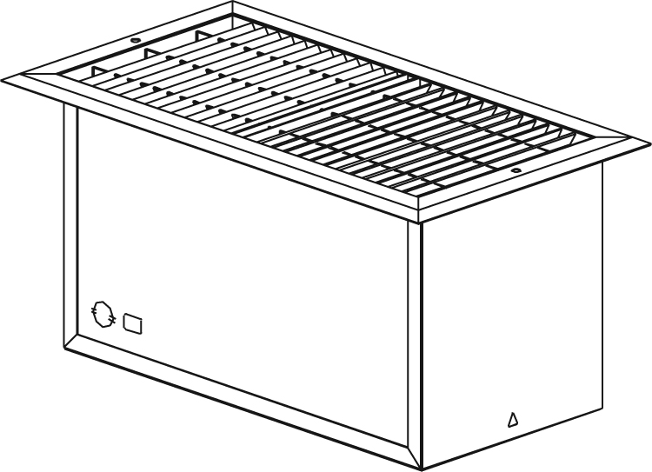

Features
Color - Standard: bronze, white, almond.
- Optional (upcharge applicable): metallic silver, metallic charcoal, aluminum,
semi-gloss black, sand.
- Custom colors available upon request.
Finish - Standard: epoxy/polyester powder paint.
Voltage - 120V, 240/208V, 1-phase.
Construction - Welded 20-gauge steel.
- Sturdy floor grille (14-gauge).
- Protective screen keeps foreign objects from falling into the unit.
- High-limit temperature control with manual reset.
Fan - Large diameter, quiet fan operating at 43.9 dBA at 80 cfm.
- Factory-lubricated motor.
Heating element - Durable tubular heating element with fins.
Installation - Minimum clearance from adjacent walls: 6 in. (15.2 cm).
- Large wiring compartment.
Warranty - 5-year warranty against defects.
Application - Bay window, near patio door.
Note: If an electronic thermostat is used, it must be compatible with forced-air heaters.

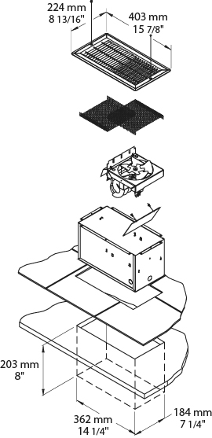
Models
Product # | Qty | Volts | Watts | Weight
 |  |  |  | lb | kg
OFH0502 |  | 120 | 500 | 16.0 | 7.3
OFH1002 |  | 120 | 1000 | 16.0 | 7.3
OFH1502 |  | 120 | 1500 | 16.0 | 7.3
OFH0500 |  | 240/208 | 500/375 | 16.0 | 7.3
OFH1000 |  | 240/208 | 1000/750 | 16.0 | 7.3
OFH1500 |  | 240/208 | 1500/1125 | 16.0 | 7.3

Add "BZ" for bronze, "BL" for white, "AM" for almond.

Others
Type | Quantity | Model et description  Complementary informations | Volts | Phase | Watts | Length  mm/in. | Informations  Color/installation

Specifications may change without prior notice
Project: | Approval  Information
Consultant Engineer: | Approval  Information
Eectrician Contractor: | Approval  Information
Distributor: | Approval  Information
Date: | Approval  Information
Contact in Ouellet: | Approval  Information
Comments:

